Red Group

Art

Create a cairn

Cairns are man-made towers of natural stones, usually built as a landmark or a memorial.
All you need to do is gather a range of flat rocks and pebbles in different sizes, and then stack them in order, with the largest at the bottom and the smallest at the top.
Can they make changes to the structure of their cairn, such as using a foundation of lots of smaller stones, and see if it still stands?

This will improve your gross and fine motor skills, hand-eye coordination and concentration. How tall can you make your cairn?

Maths

Fractions and equivalent percentages

Using a pencil and ruler and a calculator, measure the width of your own page then divide it by however many cells you need to make and copy the contents down to make your own chart.

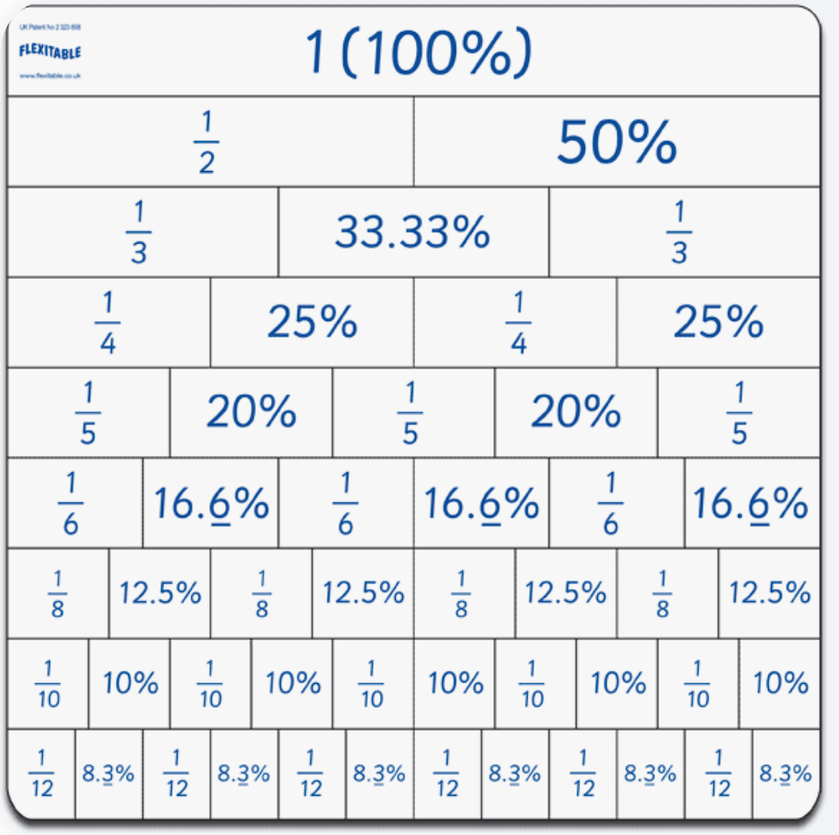

How far can you go?

Art and language:

What I’d like you to do is visit one of the virtual museum/art galleries or an art book or painting that hangs on a wall at your place. Pick a work of art that inspires you.
Virtual Museum and Art Gallery Tours. The Guardian shares breath-taking and interactive tours for cultural experiences from around the world. (Added March 31, 2020)

- Who is the painting by?
- What inspired your choice?
- If you like you could try to recreate the painting in your own style.

Discuss these questions with your family, either when you are eating together or out on a walk:

- People rarely agree about how great a particular painting is. Is it a matter of opinion, or are some people just wrong?
- If a painting is great today, will it be great tomorrow? Or does this change over time?
- What matters more: how much an artist gets out of making a painting, or how much it affects the people that view it

Questions by Aquila.

Language

Comprehension

Fairtrade – What’s it all about?

Fairtrade is all about making things fairer for the people in developing countries who grow and harvest the food we eat. It is a global movement which is represented in the UK by the Fairtrade Foundation, whose logo you’ll likely have seen on many supermarket products. When you spot it, it means that the ingredients in the product have been sourced in a way that does not damage the environment, and that all the workers who helped produce the product have been paid fairly and enjoy decent working conditions. As well as paying fair prices, companies that use the Fairtrade mark also contribute towards making life better for the people they are trading with, by giving money for things like schools, water pumps and health clinics – without them having to work their fingers to the bone just to afford bare essentials.

Fairtrade is a response to traditional trading arrangements which can be very unfair. Often, shops and businesses in first world countries such as the UK can take advantage of workers in developing countries who have very little money to put into their community or business, but badly need to sell their product. This means that farmers and other labourers have no say in their own futures, and are often taken advantage of. Long working days, back-breaking labour and poor pay are just a few of the ways workers can be exploited.
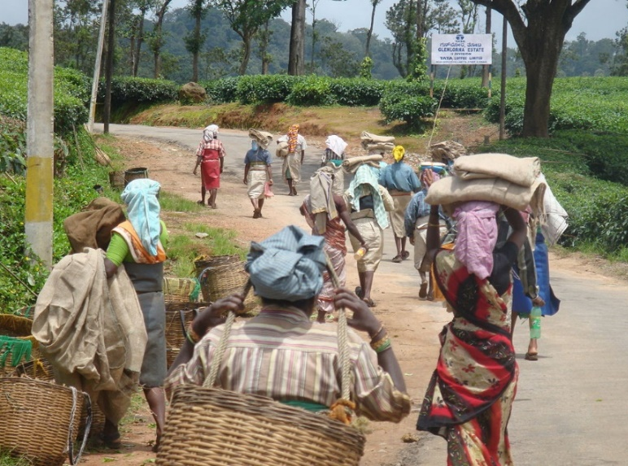
The idea of Fairtrade has been around for a long time. The first ‘Fairtrade’ shop opened in 1958 in the USA, and Oxfam UK started to sell crafts made by Chinese refugees at around the same time. Similar stores began opening around the world, and the big businesses and supermarkets caught on to the idea during the 1990s.

One product you might often see marked as ‘Fairtrade’ is coffee. It is one of the UK’s most popular drinks, and 125 million people around the world depend on its production for their livelihood. It is a sad state of affairs that most of the time, farmers are paid very little for their coffee, despite it being sold for a great deal more afterwards.

With Fairtrade, producers are guaranteed a minimum price for their coffee, which will cover their costs as well as let them invest back into their businesses, improving the quality of their product and the production process. For many workers in developing countries, it means the difference between living in poverty and looking forward to a sustainable future.

Fairtrade fortnight starts on the 25th February. This is a chance for all of us, from consumers to business owners, to really show support for Fairtrade farmers and the Fairtrade idea. Although of course, this isn’t just something we should be doing for a fortnight each year – it’s a great way of raising awareness and kick-starting better buying habits.

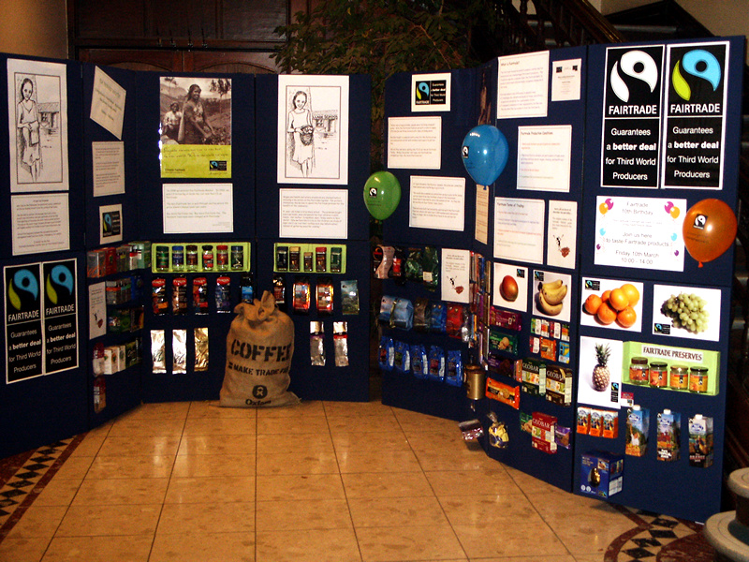

- Name TWO facts about Fairtrade from the first three paragraphs.

- State TWO reasons Fairtrade is a fairer deal for workers.

- Write out the sentence which proves that the writer thinks that Fairtrade is a good idea.

- Describe the problems caused for workers by unscrupulous employers.

- Define the terms ‘consumers’ and ‘developing countries.’ Use each term in a sentence of your own.

Physical Exercise

Make sure you are doing exercise every day, for example:

https://www.google.com/url?sa=t&rct=j&q=&esrc=s&source=video&cd=3&cad=rja&uact=8&ved=0ahUKEwiZr47xqMLoAhVNTcAKHXbfAhYQtwIINTAC&url=https%3A%2F%2Fwww.youtube.com%2Fwatch%3Fv%3DsX05HHni9Wk&usg=AOvVaw3Aet7tUWPdyxRgGlGJR9Da

Or, improve your football skills by practicing these, you may be able to do it inside if you buy a sponge ball and do a visual risk assessment:

https://blog.choosefootball.com.au/10-football-training-drills-to-improve-your-childs-soccer

Science
Space
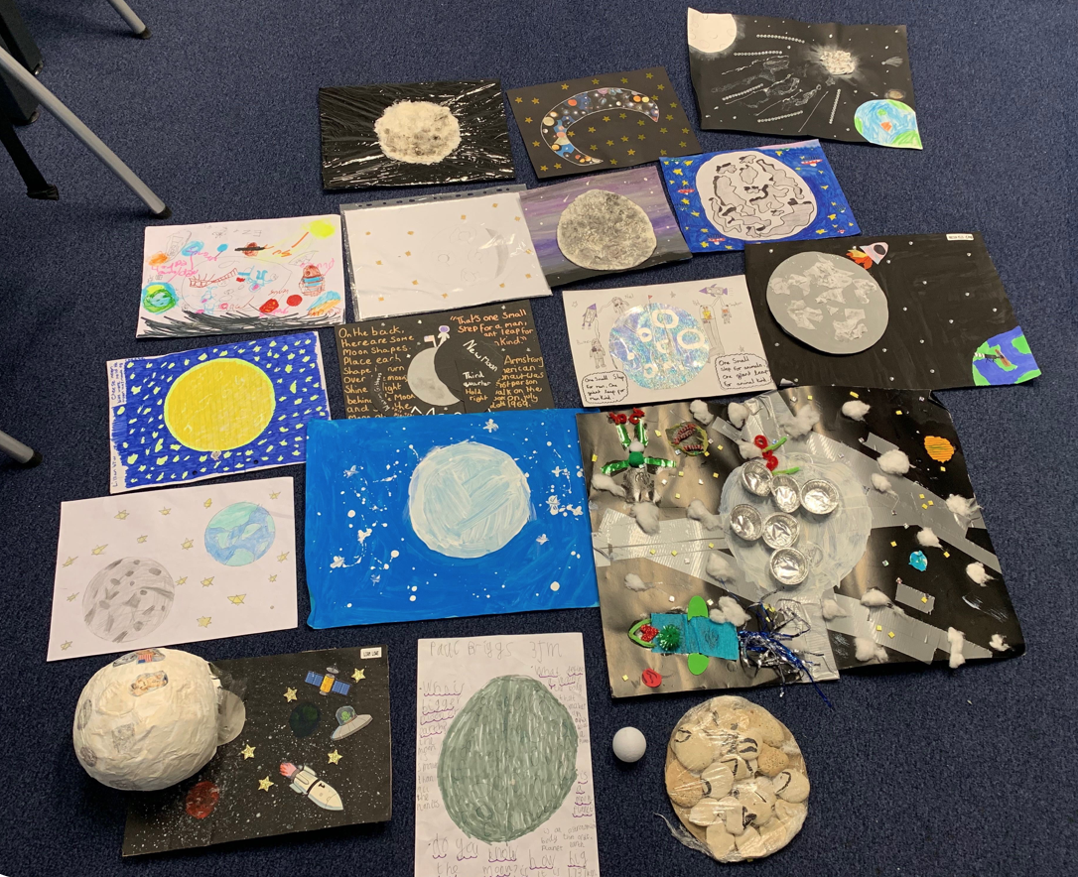

Explore the European Space Agency's website www.esa.int/esaKIDSen/ and find a section that interests you. Make a poster of some interesting facts that you learn.

Zoology
Watch (it is long so watch 30 mins maximum a day):
https://www.bbc.co.uk/iplayer/episode/b08xyqcs/the-british-garden-life-and-death-on-your-lawn
Then, go and explore in your own garden. Use your organisation skills to tell us what you find.
If you don’t have a garden…

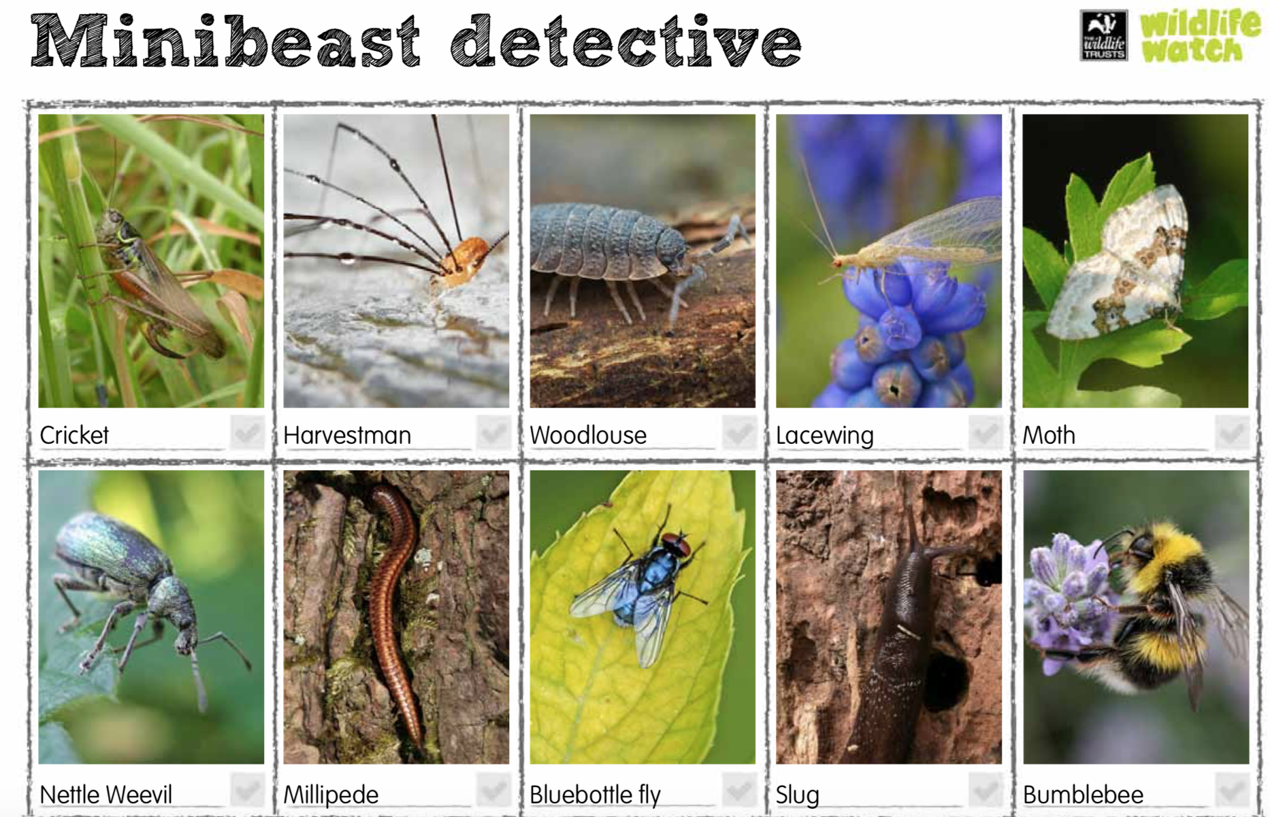

Safely looking for minibeasts can be tricky in urban woods so if you don’t want to encourage hunting at ground level, why not look in the trees?
1stretch out a sheet of white cloth (not fluffy material or your beasties will stick to it) beneath a tree branch. When choosing their tree, remind children to be aware of any thorns or prickly leaves.
2give the tree branch a few firm shakes without damaging the tree. Anything living there will be a bit surprised when it falls onto the sheet so you may have to wait for a moment for them to start to move!
3Use a paint-brush to gently scoop minibeasts into the pot (the winged ones will fly away fairly quickly!)
Comparing the variety of life found on different tree species will help to assess their biodiversity value. What trees are best for biodiversity?

