Green group

Please visit pirate poems and read or listen to the following poem:

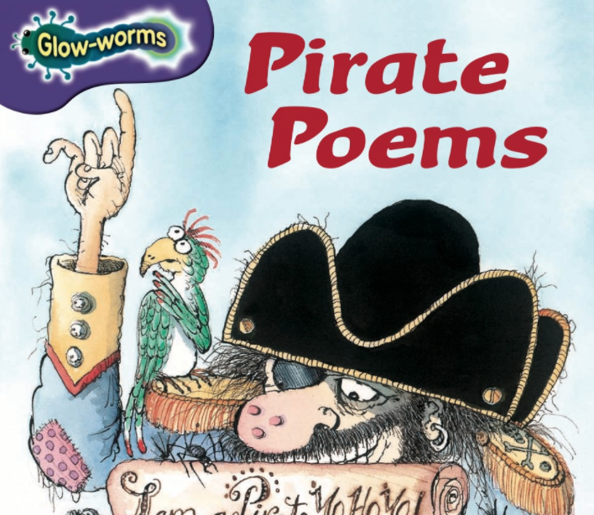

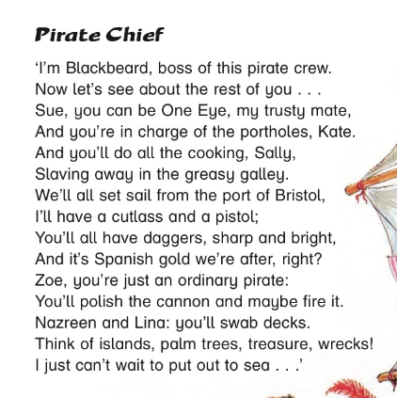
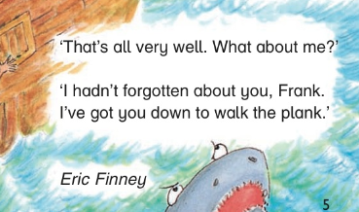

- I hope you liked it! Please, answer these questions:

_______________________________________________________

- Who is in charge of the cooking?

_______________________________________________________

- Where does she work?

_______________________________________________________

- Which English city did they set sail from?

_______________________________________________________

- What are the pirates trying to get from the Spanish?

_______________________________________________________

- Who is in charge of the canons?

_______________________________________________________

- What does poor old Frank got to do?

_______________________________________________________

Language

Poetry

Rhyming Couplets

The poem above has what is called ‘rhyming couplets’ – They are pairs of lines that both end with words that rhyme with the other.
Can you add the missing words?

Island Life

I didn’t want to come to this island,

But look I’ve found an enormous _______________.

diamond came flew jumped

The weather here is always fine.

Skies are blue here all the _______________.

rhyme everyday today time

I love the sand, the sea and the sun.

I’m having lots and lots of _______________.

enjoyment fun games excited

Yesterday I had the chance

to learn to do a Pirate _______________.

dish running chance dance

I’m learning to speak Pirate too.

‘Ohoy there matey, how are _______________?

we you friends everybody

Did you enjoy that?

Can you think up some words that rhyme with this list, then, perhaps, have a go at making your own Pirate Poem!

gold
ship
flag
plank
shark

Language
Reading/Sticking/Gluing

Aw mi hearties, cut out the words below and label this old seadog (pirate).

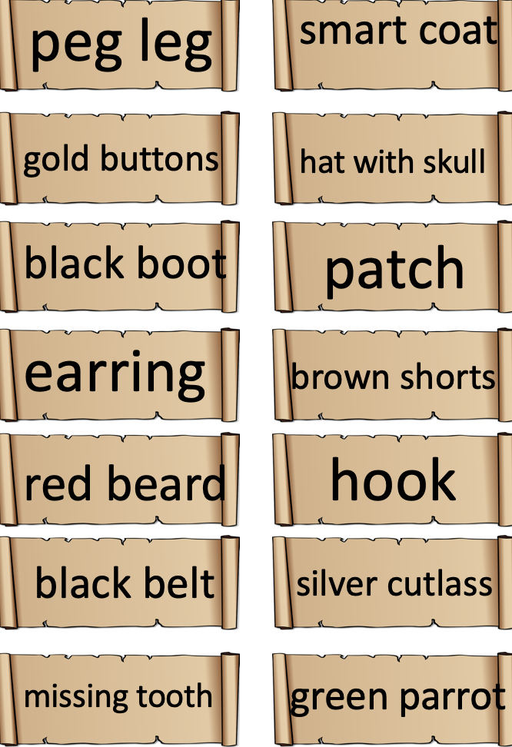

Art

Pirate Ship

https://www.youtube.com/watch?v=hSP9mjjLYbY

Mathematics

Word Problems

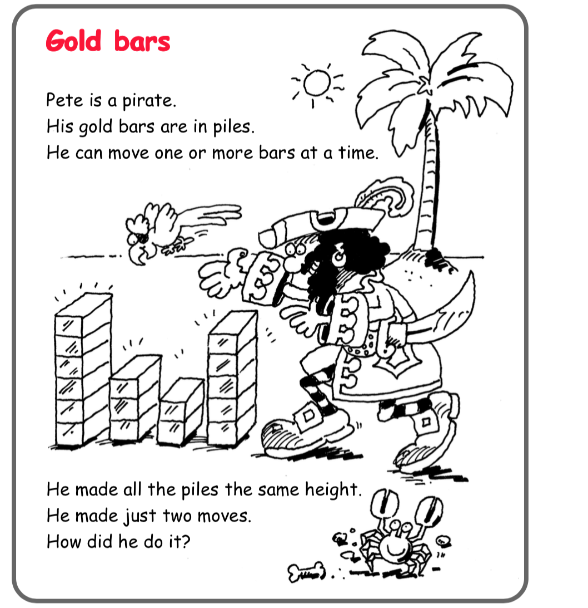

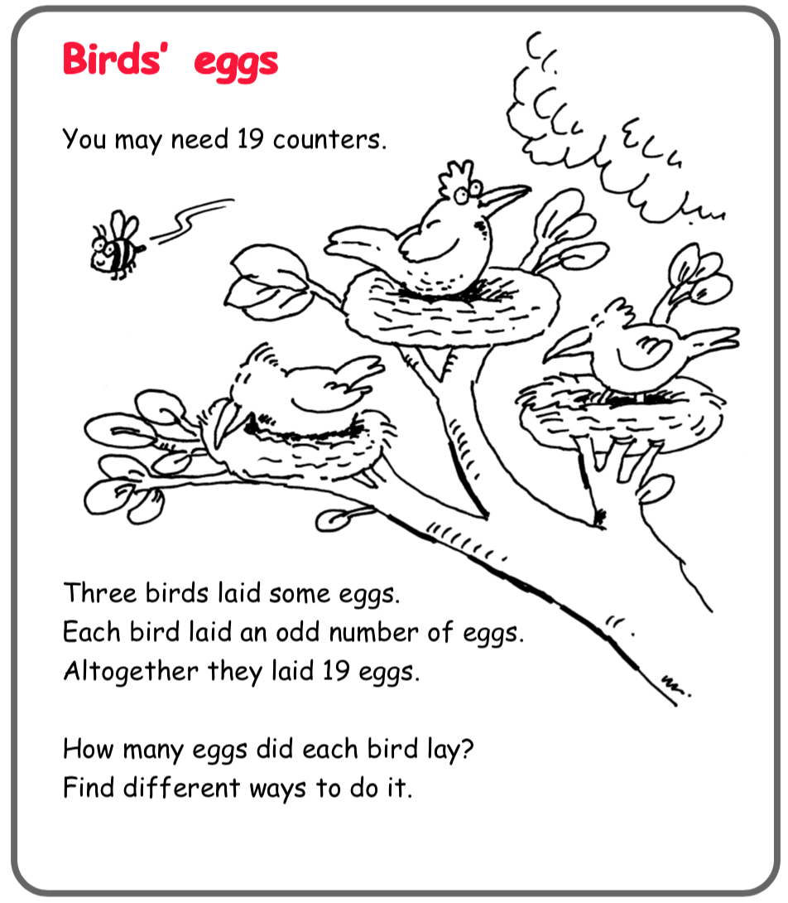

You and your Pirate chums are bored. One of them comes up with this:
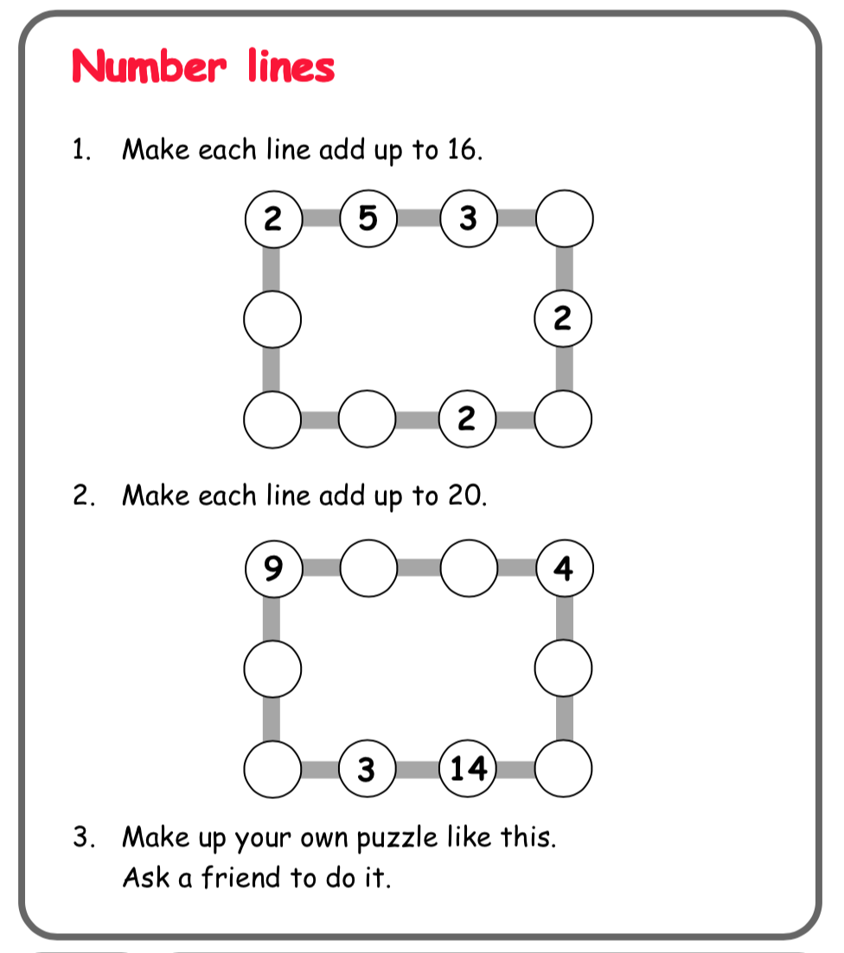

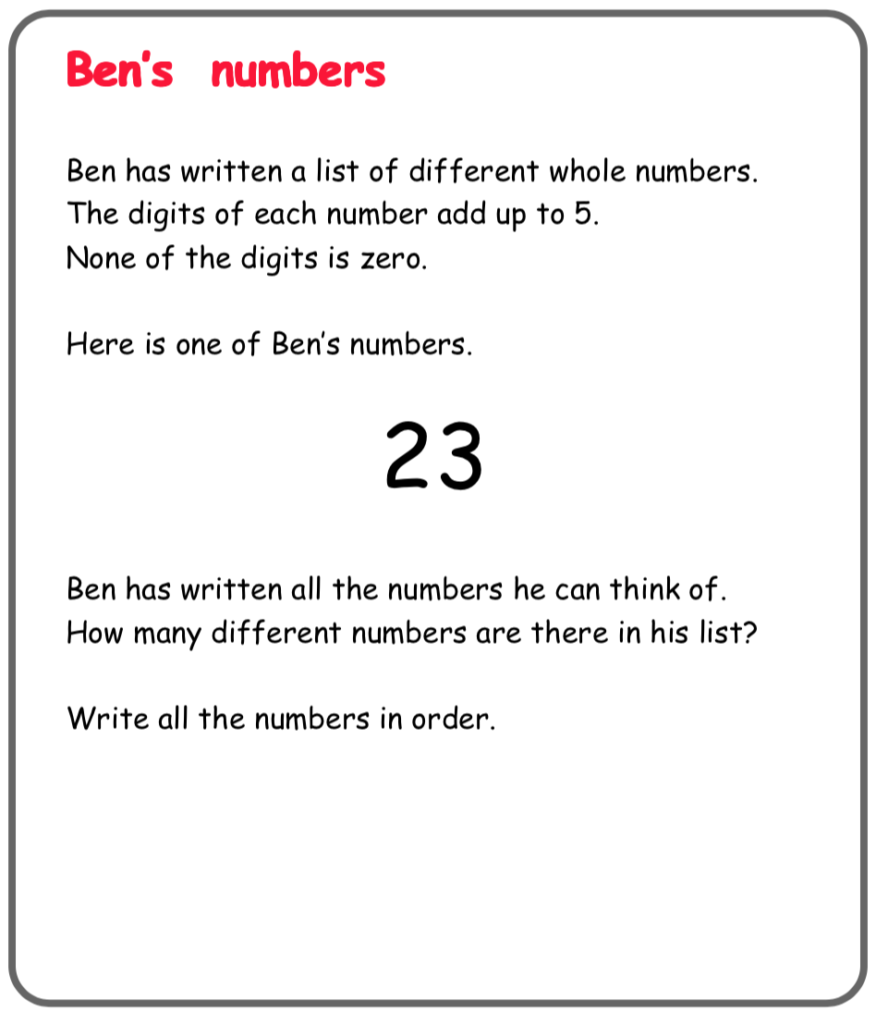

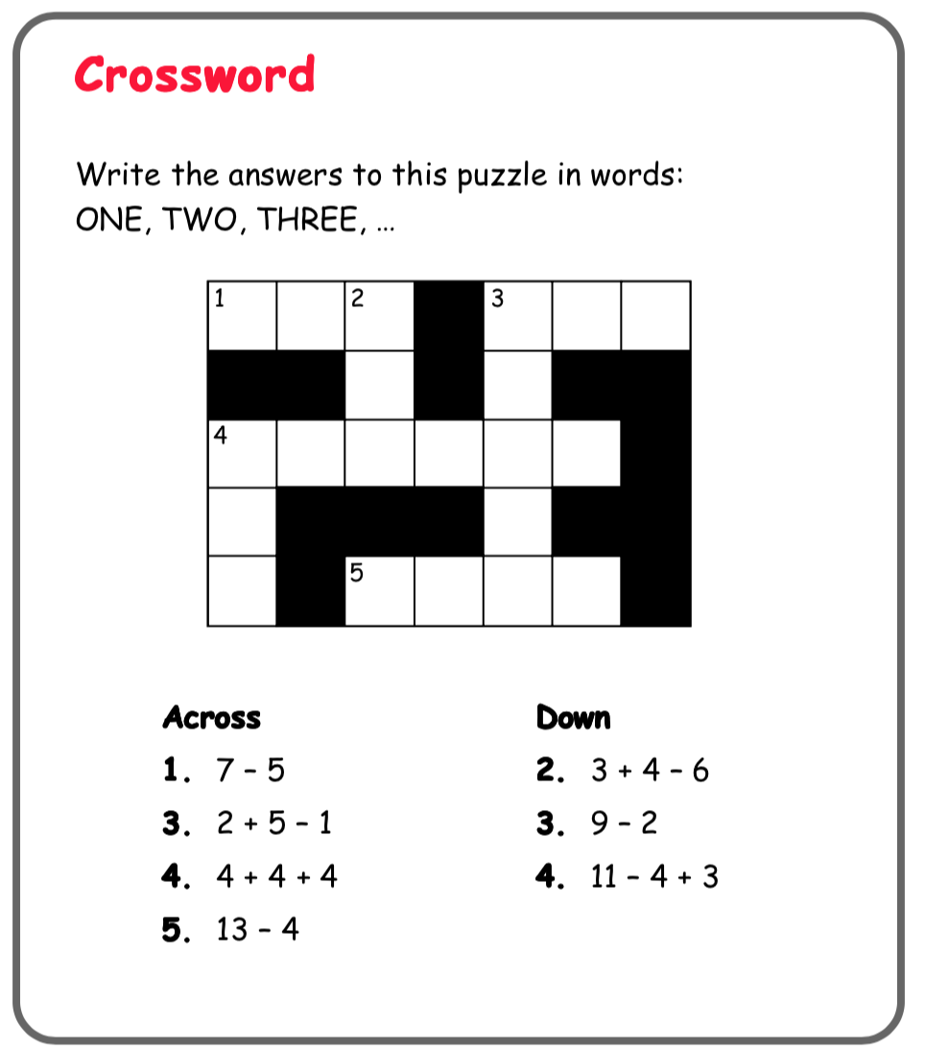
1 = one, 2 = two, 3 = three, 4 = four, 5 = five, 6 = six, 7 = seven 8 = eight, 9 = nine, 10 = ten, 11 = eleven, 12 = twelve

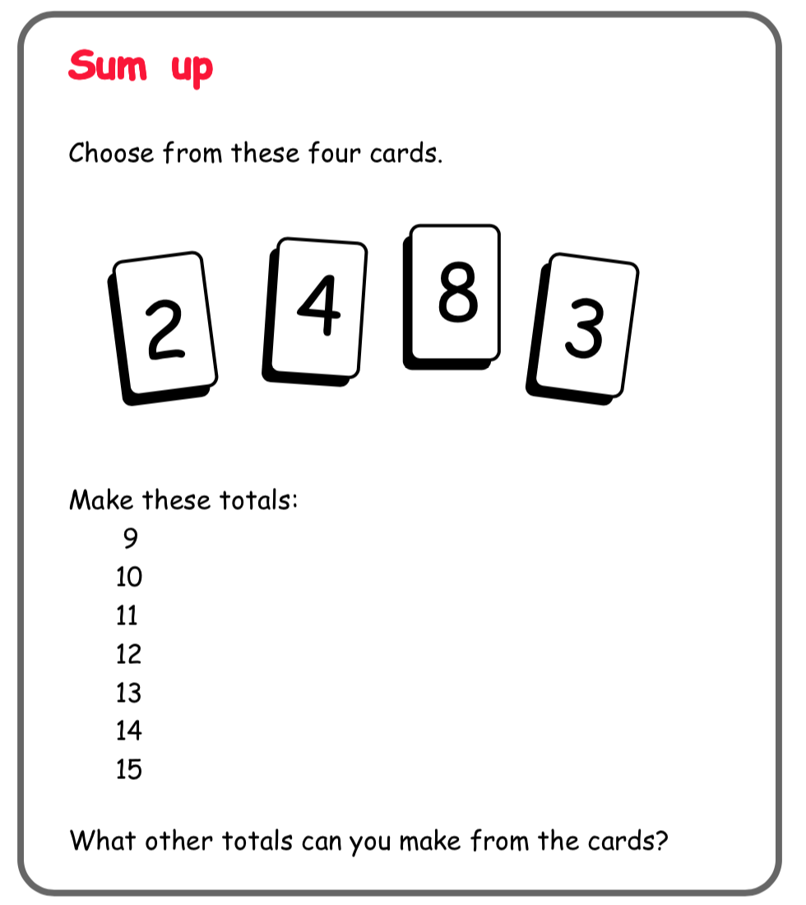
For example:
9 = 2+4+3

Science/Maths

Baking

Poor old Robinson longed for bread. Without many of the ingredients – yeast and butter to add flavour – he had to make flatbreads, with simply, flour and water. Imagine the delight if he was able to make these!
Why not have a go.

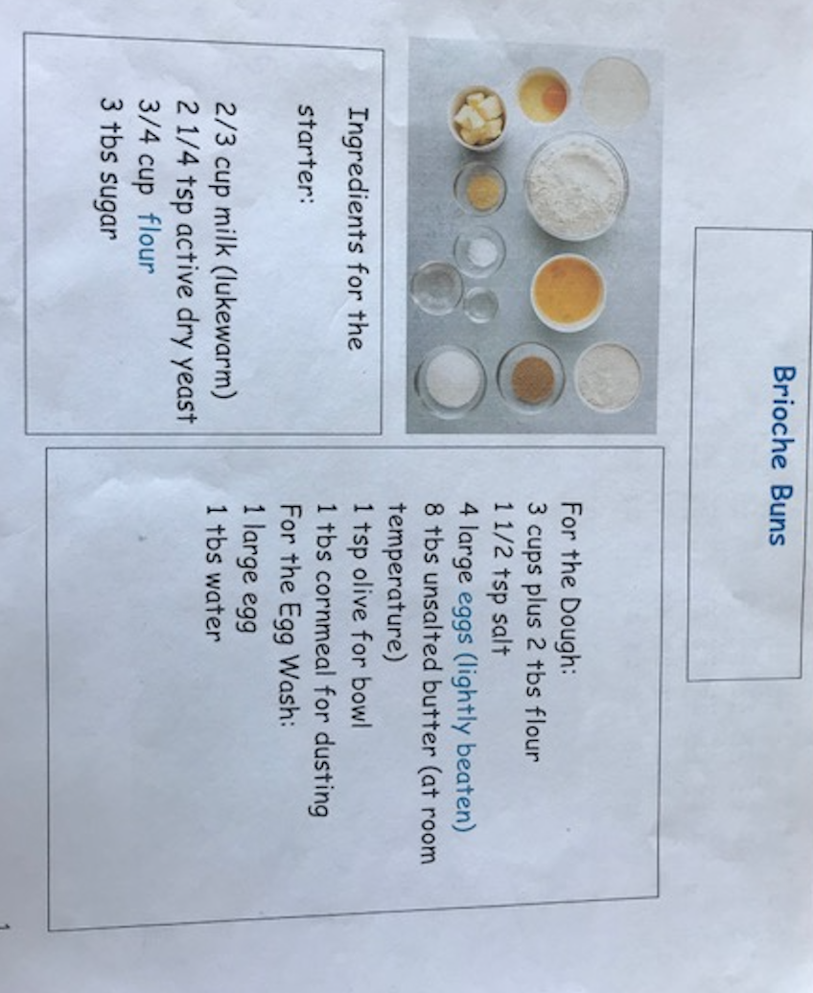

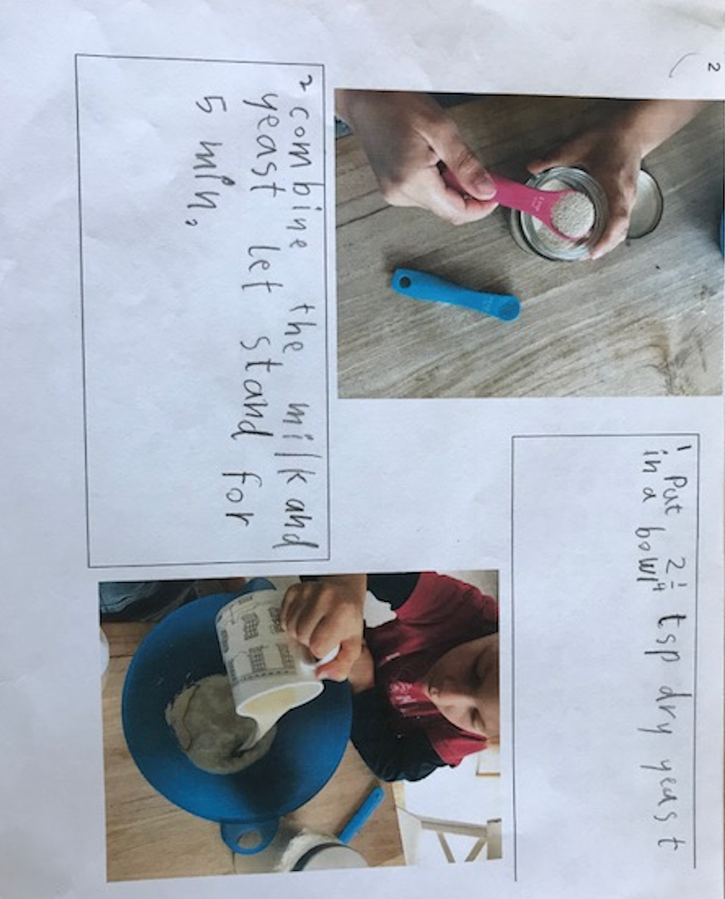

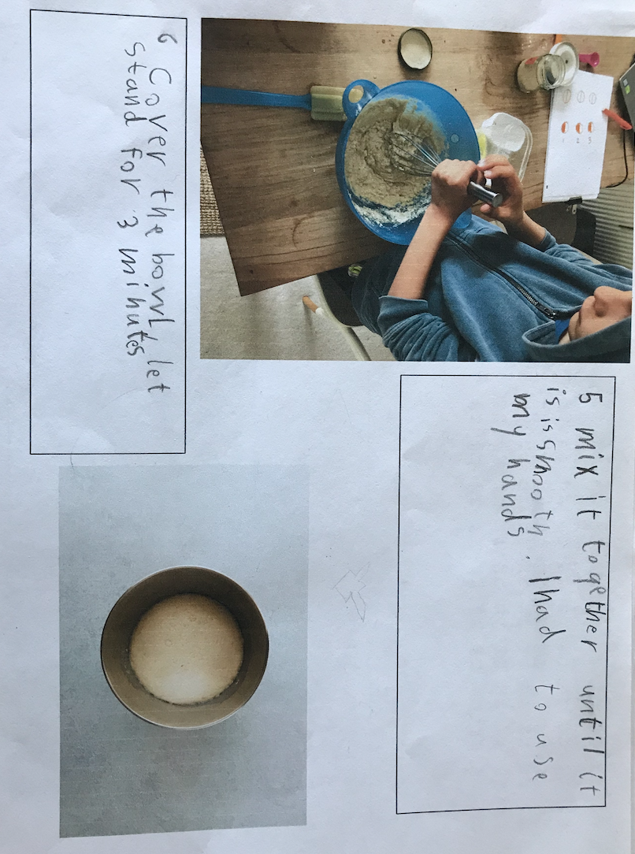
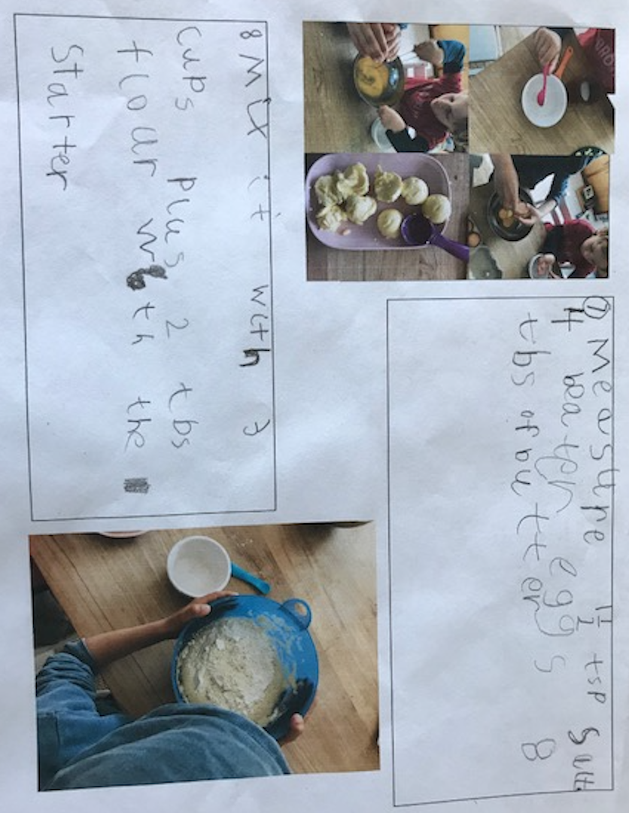

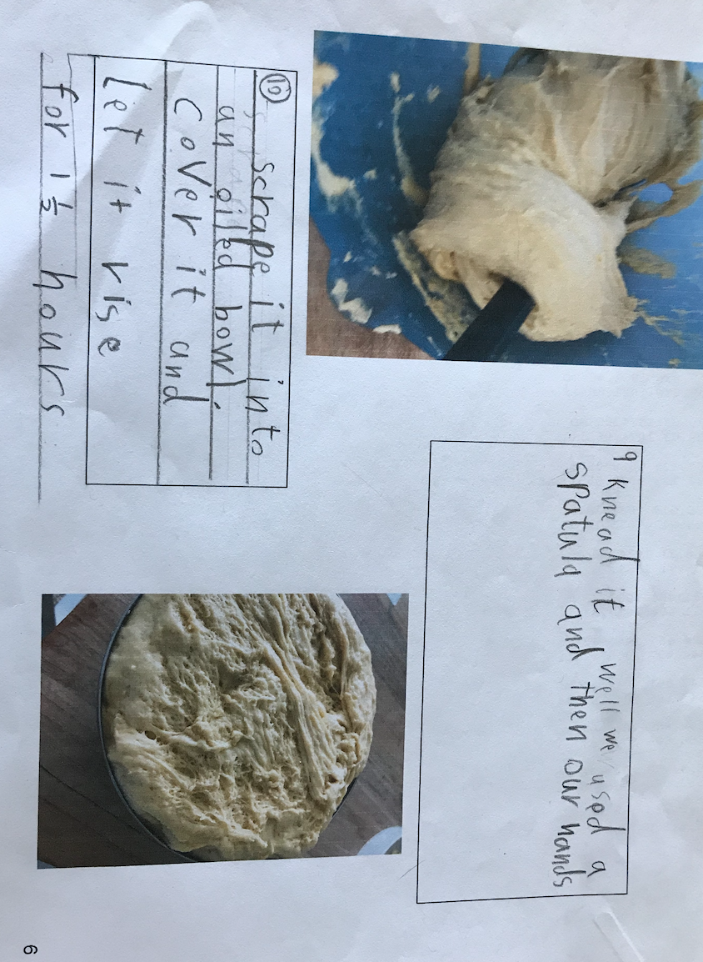

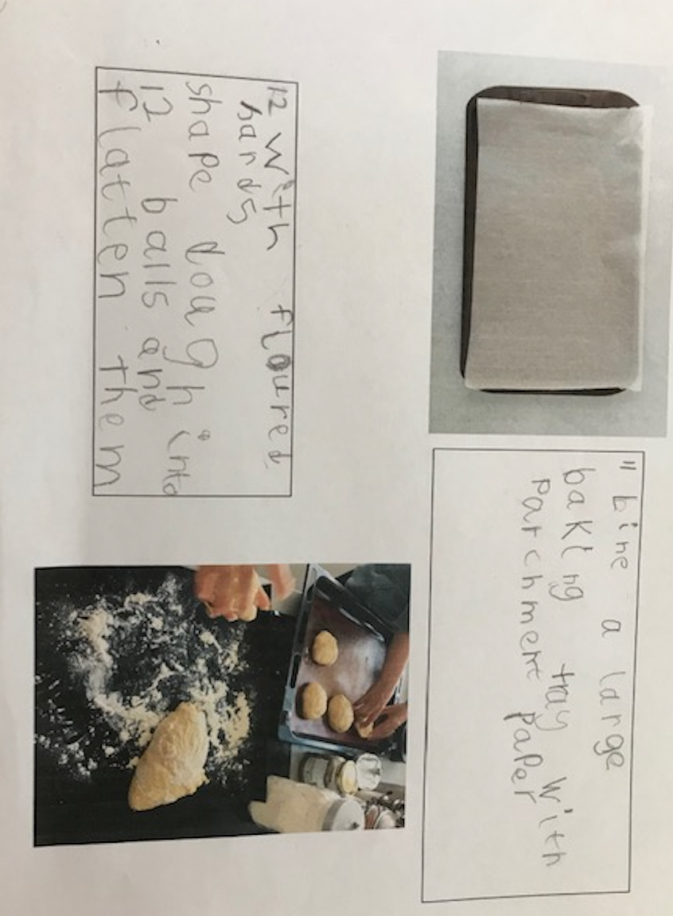

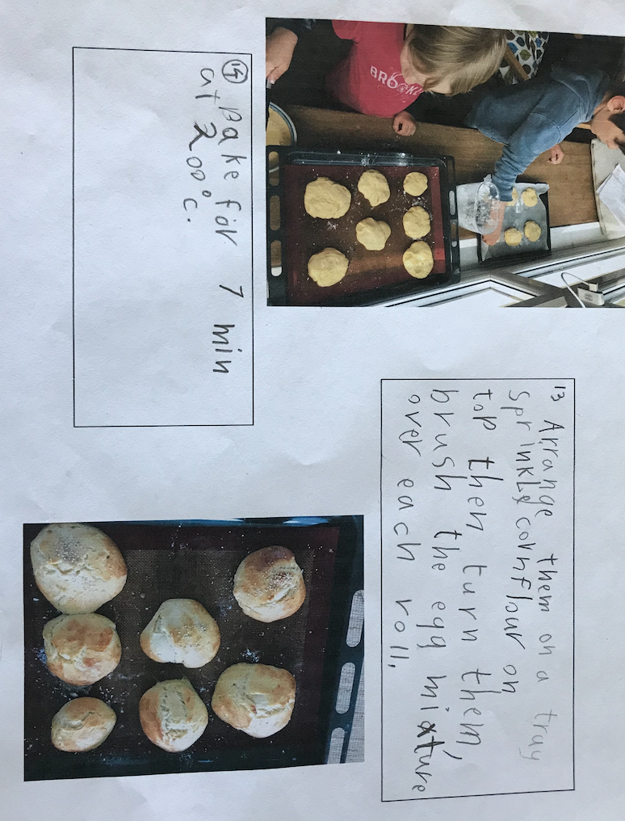

Thanks once again Emil and Friedrich for this wonderful tutorial on how to make ‘Brioche Buns’.
I will be asking you, next week, to build a shelter, on your island and write the instruction just as Emil and Friedrich have here. As you can see, most of the first words in the sentence are verbs – scrape, knead, mix…
And thanks, Emil and Friedrich, again, for numbering everything, I would have found it very difficult arranging the recipe if you hadn’t!

Good luck baking me old seadogs!

