Red Group

Hey guys,

How are we?

Please send me in the work that you’ve already done, along with any photos! I will need to record it on Montessori Compass, our record keeping system.

Zoology/Maths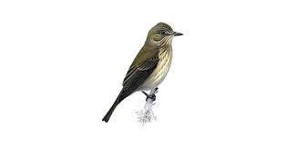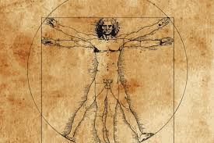

Please watch the video.

https://www.youtube.com/watch?v=VIi2O57zRwQ
Visually, humans/animals differ in their ability to see changes in their environment:
https://www.eurekalert.org/pub_releases/2016-03/uu-sbv031716.php#.XoIjywWarlU.mailto

How they perceive time can be counted using ‘Critical Flicker Fusion’ (CFF).*
* Critical Flicker-Fusion Frequency (CFF), the frequency at which a flickering light is perceived as continuous, is widely used for evaluating how animals perceive time.

Here is a list of the CFF of various animals:
Species | CFF
Ambystoma tigrinum | 30
Anguilla anguilla | 14
Asio flammeus | 70
Canis lupus familiaris | 80
Dermochelys coriacea | 15
Felis catus | 55
Gallus gallus domesticus | 87
Homo sapiens | 60
Oncorhynchus mykiss | 27
Rattus norvegicus | 39
Spermophilus lateralis | 120
Sturnus vulgaris | 100
Tamiasciurus hudsonicus | 60

Please, use the animal’s Latin names to find out their more familiar English names (use your search engine or an encyclopaedia). Input them into the table to the right (as below, but using their English names) in Purple Mash.
Choose the ‘Line graph’ (to the right of the Pie chart) to plot the CFF of each animal, lowest to highest:

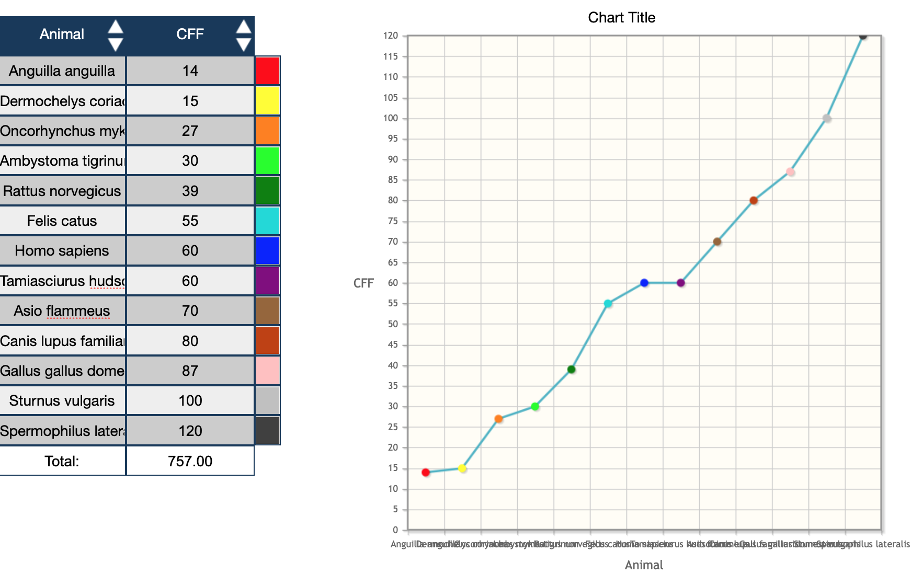

Save your work on your Purple Mash account.

Geometry

Don’t just eat the marshmallows!!!

https://www.youtube.com/watch?v=JEuwqcKsWjc

Send in photos of your creations. Measure how tall you managed to build yours!

Physical Exercise

Make sure you are doing exercise every day, for example:

https://www.google.com/url?sa=t&rct=j&q=&esrc=s&source=video&cd=3&cad=rja&uact=8&ved=0ahUKEwiZr47xqMLoAhVNTcAKHXbfAhYQtwIINTAC&url=https%3A%2F%2Fwww.youtube.com%2Fwatch%3Fv%3DsX05HHni9Wk&usg=AOvVaw3Aet7tUWPdyxRgGlGJR9Da

Science

The Solar System

Sit your family down for the spectacular second episode of ‘The Planets’.

https://www.bbc.co.uk/iplayer/episode/p06qj2qg/the-planets-series-1-2-the-two-sisters-earth-mars

Please answer these questions and embellish the border of your page with astronomy related pictures.

- What was the first mission to take pictures of Mars in 1965?

- What is the name of the most recent mission to Mars?

- What is the name of the largest volcano in the solar system?

- What is the name of the robot that set foot/tracks on Mars?

- What benefits do you feel there are in colonising Mars?

Language
Journal writing.
1. Read the three diary extracts
o Choose one of the extracts and answer the analysis questions.
o Challenge yourself to answer the questions comparing all the extracts.
2. Adverbs
o Read through the learning reminder cards.
o Work through the adverbs activities. Challenge yourself to do as many as
The Diary of a Killer Cat: Chapter 3
SO SPANK ME! I brought a dead mouse into their precious house. I didn’t even kill it. When I came across it, it was already a goner. Nobody’s safe around here. This avenue is ankle-deep in rat poison, fast cars charge up and down at all hours, and I’m not the only cat around here. I don’t even know what happened to the thing. All I know is, I found it dead. (Fresh dead, but dead.) And at the time I thought it was a good idea to bring it home. Don’t ask me why. I must have been crazy. How did I know that Ellie was going to grab me and give me one of her little talks?
“Oh, Tuffy! That’s the second time this week. I can’t bear it. I know you’re a cat, and it’s natural and everything. But please, for my sake stop.”
She gazed into my eyes. “Will you stop? Please?”
I gave her the blink. (Well, I tried, but she wasn’t having any.)
“I mean it, Tuffy,” she told me. “I love you, and I understand how you feel. But you’ve got to stop doing this, okay?”
She had me by the paws. What could I say? So I tried to look all sorry. And then she burst into tears all over again, and we had another funeral.
This place is turning into Fun City. It really is.

Diary of a Lively Labrador: Monday
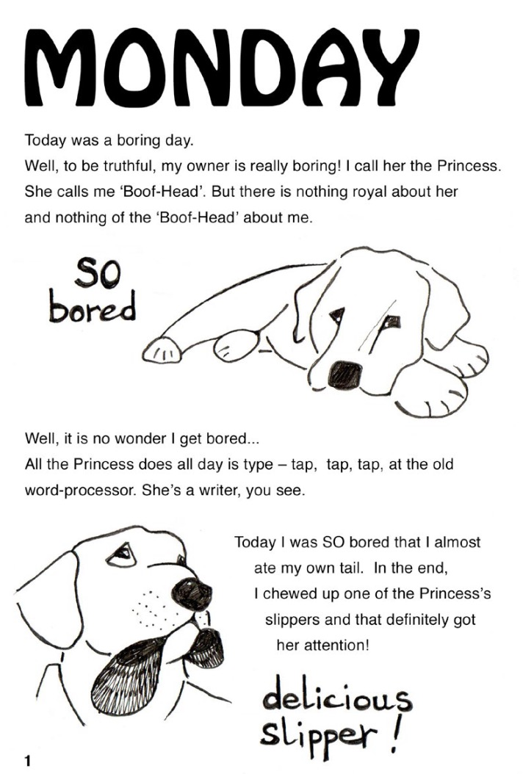

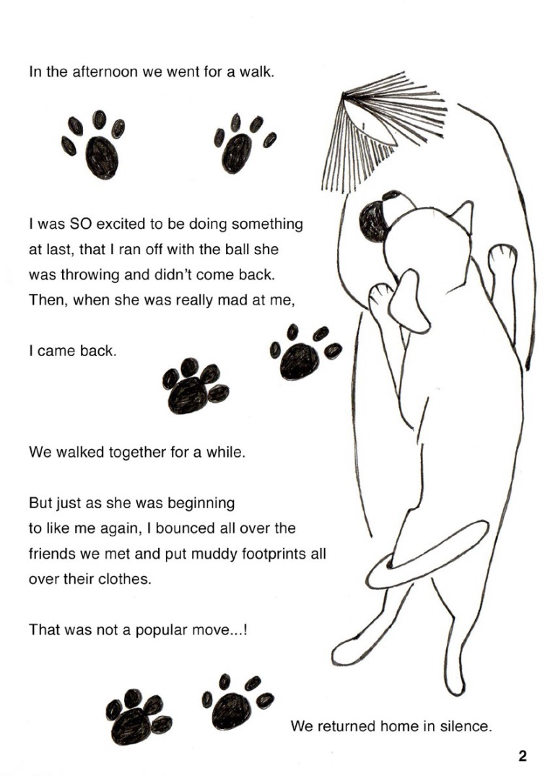

Diary of a Wimpy Kid

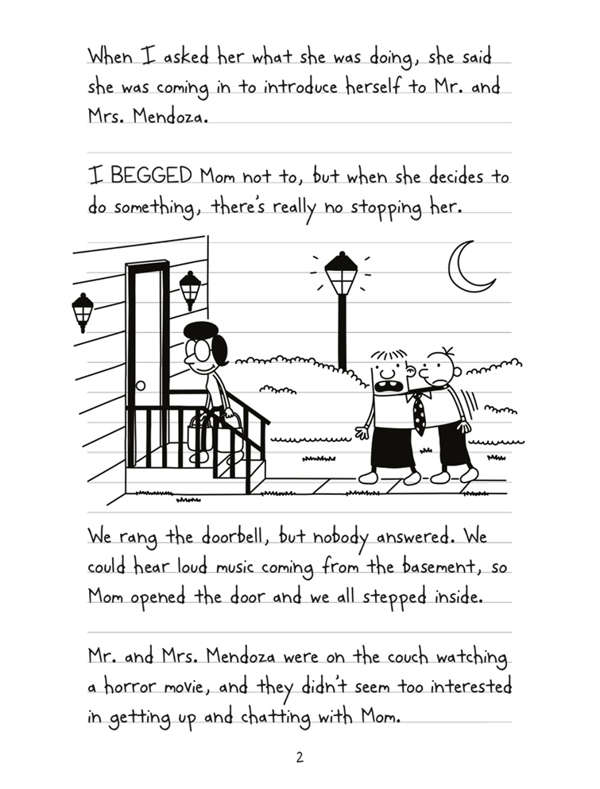
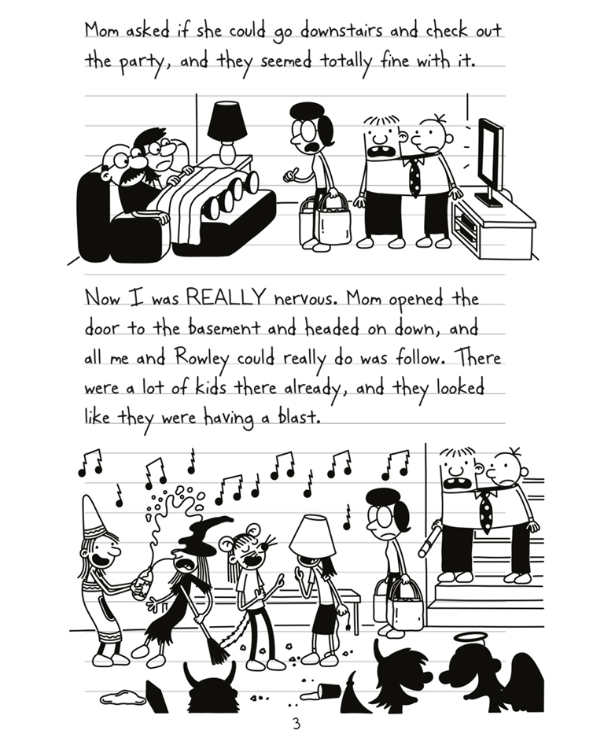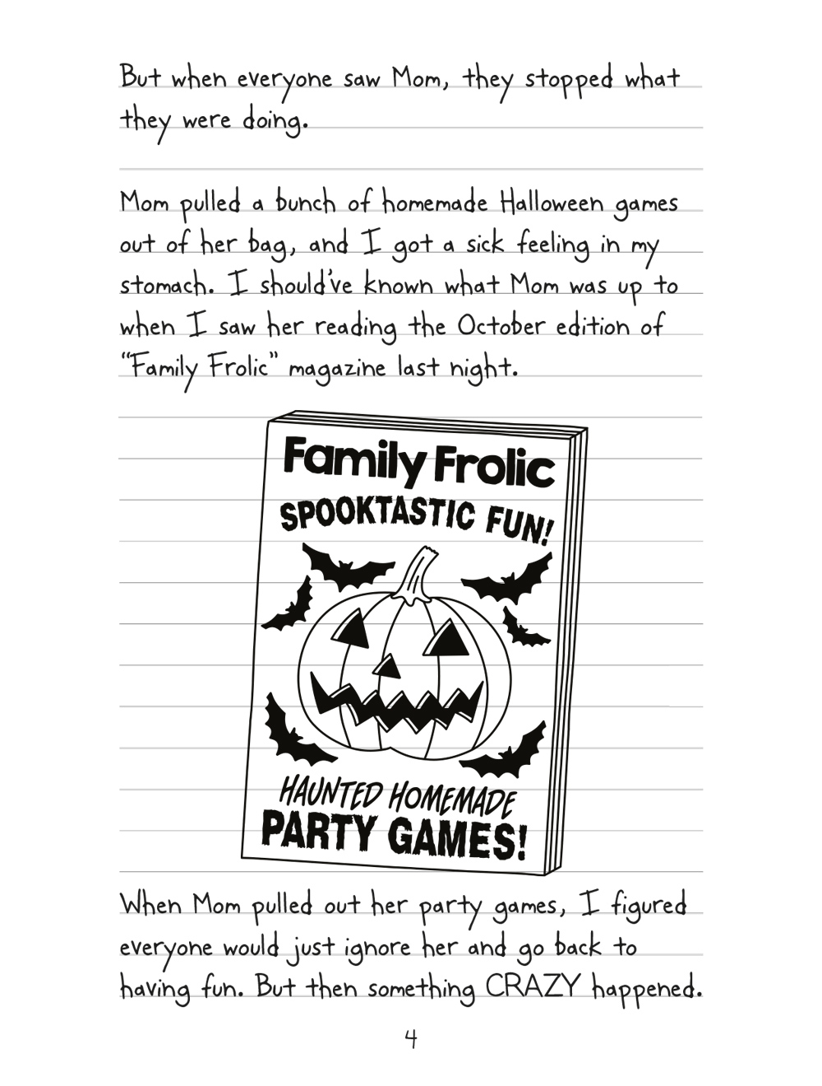

Diary Analysis Questions
Diaries are written in the first person (I, me, my, mine) and present the author’s point of view and feelings about things.
They report things that have happened, usually a recount for each day.
Choose one of the diary extracts and answer the following questions
- Who is writing the diary? What is their name?
- What are they? Human or animal, and if animal, what type?
- What tense is the diary written in?
- Is the character likeable? In what way?
- Is the diary interesting? Is there a problem to solve?
- What other characters are in the diary? What are they like?
Challenge: now think about all the diary extracts
- What is similar about the diary extracts?
- What are the differences? Can you list these?

Use these techniques to fine tune your entries in your journals.

Art

What you need:
- Watercolour paints/pencils, ink or food colouring
- Paper
- A white candle
- Paintbrush
- Surface covering

- Prepare your space, if you’re using food colouring this step is especially important as it will stain surfaces and floors.
- I find it helpful to draw a box around the area I will write in, so I know where to paint! However, if you are going to draw over the whole piece of paper you can skip this step.

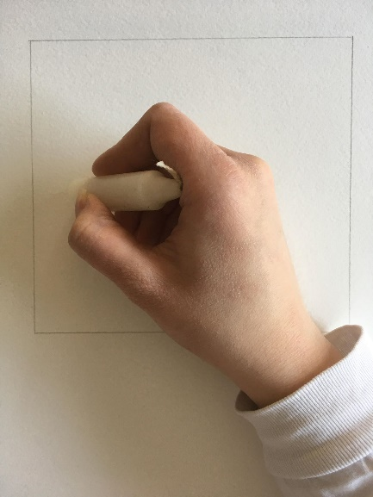
- Take your wax candle and draw with it as you would a crayon, if you want to see where you have been drawing to keep track, you can lift the page and angle it towards the light to see the wax.

- Choose your colours! If you are using ink or food colouring for this step you only need 1-2 drops, use a plastic plate to mix it with water before you apply it to your paper.
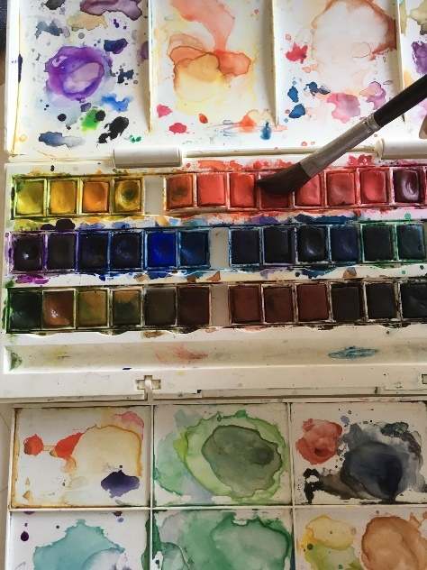
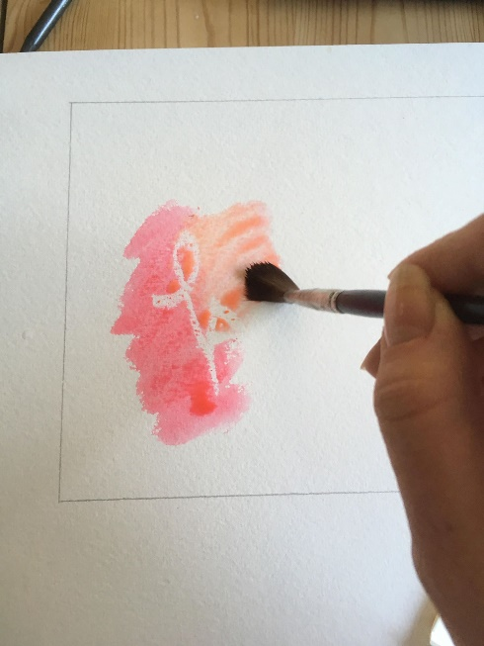
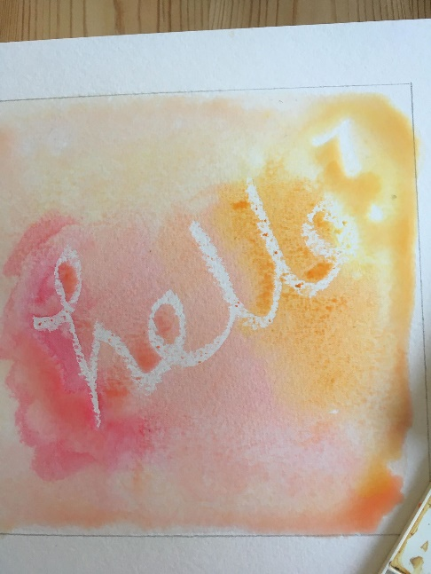
- Take your brush and paint over the wax you have drawn with! The drawing will be revealed.
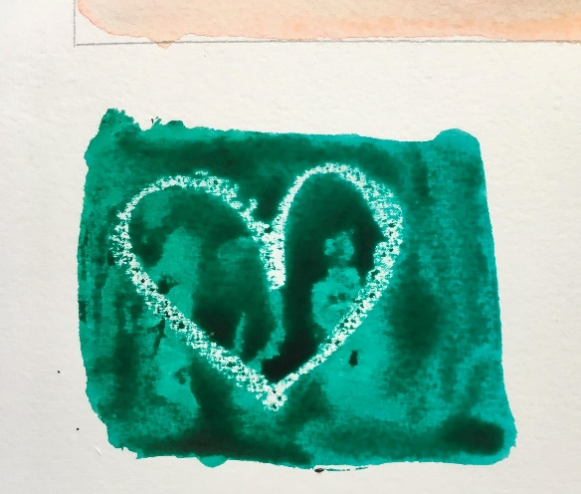
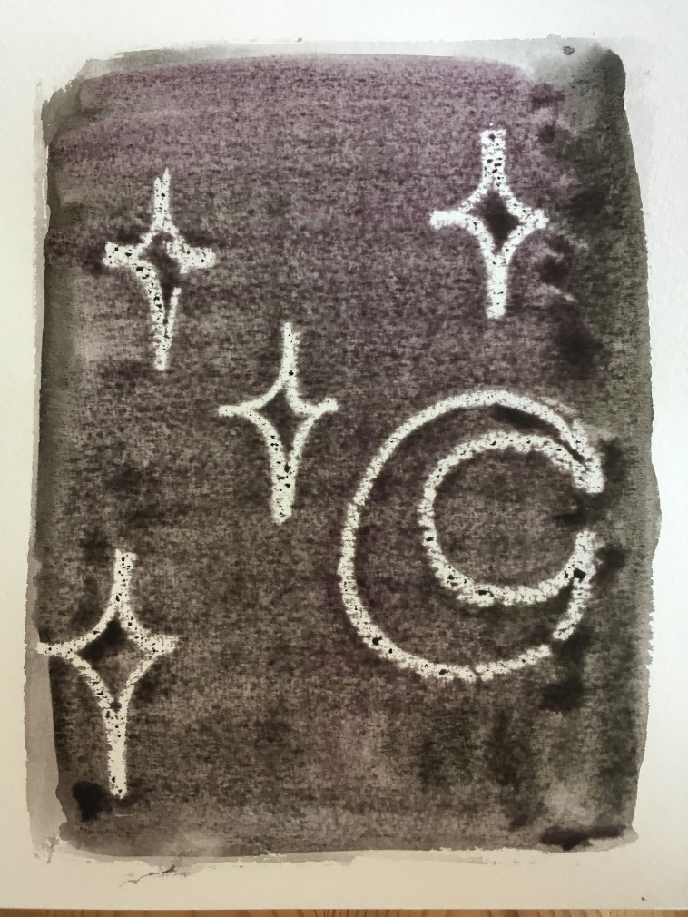

Have a think about this activity, why and how does it work? Have fun experimenting, you can write or draw whatever you like with the wax candle. If you would like to send in some photographs of your results, we would love to see them!

Have a great Easter- I won’t be sending in any work for the Easter holidays. Look out for more work posts at the start of the ‘Summer term’!

