Green Group 15/06/20

Botany
Potatoes

Do you remember back on the 3rd of June we planted the potatoes with Debbie? Half were regional and half were Rocket? Well, it’s nearly time for us to harvest them (16th of March), weigh them and send in our results to GYOP (Grow Your Own Potatoes).

What is a potato? Anyone remember? Yes, of course it’s a tuber!
Tubers give us potatoes, sweet potatoes, oca, and yams. A tuber is a short, thick, round stem or root that grows underground, usually as and offshoot from the main stem of the plant. Tubers contain all the necessary parts to produce a new plant. If you leave a potato in the kitchen drawer for too long, for example, it will sprout.

Please, watch the below link showing how our potatoes grow:

Time lapse of a potato

Read the ‘Potato Timeline’ below then answer the questions.

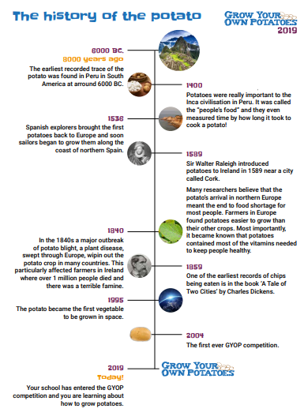
- Which country was the first ever recorded trace of the potato? Colour it in on this map:

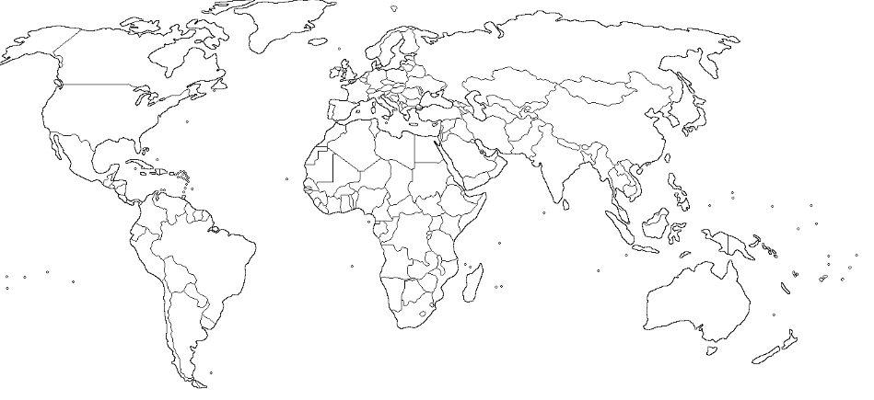

- Apart from eating them, what else did the Incas use potatoes for?

- Which country first brought back the potato to Europe. Colour it on the map!

- Give two reasons why farmers preferred to grow potatoes rather than their other crops.

- One of the first ever recordings of potatoes being made into chips, was in Charles Dickens’ ‘Tale of Two Cities’; write a list of some of Charles Dickens’ most famous novels.

Please, click on the link below and watch this short film.
Then answer the questions below:
From field to fork

Earthy potatoes – from farm to fork

- Where do the potatoes grow? (Pick one.)
- On bushes
- In trees
- In ridges in the ground
- On top of the soil
- How do farmers remove the soil from the potatoes they are harvesting?
(Pick one.)
- They wash each one in a bucket of water
- They gently shake the potatoes
- They don’t remove the soil
- The soil is removed later
- After harvesting, the potatoes are stored in big wooden boxes. What weight of potatoes does each box hold? (Pick one.)
- One tonne, the same as a small car
- One hundred tonne, the same as 100 small cars
- 2.2 pounds, the same as a bag of sugar
- 2.7 tonnes, the same as a female Asian elephant
- How does the farmer get the potatoes from the field to the pack house?
(Pick one.)
- On a bike
- In big lorries
- By helicopter
- In a wheelbarrow
- Why does the farmer put some of the potatoes into cold storage? (Pick one.)
- To keep an eye on them – look after them?
- Allows us to have potatoes all year round
- So the famers family has plenty to eat
- To stop the farmers cows eating them
- How does the farmer look after the potatoes in the cold store? (Pick one.)
- The farmer covers them with a blanket to keep them warm
- They are kept in the dark at 3°C
- The farmer keeps the light on so they can checked
- The farmer sings to them

- True or false? The potato washer in the factory can wash up to 45,000 potatoes every hour.
- True
- False
- At the packing stage, what name is given to potatoes that are bad or damaged? (Pick one.)
- Simon
- Outgrades
- Smashed
- Broken
- The farmer uses the ‘outgrades’ for other purposes. What are these? (Pick two.)
- Some are used to make electricity to power the factory
- Some are planted back into the fields
- Some are taken by local farmers to feed their cows
- Some are thrown away
- We can buy fresh potatoes from supermarkets in bags or loose. What’s your favourite potato dish?

Write a short sentence or draw a picture below

Maths
Operations

Harvest time

Can you help solve these problems and then write 2 of your own?
There are 4 tomato plants. Each plant has grown 5 tomatoes. How many tomatoes are there altogether?

There are 3 courgette plants. One grew 6 courgettes, one grew 7 courgettes and one grew 9. How many courgettes are there in total?

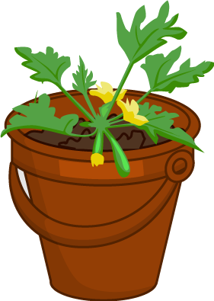

There are 20 students in Class B and 60 potatoes. How many potatoes can each student have?

18 strawberry plants were grown. 2 got knocked over during the holidays and 3 plants died. How many plants were left?

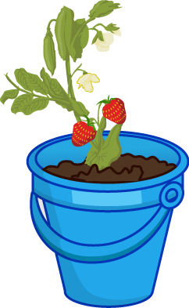

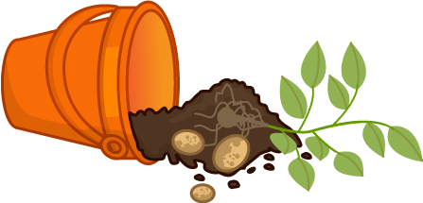

Botany
Swollen Roots

Can you match the pictures with the definitions?

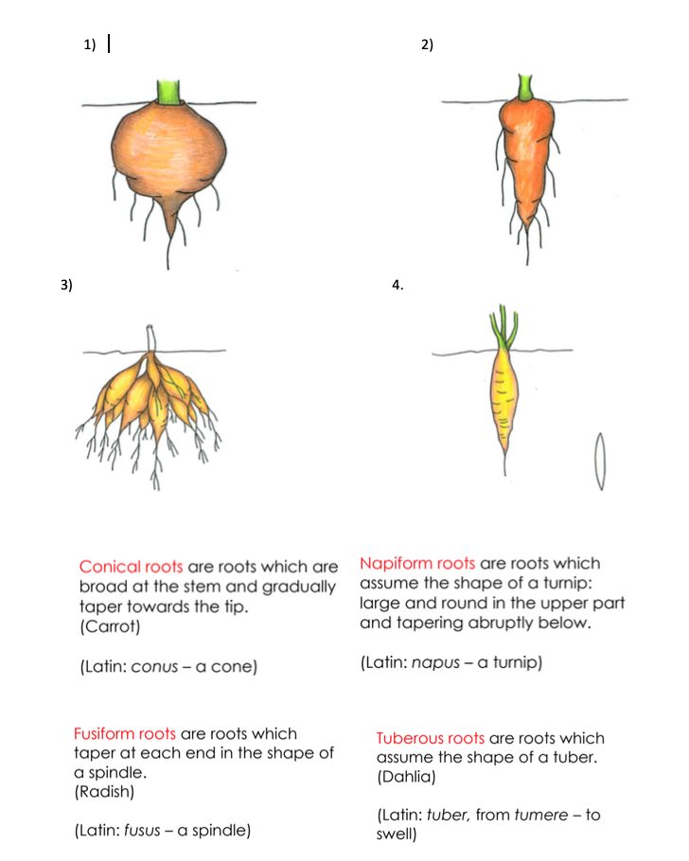
Make your own book of ‘Swollen Roots’?
Science
Science experiments

Science experiments
*Please, always have an adult present when doing these experiments.
Choose two experiments and research the science behind them.

