How can the Family Information Service support you?

Our information and advice for families and professionals
covers three main areas:
- Family support
- Childcare and childcare funding
- Employment and training

You can find all our information online on the
Family Services Directory

The directory lists all Ofsted registered childcare providers in the city, as well as wide range of local services.
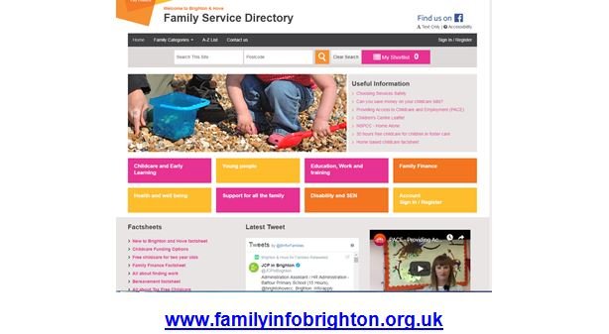

Our factsheets

We have a range of factsheets on our directory that can save you time when advising parents. These include:
- Where to find support for your family
- Separated parents
- Services for under 5’s
- Services for young people
- New to Brighton & Hove –key information for families new to the city
- Bereavement – Practical steps and emotional support
- Family Finance – Includes the main sources of financial support for families and where to go for advice
- Free childcare for two year olds
- 15 and 30 hours free childcare for three and four year olds

Practical help and support for families

We can respond to enquiries from parents and professionals via our helpline or inbox. For families who have several issues, or more complex needs, we can offer short term case work with an adviser. If you’re not sure if we can help, get in touch!
The support we can offer includes:
- Referrals to foodbanks the Local Discretionary Fund and other agencies offering support
- Advice on benefits and debt
- Applications to charitable grants for essential goods, for example beds, cots, white goods, Items for babies and children
- Guiding parents around the help that is available and joining up support

Childcare and childcare funding

- All local Ofsted registered childcare is listed on our Family Services Directory.
- We advise on all types of childcare funding including two, three and four year olds, help through Universal Credit and Tax Credits, Tax Free Childcare and support for parents who are studying
- FIS works to increase take up of funded two year old places. We contact parents directly and work with other professionals such as social workers to make sure that the most vulnerable children are able to access their place.
- Brighton & Hove currently has a take up rate of 84% for funded two year olds – the highest in the South East!
- Our Childcare Brokerage Officer supports parents who are struggling to find the right childcare and works with the PACE Team to support parents moving into work and training
Back to Work Support

Providing Access to Childcare and Employment (PACE)

PACE aims to help parents move into work, training, or volunteering.It is a supportive and friendly service which is available to parents who:

- claim out of work benefits, or if they are a non-EEA (European Economic Area) citizen have the right to work in the UK
- have a two, three or four year old child with a funded childcare place
- face additional barriers or challenges to reach their goals

PACE keyworkers work with parents every step of the way to help them achieve their goals. They can:
- Help to identify skills and abilities and build confidence
- Support with CV writing, interview skills and preparing for work
- Provide “back to work” calculations so parents know how much better off they will be in work
- Support parents to find childcare and funding for childcare
F
PACE parents have said:

“I feel a lot more confident and able to do much more in the future. I think I have more choices and I feel more happy in life than before.”

“the support I have received throughout my journey has been outstanding, I cannot fault it. I could never have achieved so much without PACE and the team behind it”
T
FIS Employment Advisers

- We have two advisers seconded to FIS from the Department of Work and Pensions that can offer employment support and advice
- The advisers case work with parents to help them improve their confidence, gain work experience and a reference, gain work skills, develop a CV, improve their job hunting and interview skills and ultimately, to get a job.

How to get in touch with FIS

- Email familyinfo@brighton-hove.gov.uk, or call 01273 293545
- To make a referral for a family who would benefit from case working with an adviser, complete the referral form at www.brighton-hove.gov.uk/frontdoorforfamilies. Please clearly indicate that the referral is for FIS and outline the issues that the family are facing.

