Blue Group 15/06/20

Botany/History
Potatoes

Do you remember back on the 3rd of June we planted the potatoes with Debbie? Half were regional and half were Rocket? Well, it’s nearly time for us to harvest them (16th of March), weigh them and send in our results to GYOP (Grow Your Own Potatoes).

What is a potato? Anyone remember? Yes, of course it’s a swollen root but which kind? Tuber! That’s right!
Tubers give us potatoes, sweet potatoes, carrots, oca, yams, and turnips. A tuber is a short, thick, round stem or root that grows underground, usually as and offshoot from the main stem of the plant. Tubers contain all the necessary parts to produce a new plant. If you leave a potato in the kitchen drawer for too long, for example, it will sprout.

Please, watch the below link showing how our potatoes reproduce:

Time lapse of a potato

Botany
Swollen Roots

Can you match the pictures with the definitions?

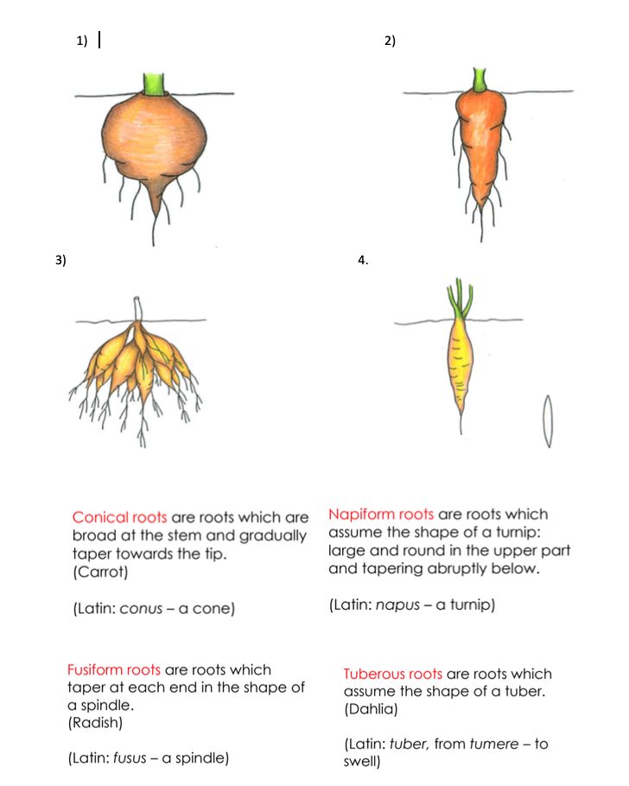

Draw your own detailed pictures and make your own definitions to make into a book. You could use the instructions on how to make a miniature book from last weeks work.

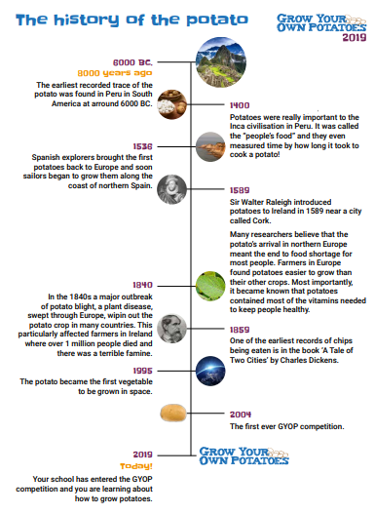

- Which country was the first ever recorded trace of the potato? Colour it in on this map:

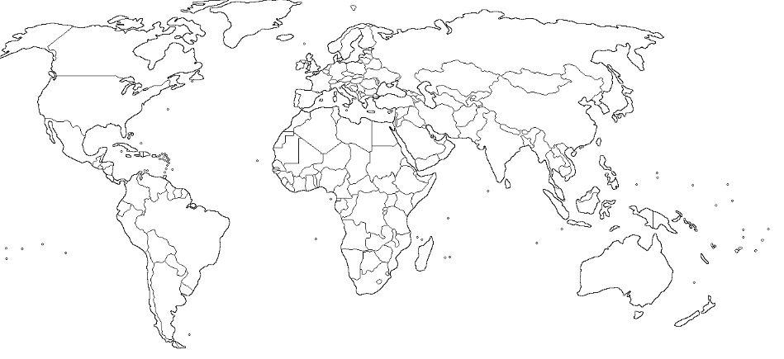

- Apart from eating them, what else did the Incas use potatoes for?

- Which country first brought back the potato to Europe. Colour it on the map!

- Give two reasons why farmers preferred to grow potatoes rather than their other crops.

- How many people, in Ireland, died due to the ‘potato blight’ in 1840?

- One of the first ever recordings of potatoes being made into chips, was in Charles Dickens’ ‘Tale of Two Cities’; can you research and give me the names of 3 other books written by Charles Dickens?

Maths
Conversion from kilograms to grams

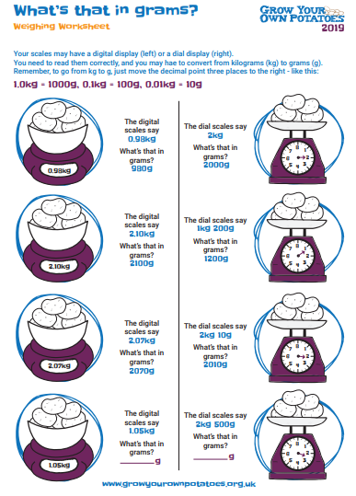

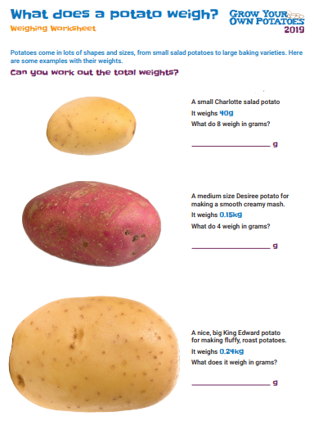

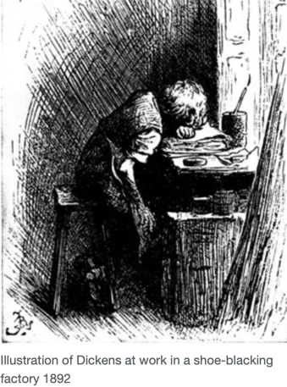
Language

Introducing Mr Dickens

Find out as much as you can about Charles Dickens.

His life

  - When and where was Charles Dickens born?
  - What were the names of Charles Dickens parents?
  - How old was Charles Dickens when he went to school?
  - What happened to his father that meant Charles Dickens left school?
  - Where did Charles Dickens go and work when the rest of his family moved to Marshalsea?
  - What were the conditions like where Charles Dickens worked as a child?
  - How long did Charles Dickens work for before going back to school?
  - In what year and to whom did Charles Dickens marry?
  - How many children did Charles Dickens have?
  - How did Charles Dickens die and in what year?

His works

- Which of his two famous novels were inspired by his experience working as a child?
- How did Charles Dickens begin his career?
- Which book shot Charles Dickens to fame in 1836?
- Which Queen did Charles Dickens perform before in 1851?
- What did Charles Dickens lecture against in the United States of America?

His times

What was ‘life’ like when Dickens was alive? Try and find out about new industry, life for the poor, schooling, Christmas.

Science
Science experiments

Science experiments
*Please, always have an adult present when doing these experiments.
Choose two experiments and research the science behind them.

