Blue Group

Hey guys!

How are we?

Please send me in the work that you’ve already done, along with any photos! I will need to record it on Montessori Compass, our record keeping system.

Reading

Read for a least half an hour a day. Tell me what books you’ve got into.

Physical Exercise

Make sure you are doing exercise every day, for example:

https://www.google.com/url?sa=t&rct=j&q=&esrc=s&source=video&cd=3&cad=rja&uact=8&ved=0ahUKEwiZr47xqMLoAhVNTcAKHXbfAhYQtwIINTAC&url=https%3A%2F%2Fwww.youtube.com%2Fwatch%3Fv%3DsX05HHni9Wk&usg=AOvVaw3Aet7tUWPdyxRgGlGJR9Da

Maths

Multiples

What do we know about multiples?:

A multiple is a number that contains another number an exact number of times with nothing left over.
And a common multiple, contains more than one number an exact number of times.

- Please, either print out tables a, b, or fill them in on the computer, they are on a separate attachment.

- Once you have filled in table a and b use the page below to help you fill in table c.

1 |  |  |  |  |  |  | 51
2 |  |  |  |  |  |  | 52
3 |  |  |  |  |  |  | 53
4 |  |  |  |  |  |  | 54
5 |  |  |  |  |  |  | 55
6 |  |  |  |  |  |  | 56
7 |  |  |  |  |  |  | 57
8 |  |  |  |  |  |  | 58
9 |  |  |  |  |  |  | 59
10 |  |  |  |  |  |  | 60
11 |  |  |  |  |  |  | 61
12 |  |  |  |  |  |  | 62
13 |  |  |  |  |  |  | 63
14 |  |  |  |  |  |  | 64
15 |  |  |  |  |  |  | 65
16 |  |  |  |  |  |  | 66
17 |  |  |  |  |  |  | 67
18 |  |  |  |  |  |  | 68
19 |  |  |  |  |  |  | 69
20 |  |  |  |  |  |  | 70
21 |  |  |  |  |  |  | 71
22 |  |  |  |  |  |  | 72
23 |  |  |  |  |  |  | 73
24 |  |  |  |  |  |  | 74
25 |  |  |  |  |  |  | 75
26 |  |  |  |  |  |  | 76
27 |  |  |  |  |  |  | 77
28 |  |  |  |  |  |  | 78
29 |  |  |  |  |  |  | 79
30 |  |  |  |  |  |  | 80
31 |  |  |  |  |  |  | 81
32 |  |  |  |  |  |  | 82
33 |  |  |  |  |  |  | 83
34 |  |  |  |  |  |  | 84
35 |  |  |  |  |  |  | 85
36 |  |  |  |  |  |  | 86
37 |  |  |  |  |  |  | 87
38 |  |  |  |  |  |  | 88
39 |  |  |  |  |  |  | 89
40 |  |  |  |  |  |  | 90
41 |  |  |  |  |  |  | 91
42 |  |  |  |  |  |  | 92
43 |  |  |  |  |  |  | 93
44 |  |  |  |  |  |  | 94
45 |  |  |  |  |  |  | 95
46 |  |  |  |  |  |  | 96
47 |  |  |  |  |  |  | 97
48 |  |  |  |  |  |  | 98
49 |  |  |  |  |  |  | 99
50 |  |  |  |  |  |  | 100

I see 1, in the top left-hand corner.
Do I have an answer for that on table a? No, so I’m going to ignore it.
Do I have an answer for 2? Yes 2 taken once.
Note: Make sure you are systematically looking across from left to right for the numbers you are searching for.
Let’s make an agreement!
What is my 2 the product of? 2, taken once. When I have a number multiplied by 1, it is not telling me anymore about the number, so I am going to ignore it (not going to write it down) but I’m not going to completely ignore it, I’m going to write a red line under it. 2.
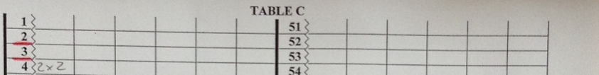

Do the same with three following the agreement:
Right, 3, I’ve found 1x3 and 3x1, but what is the agreement? When I have a number multiplied by 1 it is not telling me anymore about the number, so I am going to ignore it (not going to write it down) but I’m not going to completely ignore it, I’m going to write a red line under it, 3.

What about four? I have 2 taken twice. That tells me more about 4 so I’m going to record that (2x2) then move along, to 4 x1 – this doesn’t tell us anymore about it, but I already know something about it, so I don’t have to put a red line. (see above)

Continue in the same fashion, making sure you look across each time to make sure there are no multiples. When you come to the right side of table c, use table b, to find your answers, until the table is complete.

I want to look at the numbers with the red lines underneath them, 2,5, 7, 13 etc, these can only be written as numbers multiplied by one, these are called prime numbers.

Geometry

Don’t just eat the marshmallows!!!

https://www.youtube.com/watch?v=JEuwqcKsWjc

Send in photos of your creations. Measure how tall you managed to build yours!

Language

Guided Reading - Inference and deduction

It had grown busy while I had been in the water. Deck chairs had been dragged out. Families had pitched little tents. Balls, Frisbees and kites seemed to be everywhere. Hundreds of adults were just laid there, rigid on their towels while the children ran around shouting and squealing irritatingly.
It always got like this at the weekend. I had warned Granddad. It would have been better to have come in the evening when all the crowds had gone home. I sighed. Granddad seemed oblivious, sat in his chair reading his book, his feet buried in the sand.
The sun was at its height and beat down mercilessly.
“Perhaps you should put some cream on Granddad,” I said with concern.

1) Where is the scene set? Find evidence from the text to support your answer.

Example Answers : On a beach, I know this because in the text it says, “Deck chairs had been dragged out…adults were just laid there, rigid on their towels,” both common ways of relaxing on the beach. It also says that Grandad had, “his feet buried in the sand.” Sand is most often seen at the beach.

2) Why did the narrator think it would have been better to have come in the evening?

3) Why is the narrator concerned about Granddad?

4) Do you think the narrator is having fun? Explain your answer.

5) Would you like to be there? Explain your answer referring to the text.

History

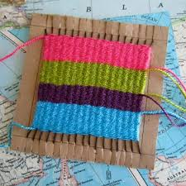

Please, watch the videos:

https://www.youtube.com/watch?v=bq58FAhuhxM

https://www.youtube.com/watch?v=0ebO4nZZQbA

Then follow the instructions in this next video to do your own weaving:

https://www.youtube.com/watch?v=QW2zwr6txdo

Art

What you need:
- Watercolour paints/pencils, ink or food colouring
- Paper
- A white candle
- Paintbrush
- Surface covering

- Prepare your space, if you’re using food colouring this step is especially important as it will stain surfaces and floors.
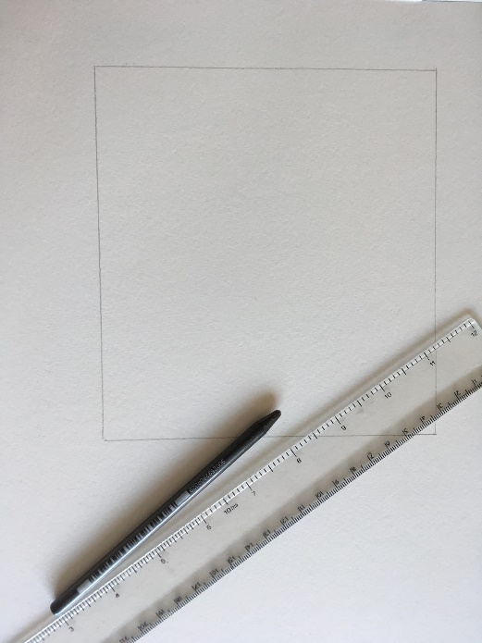
- I find it helpful to draw a box around the area I will write in, so I know where to paint! However, if you are going to draw over the whole piece of paper you can skip this step.

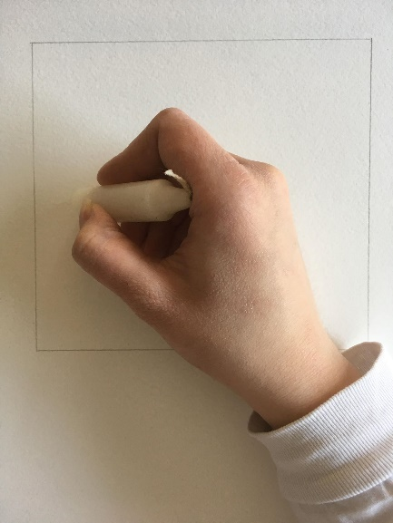
- Take your wax candle and draw with it as you would a crayon, if you want to see where you have been drawing to keep track, you can lift the page and angle it towards the light to see the wax.

- Choose your colours! If you are using ink or food colouring for this step you only need 1-2 drops, use a plastic plate to mix it with water before you apply it to your paper.
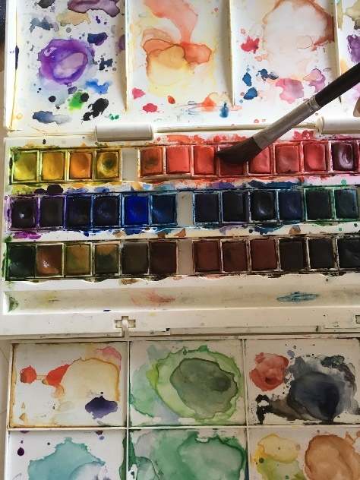
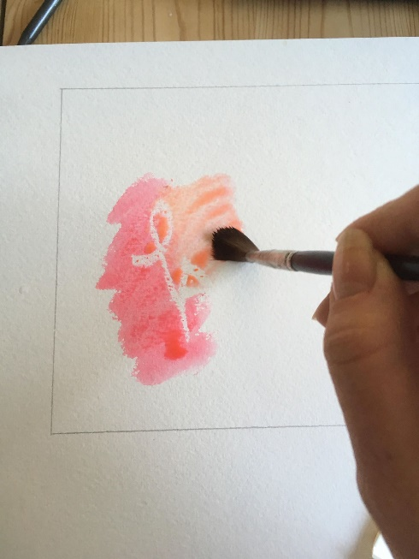
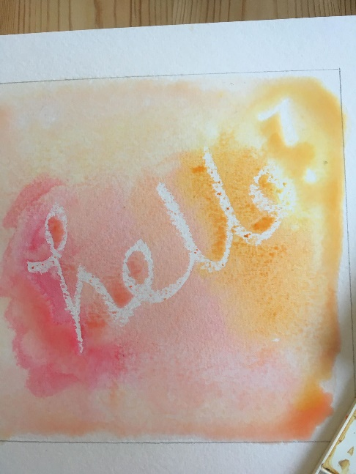
- Take your brush and paint over the wax you have drawn with! The drawing will be revealed.
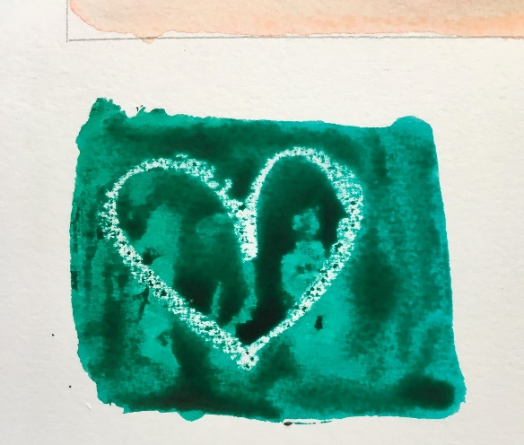
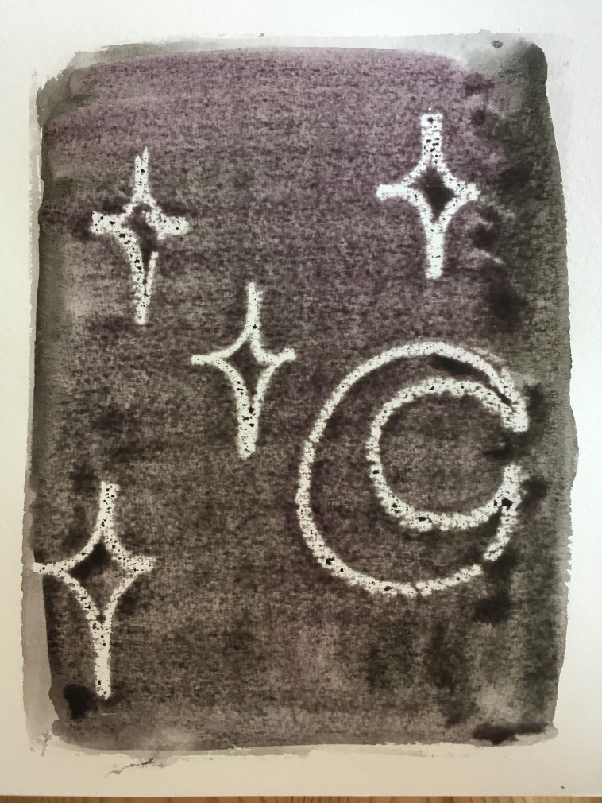

Have a think about this activity, why and how does it work? Have fun experimenting, you can write or draw whatever you like with the wax candle. If you would like to send in some photographs of your results, we would love to see them!

Work Journals

Continue to write, all the wonderful things you do, in it. Tells us what you’re doing with your family, what you’re learning to do to help out. What are your frustrations? Do you feel happy not being at school or are you missing it?
Use your journal to then fill in the graph:
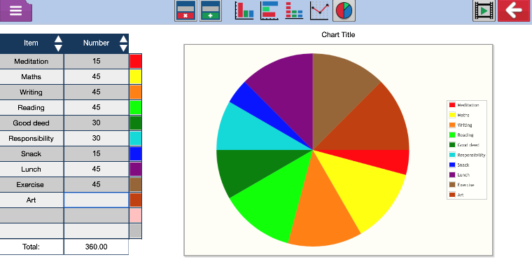
Then use it to input your data into Purple mash (2Graph)
https://www.purplemash.com/#app/tools/2graph

