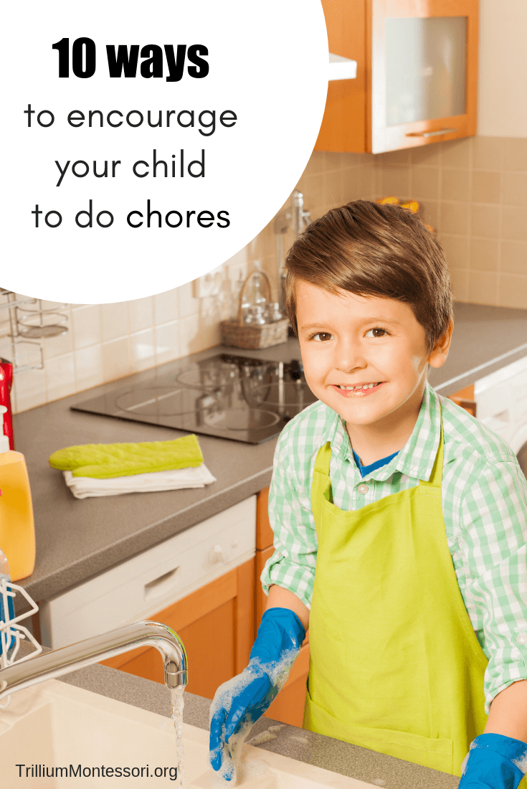
1. Involve them as much as possible, as young as possible.
It might surprise you how young children are able to help. From 1.5-2 years old children already want to do everything you do. Don’t expect much at this age though, it was only after 2 that my children were able to do and remember how to do things.
2. Allow for more time.
If a chore usually takes 15 minutes, plan for 30 minutes to reduce stress. Tackling a chore with a child will take longer. It’s the end goal of teaching independence that you need to focus on, so don’t start folding laundry with your child when you only have a few minutes. Chose a time that will allow you to properly teach him how to do it.

3. Get child sized tools or equipment for them to use.
Before going out and buying things, check around your house to see what you can already use. My vacuum cleaner shrinks down to child-size and I was able to DIY a low clothesline. The dollar store is usually my next stop for small kitchen tools, I have also found a short broom and small spray bottles.
4. Show them one step at a time, many steps will overwhelm them.
Don’t assume they know how to do things. Even if it’s something simple like cleaning a window with a spray bottle. Show them how to hold the bottle, how to spray, how to wipe, then step back and allow them to do it without criticizing.
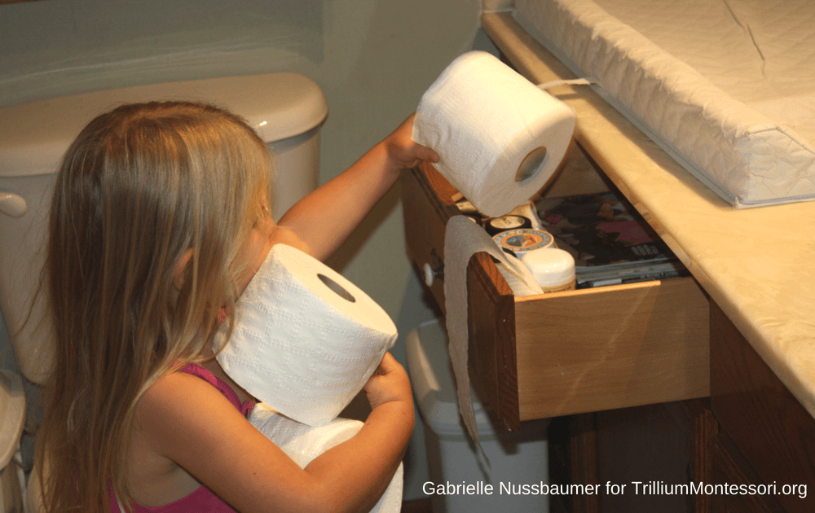

5. Ask them nicely to help you, but allow them to refuse.
This has been a tough one for me. I didn’t grow up in a Montessori home and chores were assigned and expected to be done. I have found that allowing them to say ‘no thank you!’, makes it sincerer when they do help. It also creates an environment of teamwork. Also, implementing #6 and 7 have helped reduce the amount of times they refuse.
6. Consider their mood or if they are hungry or the time of the day.
If your child is in the middle of playing a game or doing something he really enjoys, it’s probably not a good time to ask him to sweep the floor. Consider waiting until they are done or say, ‘Once you’re done playing, I would really appreciate your help sweeping the floor.’
7. Give them options.
Giving your child options, or allowing them to plan out their tasks and chores for that day, makes them feel like they are in control. It feels less like you are bossing them around and more like teamwork. Have a list of things they can chose from, crossing them out as the week goes by to make sure that everything gets done and they don’t always choose the easiest ones! On the flipside, you can also have a list of fun things you can do together.
8. Always thank your child for his help in a sincere fashion.
Your child needs to feel appreciated. After completing a task, remember to thank them for their help and tell them why you appreciate their help. During a task, you can say a kind word about how hard they are working or how cheerful they are. Focus on their attitude and character traits, not just on the end result.
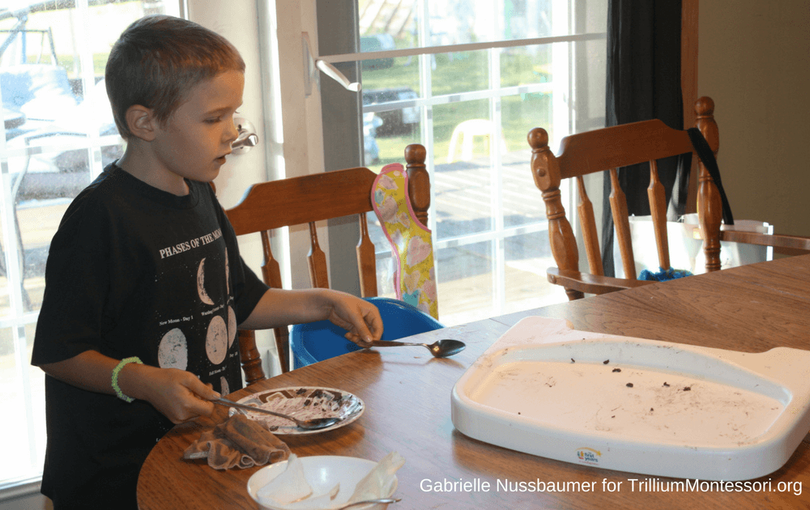
9. Do them together.
Your child wants to spend time with you. You have household duties. What more can I say?
Wait, there is one more thing. Don’t just do chores with your children. Do fun things too. Do the things that they want to do.
10. Explain the why.
Any person at any age, is more likely to accomplish a task if they know why they are doing it. Take some time to explain to your child in a simple and interesting way why things need to get done. If they are old enough, guide them to talk about the why. Ask them: ‘What do you think would happen if we never washed the windows?’ or ‘I wonder if leaving these toys on the floor might trip someone at night?’

