Blue Group

Science

Inertia Science Experiment

#2: Penny Dunk

As promised a second inertia experiment:
Make a stack of pennies land in a glass of water with this fun science experiment! The concept behind this is the same as the old-fashioned trick of yanking a tablecloth out from under a place setting of dishes… except that it’s a lot less messy if something goes wrong.
Place an index card on top of a glass of water. It’s best if you have a clear glass so that you can see what’s happening inside.
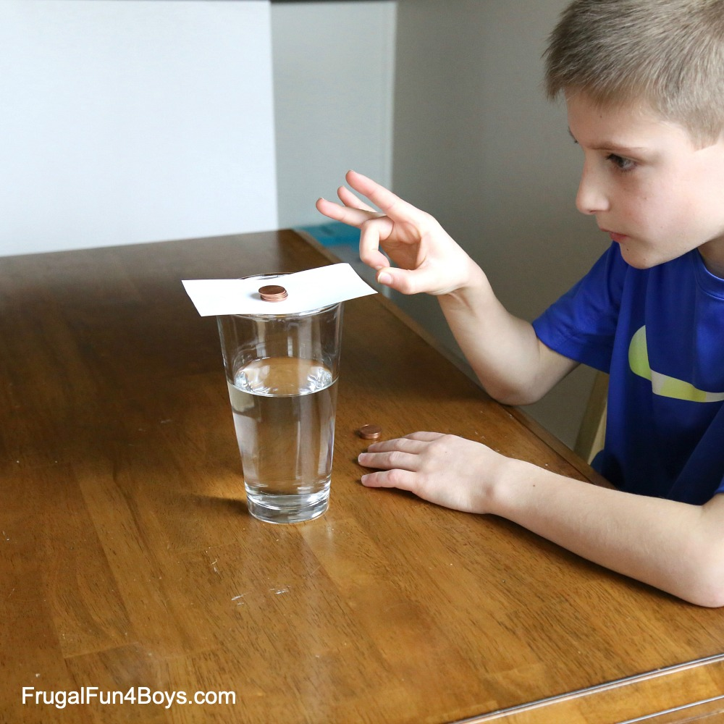
Give the index card a firm flick. It will fly away while the pennies just drop straight into the glass.
You might expect the pennies to fly off with the index card. However, they actually stay in the same place because of inertia. They are objects at rest staying at rest. Force is applied to the index card, so it moves. The pennies drop straight down into the water once the card is no longer there to hold them up.
It may take a few tries to flick the index card just right.
Please write up the experiment, along with pictures, in your science books.

Geometry

Solids

Making a cube.

Things You'll Need
- Piece of paper
- Markers or coloured pencils
- Scissors or hobby knife
- Tape
- A Ruler

Steps
- Take a piece of paper. The bigger your paper, the larger the final cube will be
- In the centre of your paper, draw a long rectangle and divide it up into four 6cm squares.
- Draw another square to the right of the second square from the top.
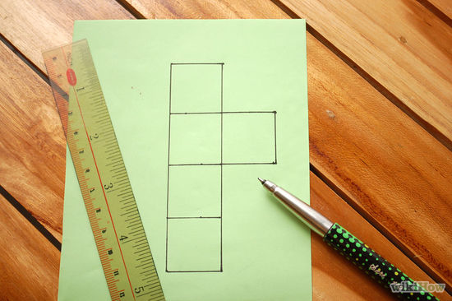
- Draw another square to the left of the second square from the top.
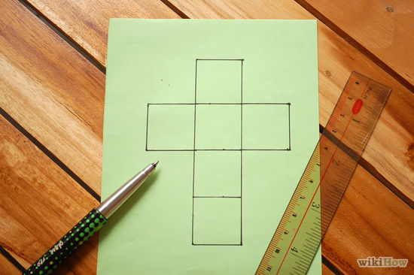
- With scissors or a hobby knife, cut along the outside edges of the shape. 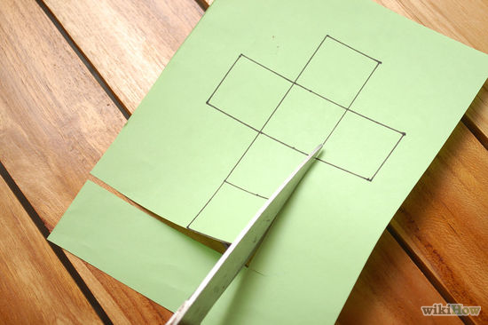
- Fold the paper. Follow along the inside lines and fold the paper inward.
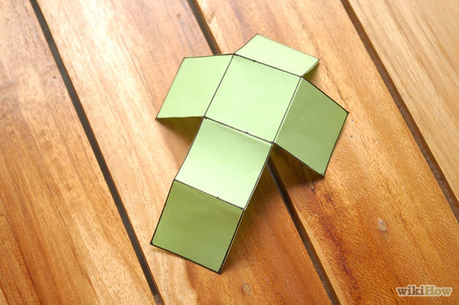
- Align the folds. The square on the very bottom should be folded so it is parallel or directly across from the square that was in the middle.
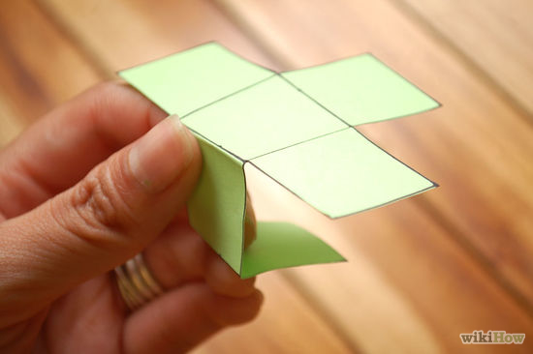
- Finish up your box. Tape all of the sides together, and you’re done!
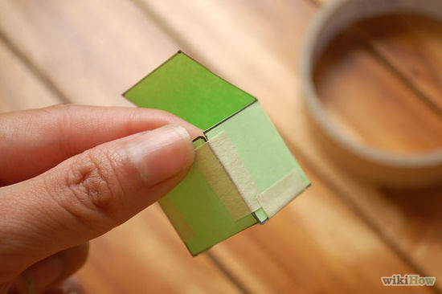
- Finished.
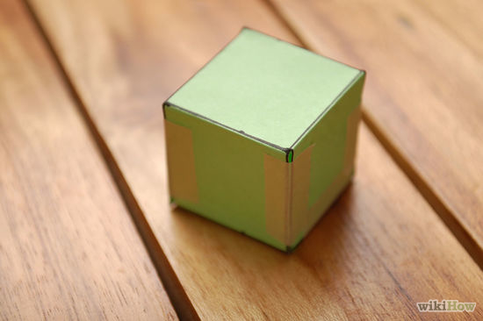

Using the same thinking, can you now make this square based pyramid:

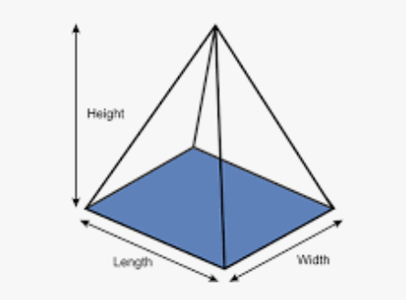

Music/Science

Musical Jars Science Experiment

Supplies Needed
- Set of Glasses of equal shape and size
- Water
- Metal Spoon
- Food Coloring (optional)

Experiment Instructions
Step 1 – Begin with empty glass jars of the same shape and size. Use the metal spoon to tap on each one. You’ll notice that each sound is the same. Now let’s find out if we can make the sounds different.

Step 2 – Pour water into each jar. Make sure that the water level is different in each jar.
Step 3 – Add food colouring to each jar to make it easier to see the different water levels. You can use the same colour in each jar or use a rainbow of colours like we did. (Optional)
Step 4 – Use the same metal spoon to tap on the jars again. Listen carefully so you can hear how the sounds have changed.

How Does the Experiment Work?
Tapping on the jars with the spoon causes them to vibrate and make a sound. When the jars were all empty the vibrations and the sounds were the same. However, adding water to the jars cause the vibrations (and sound) to change.
The more something vibrates, the higher the sound will be. In addition, the more water there is in the jar, the less it will vibrate.
That means, a jar filled with less water will produce a higher sound AND a jar filled with more water will produce a lower sound.
Write this up in your science books and label the highest note and the lowest note.

How the planets got their names

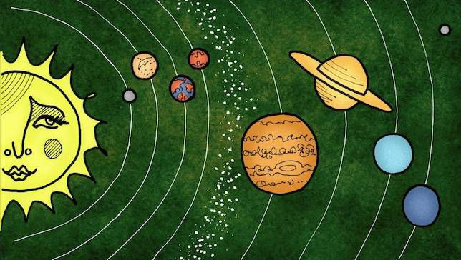

How do you honour the beguiling beauty of a twinkling celestial orb? Give it the name of a god. How do you honour a god? Name one of the sky’s bewitching wonders after him. And thus, the ancients named the sky’s brightest planets after members of the mythological pantheon, affording the highest recognition to both gods and planets. As new planets were discovered, the tradition was continued.
While many of the planets had other names before the Romans bestowed them with their divine namesakes — it's these names that are recognized by the International Astronomical Union (IAU). The IAU is the body officially recognized by international astronomers and scientists as the de facto naming authority for astronomical bodies. (Although plenty of other cultures have their own names for the planets, too.)
But why did certain gods get assigned to certain heavenly bodies? Here are the celestial back stories.
Mercury
The earliest recorded sightings of Mercury are from the Mul-Apin tablets from the 14th century B.C., in which Mercury was described in a jumble of cuneiform as “the jumping planet.” By the 1st millennium B.C., the Babylonians were calling the planet Nabu after their god of writing and destiny. The ancient Greeks called Mercury Stilbon, meaning “gleaming,” while later Greeks called it Hermes after the fleet-of-foot messenger to the gods because the planet moves so swiftly across the sky. In fact, Mercury speeds around the sun every 88 days, traveling through space at nearly 31 miles per second faster than any other planet. It's a speedy thing! The Romans took the helm from the Greeks and named the planet, Mercury — Hermes' Roman counterpart.
Venus
Although the Venusian atmosphere offers a scorched world so hot it can melt lead and has a surface pressure 90 times that of our planet, it’s an undeniably beautiful vision to behold from the comfort of Earth. Because of Venus’ proximity and the dense cloud cover that reflects the sunlight, it is the third brightest natural object in the sky (after the sun and moon). It is so bright it can cast shadows! Its brightness and morning appearance inspired the ancient Romans to associate the planet with Venus, the goddess of love and beauty. Other civilizations have named it for their god or goddess of love as well.
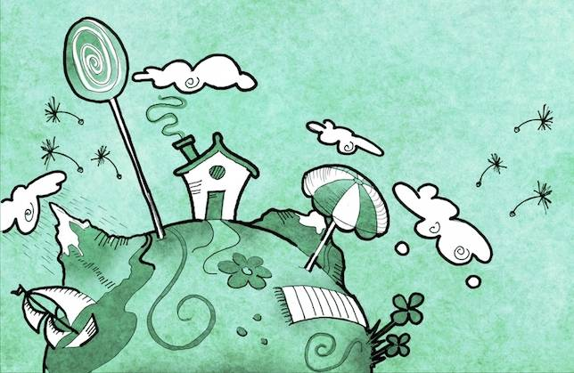
Earth
Poor Earth. While all the other planets were exalted with names of gods and goddesses, Earth's name comes from a plain old Anglo-Saxon word which simply means “ground.” Not very glamorous for a planet that has been so bounteous with life and has been such a welcoming hostess, but it’s understandable. Earth wasn’t considered a planet for much of human history. Given our early terrestrial perspective, it was thought that Earth was the central object around which the rest of the celestial bodies revolved. It wasn't until the 17th century that astronomers realized that it was the sun at the centre of things . By that time, renaming the "new" planet was likely not even a consideration.
Mars
In the ancient Roman pantheon, the god Mars was second in importance only to Jupiter. While not much is known of his genesis, in Roman times he had developed into a god of war. He was considered a protector of Rome, a nation that took great pride in its military. So what to call the mighty blood-red planet in the sky? Mars, of course. The oxidized iron in the planet’s soil along with its dusty atmosphere give Mars a red tinge that has led to other hue-inspired appellations as well, like the Red Planet, or the Egyptian name for the fourth planet, "Her Desher,” meaning the red one.
Jupiter
The largest planet in our solar system — so large it forms its own ersatz solar system — was named Zeus by the Greeks and Jupiter (Zeus’s Roman counterpart) by the Romans. Jupiter was the god of light and the sky, and the most important of all gods in the Roman pantheon. This dynamic gas giant is made up of more than twice the material of the other bodies orbiting the sun combined and has 67 moons of its own. It's no wonder it was named after Rome's official chief deity.
Saturn
Hooped by its thousands of beautiful ringlets, Saturn is unique among the planets with its spectacular and complicated system of circles. It has been known since prehistoric times and was the most distant of planets observed. As such, Saturn has been bestowed with much reverence in a number of cultures. The ancient Greeks made the sixth planet sacred to Cronus, the god of agriculture and time. Because Saturn had the longest observable repeatable period in the sky, it was thought to be the keeper of time. The Romans named it Saturn — the father of Jupiter.
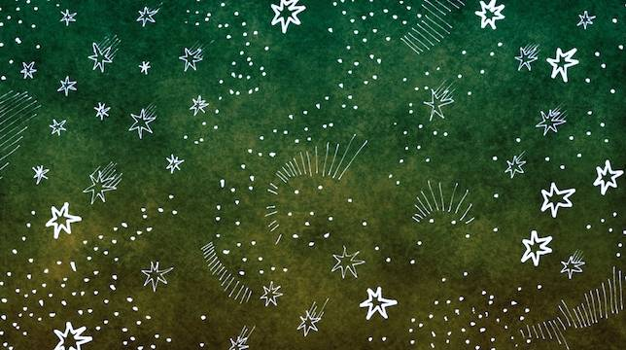
Uranus
While Uranus had been observed but recorded as a fixed star since prehistory, it was Sir William Herschel who discovered that it was a planet in 1781. He named it Georgium Sidus (George’s star) after King George III, saying, “In the present more philosophical era, it would hardly be allowable to have recourse to the same method [as the ancients] and call it Juno, Pallas, Apollo or Minerva, for a name to our new heavenly body.” The new name lacked popularity outside of Britain. Johann Elert Bode’s suggestion of Uranus, the father of Saturn and god of the sky, became widely used and the standard in 1850 when the HM Nautical Almanac Office officially accepted the new name instead of Georgium Sidus.
Neptune
Neptune was the first planet discovered by math rather than observation. It was "predicted" by John Couch Adams and Urbain Le Verrier, who accounted for the irregularities in the motion of Uranus by correctly guessing that another planet was the cause. Based on those predictions, Johann Galle found the planet in 1846. Galle and Le Verrier wanted to name the planet f ‘Le Verrier’, but this was not acceptable to the international astronomical community. Janus and Oceanus were proposed, but ultimately it was Le Verrier’s suggestion of Neptune, the god of the sea, that became the internationally accepted moniker. This was fitting given the planet’s methane-induced, rich blue tint.
Please answer the questions below, in full sentences.

- What does IAU stand for?

- Mercury was called various different names by different civilisation. Can you name them?

- How fast, in miles per second, does Mercury travel through space?

- Which civilisation did we end up getting the name Mercury from?

- How much hotter is Venus to the Earth?

- What is Venus named after?

- Why wasn’t Earth named after a Roman god or goddess?

- What Roman god was Mars named after?

- What gives it its red colour?

- What is the Roman counterpart of the Greek God, Zeus?

- How important was Jupiter to the Romans?

- Saturn had the longest observable period in the sky; therefore, it was thought to be… what?

- Who discovered that Uranus was a planet?

- What name was it originally given?

- How did scientists know that there Neptune was there, even though they couldn’t see it?

Language
Poetry
Alternate rhyme

The Light of Stars
BY HENRY WADSWORTH LONGFELLOW

The night is come, but not too soon;
And sinking silently,
All silently, the little moon
Drops down behind the sky.

There is no light in earth or heaven
But the cold light of stars;
And the first watch of night is given
To the red planet Mars.

Is it the tender star of love?
The star of love and dreams?
O no! from that blue tent above,
A hero's armor gleams.

And earnest thoughts within me rise,
When I behold afar,
Suspended in the evening skies,
The shield of that red star.

O star of strength! I see thee stand
And smile upon my pain;
Thou beckonest with thy mailèd hand,
And I am strong again.

Within my breast there is no light
But the cold light of stars;
I give the first watch of the night
To the red planet Mars.

The star of the unconquered will,
He rises in my breast,
Serene, and resolute, and still,
And calm, and self-possessed.

And thou, too, whosoe'er thou art,
That readest this brief psalm,
As one by one thy hopes depart,
Be resolute and calm.

O fear not in a world like this,
And thou shalt know erelong,
Know how sublime a thing it is
To suffer and be strong.

Why not try and memorize this lovely poem? Or write your very own alternate rhyming poem (ABAB).

