Red Group

Language

Comprehension

Please read this (made up but factually accurate) entry from Newton’s Diary and then answer, in full sentences, the questions below.

Monday 17th February, 1687
Dear Diary,
Today I made a discovery! I woke up and as usual started my day with a large glass of ale, a deliciously stale slice of bread topped with cold meat and fish. I have recently been incredibly successful in my research and studies in mathematics, optics and mechanics but today I discovered something beyond imagination. Something that has been around us all the time but something that no one had ever questioned or pondered. As I sat beneath a blooming apple tree something hit me. It literally hit me. An apple. I was minding my own business, reading Opuscula Mathematica Hactenus Inedita written by the infamous William Oughtred, and an apple bounced off my head crashing to the ground. Of course, how had I not thought of this before? Gravity! How else would everything stay grounded to Earth instead of floating in the abyss? Gravity! I was so ecstatic I jumped for joy. As the apple had fallen off the tree it hadn’t flown off into the cool spring sky. It hadn’t rocketed over into the adjoining field. It fell instantly downwards, knocking into my now swollen head. Gravity had forced it down. Like it forces everything down!
I had to tell someone of this momentous occasion, to celebrate my ingenious ingenuity. I ran instantly to revel in my success with my two dear friends, Samuel Pepys and John Locke. They couldn’t believe what had happened. Their response was not what I expected. I expected to be at the receiving end of celebratory feasts and perhaps a game of billiards. Instead, however, I was greeted with scepticism and disbelief. I must prove this theory. If this is the last thing I do.
Tomorrow I plan to write down my theory and show it off to the world. Gravity does exist, regardless of what sceptics might think. I will write a book explaining this, I think I will name my book: Philosophiæ Naturalis Principia Mathematica. That has a lovely ring to it!
Thank you for listening diary. I am going to try and get some sleep now, I have a busy day of writing tomorrow.
Yours sincerely, Isaac Newton.

- What did Newton eat and drink for his breakfast?
- According to Newton, himself, in which studies had he recently been incredibly successful?
- What force did Newton come up with that ‘had been around us all the time’?
- Why did this suddenly occur to him?
- Which two friends did he excitedly go and tell?
- Pick one of the two friends and tell me, what they were famous for.
- How did his two friends react to his exciting news?
- What did Newton realise he had to do to convince his friends, and the rest of the world, of his idea?

Science/Maths

Use this interactive website and follow these instructions:

- Drop the ball from a set distance
- Repeat for each of the nine environments which have gravity
- Answer the questions below

https://www.schoolsobservatory.org/discover/sims-cals/gravsim

- Which celestial body, in this experiment, has the weakest gravitational force?

- Which has the strongest?

- Why do you think this is?

This is a graph of the acceleration of a ball in Earth’s gravitational field.
Acceleration is the rate of change in velocity of an object, or just a fancy word for speeding up. It is part of a branch of science called physics.

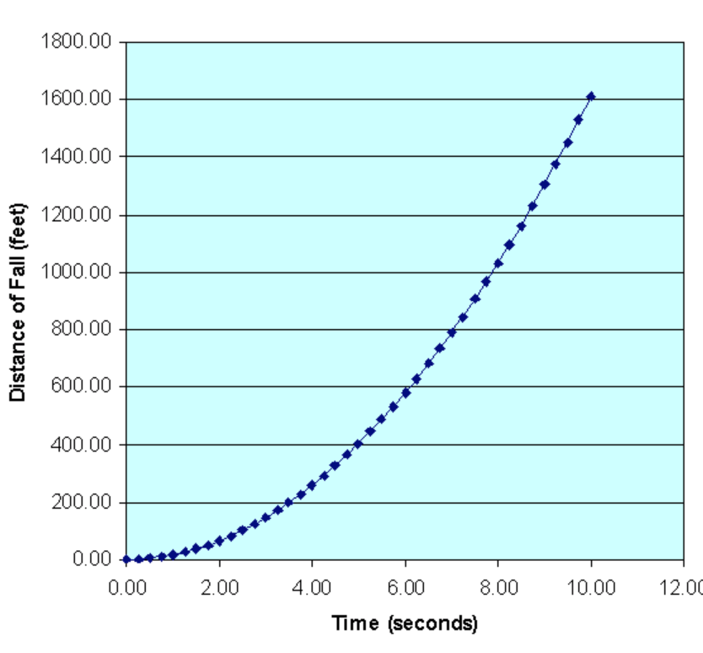

Use the graph above to answer these questions.

- Approximately how far does the ball fall after 6 seconds?

- How long does it take for the ball to fall 300 feet?

- The acceleration of the ball follows a pattern.

- Can you fill in the missing gaps?

0 | 1 | 4 | 9 |  | 25 | 36 | 49 |  | 81

How far can you continue with this pattern?

Nothing to do with gravity and accelerations, these ones, but can you figure out the missing numbers all the same?

1) 12 20 ______ 36 ______ ______

2) 1000 980 955 925 ______ ______

3) 6.4 6.9 ______ ______ 8.4 8.9

4) 10 40 _____ 100 ______ 160

5) 29 34 39 44 _____ _____

6) 15 19 ______ 27 31 ______

7) 99 87 ______ 63 51 ______

8) -9 -18 -27 ______ ______

Geometry/Science

We’ve made giant leaps in physics since Newton’s very important first step, to the extent that we now have a manned spacecraft - the International Space Station (ISS)

Feeling ambitious? Why don’t you try and make your own? See the links below and assemble the parts.

https://www.nasa.gov/pdf/616947main_Build_Station_Simulation.pdf

If you don’t have a printer, why not do it this way instead. Your choice.

https://www.esa.int/Science_Exploration/Human_and_Robotic_Exploration/mISSion_possible/Build_your_own_International_Space_Station

Art

Listen to Gustav Holst the planets:

https://www.youtube.com/watch?v=Isic2Z2e2xs

Whilst listening, draw or paint a picture of how it makes you feel.

Music

In this piece of music, you hear a lot of string or bowed instruments.

Holst gave an instruction for the instrumentalists to strike the string with their bow, rather than draw it across the strings. This gave the string instruments a more percussive sound.

https://www.youtube.com/watch?v=5qzX2HZhXec

Tissue Box Banjo

Make your own stringed instrument:

Things You'll Need

- Empty tissue box (long)
- Empty paper towel roll
- Rubber bands
- Marker
- Scissors or knife
- Decorative items (e.g. paint, stickers, gift wrap paper, etc.)
Steps
Take an old empty tissue box. A long box rather than a square one is preferable

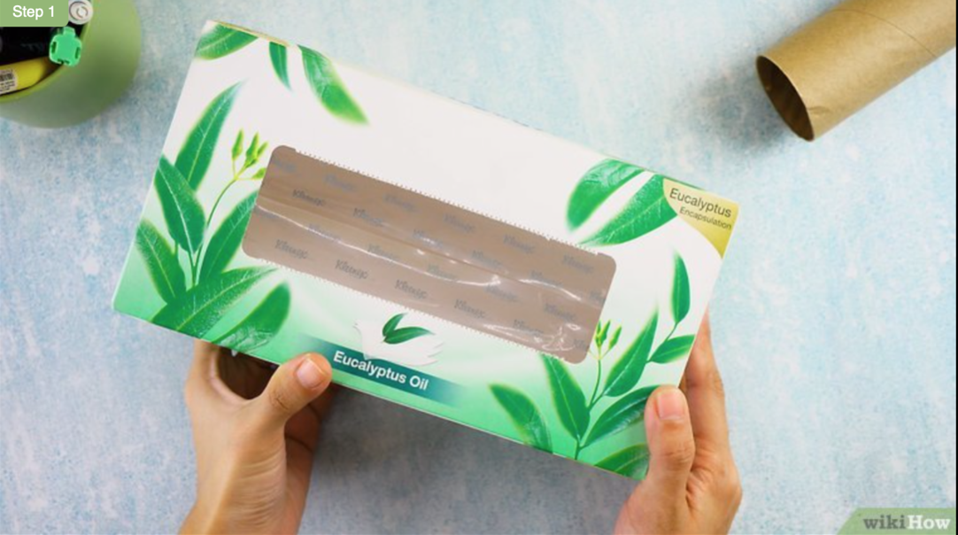

Cut off the cellophane or cardboard.

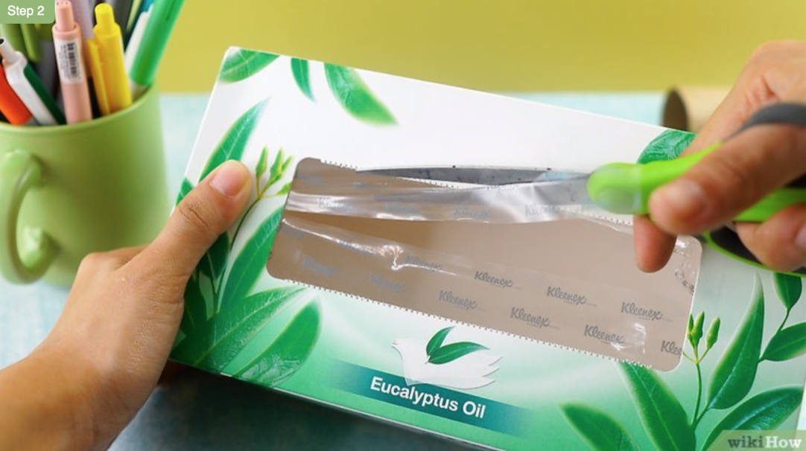

Put the paper towel roll on top, trace it with a marker, and cut along the lines.

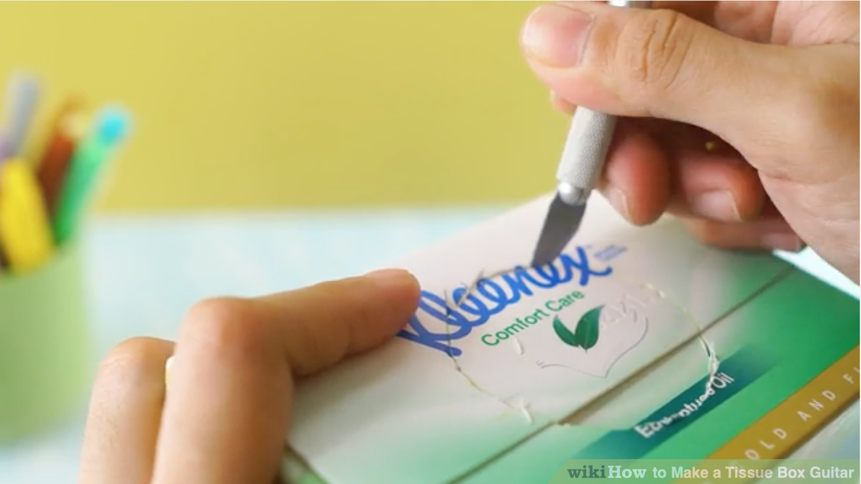

Insert the paper towel roll in the hole. Make sure it's about 6 to 9 cm in. Tape may be used to hold the roll in place and make it sturdy.

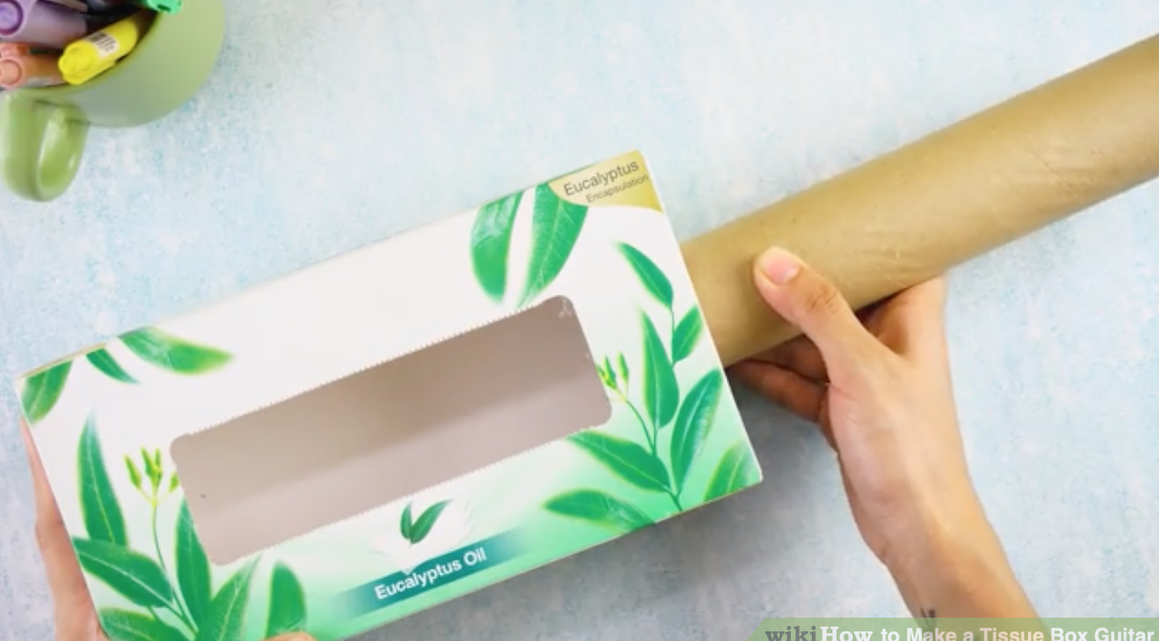

Add the rubber band strings. Wrap a couple of rubber bands around on each side of the paper towel roll. Different types and sizes of rubber bands may be used to create different tones and sounds.

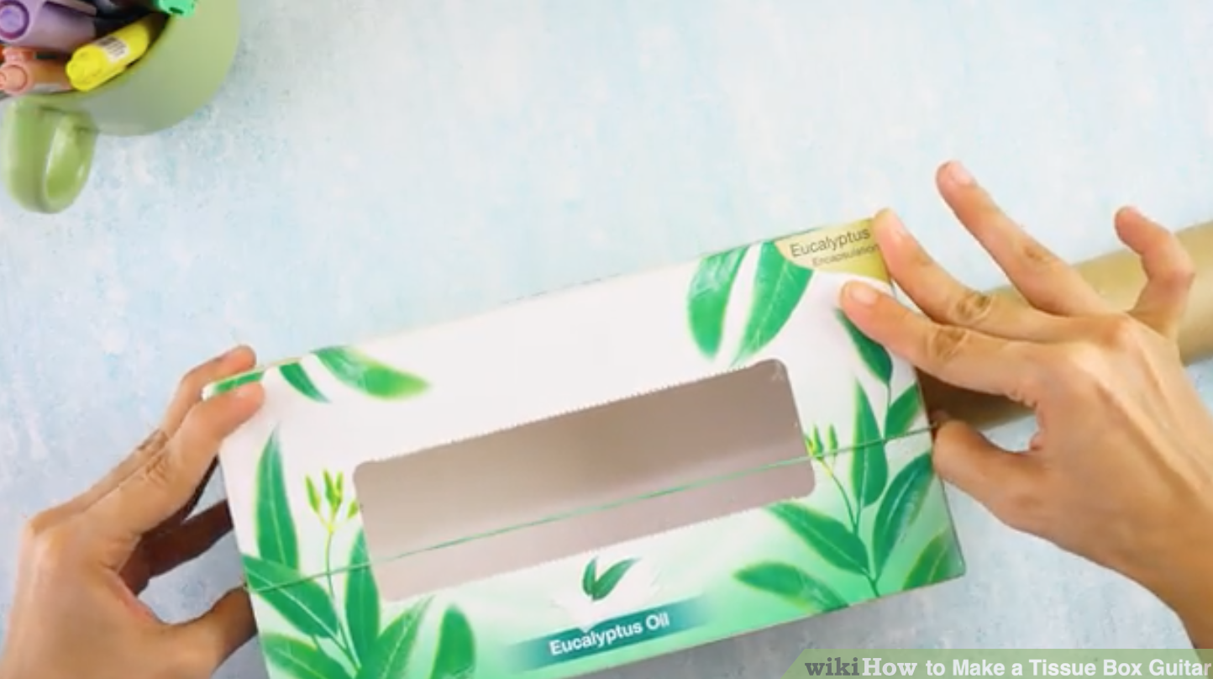

Decorate the box. Add stickers, paint some art designs, spray paint it, sprinkle glitter on it, and anything you would like. Now you're ready to roll!

You could get a thicker band for low sounds or a thin band for high sounds.

Physical Education

Catching the ball

Can you do all of these challenges?

https://www.youtube.com/watch?v=FYS9o-__MwI

