RED GROUP

## Language

## Writing: Start each day by Journaling!

Write in your journal to record what you have been doing. You could include your thoughts and feelings. Just imagine how interesting this could be for someone in the future to read! You could include photos, drawings etc. This only needs to be a few minutes and you can do it at regular intervals throughout the day.

## SUSPENSE STORIES

## Step 1: Read the extract:

All night, thunder growled over-head. Zelda crouched in the darkness, staring. Rusted dustbins rattled in the distance, wind lashed the glistening tarmac and the streetlights flickered. Zelda shivered. Where could she escape from the rain?

At that moment, Zelda heard something crawling along the pavement in the shadows. Silently, a vague shape slipped into a doorway. A green eye flickered. Zelda's fur prickled as she watched. What was it?

Without thinking, Zelda dashed out, ducked under a lorry and tucked herself into a space near the engine. It was safer there. As a purred by, the shadow of an enormous cat paced through the rain, moving silently along the rain-washed pavements. Zelda crouched as still as a stone.

Slowly, the great rai-cat drew closer and closer, Zelda could hear its claws scratching on the tarmac and see its green eyes glittering. Nearer it came until paused, sniffing at the wheel. Zelda froze. Could it smell her fear?

At that moment, Zelda could bear it no longer. Leaping out from under the lorry, she shot back across the rain swept road and leapt over the wall. She glanced back. She was alone. The rain cat had not followed. Zelda was safe - for now....

## Step 2: Look at the tools used in good suspense writing: [Suspense Writing](https://www.youtube.com/watch?v=xjKruwAfZWk" \t "_blank)

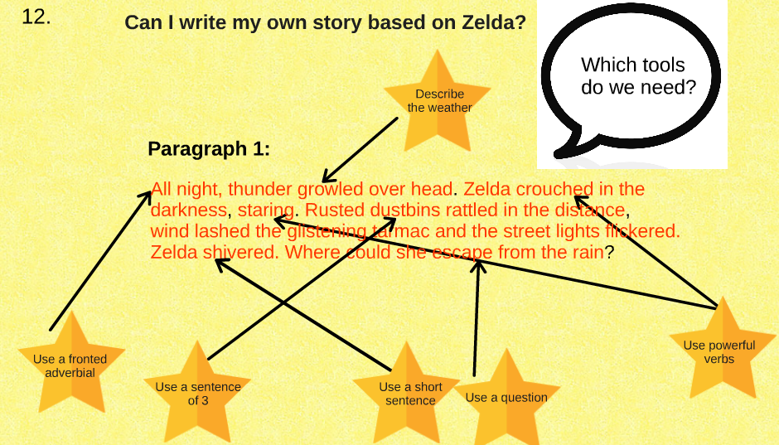

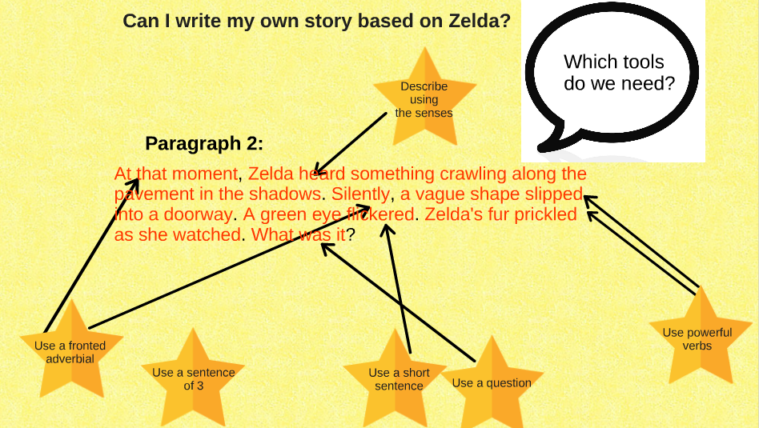

## Step 2: Plan your story using the structure below:

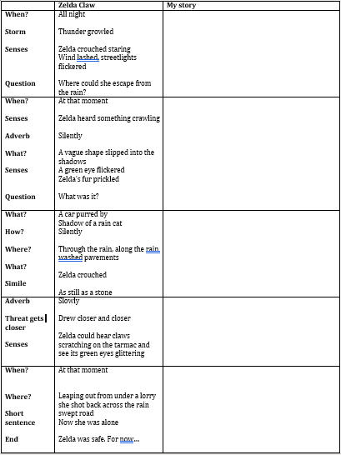

Step 3: Now using your plan and these slides see if you can write your own Suspense Story!

## Reading:

Please read daily. We look forward to hearing about the books that you have read.  
Here are a few ideas for follow up activities that can be done to help support your understanding of a text.

1. Design a new front cover for the book that you are reading.

2. Create a true/ false quiz about what you have read.

3. Tell someone about what you have read. You could maybe call a grandparent or friend to tell them about it.

4. Make a list of any super words that you could magpie (steal) from your book for your own writing.

**History**

The Solvay Conference, probably the most intelligent picture ever taken, 1927

[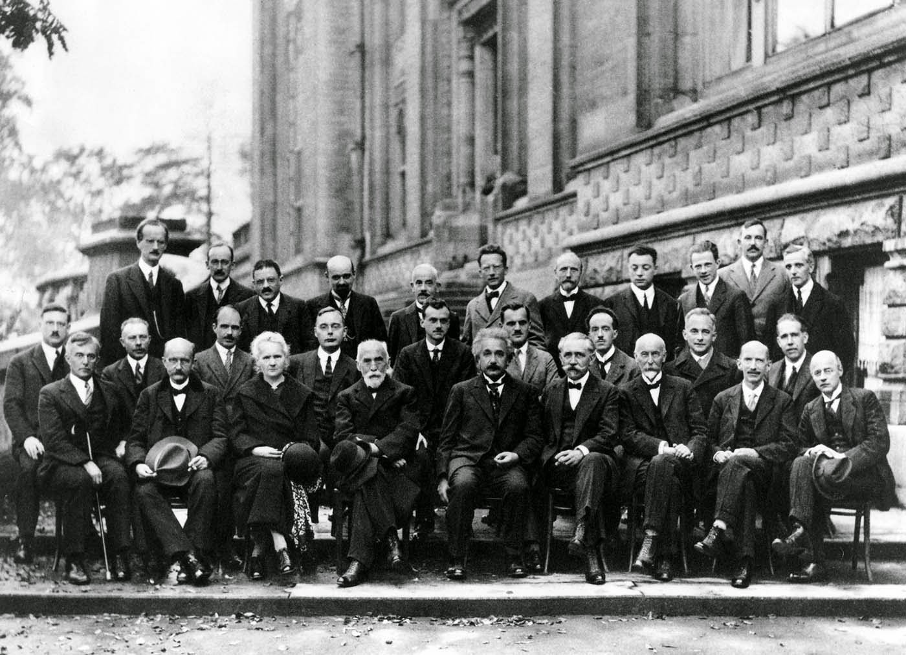](http://4.bp.blogspot.com/-PA2HL22Xylk/VIvk5dGW7KI/AAAAAAAAJ10/b-XzcYiZB54/s1600/The+Solvay+Conference,+probably+the+most+intelligent+picture+ever+taken,+1927+(1).jpg)

17 of the 29 attendees were or became Nobel Prize winners.

The Solvay Conference, founded by the Belgian industrialist Ernest Solvay in 1912, was considered a turning point in the world of physics. Located in Brussels, the conferences were devoted to outstanding preeminent open problems in both physics and chemistry. The most famous conference was the October 1927 Fifth Solvay International Conference on **Electrons and Photons**, where the world’s most notable physicists met to discuss the newly formulated quantum theory. The leading figures were Albert Einstein and Niels Bohr.

**Back to front, left to right:**

**Back:** Auguste Piccard, Émile Henriot, Paul Ehrenfest, Édouard Herzen, Théophile de Donder, Erwin Schrödinger, JE Verschaffelt, Wolfgang Pauli, Werner Heisenberg, Ralph Fowler, Léon Brillouin.**Middle:** Peter Debye, Martin Knudsen, William Lawrence Bragg, Hendrik Anthony Kramers, Paul Dirac, Arthur Compton, Louis de Broglie, Max Born, Niels Bohr.

Task: Pick one of these amazing scientists and write about their lives then draw your best portrait of them (could be a caricature).

Maths

C:\Users\user\AppData\Local\Microsoft\Windows\Temporary Internet Files\Content.IE5\2USVQG2K\MC900197778[1].wmf**Name\_\_\_\_\_\_\_\_\_\_\_\_\_\_\_\_\_**

**Alien’s Movie**

Plan a movie for Mr Alien. His bank on his planet will only give him a budget of £800. Can you get him everything he needs and not spend more than his budget?

Remember, he wants the movie to be fun, exciting and have lots of props. Good luck!

In your groups use the following pages to plan what Mr Alien needs to make his film.

You must:

* Choose 1 set from the list
* Choose at least 2 actors from the list
* Choose at least 1 advertising pack from the list
* Choose as many items from the props list

**YOU HAVE A BUDGET OF £800**

**Don’t exceed (go over) your budget!**

Please write down any working out on these sheets.

**SETS**

You need to choose **at least one** set from this list.

The film will take **2 full weeks** to make

|  |  |  |  |
| --- | --- | --- | --- |
| **Name** | **Details** | **Price** | **Notes** |
| A close up of a building  Description automatically generated  Cartoon City | * **25% off** total cost per day if hired for more than 7 days * To store your props **add** **£5** per day | £10 per day |  |
| A black and white photo of a house  Description automatically generated  Wild West | * **50% off** total cost per day if hired for more than 10 days * To store your props **minus** **£3** per day | **Price** |  |
| £26 per day |
| A picture containing water, standing, wet, group  Description automatically generated  Sci-Fi Central | * **10% off** total cost per day if hired for more than 7 days * To store your props **minus** **£2** per day | **Price** |  |
| £20 per day |
| A tree in a forest  Description automatically generated  Forest Films | * **20% off** total cost per day if hired for more than 7 days * To store your props **add** **£4** per day | **Price** |  |
| £17 per day |
| **Notes** | | | |

**Actors & Actresses**

You need to choose **at least two** people from this list

|  |  |
| --- | --- |
| **Adam Sandler**  £10 per day  Add 50p per day for lunch money | **Jack Black**  £11.50 per day  Lunch is £3 per day |
| **Amy Adams**  £11 per day  Add £1 per day for lunch money | **Johnny Depp**  £15 per day  Lunch is £1.50 per day |
| **Angelina Jolie**  £14 per day  Add £2.50 per day for lunch money  50% off total salary if she works with Brad | **Jonah Hill**  £10 per day  Lunch is £2 per day |
| **Brad Pitt**  £14 per day  Add £3 per day for lunch money  Works for just lunch money if A person looking at the camera  Description automatically generatedworking with Mr Bean | **Mr Bean**  £10 per day  Will work for 50% less per day if Brad Pitt is NOT in the film   |
| **Naomi Watts**  £8 per day  Add £1 per day for lunch money  A person smiling for the camera  Description automatically generatedTake away £4 per day from total cost if she works with a male actor | **Natalie Portman**  £9 per day  Minus £1 per day if works with Mr Bean  She brings her own lunch |
| **Notes** | |

**ADVERTISING PACKS**

Choose at least one advertising pack

|  |  |  |
| --- | --- | --- |
| **Advertising Pack** | **Details** | **Price** |
| A picture containing text, food  Description automatically generated  Pack A | Includes:  Movie trailer  Movie posters  Movie Website  Movie Facebook Page | £55 |
| A picture containing newspaper, food, device  Description automatically generated  Pack B | Includes:  Interviews with actors on the news  Interviews with actors on the TV  Movie posters | £25 |
| A close up of a fruit  Description automatically generated  Pack C | Includes:  Movie trailer  Movie posters  Movie Website  Movie Facebook Page  Large advertising billboards/posters by roads | £75 |

**PROPS**

You can choose as much as you want from this list. You just pay once for these, not per day.

Remember to keep within your budget!

|  |  |  |  |
| --- | --- | --- | --- |
| **Item** | **Details** | **Price** | **Tick** |
| Wave machine | Uses cams to move waves | £10.00 |  |
| Spaceship | Has levers, cams and pulleys for movable parts | £75.00 |  |
| Alien costumes | Full set for all actors | £25.00 |  |
| Cowboy costumes | Full set for all actors | £25.00 |  |
| Custom costumes | Full set for all actors – DESIGN YOUR OWN | £28.00 |  |
| Wizard costumes | Full set for all actors | £20.00 |  |
| Large robotic spider | Has movable legs and fangs | £14.00 |  |
| Large robotic horse | Can also be pushed along on wheels | £17.00 |  |
| Green screen | For filming against amazing scenery | £80.00 |  |
| Forrest scenery | Trees come with free oversized woodland animals | £15.00 |  |
| Woodland animals | Real life animals but they may make a mess | £14.00 |  |
| Princess castle | Add a bit of sparkle | £50.00 |  |
| Car | Price is per one car | £30.00 |  |
| Motorbike | Price is per one motorbike | £25.00 |  |
| Caravan | Price is per one caravan | £2.50 |  |
| Horse and Cart | Real life horse and one wooden cart | £15.00 |  |
| Lighting | Set the scene to night or day | £35.00 |  |
| Sound effects | Add drama and tension to your film | £72.00 |  |
| Army Tank | Price is per tank | £28.00 |  |
| Fireworks | Start your film off with a bang | £35.00 |  |
| Design a weapon | Design weapons of your choice for your actors | £30.00 |  |
| Tiny buildings | Make your actors look like giants | £68.00 |  |
| Animation Studio | Add animated effects to your movie | £100.00 |  |

**BUDGET PLANNER**

|  |  |  |
| --- | --- | --- |
|  | **Cost** | **Total Cost** |
| **Sets** |  |  |
| **Actors** |  |  |
| **Advertising** |  |  |
| **Props** |  |  |

**Final Cost of Film \_\_\_\_\_\_\_\_\_\_\_**

**Amount over or under budget\_\_\_\_\_\_\_\_\_\_\_\_\_\_\_**

Multiplications

Customise your times table test on Purple mash.

1. Pick a times table you’d like to master
2. Take 10 minutes trying to memorize them
3. Set the parameters on Purple Mash/multiplication/custom

Botany

Plant a seed

1. Moisten the surface of the compost
2. Sprinkle the seeds evenly over the compost
3. Cover the seed pot (this will help germination)
4. Place the seed pot in a warm place
5. Uncover the seedlings once they germinate
6. It's very important to uncover the seedlings and expose them to light once they germinate,.
7. Place the seed tray on a windowsill where it should get enough light.
8. Turn the tray each day so seedlings are evenly illuminated.
9. Keep the compost moist with a spray mister.
10. During severe frosts, seed trays should be brought indoors or covered with insulation to guard against frost.
11. Take photos of their development.

Flower Classification

Collect one specimen of any spring flowers you come across the next time you go out and about (safely). Use the sheet provided to classify them. We can add to the list through the summer but ask yourself this. Why do certain flowers come out in spring and some in the summer? Have a discussion with loved ones.

Zoology

Make a loo roll bird feeder

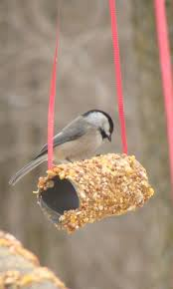

This is messy fun you can enjoy getting stuck into. And it will help you learn about the birds in your neighbourhood.

You can make this simple feeder with items you probably already have at home:

1. Smother a cardboard tube in peanut butter/lard (no added salt and sugar versions are suitable for birds).
2. Roll it in bird seed and thread some string through the hole.
3. Tie it up in your garden where birds will feel safe eating.

If you are very quiet, you might hopefully spot a number of birds.

Nature Walk

To mix things up, put the pencils and crayons to one side and look for natural art materials instead. Collect fallen leaves, petals and sticks and use them to make a picture or sculpture.

You could even use the objects as 'stampers' or paintbrushes - dipping them in paint and rolling, brushing or stamping them on paper to create interesting patterns and effects.

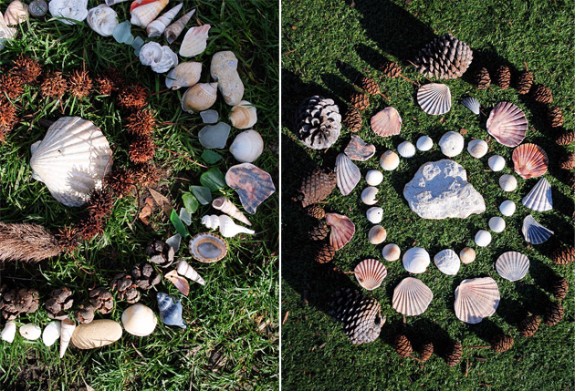

The Solar System

After a nice long walk why not settle in, draw the curtains and watch the spectacle that is ‘The Planets’.

<https://www.bbc.co.uk/iplayer/episode/p06qj2l5/the-planets-series-1-1-a-moment-in-the-sun-the-terrestrial-planets>

Read these questions before you start and give your response on a piece of lined paper:

1. How is it that Mercury’s day is longer than its year?
2. What ‘unusual’ chemicals were detected on Mercury and what does this tell us about Mercury’s history?
3. How is it that Mercury has water on it? Draw a picture to explain.
4. Which moon has rivers of methane and rocks of solid ice? Why might the conditions change on this moon in the future, and what might be the results?

Geometry

Decorate the net (flat 3D shape) before cutting it out and sticking it together. Cut around the flaps, as these will help you to stick it together.

Art

Equipment

* 4x sugar paper
* Pencil
* Paints

1st page: Using the paints mix the primary colours (Red, Blue and Yellow) together to see what happens. Think about combinations that you already know, and experiment with ones that you don’t.

2nd page: Look at the environment around you, take the colours from around you and try to replicate them. Think about the colour mixing that you have just done and how it will help you to create the colours in your environment.

3rd and 4th pages: Try to use the colours that you have made to paint the world that you see around you, you may wish to sketch out the shapes of the objects first.

How did you fill your day?

Input your data into Purple mash (2Graph)

<https://www.purplemash.com/#app/tools/2graph>