Green Group

Hey guys,

How are we?

Please send me in the work that you’ve already done, along with any photos! I will need to record it on Montessori Compass, our record keeping system.

Language

Logical Analysis:

In the sentence the action or the verb is called the predicate. The person who did the action is called the subject. The thing or the person the action was done to is called the direct object.

Amusing sentences

Use the words below to come up with some amusing sentences.

SUBJECT | PREDICATE | DIRECT OBJECT
Dog | flushed | buns
Monkeys | ate | cow
Mr. Chubbs | scratched | toilets
Trees | smelled | mud
Trucks | flew | toenails
Butterflies | gargled | airplanes

Don’t forget to put in articles (a, an, the) too:

Example: Mr Chubbs gargled the toenails.

Write 6 sentences on strips, using all the words, cut them out and mount them on the correct circle.

Compound words:

When we have a word that is made up of two smaller words and each word has its own meaning that’s called a compound word, for example:

- Sheepskin
- Shopkeeper

- Blackberry

Use these games on Purple Mash to help you compile a list and draw pictures of your favourite compound words:

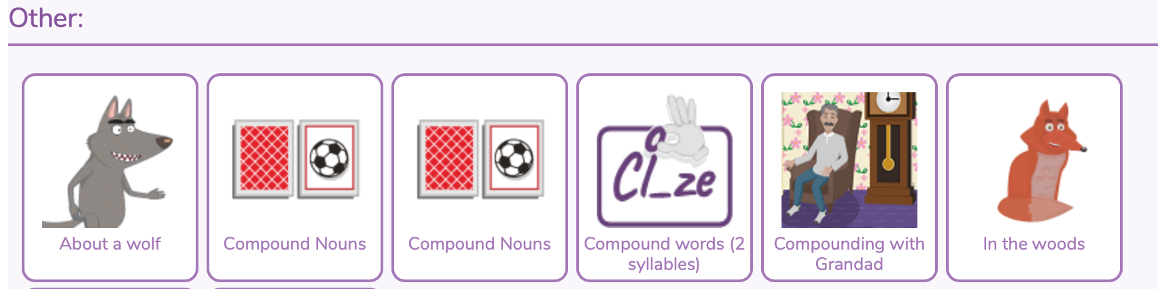

Maths

Multiples

Please, see the PowerPoint attachment for work on multiples.

Economic Geography

Please see the Powerpoint attachment on ‘Interconnectedness’.

Art

What you need:

- Watercolour paints/pencils, ink or food colouring
- Paper
- A white candle
- Paintbrush
- Surface covering

- Prepare your space, if you’re using food colouring this step is especially important as it will stain surfaces and floors.
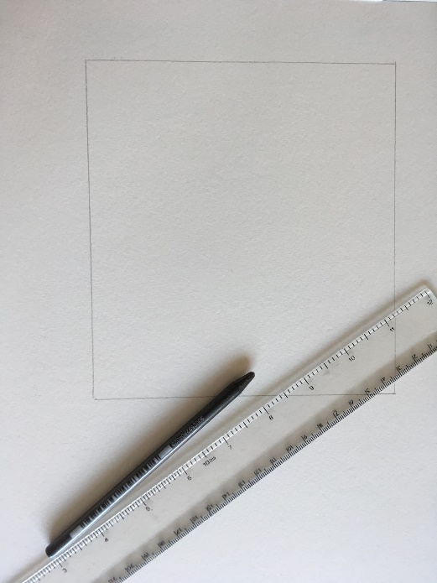
- I find it helpful to draw a box around the area I will write in, so I know where to paint! However, if you are going to draw over the whole piece of paper you can skip this step.

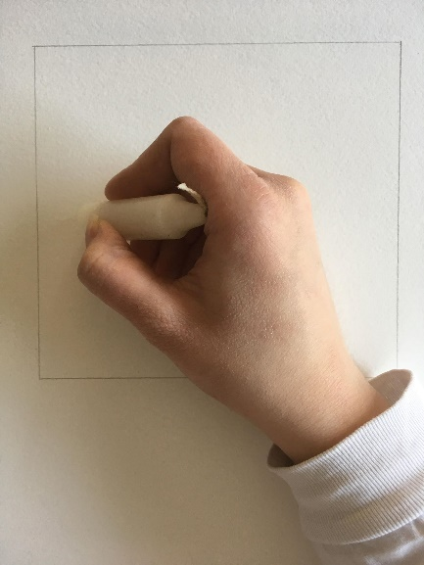
- Take your wax candle and draw with it as you would a crayon, if you want to see where you have been drawing to keep track, you can lift the page and angle it towards the light to see the wax.

- Choose your colours! If you are using ink or food colouring for this step you only need 1-2 drops, use a plastic plate to mix it with water before you apply it to your paper.
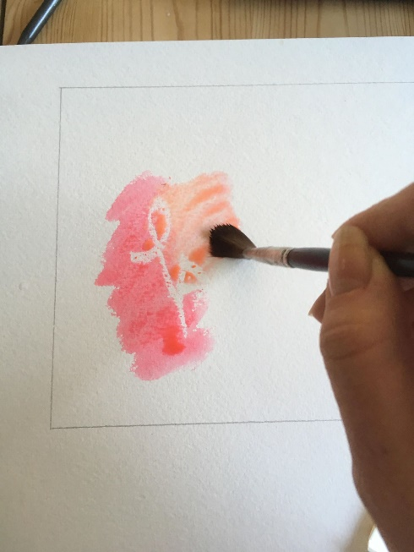
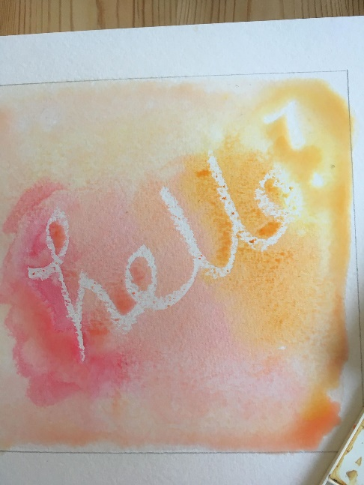
- Take your brush and paint over the wax you have drawn with! The drawing will be revealed.
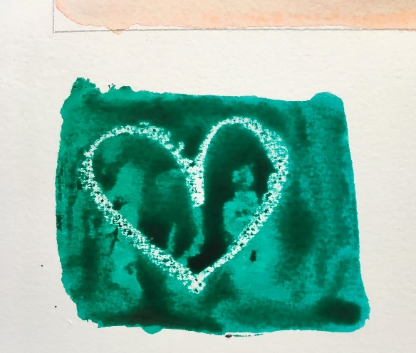
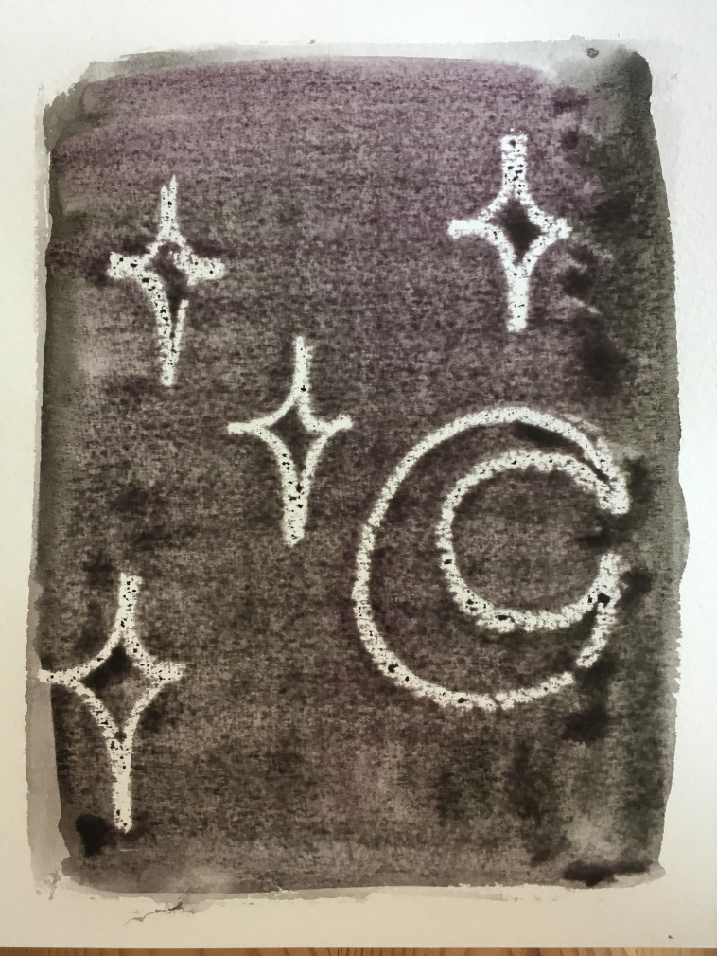

Have a think about this activity, why and how does it work? Have fun experimenting, you can write or draw whatever you like with the wax candle. Please, send in some photographs of your results, we would love to see them!

Physical Exercise

Make sure you are doing exercise every day, for example:

https://www.google.com/url?sa=t&rct=j&q=&esrc=s&source=video&cd=3&cad=rja&uact=8&ved=0ahUKEwiZr47xqMLoAhVNTcAKHXbfAhYQtwIINTAC&url=https%3A%2F%2Fwww.youtube.com%2Fwatch%3Fv%3DsX05HHni9Wk&usg=AOvVaw3Aet7tUWPdyxRgGlGJR9Da

Have a great Easter- I won’t be sending in any work for the Easter holidays. Look out for more work posts at the start of the ‘Summer term’.

