Green group

Art

Matisse-inspired collage

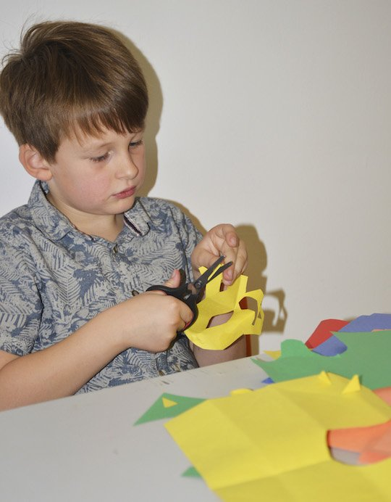

You are going to make your very own Matisse-inspired collage. Take a closer look at nature and be creative with shapes and colours as you cut out your own masterpiece!
Henri Matisse is a French artist known for making colourful works of art. He used a variety of materials in his work, including paint, bronze (for his sculptures), and he also made drawings using charcoal. As Matisse became older, he began to work with brightly coloured paper and would ‘paint with scissors’ to cut out shapes, animals, leaves, dancers and flowers and then arrange them.
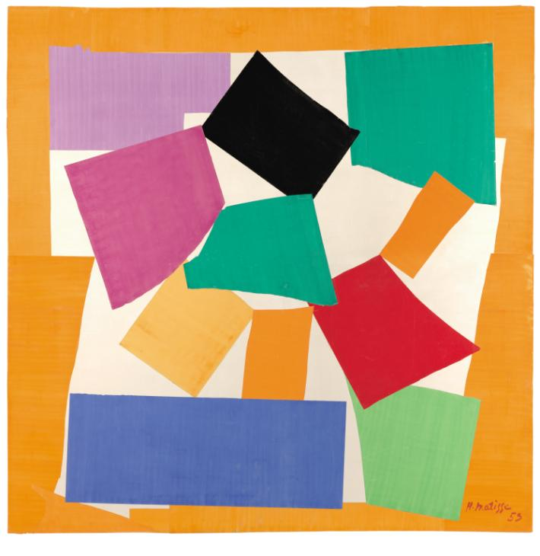

Henri Matisse
The Snail 1953
Tate
One of Matisse's most famous works is called The Snail. Does the spiral pattern of shapes remind you of anything?
It was made in 1953 and shows Matisse's interest in bright colours. He arranged complementary colours alongside each other to create a vibrant effect. For example, you'll see that by putting green next to red, and blue next to orange the colours seem to buzz and really attract your attention.

WHAT YOU NEED

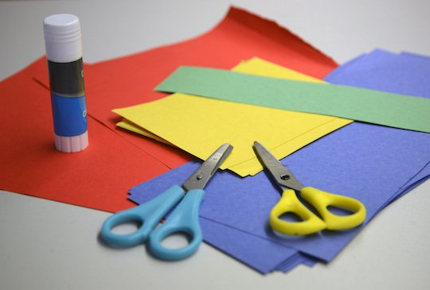
- Brightly coloured paper/white paper painted different colours
- Scissors
- A clear space to work on
- Glue
- Pencil
- Music
- Creativity (essential!)

How to do it!
- Matisse would listen to music as he worked. To get the creative juices flowing put on the radio and let the fun times begin.
- 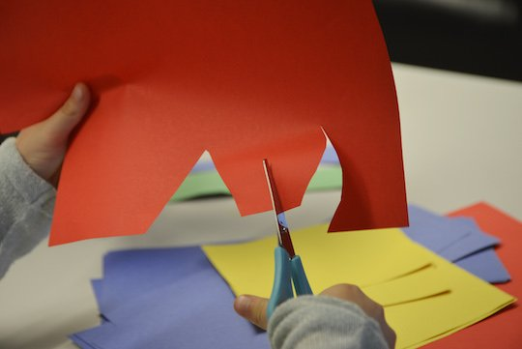
- Take your scissors and cut out shapes from the brightly coloured paper. They can be any shape you want; they can be wavy like the sea or sharp like a cactus, they can be in the shape of love hearts or spell out words! Just let your imagination take over.
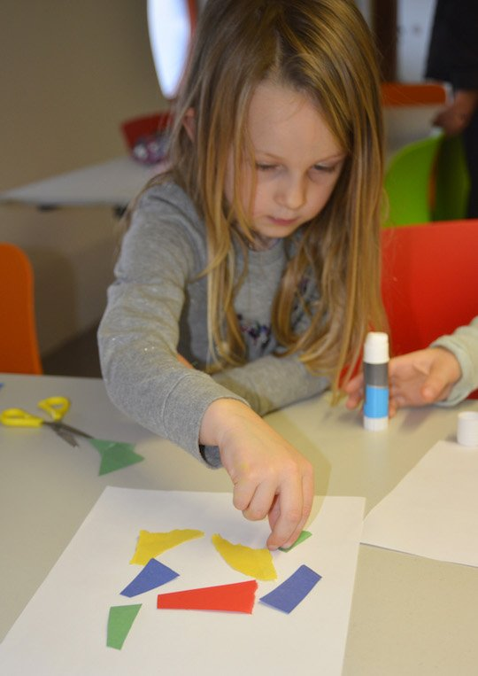
- When you have made a pile of brightly coloured shapes take a large sheet of coloured paper and start composing your picture. This means arranging the shapes onto the page to make a picture that looks nice. Composition is very important to artists' work. Don't be afraid to experiment with your shapes, they can be apart or touching. You could even overlap them to make a new shape – just play around and see what happens.
- Once you're happy with your picture you can stick your paper shapes down.

Maths

Time

Sundial

You have been learning to tell the time this year. Here, we made this very simple yet effective sundial by placing a pencil in a ball of clay/salt dough, Every hour, go went out and marked the hour with a stone. This sundial goes from 9 a.m. to 4 p.m. Easy cheesy! And fun!
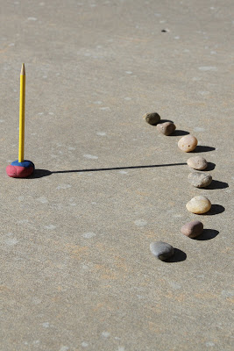

Zoology

Reptiles

Snakes

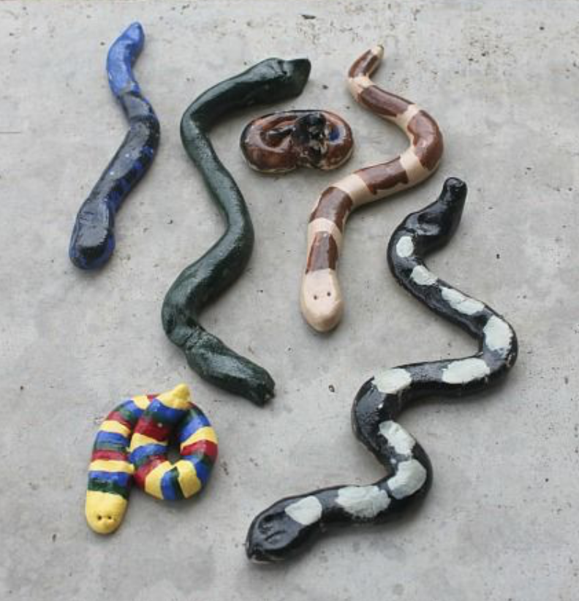

Why not make your own set of snakes out of salt dough then carefully paint (acrylic works best) their awesome patterns on them?
If you’re not interested in snakes then choose a different collection of animals. Your choice.

Below shows how to make salt dough:

INGREDIENTS FOR THE CLASSIC SALT DOUGH RECIPE
500 g plain flour
500 g table salt
250 ml warm water

HOW TO MAKE SALT DOUGH
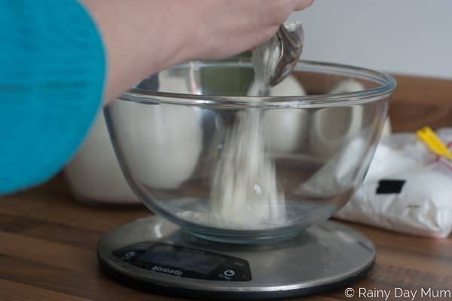
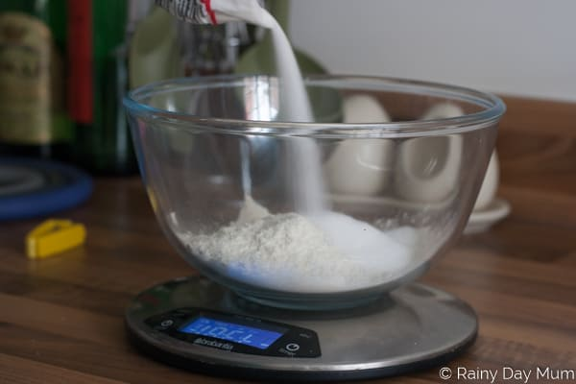
- Mix together the flour and the salt in large bowl
- Add the warm water slowly mixing together at the same time
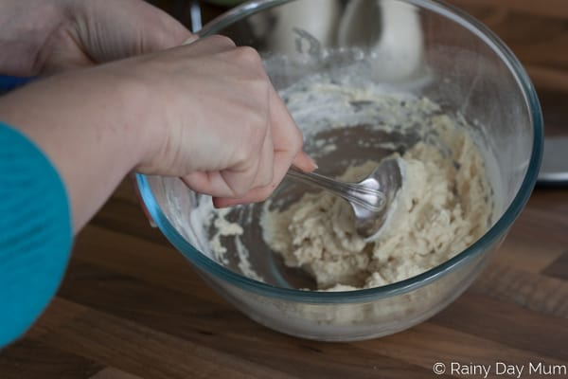
- When combined turn out onto a lightly floured surface
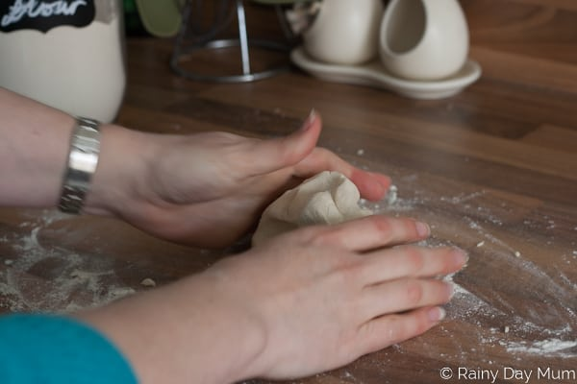
- Knead for 5 to 10 minutes until smooth and elastic
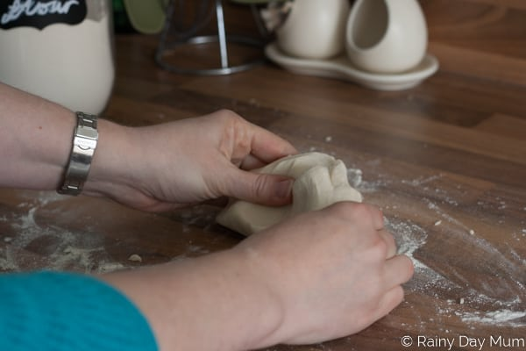

- This dough can be stored for a couple of weeks in an airtight container or ziplock bag with the air expelled
- Once your creation is made either leave to air dry or
- Place in the oven at 150C for around 1hr and check it may need longer
Art and design

Please watch this video and do your best to recreate your own flipbook:

https://www.youtube.com/watch?v=Un-BdBSOGKY

Maths

Stamp game

Multiplication

I hope you’ve been practicing lots with the stamp game using addition and subtraction.

Now it’s time to move onto multiplication.

https://www.youtube.com/watch?v=1uJP6MuWlpA

Use the interactive stamp game:

https://montessori.tools/stamp-game

The values you are multiplying are called the factors. The answer in a multiplication problem is called the product.
Please copy out the factors and fill in the correct product.

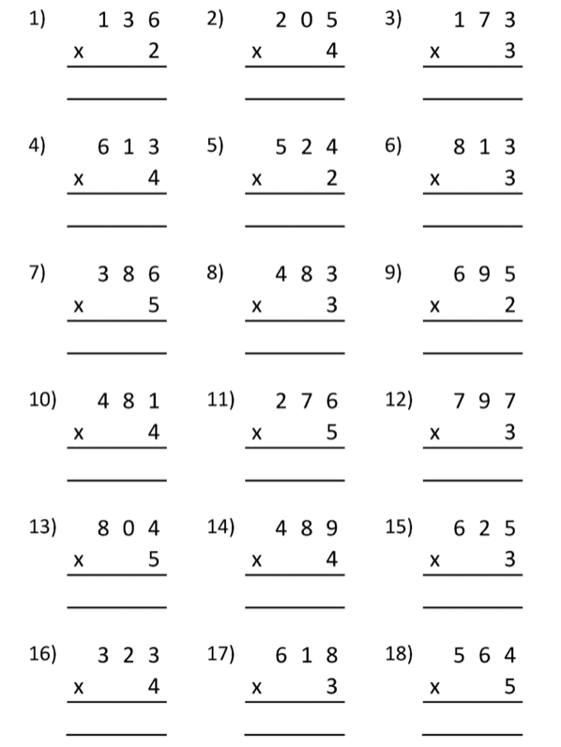
Language

Can you remember we read that story about the mole that like labelling everything in this book?

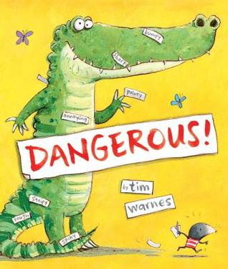

Now I want you to be that mole.
Use sticky notes to “label” a room. If you can’t spell a word, it’s okay. Do you best to use the sounds you know. Do a different room each day.

Biff, Chip and Floppy

You’ll have to get your parents to give you a login for this one but it’s free and has many of the titles we already have at school.

https://home.oxfordowl.co.uk/books/free-ebooks/

See if you can go up a level, each week.

