A list of activities to do with your child at home.
Many of these activities your child will be familiar with as we have been doing them at school. Please feel free to email me if you have any questions regarding a particular activity or need any other help.

Best wishes
Hanako

Practical Life activities
1. Making clove apples or oranges: Provide your child with a small tray with a bowl of whole cloves and an apple or orange to poke them into. The small size of the cloves makes this great for fine motor development and your child will create something that smells beautiful to decorate the house or give to a friend.
2. Button sorting (not for children under 3-years-old): Give your child a bunch of buttons differing in size or colour and little bowls to sort them in. For example, if you give them red, blue, and green buttons, give them three little bowls to sort them in. Any type of object your child is interested in can be used for sorting!
3. Carrot cutting: Even children who don't like eating carrots love cutting them and preparing them for others. It's helpful if you provide your child with a tray with everything they'll need: an apron, bowl for water, scrub brush, peeler, small cutting board, wavy chopper, and sponge or small towel for spills. Show your child how to wash, peel and cut a carrot and then let them try on their own!
Tip! For toddlers, use pre-washed and peeled baby carrots so it's easier to chop.
4. Apple slicing: Another popular Montessori food prep activity is apple slicing. For this one your child will need an apron, bowl for water, scrub brush, cutting board and apple slicer. For young children, it helps to cut the apple in half horizontally first so it's easier to slice.
You can use any food your child likes for food prep. Clementine peeling and hardboiled egg peeling are also fun.
5. Make trail mix: Give your child large containers of several different snack items they like (dried fruit, nuts if they're old enough to eat them, cereal, etc.). Give them a measuring scoop and let them scoop some of each item into a big empty container and mix it up. If you like, make this available to them on a shelf they can reach so they can get their own snack.
For an older child, you can write a simple recipe (e.g., 2 scoops of cereal, 1 scoop of cashews, etc.) to make it more challenging.
6. Window washing: This is always a popular activity in Montessori classrooms and all you need is a small spray bottle (full of water or water mixed with white vinegar or a few drops of washing up liquid), a small squeegee, and a sponge.
7. Scrubbing: Many young children love scrubbing because they can see the tangible results! Scrubbing often comes with water spills and mess, but that's okay—learning how to clean the spills is part of the purpose. You can make this super simple with a tub, scrub brush, and towel, or add extra elements like soap and a bottle brush to clean crevices. Children love scrubbing tables, chairs, rain boots or their waterproof toys!
8. Babydoll washing: An extension of scrubbing, your child can wash a baby doll with a small wash cloth—especially perfect for soon-to-be siblings.
9. Leaf polishing: Taking care of indoor plants is something even very young children can do. All your child needs is a small dish for water and a sponge and they can wipe the dust off of the leaves of indoor plants.
10. Plant watering: Provide a small watering can and show your child how to check if an indoor plant needs water.
11. Flower arranging: Get an inexpensive bouquet of flowers and let your child trim the stems, fill small vases with water, and arrange the flowers in little vases around the house.
12. Matching socks: Put your child in charge of matching socks when it's laundry time—a great lesson in visual discrimination, as well as responsibility.
13. Grinding egg shells: Egg shells are great fertilizer. Show your child how to grind them with a mortar and pestle and sprinkle them in potted plants.
14. Sweeping/mopping: Sweeping the floor with a small broom and dustpan is one of the first ways toddlers and young children can learn to help take care of the house. If they're getting stir crazy, give them a purpose and invite them to help you sweep. This little cleaning set is perfectly sized for little hands to help.
15. Bubble making: All you need for this one is a mixing bowl, pitcher for water, whisk and small dropper bottle with dish soap. Your child will have fun adding soap and mixing to make bubbles, but make sure to put them in charge of the clean up too, that's where a lot of the learning happens!

Sensorial Activities

16. Mystery bag: Give your child a drawstring bag with a few themed items from around the house (e.g., their small dino toys or kitchen objects). Instruct them to close their eyes and use only their hands to guess what the objects are.
17. Smelling bottles: Fill a few spice jars with herbs or cotton balls with kid-safe essential oils. Let your child enjoy smelling and guessing what they are. For an older child, you can provide two sets of bottles and let them match the smells.
18. Sound matching: Fill little bottles or jars (paint or cover if transparent) with little objects like rice, beans, beads, acorns, tiny bells, etc. You'll need two bottles, each a different color or marked with a colored sticker (one set with blue stickers, one set with red stickers) for each filling. Let your child try to match the sounds.

Gross motor activities
19. Puzzle distance game: Take any puzzle your child loves and put it in the living room. Have them build the puzzle in their room so they have to walk back and forth each time to find a piece. This kind of distance game is used all the time in Montessori classrooms, to keep kids moving and encourage them to practice keeping information (i.e. what piece they need) in their mind while they walk.
20. Throwing baskets: Take two baskets and a set of small bean bags or soft balls and show your child how to throw the balls from one basket to the other.

Art activities
21. Gluing: Give your child a small jar of glue and a paintbrush and show them how to use just a little bit of glue. The smaller the objects they're gluing, the bigger the fine motor challenge.
22. Painting: Even 3-year-olds have independent access to paints in Montessori classrooms. The key is starting them off with just two or three colours at a time until they learn to rinse their brush, and showing them how to clean spills.
23. Colour mixing: Fill small dropper bottles with red water, blue water, and yellow water. Let your child mix the colours in a paint palette to explore what different colour combinations make.
24. Makerspace: Designate a small corner or table for a "makerspace" for your child. Keep a variety of objects there (simple things like boxes, toilet paper rolls, buttons, string) and encourage your child to construct whatever they like.

Sewing activities
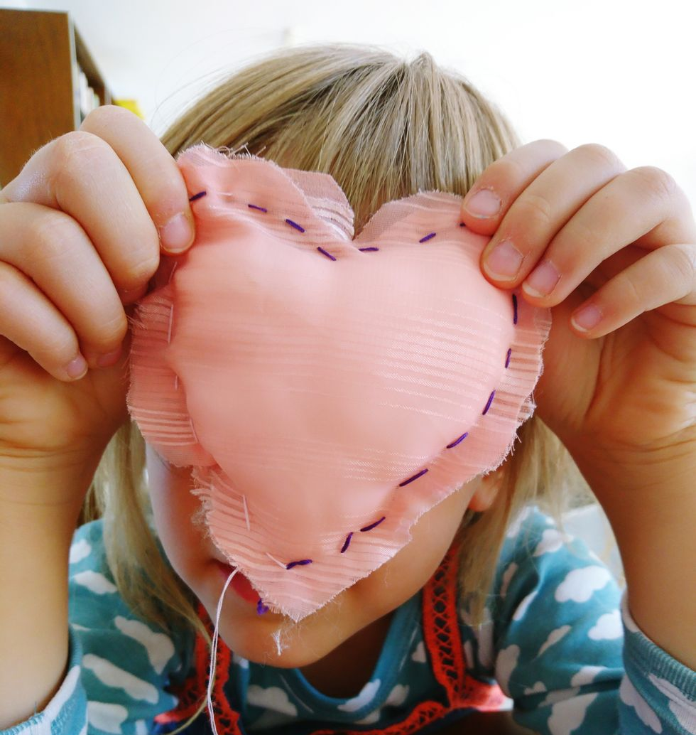

25. Lacing cards: These help children practice the up-down pattern of sewing before they're ready for a needle. If you don't want to buy them, simply punch evenly spaced holes around the edge or a card stock shape and let your child practice with a shoelace.
26. Necklace making: This is usually the first activity where children use a needle, but it is a yarn needle, so is not sharp. They'll also need a variety of beads. You will need to tie the knot, but even young children can thread the needle with practice so encourage them to give it a try!
27. Button sewing: All you need is a piece of fabric, a needle, and thread. Show your child how to thread the needle, tie a knot and sew on the button. Most children are ready for this around 3 1/2 or 4 years old, with supervision.
28. Pillow making: When a child has mastered button sewing, they are ready for pillow making. Show them how to sew two pieces of fabric together and stuff with pillow batting. Making a sachet full of dried lavender is a fun extension
Language activities
29. Small to big matching: Take an old calendar and cut out the little images on the back. Cut out the big images for each month. Show your child how to match the small images to the big ones.
30. Story box: Provide a small basket with a few seasonal items (e.g., a mitten, a small snow globe, an ornament) and show your child how to create a story. If they know how to write, they can record it, if not they can tell you and you can write it down while they illustrate!
31. "I Spy": Help your pre-reading child learn to isolate sounds with "I spy". Choose a phonetic sound and say "I spy something that starts with 'a'". Play as long as they like!
32. Rhyming games: Collect a set of household objects or toys (e.g., dino and rhino, doll and ball) and show your child how to match the rhyming objects. Alternatively, take turns coming up with a word and asking each other to think of a rhyme.
33. Household labels: If your child has started to read, write the name of a household object on a slip of paper and let your child read it and place it on the object. Start with easy words like "box" or "cup" and increase the challenge as they're ready.
34. Story writing: If your child knows how to write, encourage them to write their own stories. If they need inspiration, let them cut out pictures from old magazines to use as the illustrations or draw a picture for them and let them make up a story about it.
35. Commands: This is a fun one because it incorporates gross motor and reading! Write action words on slips of paper (e.g., jump, walk, spin, etc.) and take turns choosing a paper. Whoever's turn it is reads the paper silently and acts it out while the other guesses the action.
Maths activities
36. Sticker patterns: Working with patterns helps young children develop mathematical minds. Take a strip of card stock and create a pattern with stickers. Encourage your child to recreate the pattern, and then to create their own patterns.
37. "Bring me" game: Montessori math for young children is extremely hands-on. Practice with your child who is learning to count by playing a "bring me" game. Say something like, "Bring me 8 red Lego bricks" or "Bring me 3 coloured pencils". Your child will have to keep the number in their mind while they find the objects, which makes it more challenging.
Science Activities
38. Sink or float: Use a tub of water (or the actual bathtub to avoid the mess!) and give your child a variety of objects. Ask them to hypothesize which will sink and which will float and then test their theory.
39. Magnetic/non-magnetic: Provide your child with a variety of objects, some magnetic and some not, and let them guess which are magnetic and test their theory.
40. Living/non-living: Explain to your child the difference between living and non-living things—for example, a house plant is "living" but the pot it's in is "non-living.". Make little labels ("living" on green paper and "non-living" on white paper so pre-readers can tell the difference) and let your child label things in your home as living or non-living.
41. Air, land, water: Collect small objects or images representing things found in air, land, and water and let your child practice sorting them.
42. Bird watching: Set up a little bird watching station by a window. All you need is a small chair or floor cushion, some images of common birds in your area (or a bird book!) and binoculars if you like. You can set up a bird feeder outside of the window to increase the action!

