Red Group

Language

Writing

Task 2:

How did you get to your island?
Write about your arrival, explaining how you got there. Are you alone or with someone? Try and think of an interesting and unusual way to arrive. If you are writing it as a diary then give it a date. Were you alone when you travelled and what about now?
Remember to write in paragraphs and think carefully about punctuation and presentation. Use the best descriptive language you can, for example.
The stark contrast between the bright sun-drenched white sand and the dark Write a rhetorical question to finish the paragraph, for example:

- There's no hope, is there?
- How much longer will this injustice continue?

Maths

Timetable reading

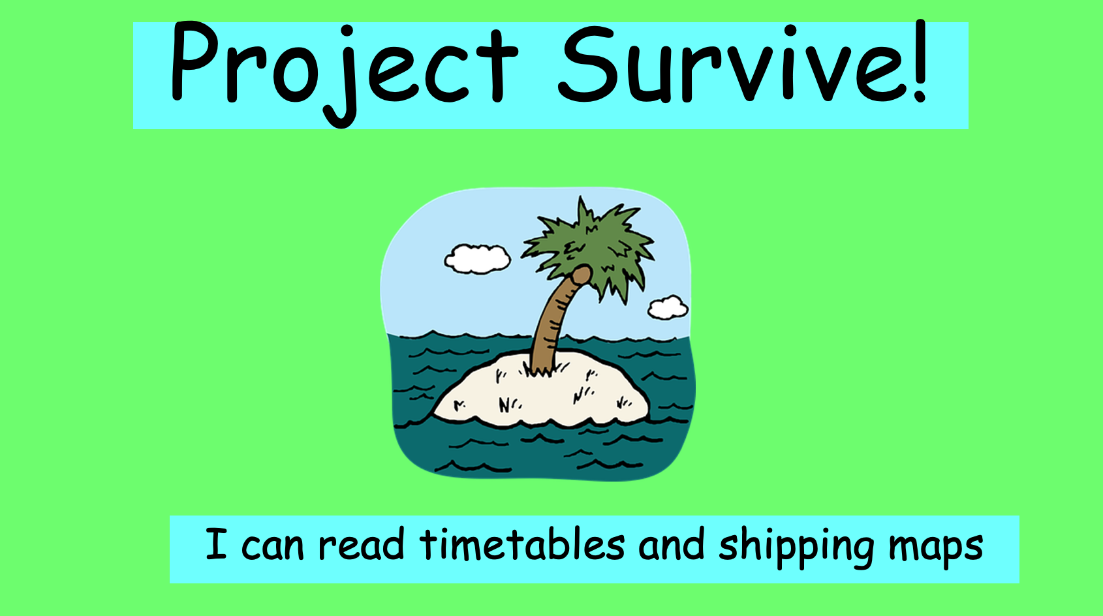

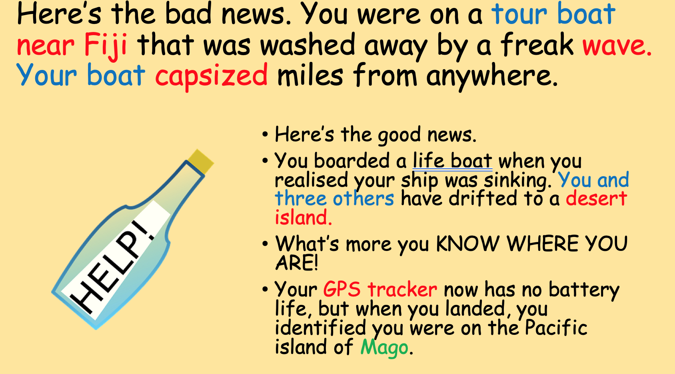

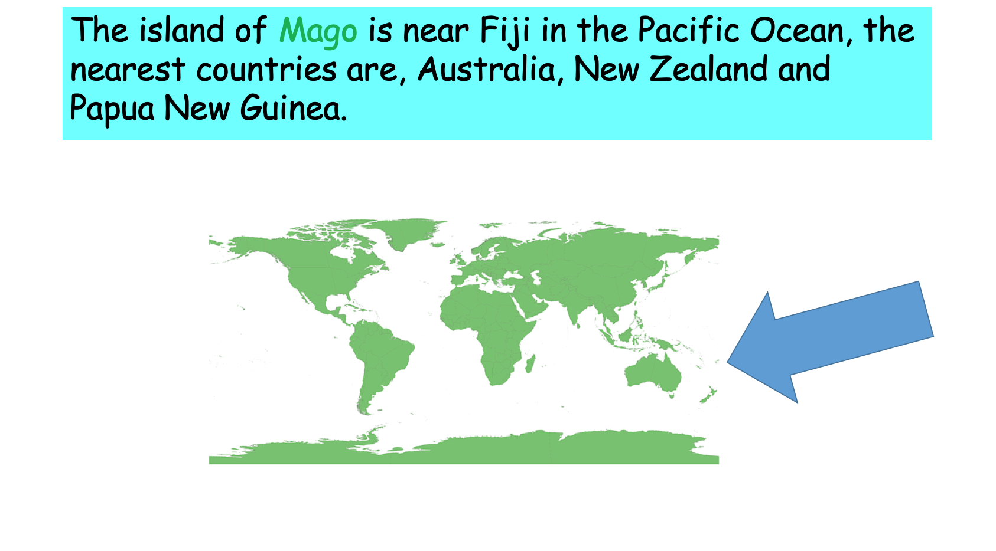

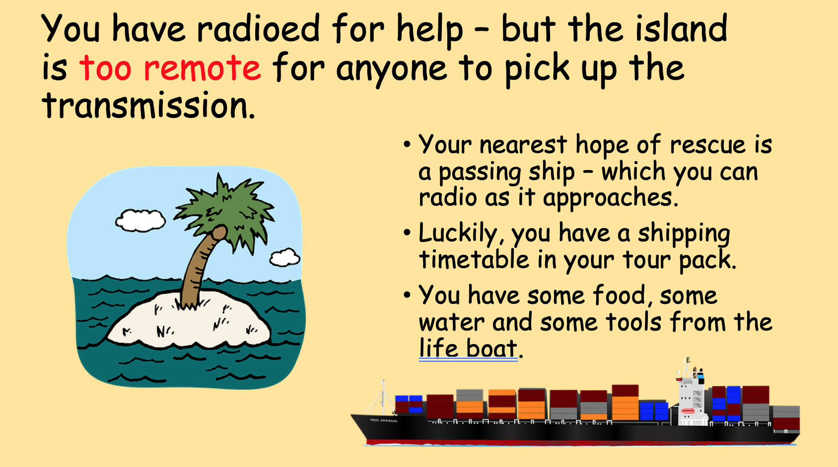

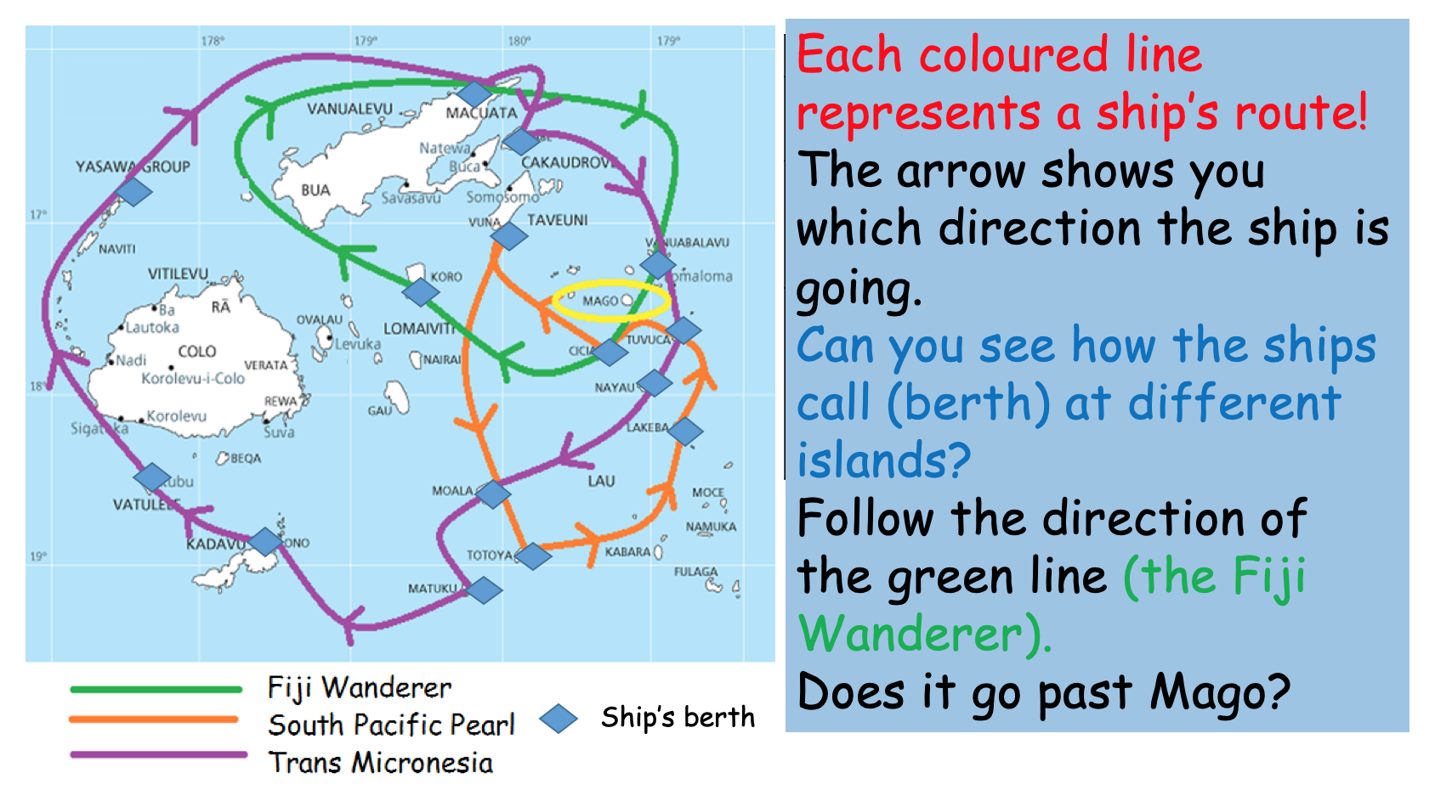

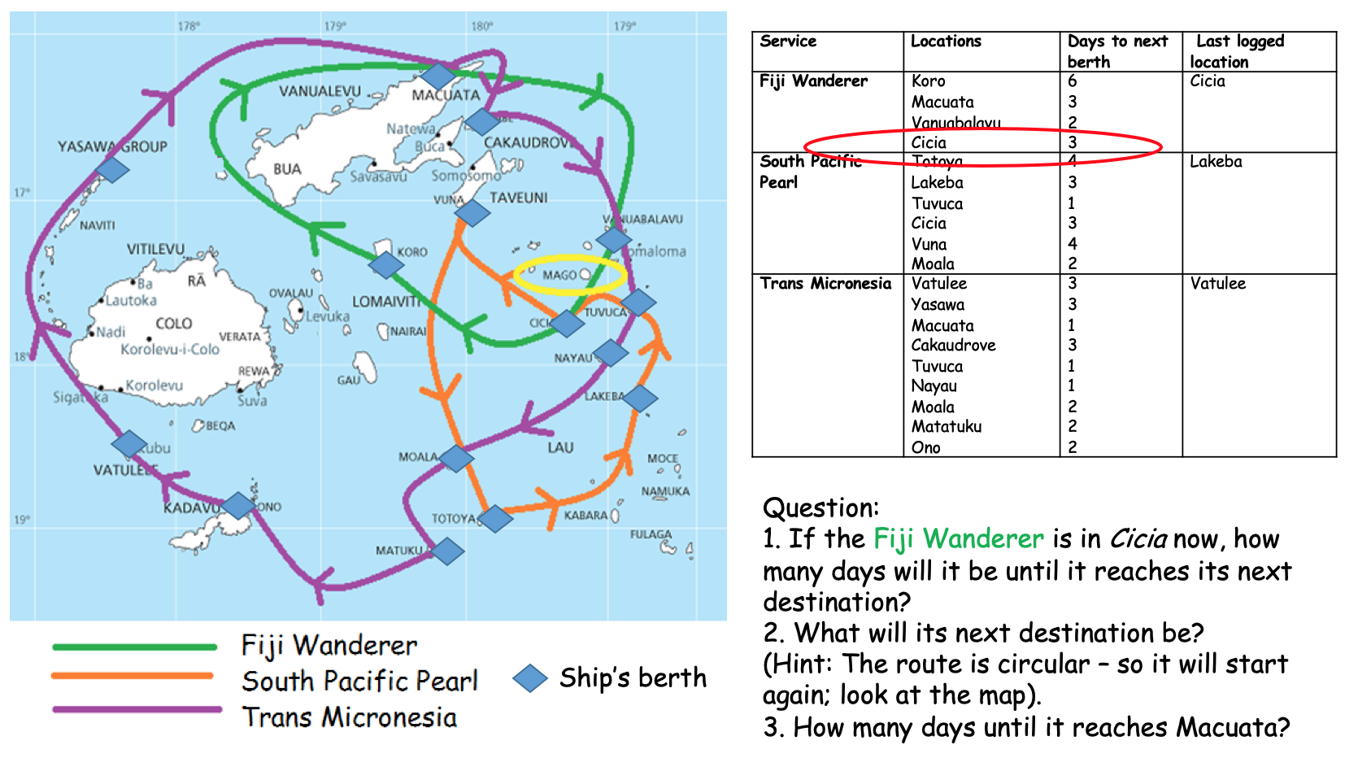

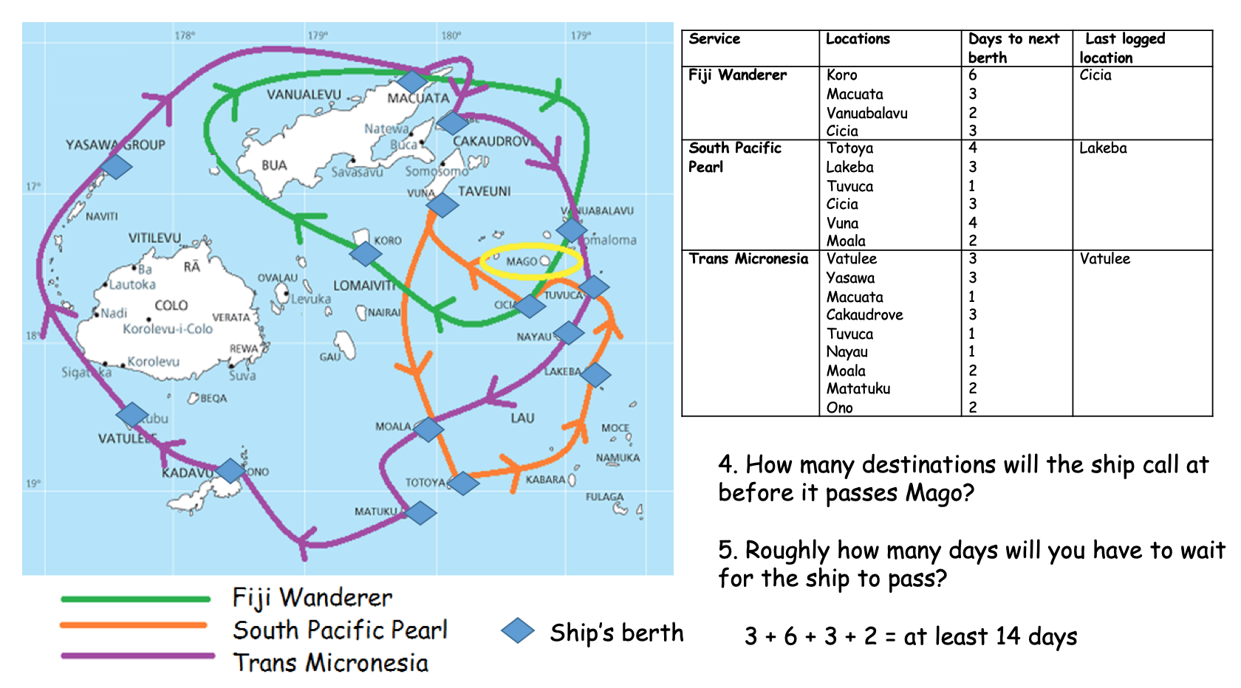

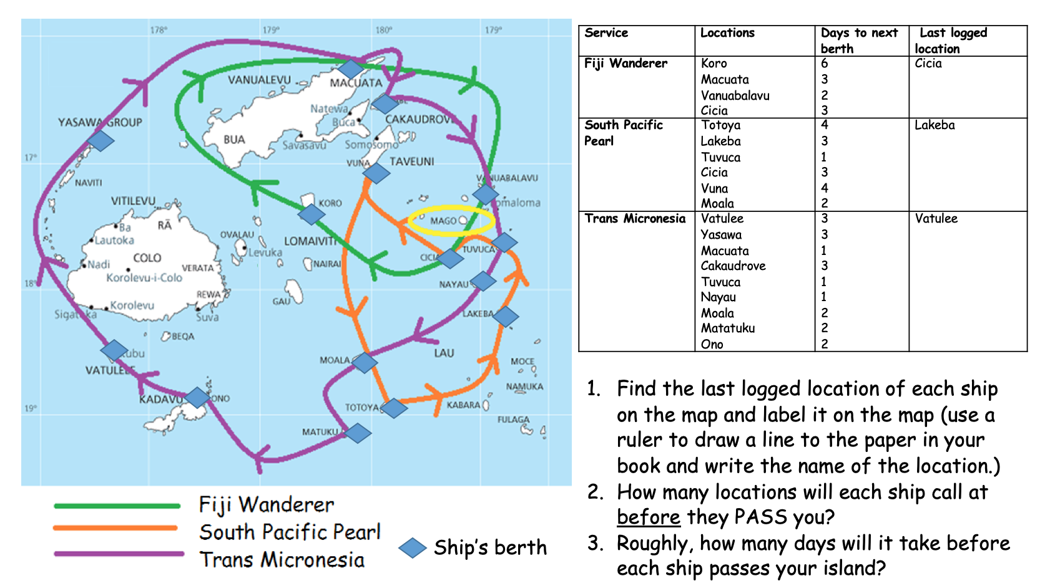

Science
Evaporation
Imagine you have yet to find a fresh water source on your island. You would need to make this in the meantime:

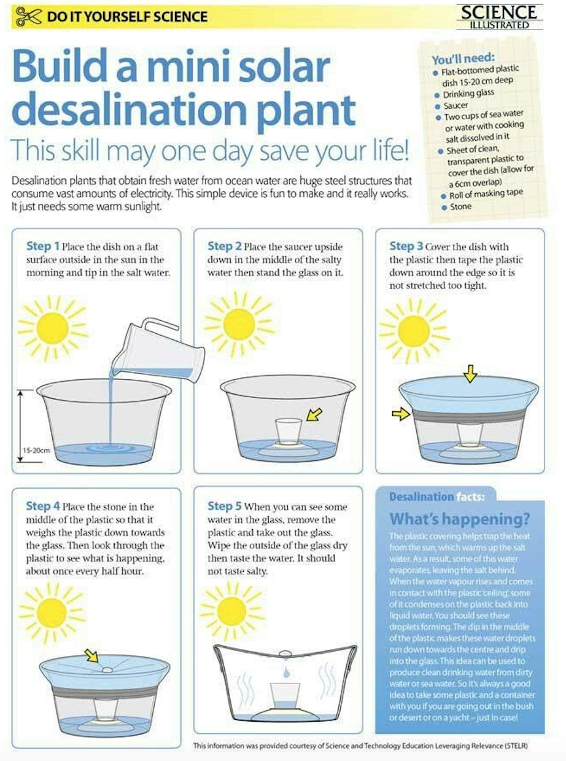
History
Tudors
Galleons

Why not listen to some Tudor music to inspire you whilst you work.

https://www.bbc.co.uk/teach/school-radio/history-tudors-music/zm4gvk7

Please, read the section below then answer the questions.

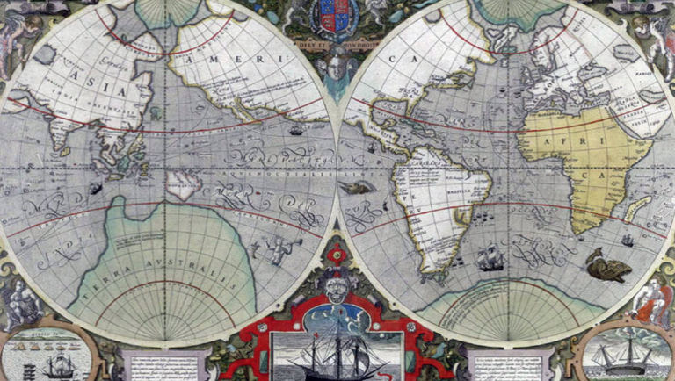
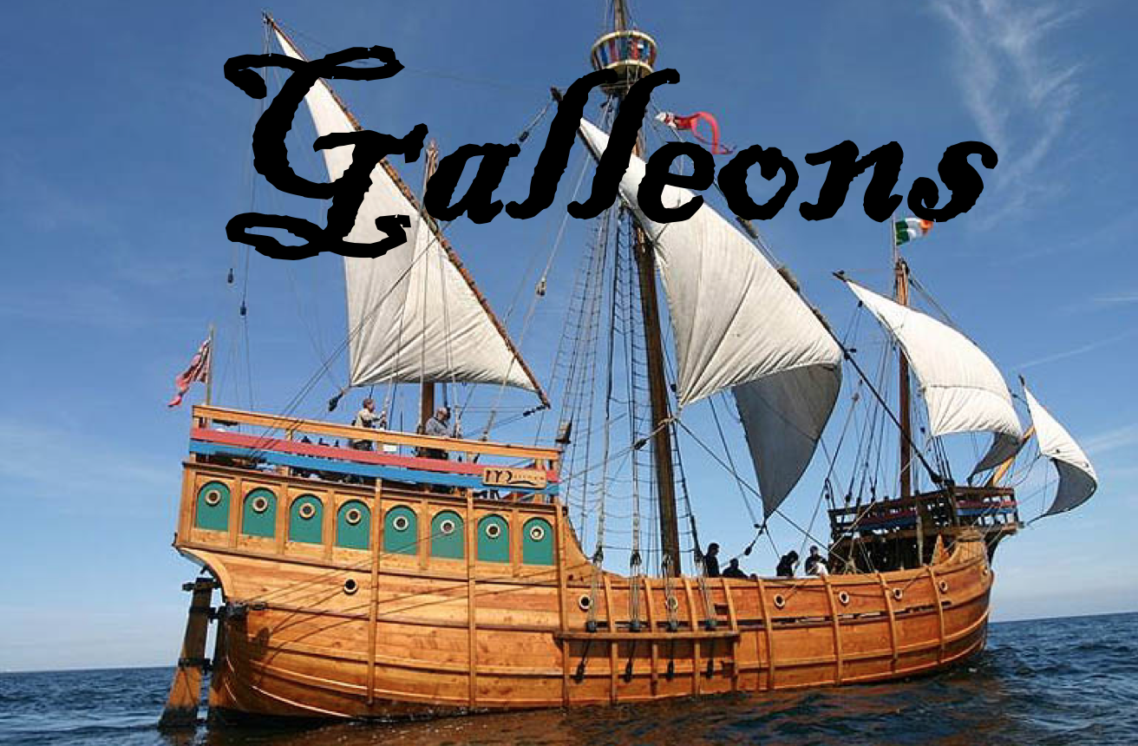
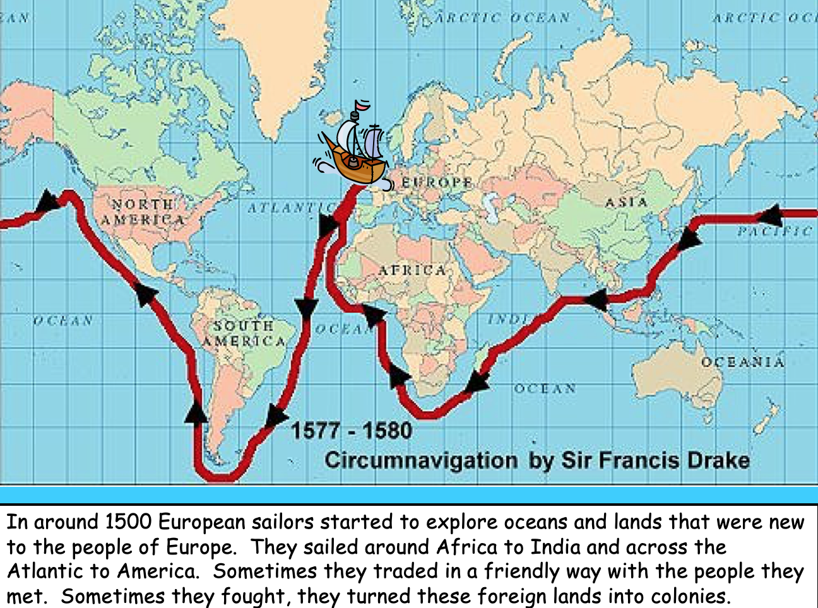
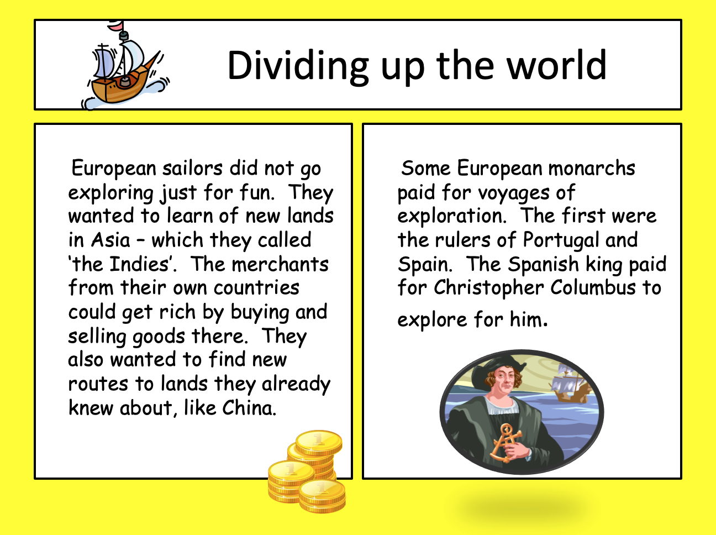
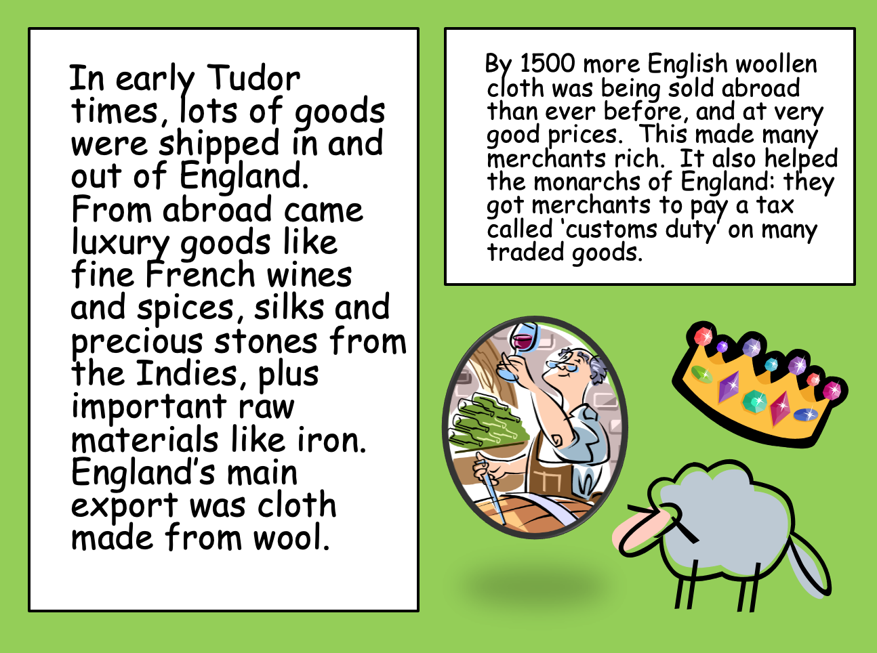
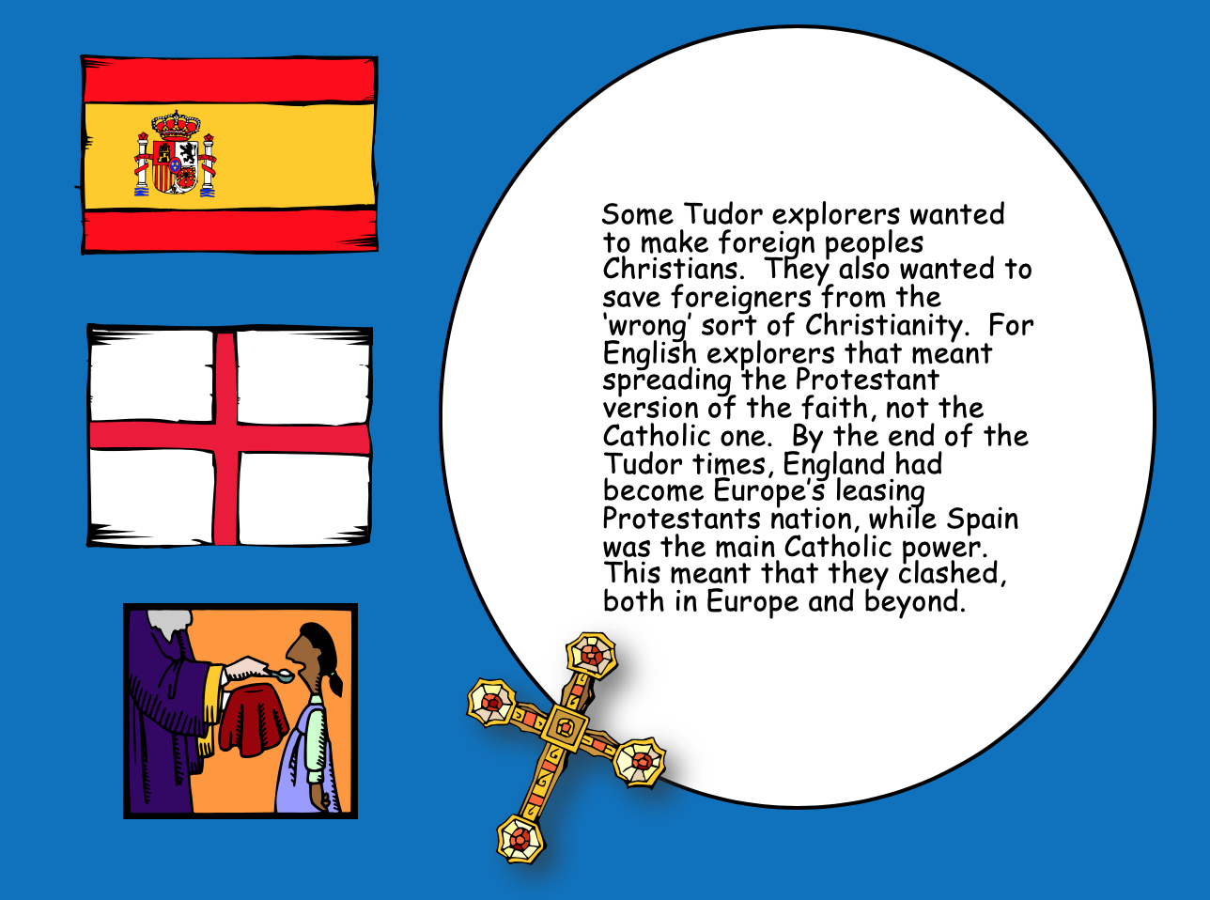
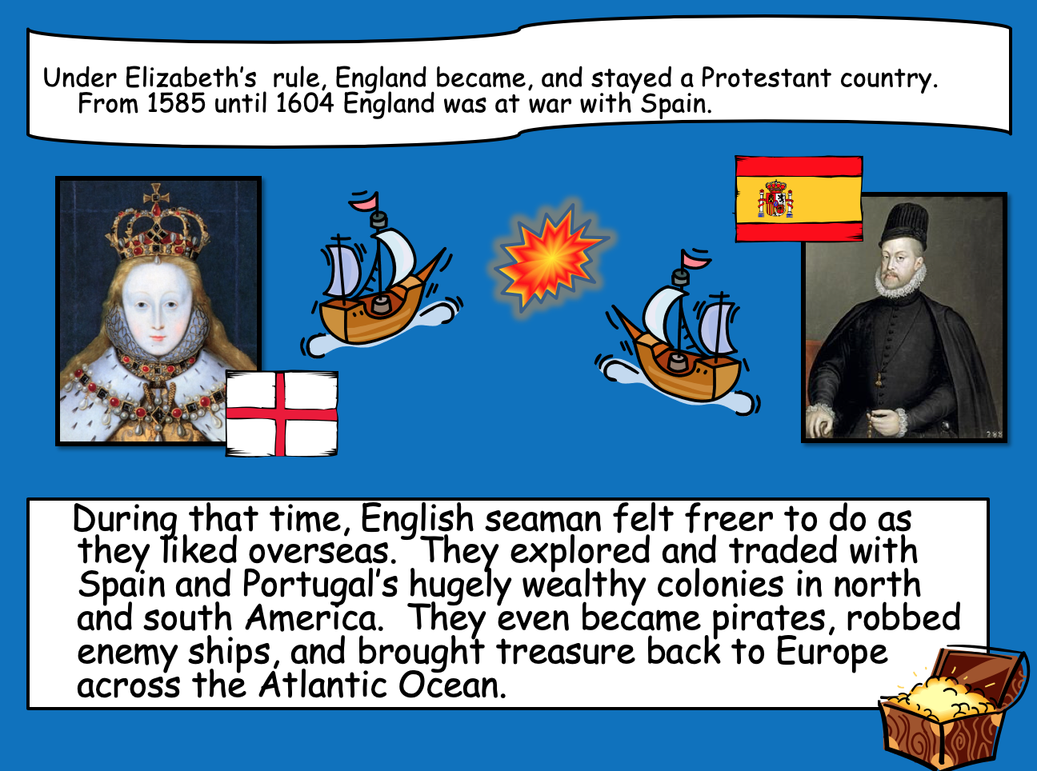
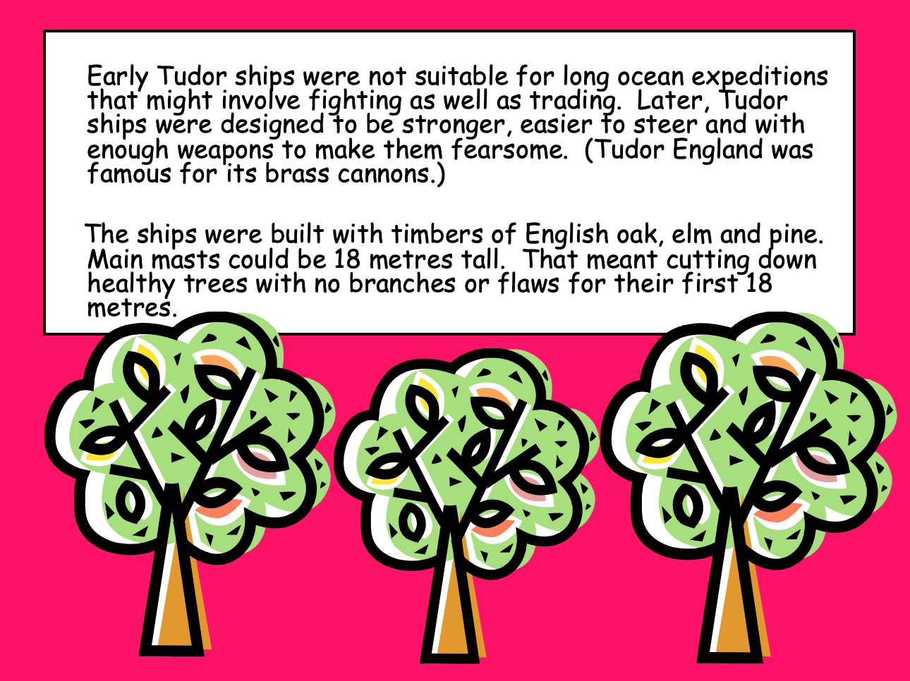
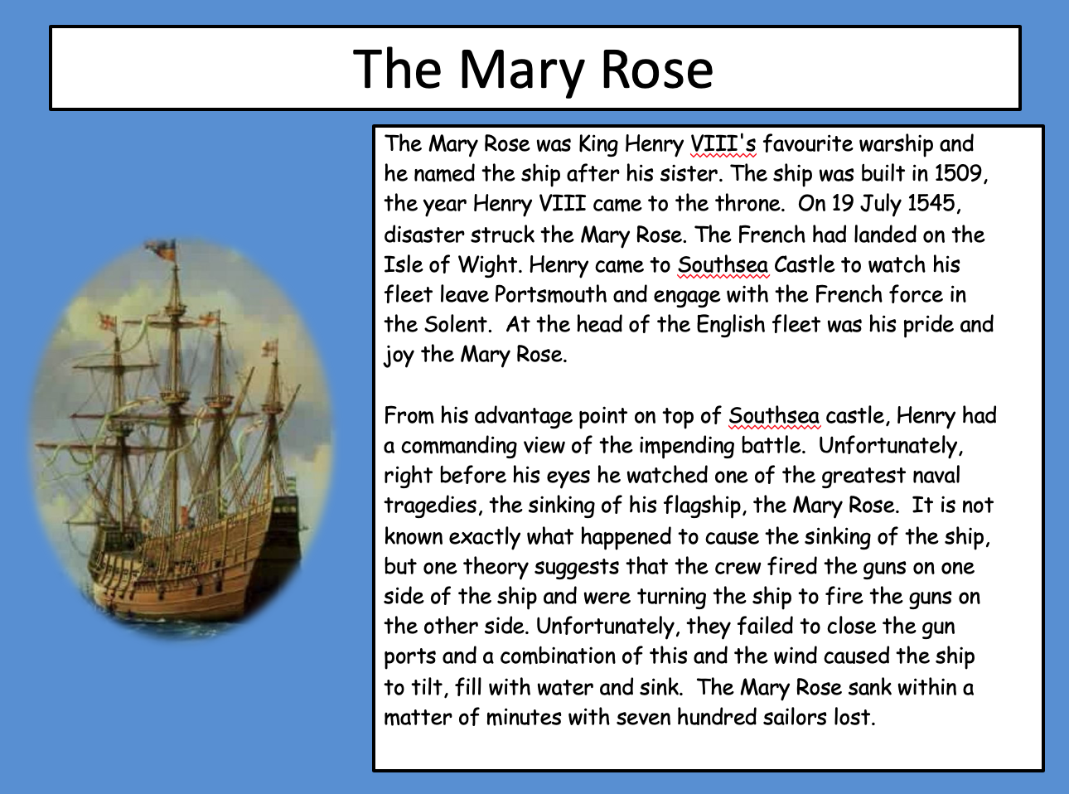
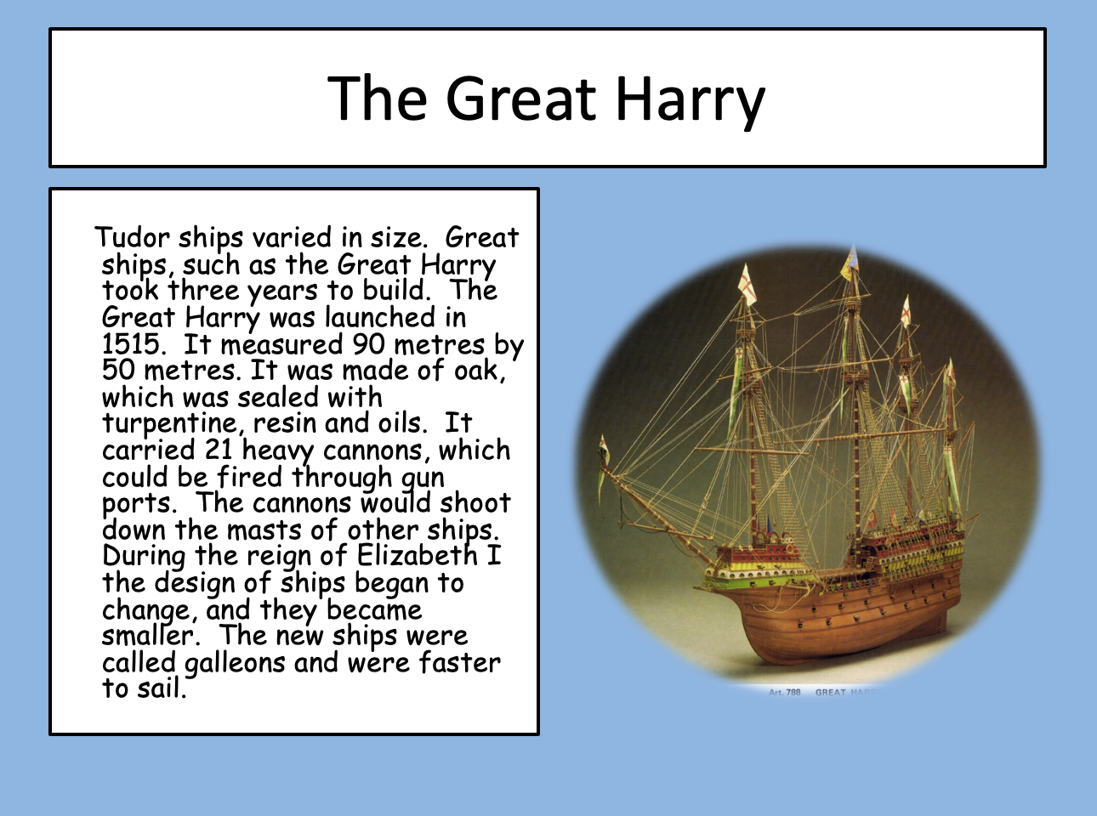
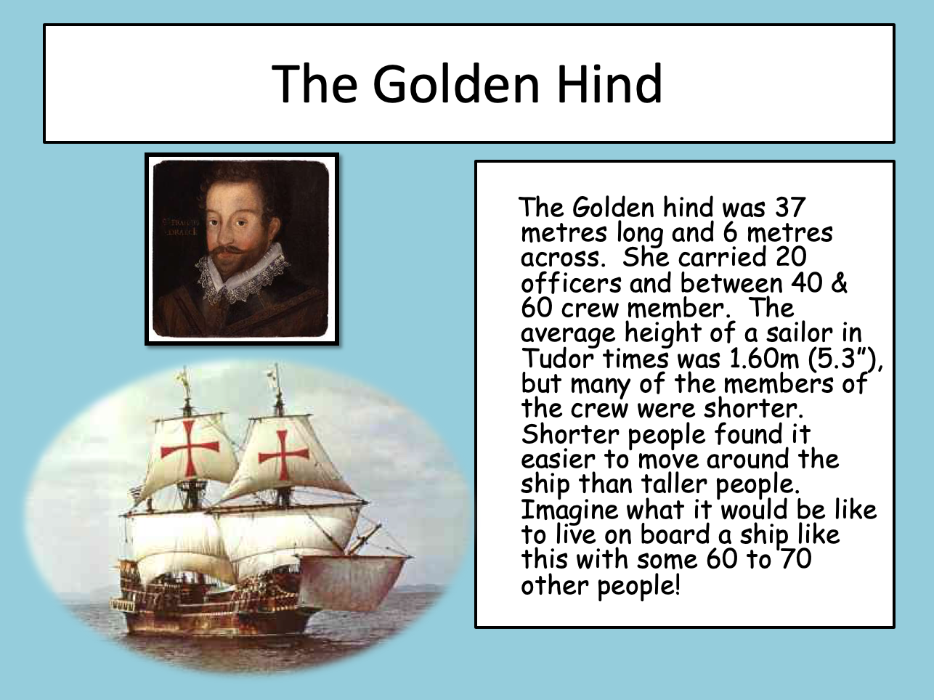
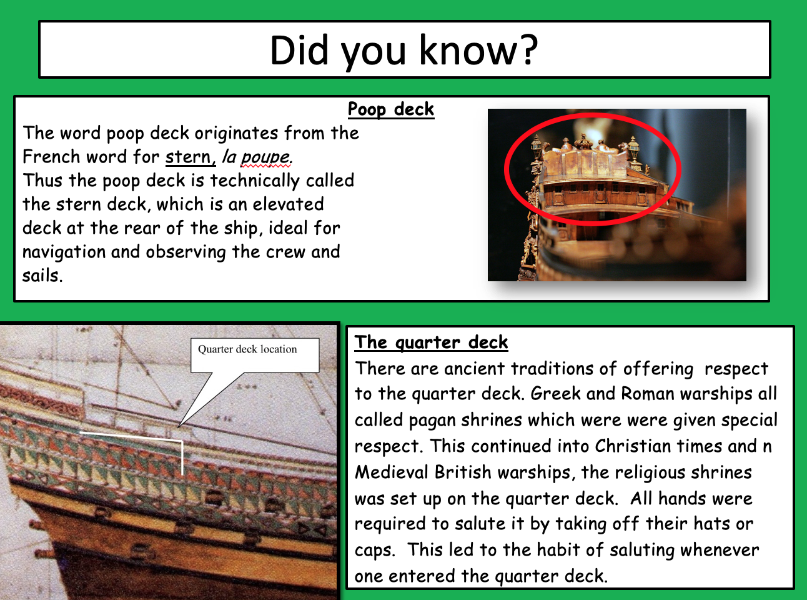
- Robin Crusoe wanted to be a sailor because of the adventure but what other reasons did sailors set sail?

- Who funded the first voyages?

- We imported many wonderful things but what did we export (trade out of England)?

- What according to the English was the wrong kind of ‘Christianity’?

- Between which dates were England and Spain at war?

- What kind of wood were the ships made from?

- Who was the Mary Rose named after?

- Where did it sink?

- What were the dimensions of ‘The Great Harry’?

- Why did they start building ships that were smaller?

- The average height of a sailor in Tudor times was 5.3” (five foot three inches), nowadays the average height for an Englishman is 5.9”, why do you think we’ve got taller?

- Research from a book or the internet, the average life expectancy of woman or men from Tudor times. What is the difference in years between now and then?

- Why is it called the poop deck?

Art

Galleon

https://www.youtube.com/watch?v=vmK826mU6Yc

Music by Wolfgang Amadeus Mozart (27 January 1756 – 5 December 1791, much later than galleons), baptised as Johannes Chrysostomus Wolfgangus Theophilus Mozart, was a prolific and influential composer of the Classical period.

Science/Maths

Baking

Poor old Robinson longed for bread. Without many of the ingredients – yeast and butter to add flavour – he had to make flatbreads, with simply, flour and water. Imagine the delight if he was able to make these!
Why not have a go.

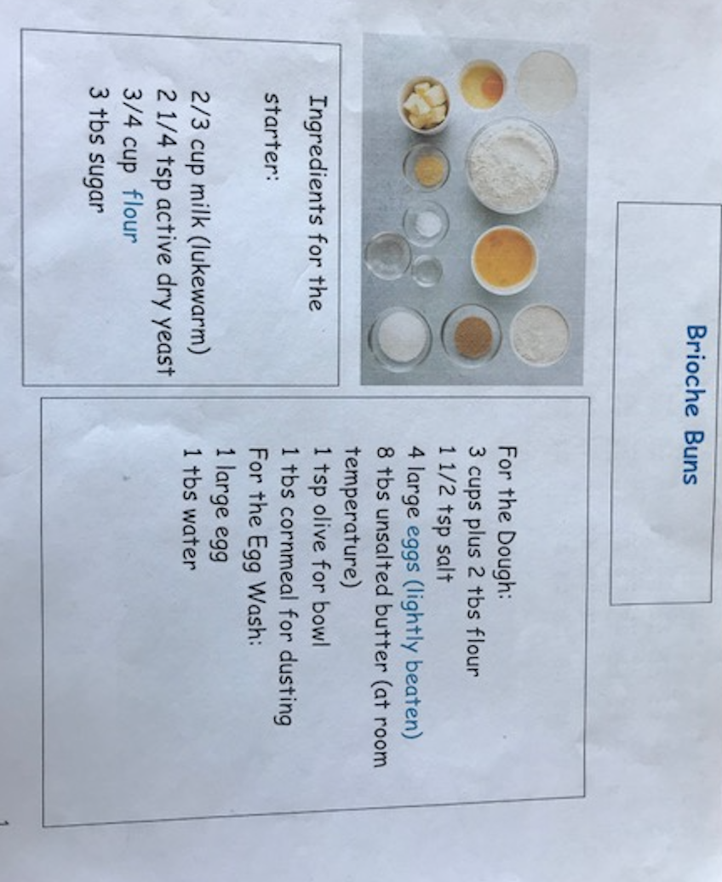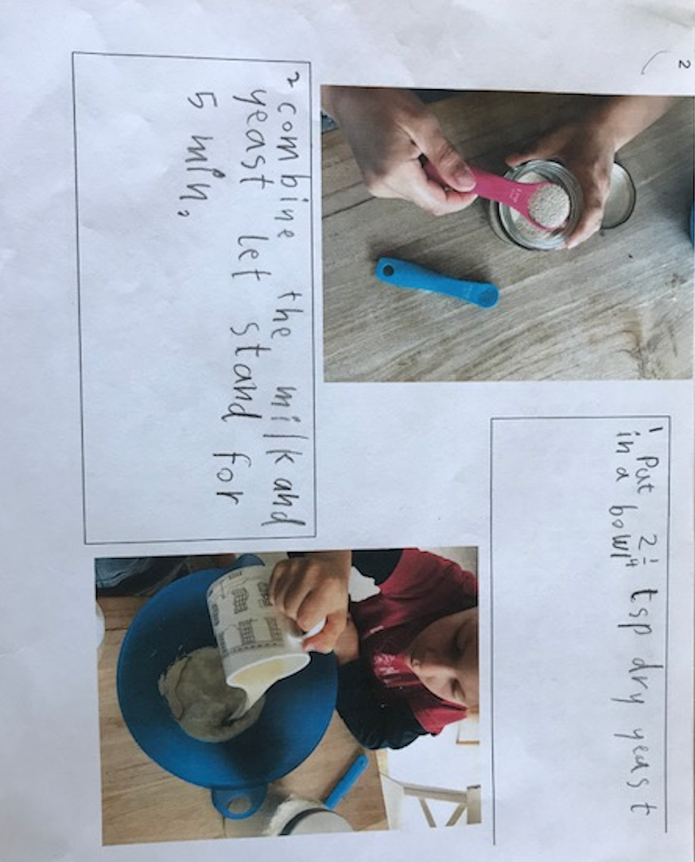

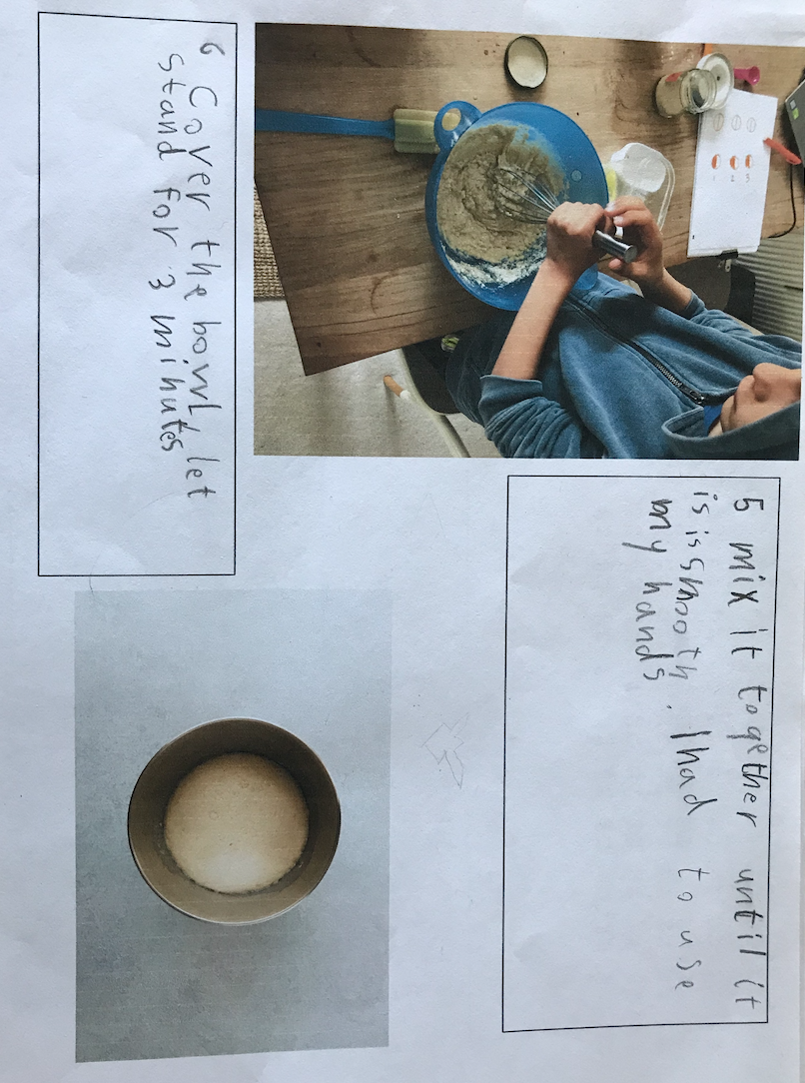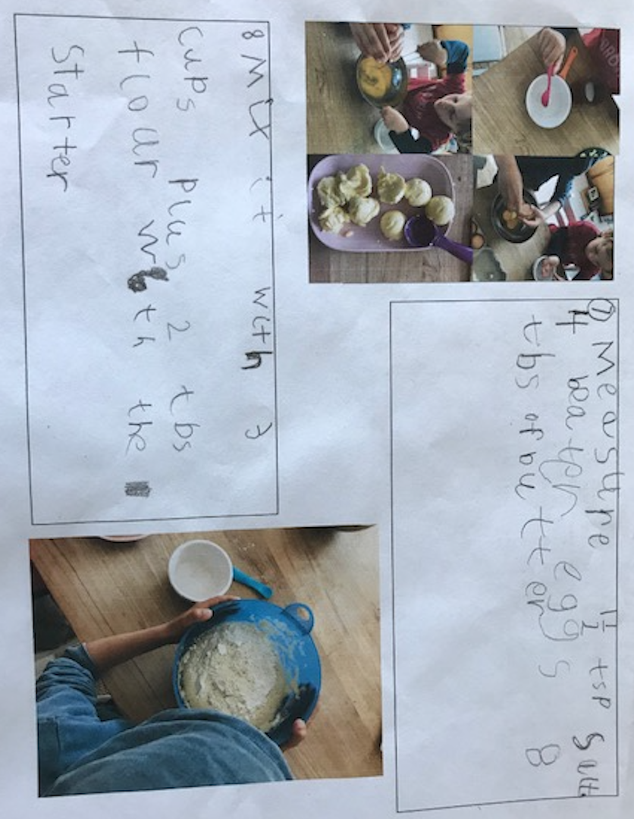

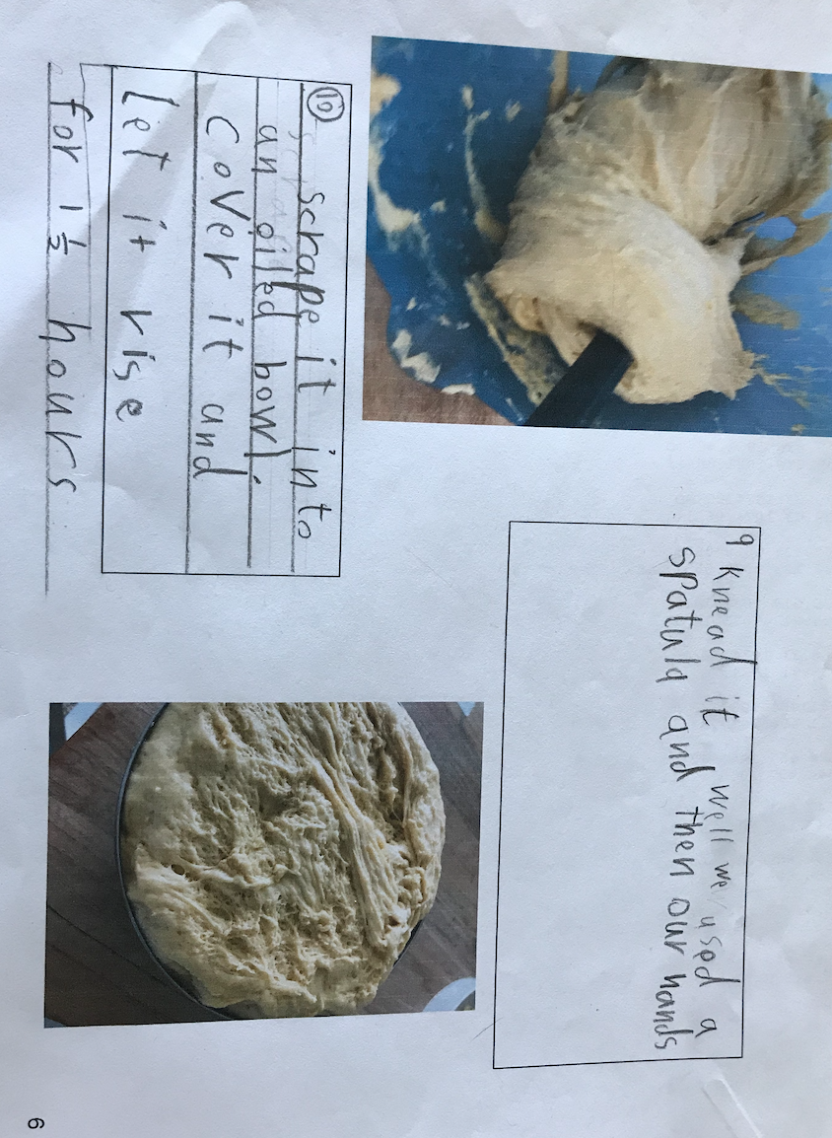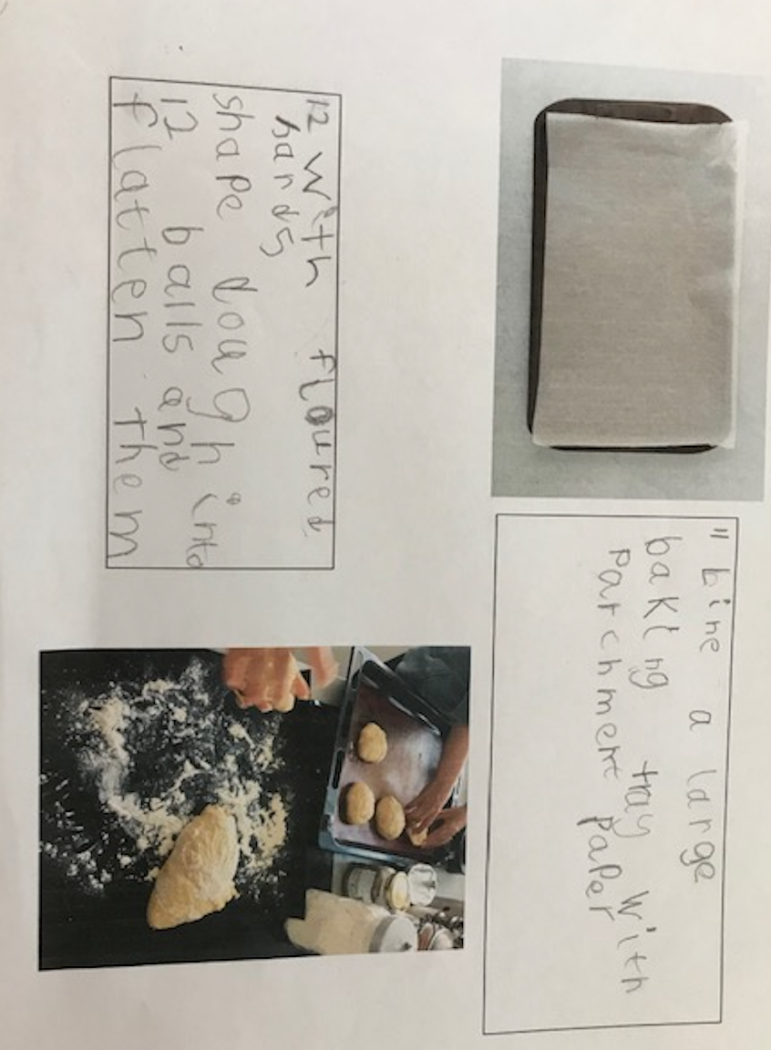

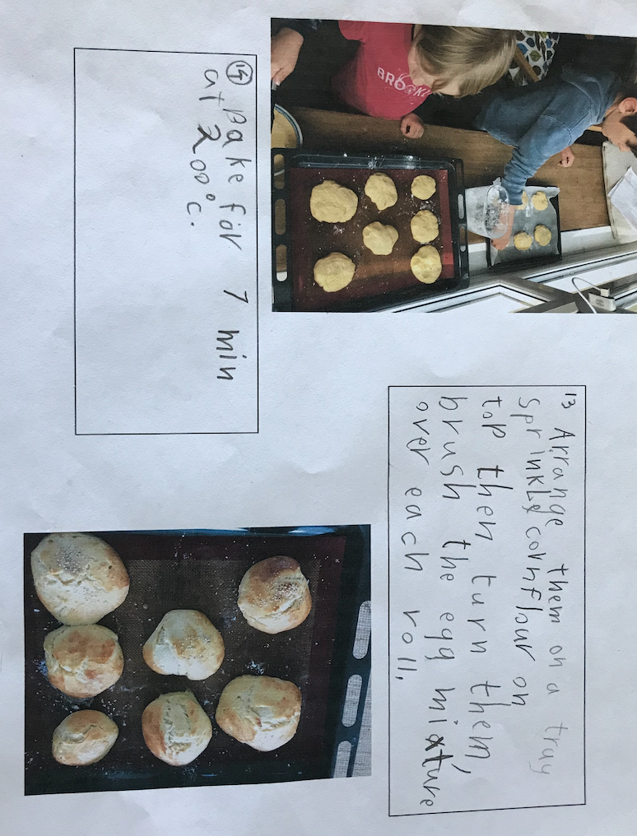

Thanks once again Emil and Friedrich for this wonderful tutorial on how to make ‘Brioche Buns’.
I will be asking you, next week, to build a shelter, on your island and write the instruction just as Emil and Friedrich have here. As you can see, most of the first words in the sentence are verbs – scrape, knead, mix…
You saw how useful the numbers were, especially with the four pictures grouped together, to enable you to follow the instructions.

Good luck baking me old seadogs!

