Green Group 22/06/20

Biology
Invertebrates and Vertebrates
Cut out these animals and correctly classify them by sticking them in the table below.
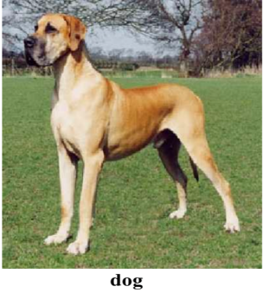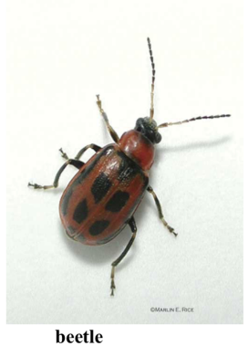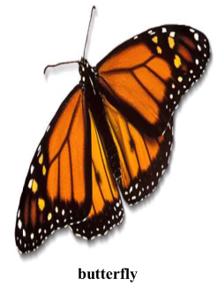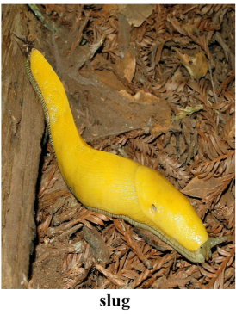
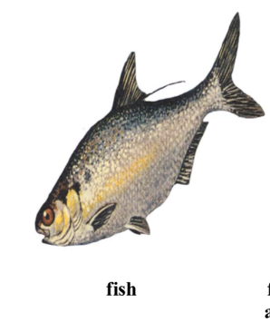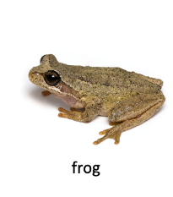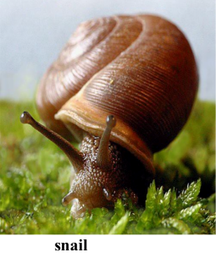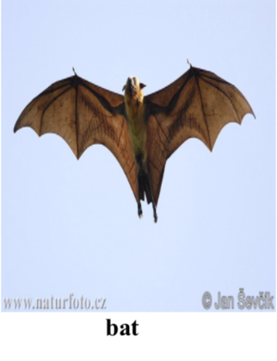

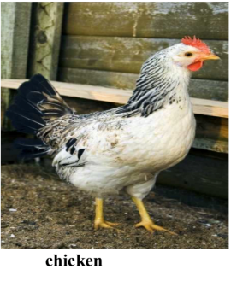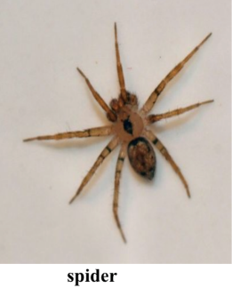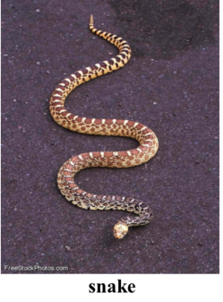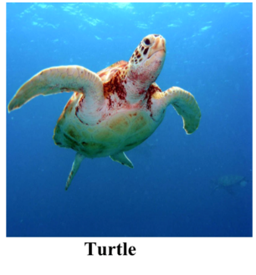

Invertebrates | Vertebrates

Were you correct? Check your answers by looking at the skeletons of the vertebrates (ones with a rod in their back).

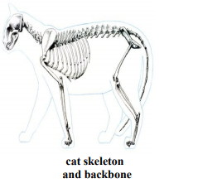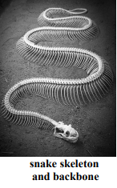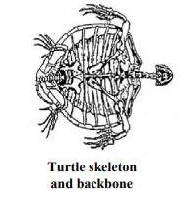

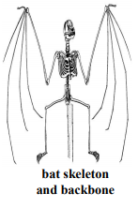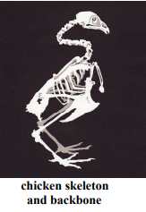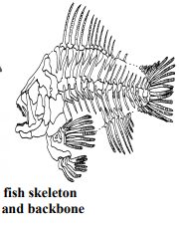

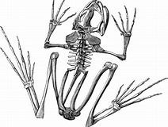
frog

Biology
Invertebrates
Butterflies
This activity can also be found online courtesy of Trillium Montessori, which have many more resources (classified cards) for you to make all kinds of books. I know one lucky boy who has a caterpillar growing kit - where the butterflies are just coming out of their chrysalises.

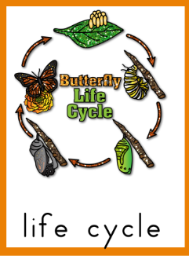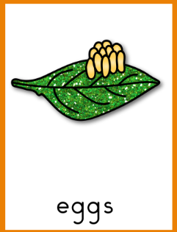
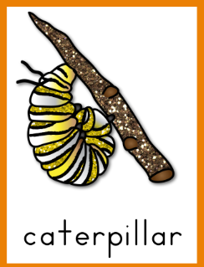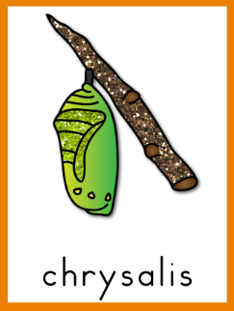
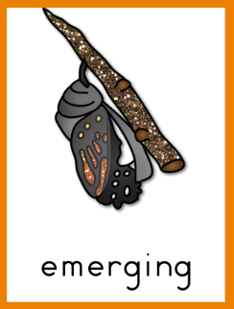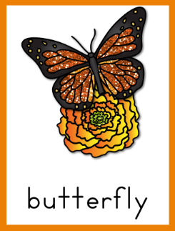

Use the blank sheets below to make your own life cycle book!

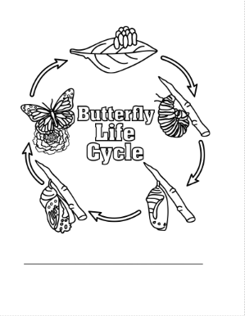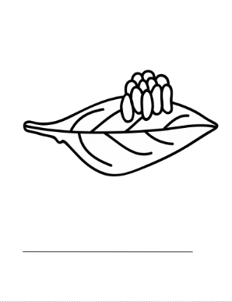

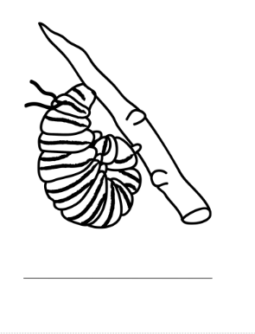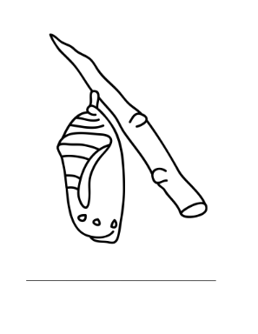
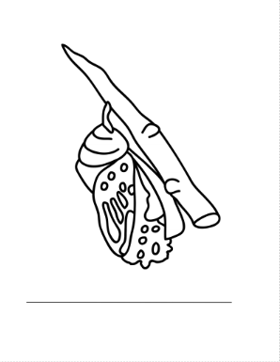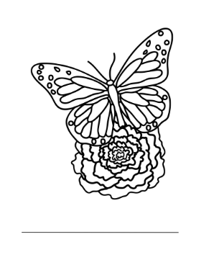

Literature
The Very Hungry Caterpillar

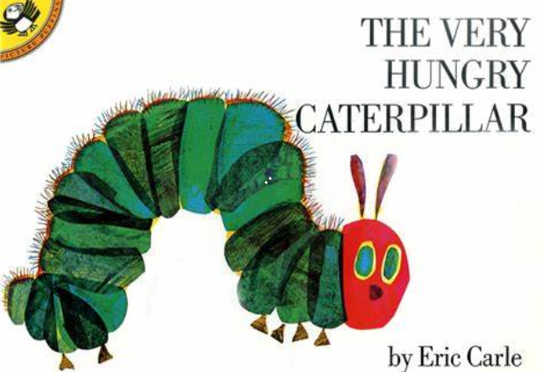

Listen to the story below and fill in the missing words, below.

https://www.bing.com/videos/search?q=the+very+hungry+butterfly&&view=detail&mid=787322209CF80D4323C3787322209CF80D4323C3&&FORM=VRDGAR&ru=%2Fvideos%2Fsearch%3Fq%3Dthe%2Bvery%2Bhungry%2Bbutterfly%26FORM%3DHDRSC4

Literature
The Hungry Caterpillar

Fill in the missing words:
warm ate Tuesday oranges four caterpillar

In the light of the moon a little egg lay on a leaf.
One Sunday morning the ____________ sun came up and – pop! – out of the egg came a tiny and very hungry ________________.
He started to look for some food.
On Monday he ate through one apple. But he was still hungry.
On ____________ he ate through two pears, but he was still hungry.
On Wednesday he _________through three plums, but he was still hungry.
On Thursday he ate through ___________ strawberries, but he was still hungry.
On Friday he ate through five ____________, but he was still hungry.

Art
Caterpillar Colouring
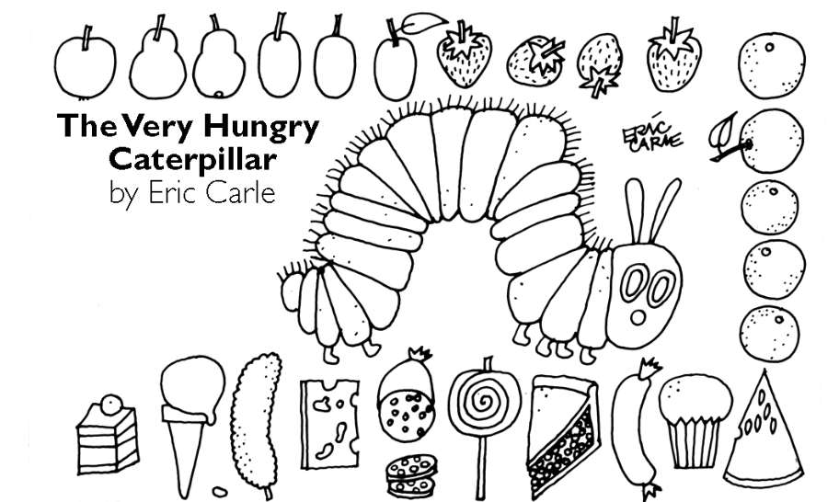
Music

Einaudi: Golden Butterflies

Listen to this wonderful piece of music below:
https://www.youtube.com/watch?v=juna42yknaY

Three instruments play this music. Can you ring which ones you think they are? *

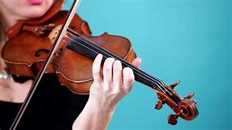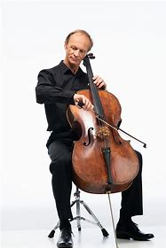

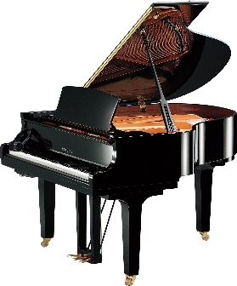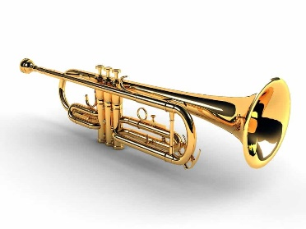

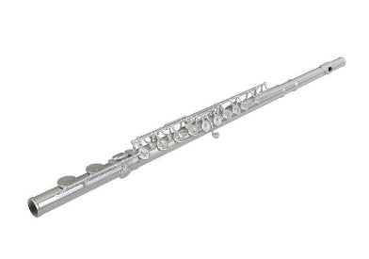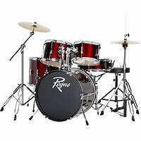
Match the names with the musical instrument and write them underneath:
Drums flute piano trumpet cello violin
*If you guessed piano, violin, and cello, you are correct!
Maths
Number bonds

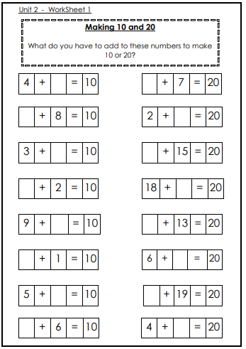
Maths
Doubling

Make the same amount of dots on the other wing of the butterflies then write down how many spots in total they’ll be.
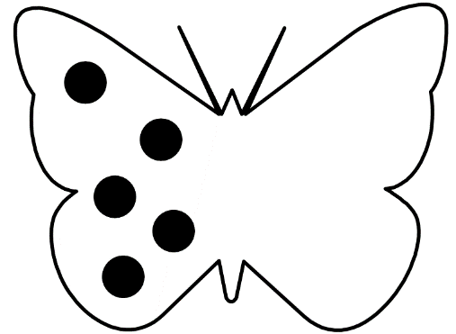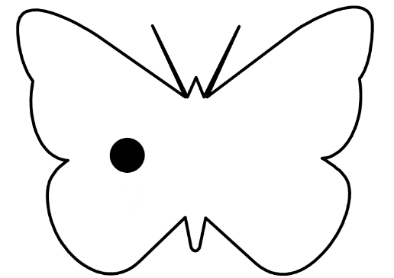
Double 5 = Double 1 =

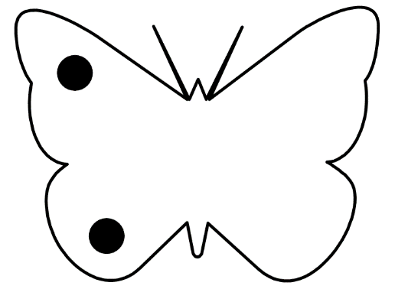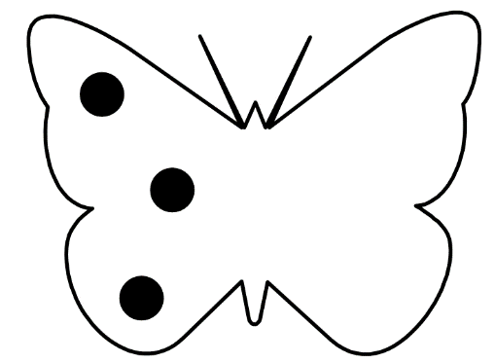
Double 2 = Double 3 =
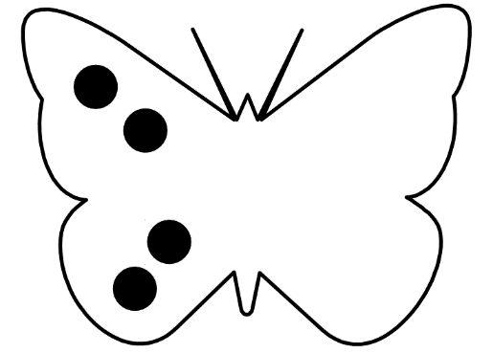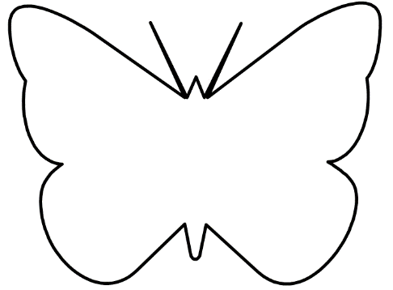
Double 4 = What number are you going to double this time?

