Blue Group 08/06/20

Language
Robinson Crusoe
What do you think?
Questions for Discussion

The following questions are about Robinson Crusoe. But this is not a quiz! They are designed to help you look at the people, places and events in the story from a different angle.
These questions do not have specific answers. Instead, they might make you think of the story in a completely new way.
Please, answer, in detail, 3 or more.

- At the beginning of the book, Robinson claims that he ‘craved grand adventures and far away lands.’ Do you think he still feels this way at the end of the book? What place would you like to visit most?
- Robinson’s parents try everything they can to make him change his mind about being a sailor. Do you think they’re right to do so? Has anyone asked you to change your mind about something? Did it work?
- Robinson quickly finds out that life at sea is not what he expected. Have you ever dreamed about something only to find out that the reality is very different?
- Robinson never seems to stay in one place for long. In Brazil, he sets up a farm and is beginning to settle down, but his desire for excitement and travel gets the best of him. Would you leave the safety of your home to go exploring?
- Robinson says, ‘How glories home is when you’ve been away.’ Do you agree in this statement? What was the longest time you were away from home?
- One of Robinson’s most frightening moments on the island occurs when he finds a footprint. How would you have reacted if you were in his position? What’s the scariest thing that ever happened to you?
- Robinson says that his one special talent is the ability to survive. Do you agree? What’s your special talent?

- What trait do you most admire in Robinson? What trait do you least like about him? Is there one thing that you like or dislike about yourself?

All subject areas
As discussed in the Zoom group, I would like you to undertake a project with a fellow pupil about a subject of your interest. For the moment we’re going to keep it real, therefore no modern fictional interests, please. i.e. Pokémon, Harry Potter et al (Greek Mythology, I’ll accept, at a push).

I will attach the project prompts for you, which you’re familiar with from the classroom. You could enlarge the ones you are interested in doing – this will save on paper:

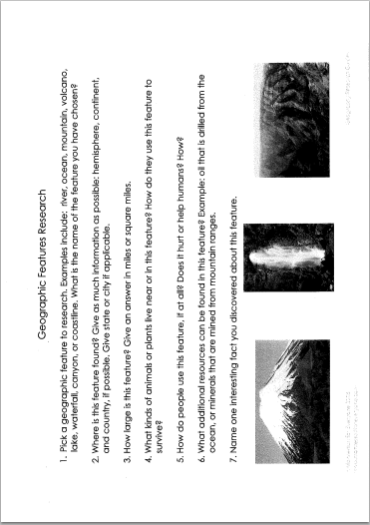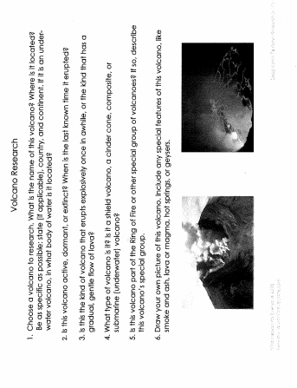
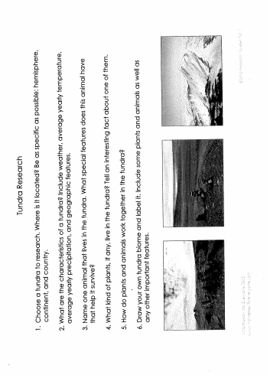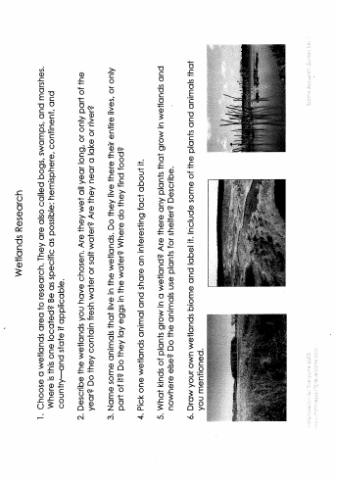
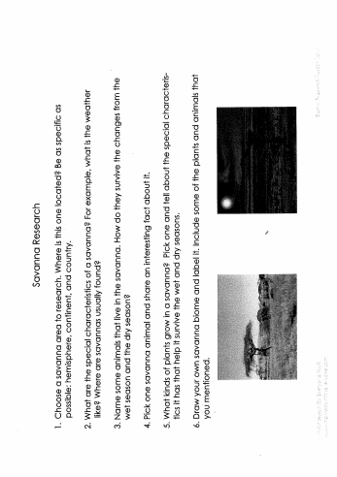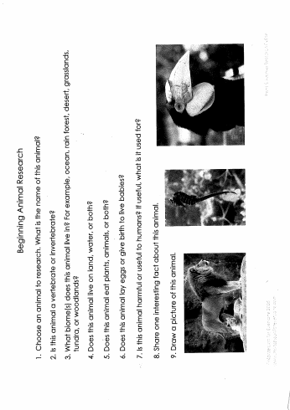

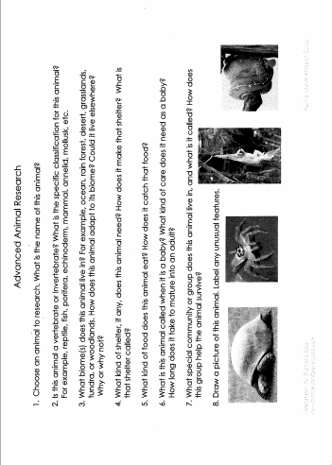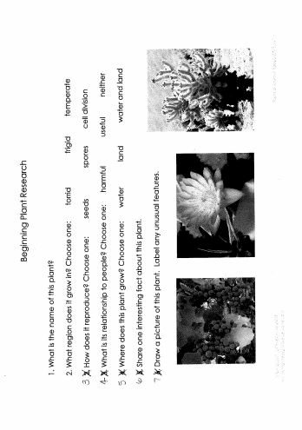

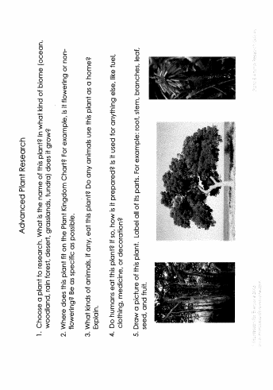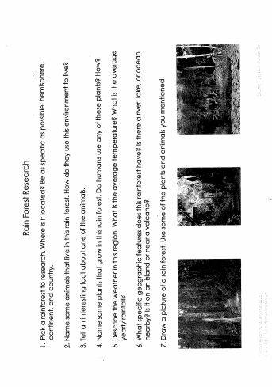

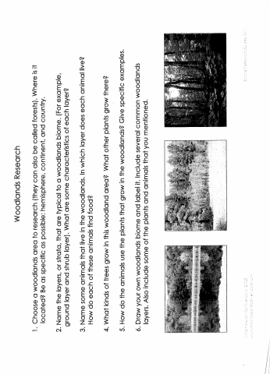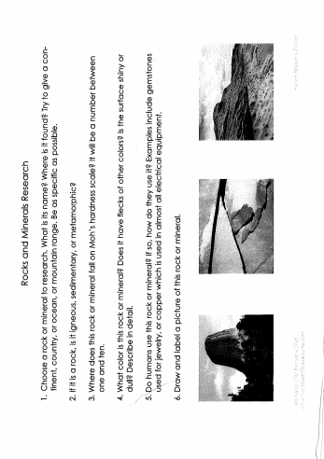

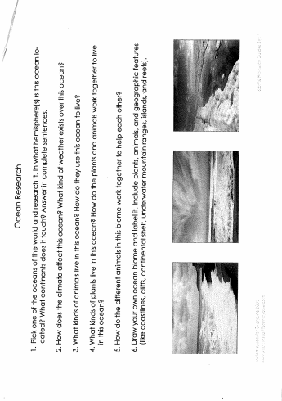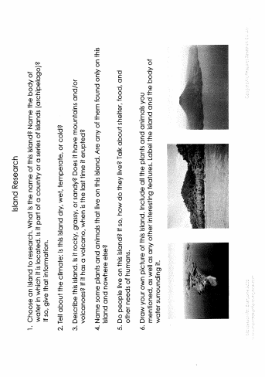
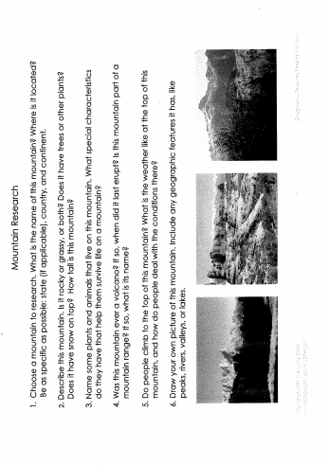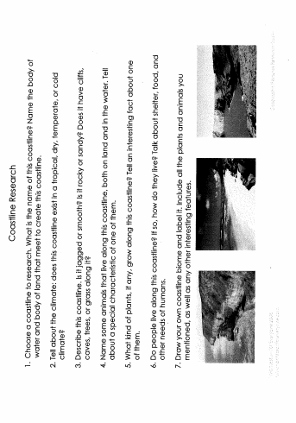

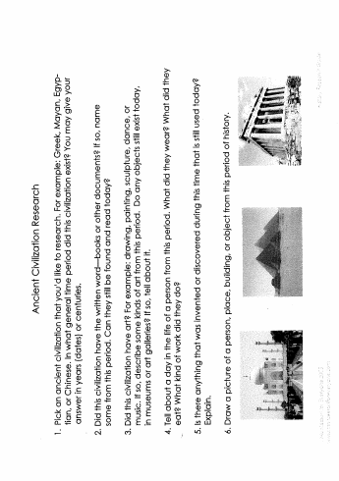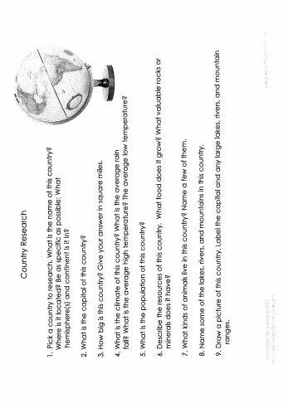

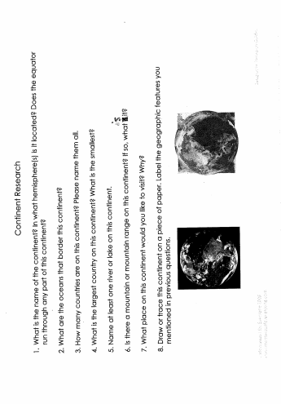

If you have other interests, for instance, space; you can ask me for some question prompts, should you need them.
Don’t forget your interests could also be maths or language. You and a friend could work out all the prime numbers between 100-500 or finding all the names of animals with compound words.
Think about how you are going to display your research. In a book, timeline, poster, video presentation, PowerPoint?
Make sure you are clear with each other, which method of display you choose to do and which questions each of you are going to undertake - there’s little point both answering the same questions.
Best of luck!
Language
Listening/Making/Writing/Drawing

Miniature books by your favourite authors
Why not listen to these ‘small’ stories

https://www.bl.uk/childrens-books/activities/miniature-books-by-your-favourite-authors

Try and make one of your own!

https://www.bl.uk/childrens-books/activities/make-a-miniature-book

Geography
Earth formed according to weight
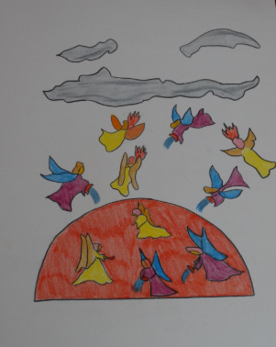
Lava lamp in a wine glass
Can you remember the ‘dance of the elements’ chart, above?
Can you remember the story I told about how the earth came to be? And the experiment with the honey, water and oil?
Here’s an extract from the1st Great Story:
‘The heavier particles went nearer to the heart of the earth and the lighter ones floated above them like oil floating on water.
Can you remember the names of the layers?
Why not re-enact the experiment and add some more fizz!

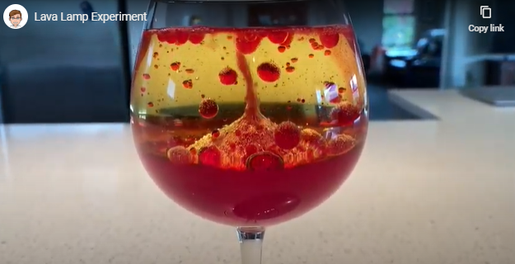

https://www.bing.com/videos/search?q=lava+lamp+in+a+wine+glass&&view=detail&mid=6F0DD88D35D1A0E176516F0DD88D35D1A0E17651&&FORM=VRDGAR&ru=%2Fvideos%2Fsearch%3Fq%3Dlava%2Blamp%2Bin%2Ba%2Bwine%2Bglass%26%26FORM%3DVDVVXX

Maths

Please visit here and try out the work for your age group. Too easy? Go for the class above. Too hard? Go to the class below. Find your level and work happily from there.

https://www.hamilton-trust.org.uk/blog/learning-home-packs/

Physical Exercise

I strongly recommend Joe Wicks. He’s been keeping my family sane for the last 10 weeks!

https://www.youtube.com/watch?v=1MBFhUtyyQM

