Green Group

Botany

Plant a seed

- Moisten the surface of the compost
- Sprinkle the seeds evenly over the compost
- Cover the seed pot (this will help germination)
- Place the seed pot in a warm place
- Uncover the seedlings once they germinate
- It's very important to uncover the seedlings and expose them to light once they germinate.
- Place the seed tray on a window sill where it should get enough light.
- Turn the tray each day so seedlings are evenly illuminated.
- Keep the compost moist with a spray mister.
- During severe frosts, seed trays should be brought indoors or covered with insulation to guard against frost.
- Take photos of their development and send them into us!

Geography
Land and water forms:
A Bay
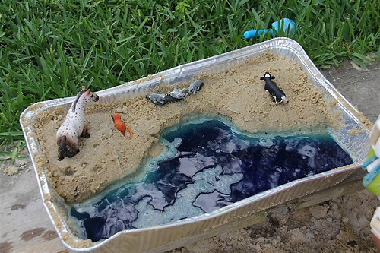

If you have the chance to visit the beach, this is a fun Montessori geography activity that requires very little preparation or expense. And if you can’t go to the beach, a sandbox will work well also.
If you add blue food colouring (and maybe miniature boats) to the water along with miniature plastic animals to the sand, you can have even more fun.

Choose one and send in your picture:
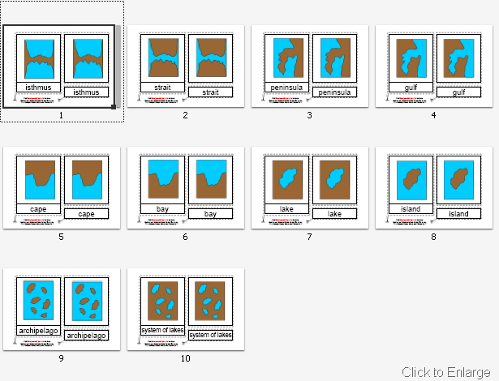

Latitude

The equator is an imaginary line of latitude and runs around the center of the Earth splitting it into Northern and Southern hemispheres.
Make flags for 5 countries that are on the same line of latitude as the U.K
Zoology

The Five Classes of Vertebrates

Cut out the animals and labels, and correctly stick them in the animal class columns provided.
If you have any magazines spare or fancy doing some small drawings, find/draw any vertebrates and add them on.
Pick one of the animals and use the ‘Beginning Animal Research’ sheet, to put a poster/book together. Make sure there are lots of drawings!

Make a loo roll bird feeder
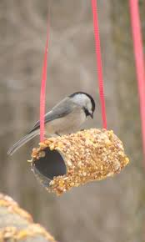
This is messy fun you can enjoy getting stuck into. And it will help you to learn about the birds in your neighbourhood.
You can make this simple feeder with items you probably already have at home:
- Smother a cardboard tube in peanut butter/lard (no added salt and sugar versions are suitable for birds).
- Roll it in bird seed and thread some string through the hole.
- Tie it up in your garden where birds will feel safe eating.

If you are very quiet, you might hopefully spot a number of birds.

Use the bird identification sheet in your pack to see how many visit your street/garden.

Woodland (log book)

Take your woodland log book with you the next time you go off the beaten track, make it as colourful as you can. Can’t wait to see the results!

Mini Beast Hunt

Go and explore in the garden, or in the wood for any mini beasts (invertebrates). Tick the box on the sheet provided. Happy hunting.

Rock Pools

See what you can spot using the ‘Plants and Animals Inhabiting Rock Pools’.

Can you think of an adjective (smooth stone) for each example. Write it on the red and blue lined paper provided. Draw a large black triangle above the noun, small light blue triangle for the article (a, an, the) and a medium dark blue triangle for the adjective.

Maths

Stamp Game

We’ve been doing a lot of addition with the bank game. Here is a video showing how to do it with the stamp game:

ADDITION
https://www.bing.com/videos/search?q=montessoritech&&view=detail&mid=3D514BBAA1607C9C174C3D514BBAA1607C9C174C&&FORM=VRDGAR&ru=%2Fvideos%2Fsearch%3Fq%3Dmontessoritech%26qs%3Dn%26form%3DQBVR%26sp%3D-1%26pq%3Dmontessoritech%2520stamp%2520game%2520addition%26sc%3D0-34%26sk%3D%26cvid%3D8BEE86CFC7324D798860EB0B77E92CA1

SUBTRACTION
https://www.bing.com/videos/search?q=montessoritech&ru=%2fvideos%2fsearch%3fq%3dmontessoritech%26qs%3dn%26form%3dQBVR%26sp%3d-1%26pq%3dmontessoritech%2520stamp%2520game%2520addition%26sc%3d0-34%26sk%3d%26cvid%3d8BEE86CFC7324D798860EB0B77E92CA1&view=detail&mid=65B06F2472521B59EECF65B06F2472521B59EECF&rvsmid=3D514BBAA1607C9C174C3D514BBAA1607C9C174C&FORM=VDQVAP

Use this virtual stamp game to complete the addition/subtraction problems in your pack.

https://montessori.tools/?fbclid=IwAR2YrrfGQoqCUTDyFJU1A_h_lqcYSNer5QMmMiL2ZmbEnRKpoKzXRXooBzo

Once you’ve completed them, feel free to write your own on the blank hierarchical sheets in the pack – make sure your thousands don’t exceed 9 as there are no ten thousands to use!

Fraction

Cut out the fractions, muddle them up and put them together again, making wholes. Keep them safe, as we will be using them again in the coming weeks! Enjoy.

Multiplications

Customise your times table test on Purple mash.

- Pick a times table you’d like to master
- Take 10 minutes trying to memorize them
- Set the parameters on Purple Mash/multiplication/custom

Geometry
Decorate the net (flat 3D shape) before cutting it out and sticking it together. Cut around the flaps, as these will help you to stick it together.

Language
Logical Analysis
Cut out the Logical Analysis arrows and circles.
Write one of the suggested sentences on a slip of paper.

- Henry folded the mat.
- John carried the ball.
- The kitten chased the mouse.

Put the red circle (predicate/verb) in the middle and ask yourself:
‘What word tells me what to do?’
Cut them out and place them on the circle.
Then use the arrows to ask:
‘Who is it that (did the predicate? - the subject.
‘Whom? What? – direct object

Now, write your own sentences with a subject, predicate and direct object.
Do the same again, finding the subject and the predicate. With the bits that you have left, try and work out (by reading the orange arrows) ‘What question they are the answer to’.

- Alice went timidly up to the door
- The White Rabbit was by the fence

- Little Emily gazed longingly.

- The man drank from the basin.

- Alan retreated fearfully.

- Winnie the Pooh woke up suddenly in the middle of the night.

Now, write your own.
Mnemonic Elephants
It can be quite difficult to learn spellings. Sometimes people use tricks to help them remember how to spell certain words.
One trick is to make up a little rhyme using the letters of the word that you are trying to learn.
For example: BECAUSE
Big Elephants Can Always Understand Small Elephants.
If you can remember the rhyme, then you’ll always know how to spell because!
Think of some words that you find hard to spell. Try and see if you can make up a rhyme to help you remember the spelling.
It doesn’t matter how silly your rhyme is, as long as you remember it!
Write your rhyme down and send a picture in for others to use.
Recipe
Write down, in your best handwriting, a recipe that you enjoy making and would like to share with your friends.

Art

Equipment
- 4x sugar paper
- Pencil
- Paints

1st page: Using the paints mix the primary colours (Red, Blue and Yellow) together to see what happens. Think about combinations that you already know, and experiment with ones that you don’t.
2nd page: Look at the environment around you, take the colours from around you and try to replicate them. Think about the colour mixing that you have just done and how it will help you to create the colours in your environment.
3rd and 4th pages: Try to use the colours that you have made to paint the world that you see around you, you may wish to sketch out the shapes of the objects first.

Work Journals
Just think about how important it would be if a child found your journal in one hundred years’ time!
Continue to write, all the wonderful things you do, in it. Tells us about your emotions too, what/who you miss.
Maybe, do a good deed for the day and write about what you did.
Use your journal to then fill in the graph:
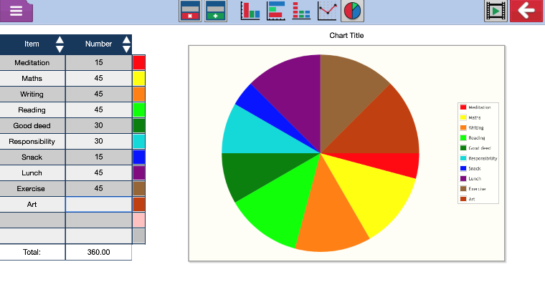
Then use it to input your data into Purple mash (2Graph)
https://www.purplemash.com/#app/tools/2graph

