Red Group

I hope you’ve been enjoying listening to Robinson Crusoe!
We are going to put ourselves in the shoes of our dear friend, Robinson, where You have arrived at an island (you will create and design the island yourself). We don’t know how you have arrived or where you have come from – that is up to you – but during the coming weeks you are going to complete activities that will be based around your island.

Task 1:

Create your island and give it a name. You can design your island in any way you would like but take your time over it. It should take weeks to embellish rather than minutes! Give it some thought first. Make it with salt dough, perhaps? Make your island as colourful as you can. You can include such things as forests and rivers, paths and roads, mountains and swamps. Try and make it as realistic as you can. If you are thinking of adding animals, make sure you adapt the biome accordingly. A polar bear on a tropical island! Really? Perhaps, stranger things have happed at sea.

Doing this exercise might help:

Biology/Zoology/Geography

Biomes:

Tundra

It is crazy cold in the Arctic tundra. It’s so cold that the ground is frozen most of the year, and a deep layer of soil below the surface—called the permafrost—never melts at all. However, for two months during the summer, the temperature rises above freezing. The snow and surface soil melt, creating big pools of water and bogs.
During this brief summer season, plants have a chance to grow. But due to the harsh conditions and high winds, tundra plants grow very low to the ground. In fact, the tundra is a treeless landscape.
Historically, the tundra covered about 15 percent of the Earth’s land surface. However, scientists estimate that the tundra has shrunk by almost 20 percent over the last 20 years due to climate change. In the southern part of the tundra, parts of the permafrost have melted. Trees now dot the landscape, and animals from warmer climates are moving in.
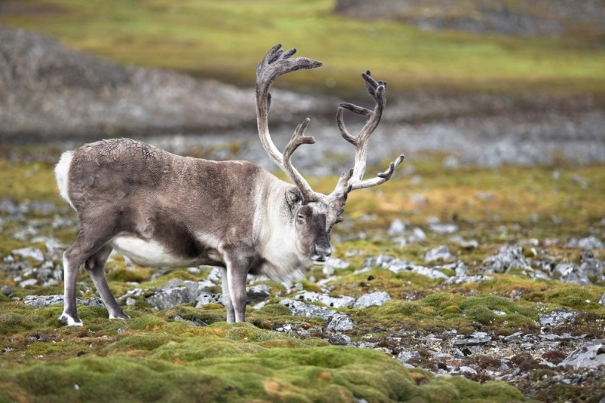
The tundra is a rocky landscape. Lichen—a combination of fungi and algae—grow on the rocks. Lichens are a favorite food of reindeer that migrate across the tundra in vast herds. During winter, these lichens are one of the only foods available and reindeer will dig through snow to find them.

- What is permafrost?
- What doesn’t much grow here?
- What are lichens?
- How much of the world did the Tundra once occupy?

Taiga

The taiga is the world’s biggest biome. It covers nearly one-fifth of the Earth’s land surface and stretches across northern Canada and northern Eurasia in an almost unbroken belt for 7,000 miles. The main features of the taiga are its evergreen forests of needle-leafed trees, including pine, spruce, hemlock, and fir. Although this biome is not as harsh as the tundra, all its plants and animals have evolved to survive the taiga’s long, snowy winters.
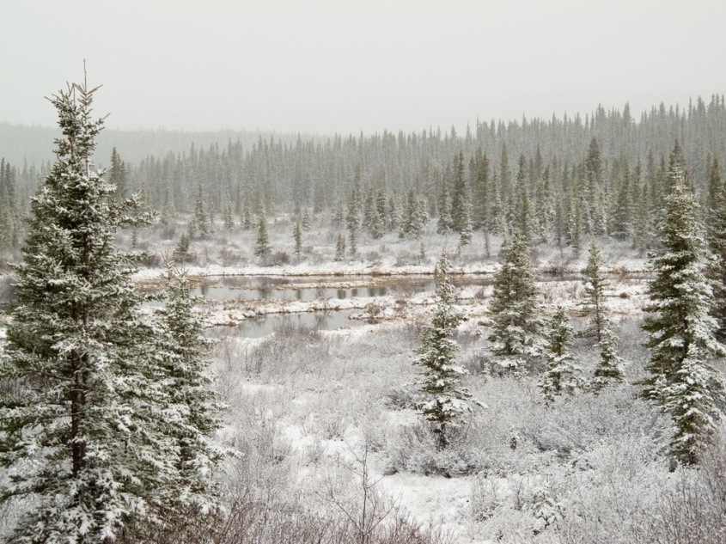
Taiga trees have many adaptations for surviving harsh winters, a short growing season, and nutrient-poor soil. Their conical shapes allow snow to slip off easily, without weighing down and breaking branches. Their needle-shaped leaves have waxy, protective coatings to lock in moisture. Plus, the needles don’t all fall off in autumn. Keeping the leaves through the winter means taiga trees don’t need to use energy to grow an entire set of new leaves each spring and they
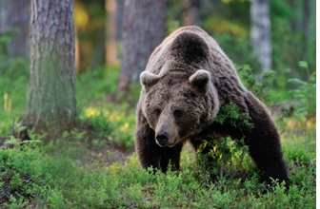
Brown bears are top predators of the taiga, hunting everything from deer to fish. They also like berries, nuts, roots, and other vegetation. During the summer, they eat massive amounts of food, sometimes as much as 40 pounds per day. Their bodies convert much of this extra food and store it as fat. In autumn, brown bears dig dens and begin long winter hibernations, during which they live off the stored fat.
The vast forests of the taiga are being shrunk by massive logging operations. The wood is used to make paper and build houses. When trees are clear cut, the forest habitat is destroyed. Reducing the size of the world’s forests also contributes to global warming. Forests are called “carbon sinks” because they absorb carbon dioxide and help keep the world’s carbon cycle in balance. When too much carbon gas is released into the atmosphere, the climate tends to warm—and that can have serious consequences for humans and ecosystems.
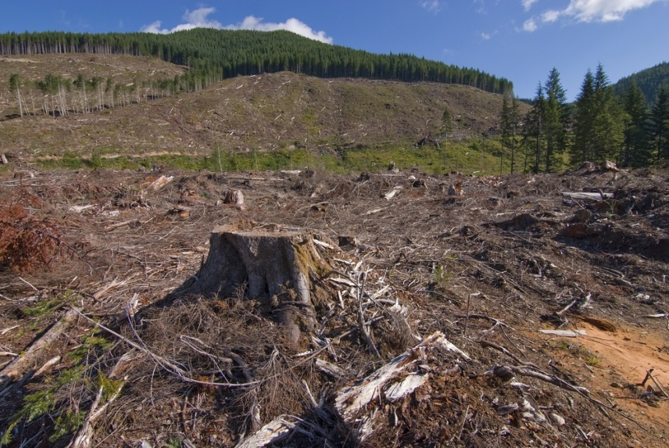

- How far does the Taiga stretch?
- What 4 types of trees grow there?
- What is the top predator in this biome and what do they eat?
- Which biome is colder than the Taiga?
- Why is this region in danger?

Temperate Deciduous Forest
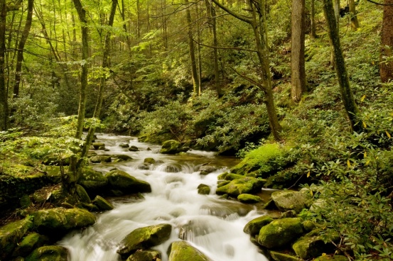
This biome is defined by its four distinct seasons and its forests of trees that drop their leaves in autumn. (The word “deciduous” [dih-SID-yoo-uhss] comes from a Latin word meaning “to fall.”) Located in the eastern United States, all over Europe, Japan, and parts of Russia and China, temperate deciduous forests are home to deer, wolves, hawks and owls, songbirds, and many other species.
Temperate deciduous forests change dramatically with the seasons. Deciduous forests have at least three layers. The tallest trees make up the canopy. Saplings and shrubs are found in the understory. Ferns, moss, and wildflowers grow on the forest floor.
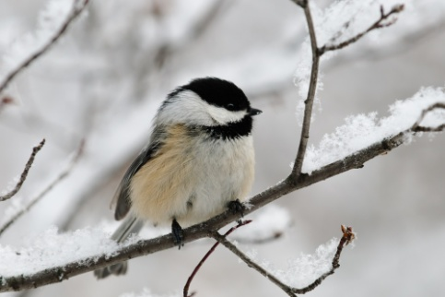
Although many birds of the temperate deciduous forest head south for the winter, black-capped chickadees stick around. How do they do it? They hide thousands of seeds under tree bark during the autumn and eat them throughout the winter.

- What does deciduous mean?
- What does there need to be for deciduous trees to exist?
- Name the 3 kinds of layers in a deciduous forest
- How are the black-capped chickadees able to survive the harsh winter months?
Desert

The desert is the driest biome. Some deserts, such as the Sahara, get less than 3cm of rainfall in an entire year. The flora and fauna that survive there have to be tough. Desert plants have evolved strategies to save water.
Desert animals also have to deal with high temperatures and minimal water supplies. Typically, they are nocturnal, hiding out in burrows during the day to beat the heat. Some animals, such as the desert tortoise, go into “estivation” in their burrows during the hottest part of the year. Estivation is the desert version of hibernation—the animal’s pulse and breathing slow down dramatically—so that they don’t need to use much water or energy.
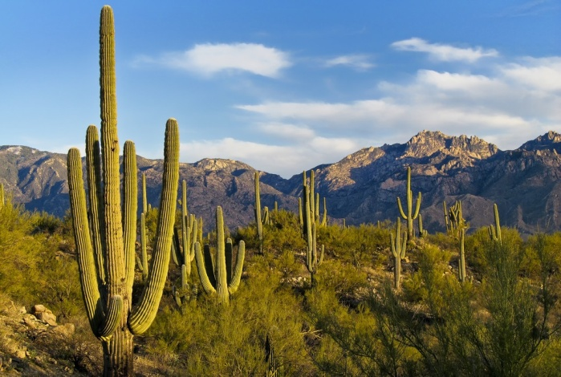
The saguaro [suh-WAHR-oh] cactus grows in the deserts of the south-western United States. When it rains, the trunk of the saguaro can expand to hold water. Sharp spines defend it from animals who might try to break open the saguaro and take a drink.
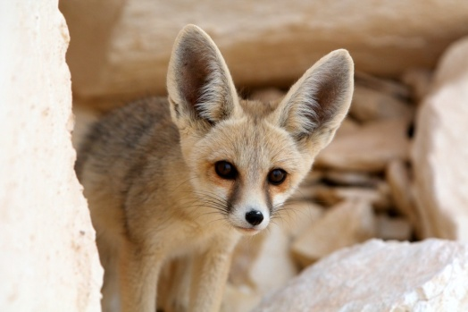
The smallest fox in the world, the fennec fox lives in Africa’s Sahara desert. Its most obvious adaptation to desert life is its oversized ears. With blood vessels very close to the skin surface, the big ears help the fox radiate body heat and keep cool. What is unseen is the fox’s ability to conserve water—it rarely needs to take a drink.

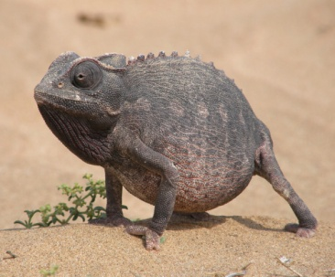
Chameleons are famous for their ability to change color and blend in with their surroundings. The Namaqua chameleon of southwestern Africa is no exception. However, unlike other chameleons that live in trees, this desert-dwelling species digs burrows in the sand to make its home. The Namaqua chameleon uses its long, sticky tongue to nab insects and scorpions.

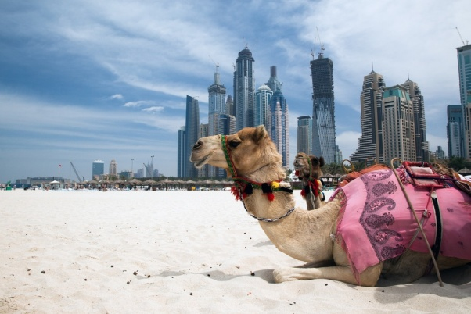
Desert-adapted dromedaries (one-humped camels) were domesticated thousands of years ago. People ride them, drink their milk, and even race them. Camels can travel for 100 miles across the desert without water, and they can easily handle temperatures of 110 degrees Fahrenheit. This one is hanging out on a beach next to Dubai, waiting to take tourists for a ride.

- Roughly, how much rain falls in the Sahara each year?
- Typically, how do animals survive in the heat of the desert?
- Where does the Namaqua chameleon make its home?
- What is a one humped camel called?

Rainforests
Located in a belt around the equator, rain forests are a riot of life, with plants growing non-stop year-round. The hot, wet climate supports a jungle of plants and wildlife, from the towering trees that make up the canopy down to the dark forest floor where sunlight barely penetrates due to the thickness of the foliage above. Rain forests get drenched by as much as 540 cm of rain annually.
The rain forest has more species than any other biome. Trees in the rain forest grow as high as 200 feet, and each tree may be home to hundreds of species, from vines and bromeliads, to butterflies, monkeys, birds, and frogs.
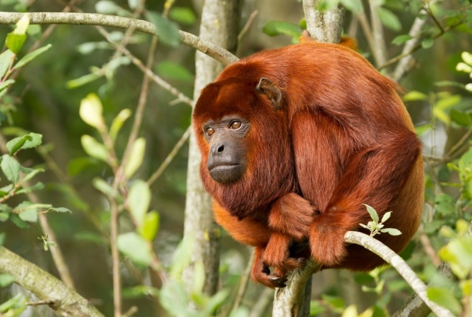
Rain forests once covered about 14 percent of the Earth’s land surface, but now account for only about 6 percent. Rain forest habitats continue to be cut down for their wood products and to create land for farming. Every year about 9,000 square miles of rain forest is cut down—that’s an area about the size of New Jersey.
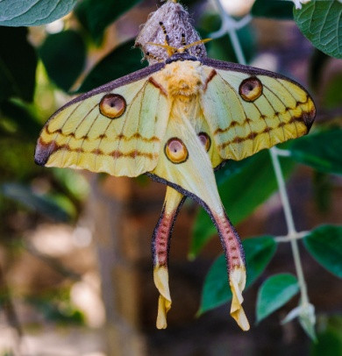
Howler monkeys live almost entirely in the rain forest canopy. Leaves are the main part of their diet, so they have everything they need high in the sky. Since it’s hard to see through the greenery in the canopy, animals that live there make a lot of noise to communicate. In fact, howler monkeys are thought to be the loudest animals on land. Their bloodcurdling roars can be heard for three miles.
Plants grow everywhere in the rainforest—even on other plants. This tree trunk in Panama’s rain forest is home to several bromeliads. The mop-top leaves of each bromeliad form a bowl-shape that catches rainwater—and these tiny ponds in the sky are home to insects and even frogs.
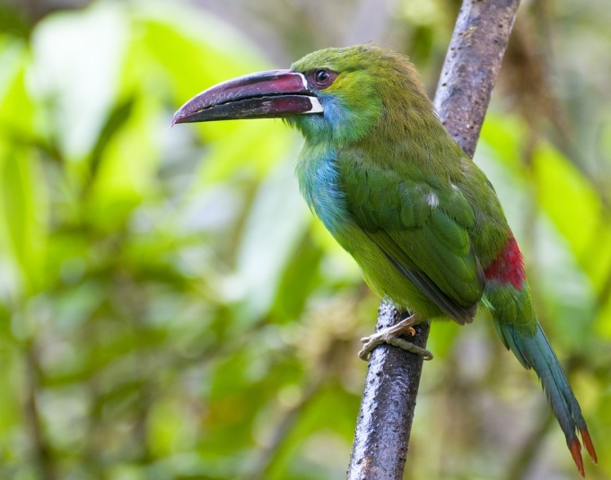
Madagascar’s rain forests are filled with astonishing animals, from lemurs and aye-ayes to flying foxes and fossas. This Comet Moth, also called the Madagascan Moon Moth, is one of the largest moths in the world, with a wingspan of eight inches and a six-inch-long tail. It evolved its showy appearance to attract mates. The eyespots mimic the red eyes of lemurs—and are there to confuse predators.
About 40 species of toucans live in rain forests in Central and South America. These big-billed birds nest in tree hollows and eat mostly forest fruits. The crimson-rumped toucanet—pictured here—lives in the mountain rain forests of Ecuador.

- How much does it rain annually in this biome?
- What doesn’t usually reach the forest floor?
- What has the rainforest got more of than any other biome?
- Name, or draw the different species, mentioned above.
Tropical Savanna

Tropical savannas are vast grasslands dotted with trees that spread across Africa, northern Australia, and parts of South America and India. With wide open spaces and so much grass to graze on, savannas are home to large herds of plant-eating animals (herbivores). They are also usually home to large predators that stalk the herds. In the African savanna, the plant-eaters include zebras, antelopes, wildebeest, giraffes, elephants, and rhinos. Predators include lions, leopards, cheetahs, and hyenas. In the Australian savanna, kangaroos are the primary plant-eaters.
Many of Africa’s savanna herbivores have long, powerful legs to help them travel long distances and run away from predators. Some, like the ostrich and giraffe, have VERY long legs—and they can even use them to kick predators. In the Australian savanna, kangaroos have a slightly different strategy for getting around: They don’t run, but hop—as far as 30 feet in a single leap and can speed-hop at 35 mph.
The weather in the savanna is warm year-round, and there are basically two seasons—wet and dry. To survive the dry season, many savanna animals must migrate in search of water.
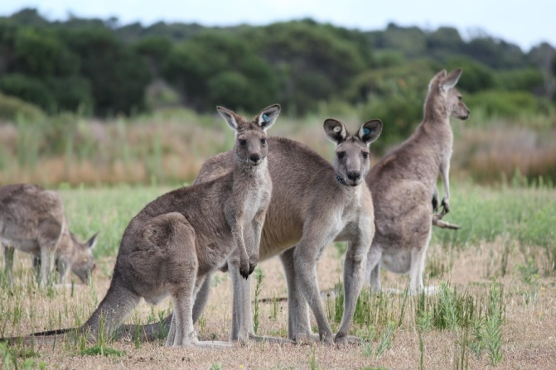
These eastern gray kangaroos are just one of over 40 species of kangaroo-like animals, living in Australia’s savannas—better known as “the bush.” Want to know something strange? While kangaroos still have the hair-trigger ability to leap out of danger and escape the sharp teeth of carnivores, most of the kangaroos’ predators have gone extinct.
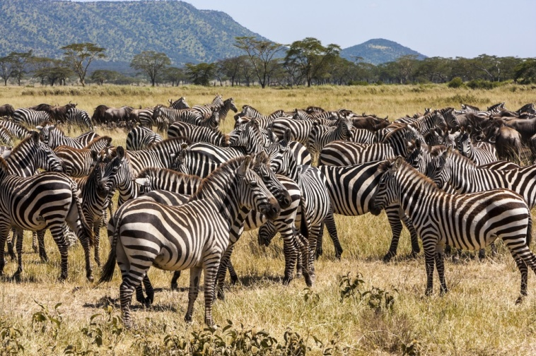
Every year, 300,000 zebra and 1 million wildebeest in Africa’s Serengeti Plain embark on an extended migration. To find water and green grass, they must cross the Mara River. But the crossing is dangerous, with some animals swept away by strong currents and a few attacked by crocodiles.
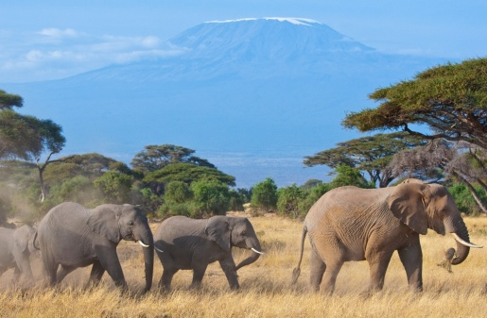
These African elephants are on the move in the savanna beneath Africa’s Mount Kilimanjaro. During the rainy season, elephants get about 50 percent of their diet from grasses. In the dry season, they rely more on trees and shrubs for food.

- Name 4 herbivores that graze on the savanna plants.
- How do the herbivore’s powerful legs help them in this environment?
- What predators do they need to be wary of?
- Do your best to draw one of these magnificent creatures.
- How many seasons are there considered to be in the Savanna?

Visit NASA and try and match the graphs to the correct biomes:
https://earthobservatory.nasa.gov/experiments/biome/graphindex.php

Try and help Shakespeare plant plants in the correct biomes:
https://earthobservatory.nasa.gov/experiments/biome/plantindex.php

Language

Comprehension

The Story of Robinson Crusoe
by Daniel Defoe, first published in 1719

If you haven’t been listening… Robinson Crusoe has been shipwrecked on an uninhabited island off the coast of America. ‘near the Mouth of the Great River of Oroonoque; Having been cast on shore by shipwreck, wherein all the men perished but himself’. He has managed to salvage many things from the ship before it finally sunk, including ‘bread, rice, three Dutch cheeses, five pieces of dried goat’s flesh (which we lived much upon), and a little remainder of European corn’, several cases of liquor, some clothes, some tools, guns, ammunition and swords. He has set up a tent and started to work his way into the rock to build a cave.

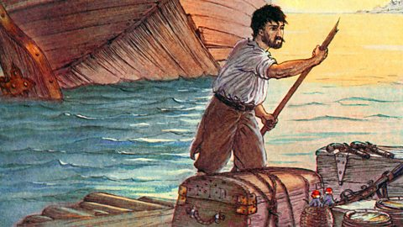
After I had been there about ten or twelve days, it came into my thoughts that I should lose my reckoning of time for lack of books, and pen and ink, and should even forget the Sabbath* days; but to prevent this, I cut with my knife upon a large post, in capital letters—and making it into a great cross, I set it up on the shore where I first landed—“I came on shore here on the 30th September 1659.”

Upon the sides of this square post I cut every day a notch with my knife, and every seventh notch was as long again as the rest, and every first day of the month as long again as that long one; and thus I kept my calendar, or weekly, monthly, and yearly reckoning of time.
In the next place, we are to observe that among the many things which I brought out of the ship, in the several voyages which, as above mentioned, I made to it, I got several things of less value, but not at all less useful to me, which I omitted setting down before; as, in particular, pens, ink, and paper, several parcels in the captain’s, mate’s, gunner’s and carpenter’s keeping; three or four compasses, some mathematical instruments, dials, perspectives, charts, and books of navigation, all which I huddled together, whether I might want them or no.
I found three very good Bibles, which came to me in my cargo from England, and which I had packed up among my things; some Portuguese books also; and among them two or three prayer-books, and several other books, all which I carefully secured.
And I must not forget that we had in the ship a dog and two cats, of whose history I may have occasion to say something in its place; for I carried both the cats with me; and as for the dog, he jumped out of the ship of himself, and swam on shore to me the day after I went on shore with my first cargo, and was a trusty servant to me many years; I wanted nothing that he could fetch me, nor any company that he could make up to me; I only wanted to have him talk to me, but that would not do.
And this put me in mind that I wanted many things notwithstanding all that I had amassed together; and of these, ink was one; as also a spade, pickaxe, and shovel, to dig or remove the earth; needles, pins, and thread; as for linen, I soon learned to make do without much difficulty.
This lack of tools made every work I did go on heavily; and it was near a whole year before I had entirely finished my little pale**, or surrounded my habitation. The piles, or stakes, which were as heavy as I could well lift, were a long time in cutting and preparing in the woods, and more, by far, in bringing home; so that I spent sometimes two days in cutting and bringing home one of those posts, and a third day in driving it into the ground; for which purpose I got a heavy piece of wood at first, but at last bethought myself of one of the iron crows; which, however, though I found it, made driving those posts or piles very laborious and tedious work.
But what need I have been concerned at the tediousness of anything I had to do, seeing I had time enough to do it in? Nor had I any other employment other than ranging the island to seek for food, which I did, more or less, every day.
I now began to consider seriously my condition, and the circumstances I was reduced to; and I drew up the state of my affairs in writing, not so much to leave them to any that were to come after me—for I was likely to have but few heirs—as to deliver my thoughts from daily poring over them, and afflicting my mind; and as my reason began now to master my downcast mood, I began to comfort myself as well as I could, and to set the good against the evil, and I stated very impartially, like debtor and creditor, the comforts I enjoyed against the miseries I suffered, thus:—

Evil. | Good.
I am cast upon a horrible, desolate island, void of all hope of recovery. | But I am alive; and not drowned, as all my ship’s company were.
I am singled out and separated, as it were, from all the world, to be miserable. | But I am singled out, too, from all the ship’s crew, to be spared from death; and He that miraculously saved me from death can deliver me from this condition.
I am divided from mankind—a solitaire; one banished from human society. | But I am not starved, and perishing on a barren place, affording no sustenance.
I have no clothes to cover me. | But I am in a hot climate, where, if I had clothes, I could hardly wear them.
I am without any defence, or means to resist any violence of man or beast. | But I am cast on an island where I see no wild beasts to hurt me, as I saw on the coast of Africa; and what if I had been shipwrecked there?
I have no soul to speak to or relieve me. | But God wonderfully sent the ship in near enough to the shore, that I have got out as many necessary things as will either supply my wants or enable me to supply myself, even as long as I live.

Upon the whole, here was an undoubted testimony that there was scarce any condition in the world so miserable but there was something negative or something positive to be thankful for in it; and let this stand as a direction from the experience of the most miserable of all conditions in this world: that we may always find in it something to comfort ourselves from, and to set, in the description of good and evil, on the credit side of the account.
Having now brought my mind a little to relish my condition, and given over looking out to sea, to see if I could spy a ship—I say, giving over these things, I began to apply myself to arrange my way of living, and to make things as easy to me as I could.
I have already described my habitation, which was a tent under the side of a rock, surrounded with a strong pale of posts and cables: but I might now rather call it a wall, for I raised a kind of wall up against it of turfs, about two feet thick on the outside; and after some time (I think it was a year and a half) I raised rafters from it, leaning to the rock, and thatched or covered it with boughs of trees, and such things as I could get, to keep out the rain; which I found at some times of the year very violent.
I have already observed how I brought all my goods into this pale, and into the cave which I had made behind me. But I must observe, too, that at first this was a confused heap of goods, which, as they lay in no order, so they took up all my place; I had no room to turn myself: so I set myself to enlarge my cave, and work farther into the earth; for it was a loose sandy rock, which yielded easily to the labour I bestowed on it: and so when I found I was pretty safe as to beasts of prey, I worked sideways, to the right hand, into the rock; and then, turning to the right again, worked quite out, and made me a door to come out on the outside of my pale or fortification. This gave me not only entrance and exit, as it was a back way to my tent and to my storehouse, but gave me room to store my goods.
Adapted slightly from ‘Robinson Crusoe’ chapter 4

Please answer the questions below:

- List five useful items from the passage that Robinson Crusoe managed to also save from the boat. 1._____________________________
2._____________________________
3._____________________________
4._____________________________
5._____________________________
- How did he make and use his calendar? ______________________________________________________________________________________________________________________________________________________________________________________________________________________________________________________________________________________________________________________________________________________________________________________________________________________________________________________________________________________
- Why did it take him nearly a year to build his cave? ______________________________________________________________________________________________________________________________________________________________________________________________________________________________________________________________________________________________________________________________________________________________________________________________________________________________________________________________________________________

- Write a summary in your own words of the advantages and disadvantages of him being stranded on the island.
__________________________________________________________________________________________________________________________________________________________________________________________________________________________________________________________________________________________________________________________________________________________________________________________________________________________________________________________________________________________________________________________________________________________________________________________________________________________________________________________________________________

Art and design

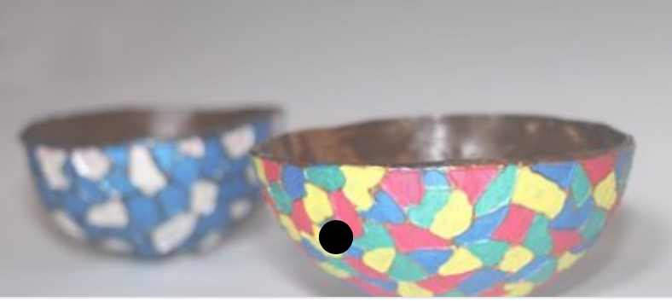

Making coconut bowls

*Please be extremely careful when using any sharp tools. Always make sure you have adult supervision.

You will need:

- Coconuts (you can buy these in most supermarkets or greengrocers)
- Hammer
- Sandpaper
- Screwdriver
- Knife
- Spoon
- Sealer or decoupage glue.

STEP BY STEP

- Use a screwdriver and a hammer on the bottom of the coconut. Hit the screwdriver several times with the hammer until you feel and hear a hollow sound. Make 3 holes in each.

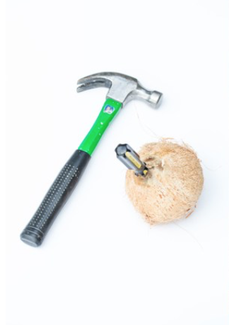

- Shake the coconut over a bowl to get all of the water out. Strain the water so you can drink it! Yum!

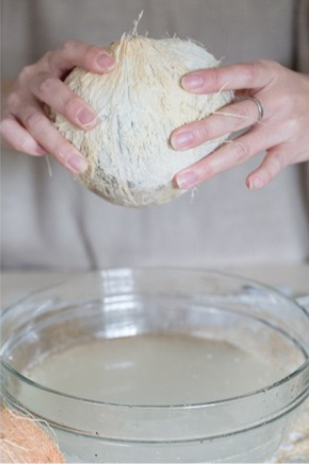

- Using a hammer, pound in the centre of the coconut, all the way around. This will create a line and eventually the coconut will break! You will have to go around a few times for the coconut to break.

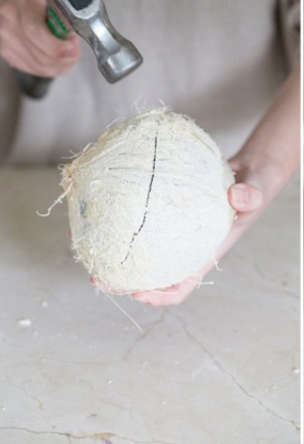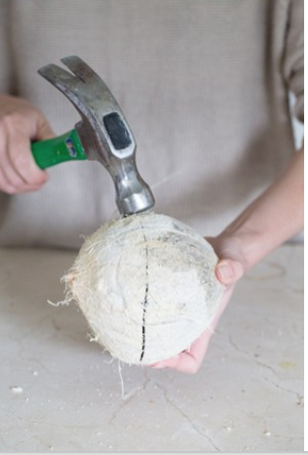

- When the coconut breaks in half, you can scrape some of the flesh out. After removing some of the flesh out, you can microwave the coconuts to soften the rest. Then using a spoon and knife lift the remaining flesh out in larger chunks. It does take some time, but it’s worth it!
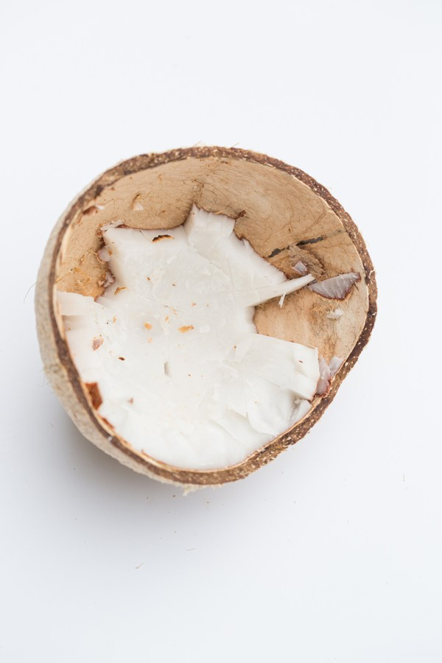

- Using very course sandpaper, sand the inside and all of the outside until completely smooth

- Seal the coconuts with decoupage; or food safe sealer if you’re going to use them to serve food.
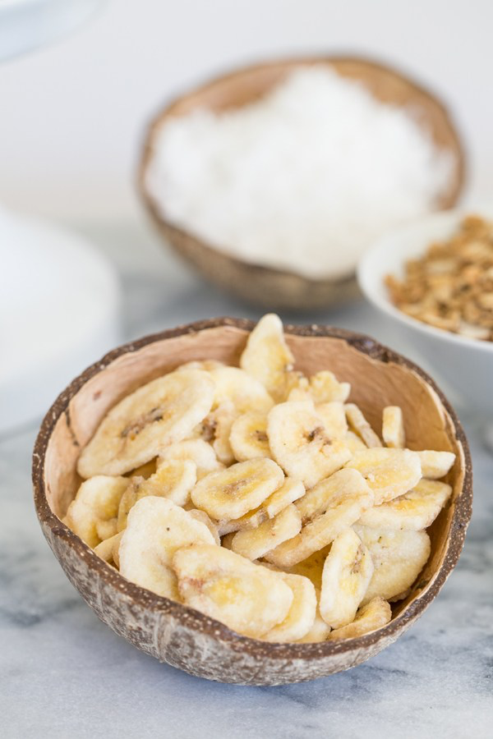

If you use a food-safe sealer, you can use these bowls for serving food and if you have decoupage/PVA glue, use the bowls for coins, hairclips, keys or jewellery. You can even decoupage paper them or paint the outside of them like in the youtube video below. Get creative and go coconuts!

You can watch a video here for further instructions:
https://www.youtube.com/watch?v=LbTD_S44A7E

Maths
Arithmetic
Word problems

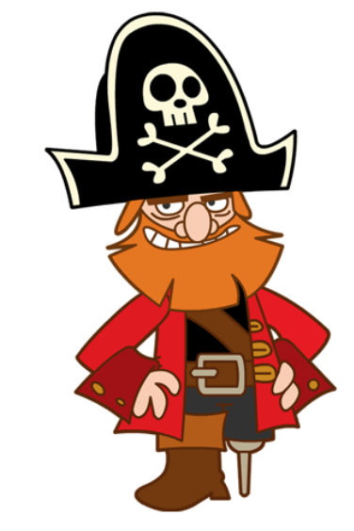
- Blackbeard found 1323 gold coins and he shared them out equally between 3 pirates. How many gold coins did each pirate have?
- The pirates had 150 fish and they ate 2/5 of them. How many were left?

- The pirates had 222 swords but they dropped half of them into the sea. Then they found another 37. How many did they have now?
- On Saturday, the pirates went to sea. If it took them twenty four hours to travel 10km, how long would it take them to travel 500m?

- There were nineteen parrots on the pirate ship on Tuesday, and double that number arrived on the ship on Wednesday. The numbers doubled the following day. Then eight flew away. How many were now on the ship?
- On Sunday, Pirate Pete ate four fish. He ate double that amount on Monday. On Tuesday, he ate half the amount he had eaten on Sunday. How many fish had he eaten in total?
- Pirate Pat had 264 gold coins. He lost one quarter of them, then he found another 12. How many did he now have?
- Eight pirates had a party. One quarter of them drank 2 jugs of grog each, one quarter of them drank three jugs of grog each and the rest drank one jug each. How many jugs of grog were drunk all together?

- There were twenty-four pirates on the ship. One eighth of them had an eye patch. How many real eyes were there in total?

- On Saturday, eight pirates ate five eggs each. On the following day, each pirate ate half the amount they had eaten the previous day. How many eggs were eaten in total?

Ahoy there! Too hard? Why not try the Blue Groups maths question?

Physical Exercise

Eye to hand coordination

Can you do them all? Do a risk assessment, beforehand, of course.

https://www.youtube.com/watch?v=GvdLf45mGq0

Don’t forget to keep fit! Joe Wicks is always a go too if you think you’re not going to be out and about.

Recipe

Rhubarb Crumble

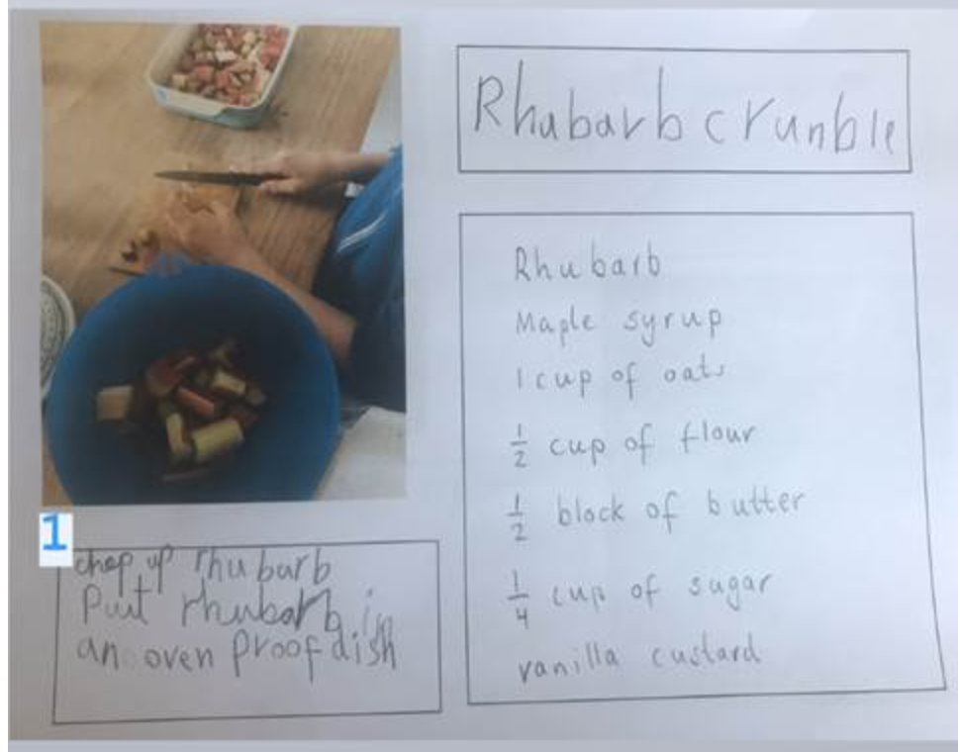

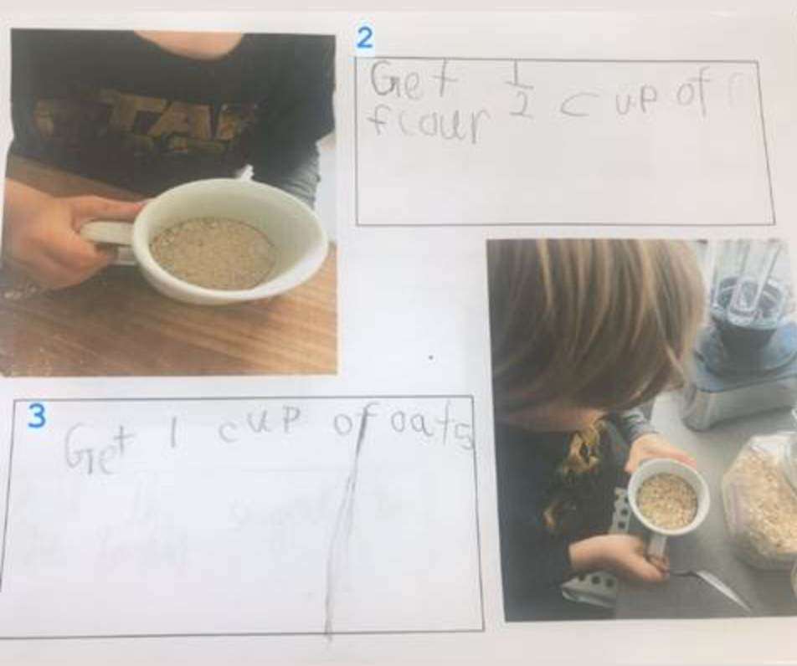

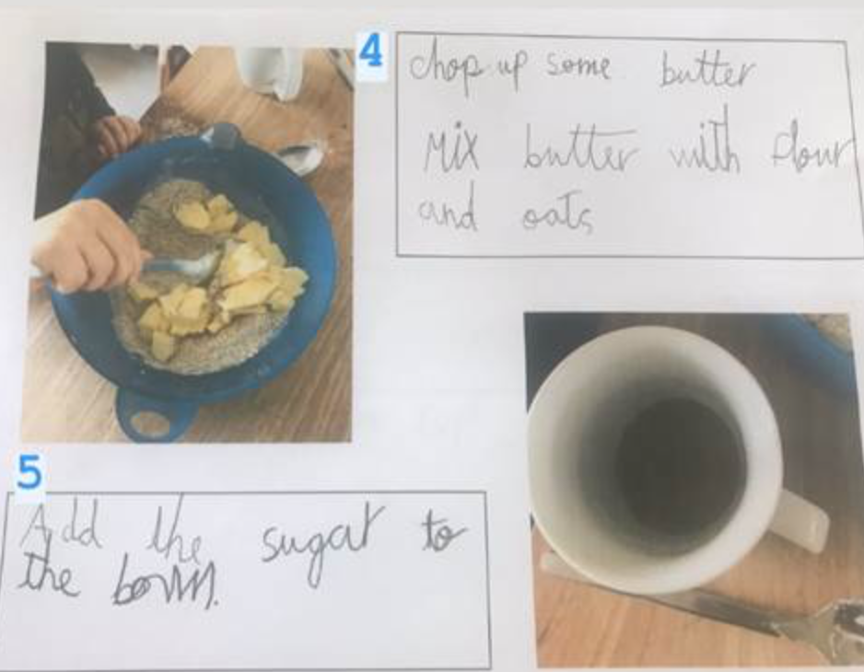

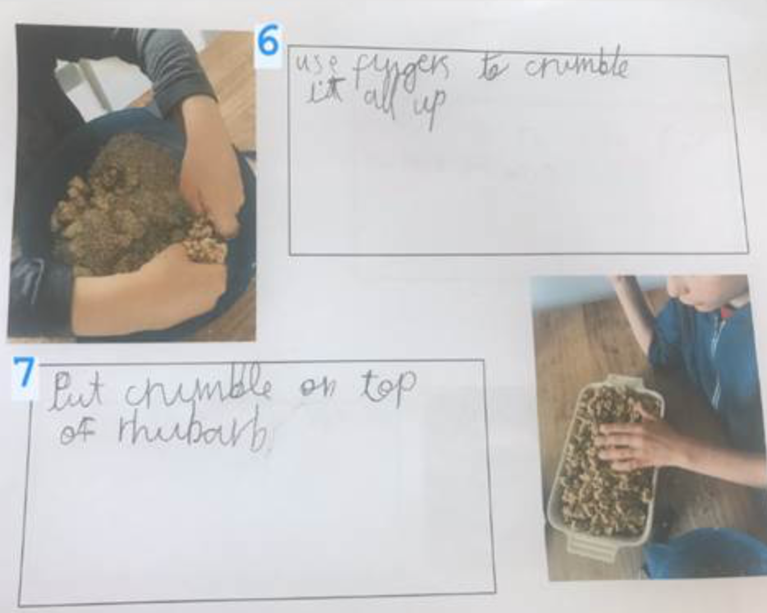

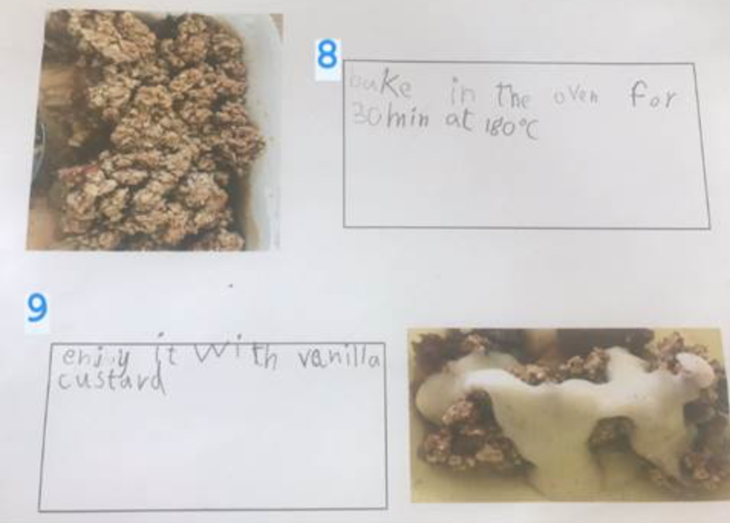

Thank you so much for this wonderful recipe, Emil and Friedrich.

I wonder what part of the world rhubarb is native to?

