Blue Group

Science

Gravity and Inertia

This science experiments demonstrates inertia.

Inertia is summed up in Newton’s First Law of Motion:

An object in motion stays in motion and an object at rest stays at rest unless an outside force acts on it.

Inertia Science Experiment #1: Penny Stack

- Find some pennies.
- Stack 5 pennies and grab one more to use as the shooter.
- Flick one penny toward the stack. Give it a good, solid flick.
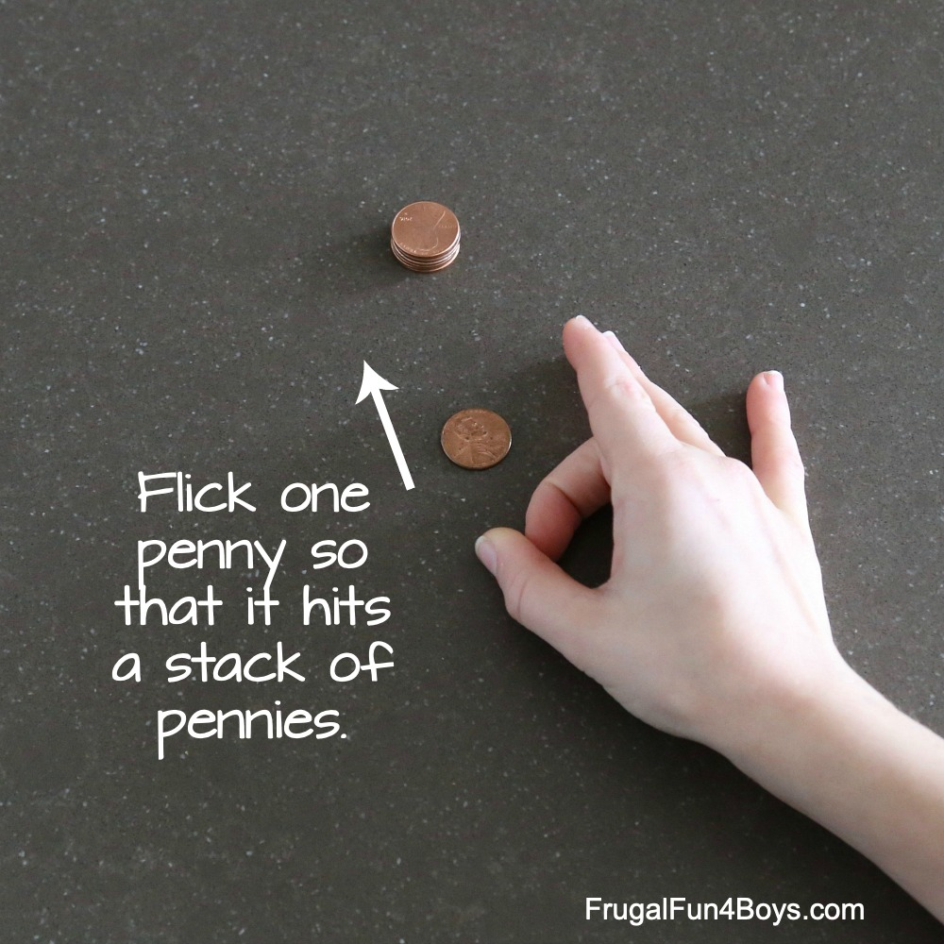

You may expect that the stack will fall over when the penny hits the stack, but this is not the case!
The one penny will transfer its energy to the penny at the bottom of the stack, which will then zoom forward. The rest in the stack will stay right where they were because an object at rest stays at rest unless acted on by a force!
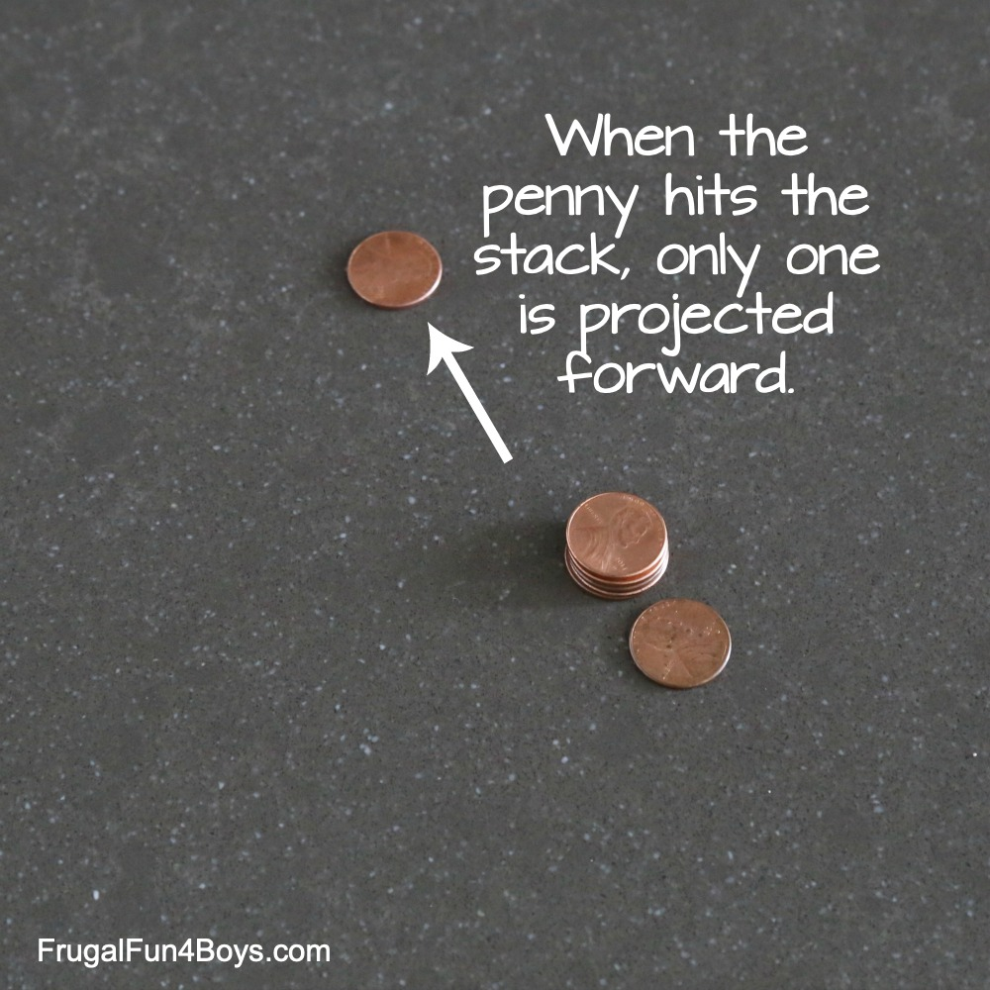

Please, write and draw up the experiment in your science books and write out Newton’s First Law of Motion.
They’ll be a second inertia experiment next week!

Language

Comprehension

Please read this (made up but factually accurate) entry from Newton’s Diary and then answer, in full sentences, the questions below.

Monday 17th February, 1687
Dear Diary,
Today I made a discovery! I woke up and as usual started my day with a large glass of ale, a deliciously stale slice of bread topped with cold meat and fish. I have recently been incredibly successful in my research and studies in mathematics, optics and mechanics but today I discovered something beyond imagination. Something that has been around us all the time but something that no one had ever questioned or pondered. As I sat beneath a blooming apple tree something hit me. It literally hit me. An apple. I was minding my own business, reading Opuscula Mathematica Hactenus Inedita written by the infamous William Oughtred, and an apple bounced off my head crashing to the ground. Of course, how had I not thought of this before? Gravity! How else would everything stay grounded to Earth instead of floating in the abyss? Gravity! I was so ecstatic I jumped for joy. As the apple had fallen off the tree it hadn’t flown off into the cool spring sky. It hadn’t rocketed over into the adjoining field. It fell instantly downwards, knocking into my now swollen head. Gravity had forced it down. Like it forces everything down!
I had to tell someone of this momentous occasion, to celebrate my ingenious ingenuity. I ran instantly to revel in my success with my two dear friends, Samuel Pepys and John Locke. They couldn’t believe what had happened. Their response was not what I expected. I expected to be at the receiving end of celebratory feasts and perhaps a game of billiards. Instead, however, I was greeted with scepticism and disbelief. I must prove this theory. If this is the last thing I do.
Tomorrow I plan to write down my theory and show it off to the world. Gravity does exist, regardless of what sceptics might think. I will write a book explaining this, I think I will name my book: Philosophiæ Naturalis Principia Mathematica. That has a lovely ring to it!
Thank you for listening diary. I am going to try and get some sleep now, I have a busy day of writing tomorrow.
Yours sincerely, Isaac Newton.

- What did Newton eat and drink for his breakfast?

Newton ate…

- According to Newton, himself, in which studies had he recently been incredibly successful?
- What force did Newton come up with that ‘had been around us all the time’?
- Why did this suddenly occur to him?
- Which two friends did he excitedly go and tell?
- Pick one of the two friends and tell me, what they were famous for.
- How did his two friends react to his exciting news?
- What did Newton realise he had to do to convince his friends, and the rest of the world, of his idea?

Art

Listen to Gustav Holst the planets:

https://www.youtube.com/watch?v=Isic2Z2e2xs

Whilst listening, draw or paint a picture of how it makes you feel.

Music

In this piece of music, you hear a lot of string or bowed instruments.

Holst gave an instruction for the instrumentalists to strike the string with their bow, rather than draw it across the strings. This gave the string instruments a more percussive sound.

https://www.youtube.com/watch?v=5qzX2HZhXec

Tissue Box Banjo

Make your own stringed instrument:

Things You'll Need

- Empty tissue box (long)
- Empty paper towel roll
- Rubber bands
- Marker
- Scissors or knife
- Decorative items (e.g. paint, stickers, gift wrap paper, etc.)
Steps
Take an old empty tissue box. A long box rather than a square one is preferable

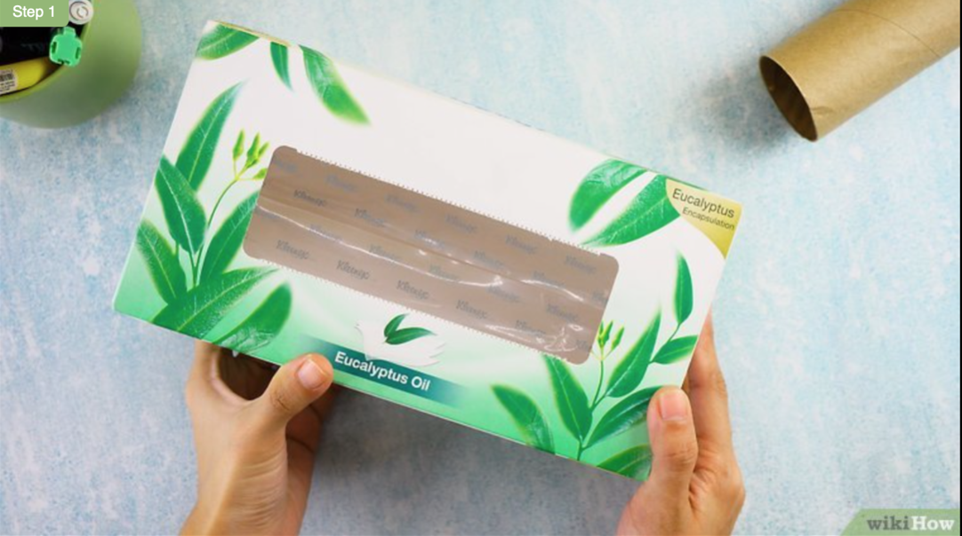

Cut off the cellophane or cardboard.

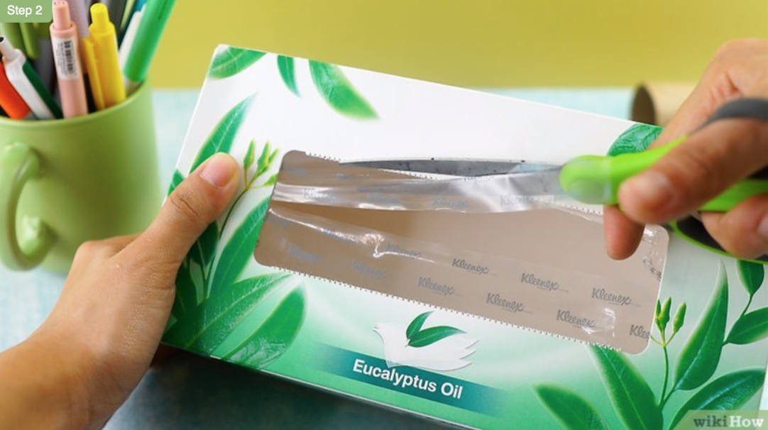

Put the paper towel roll on top, trace it with a marker, and cut along the lines.

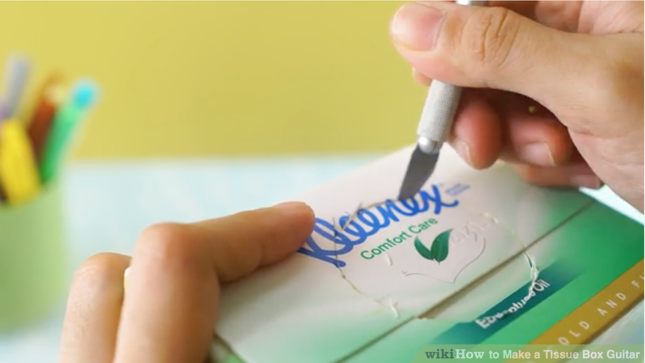

Insert the paper towel roll in the hole. Make sure it's about 6 to 9 cm in. Tape may be used to hold the roll in place and make it sturdy.

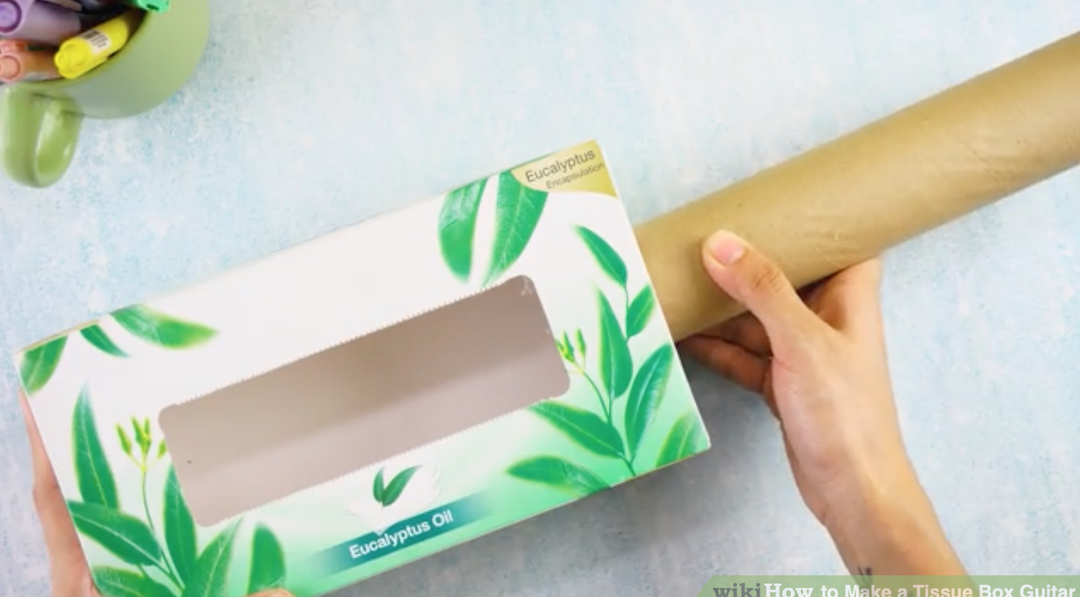

Add the rubber band strings. Wrap a couple of rubber bands around on each side of the paper towel roll. Different types and sizes of rubber bands may be used to create different tones and sounds.

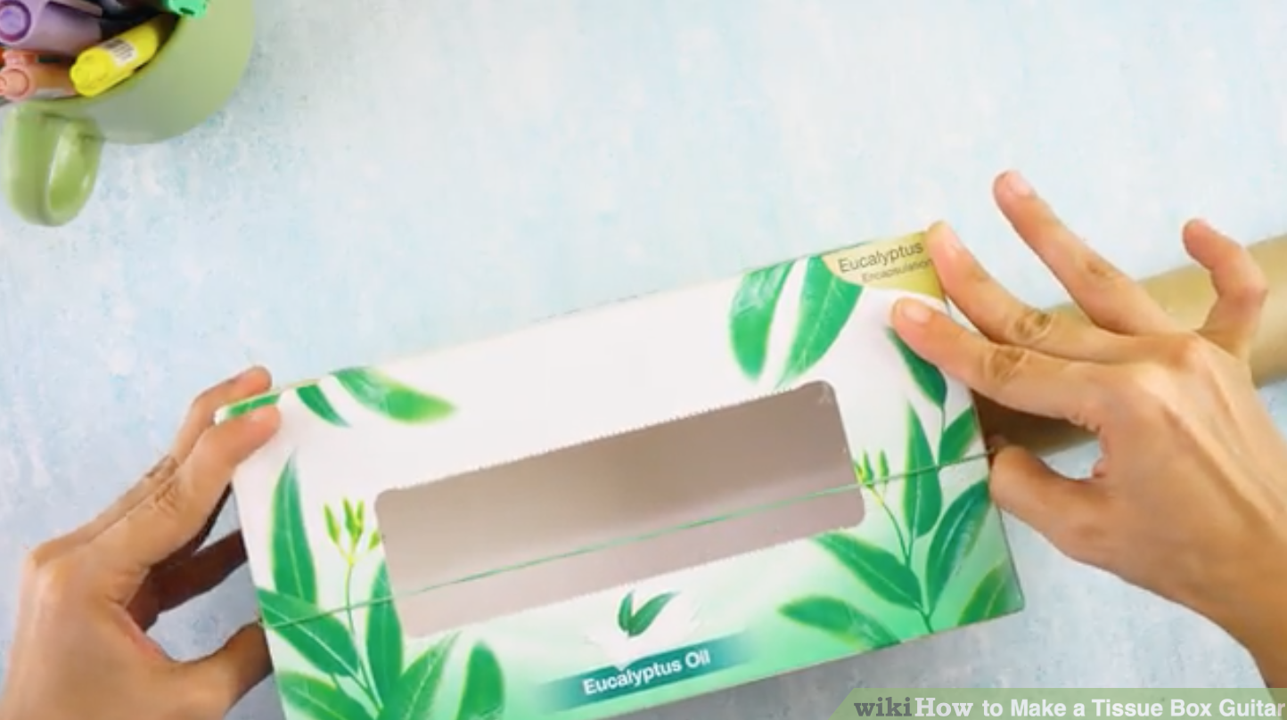

Decorate the box. Add stickers, paint some art designs, spray paint it, sprinkle glitter on it, and anything you would like. Now you're ready to roll!

You could get a thicker band for low sounds or a thin band for high sounds.

Physical Education

Catching the ball

Can you do all of these challenges?

https://www.youtube.com/watch?v=FYS9o-__MwI

Geography

Solar system

Papier Mache Planets

Why don’t you and a friend(s) team up to make all 8 planets. Discuss with each other which ones you’d like to do.

Whilst doing this listen to Gustav Holst’s Planets:

https://www.youtube.com/watch?v=Isic2Z2e2xs

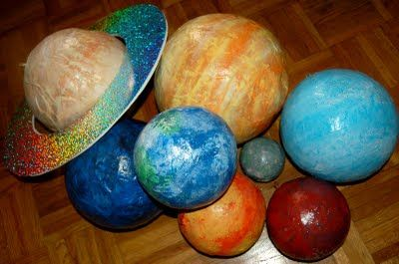

Step 1: Gather Balloons
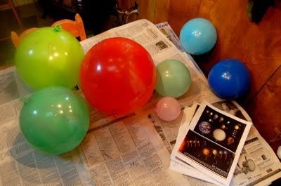

Step 2: Create Papier Mache Mixture

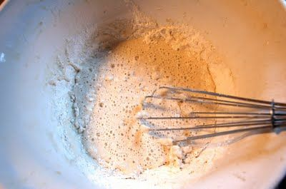

Create a papier-mache mixture by mixing flour and water. This is your "glue" to the consistency of pancake mix.
Step 3: Start Applying
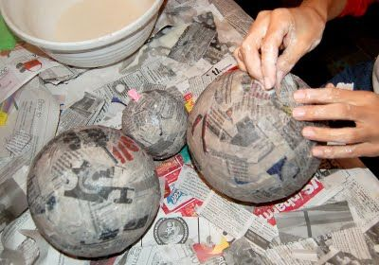
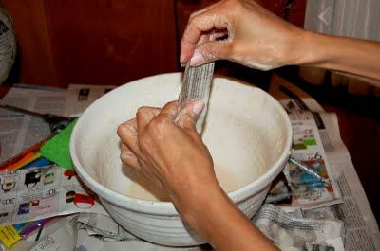

Apply three layers of strips to each balloon, allowing each layer to dry in between.

Step 4: Drying Process

To help them dry, place them outside or on a windowsill in the sun.

Step 5: Base Coat

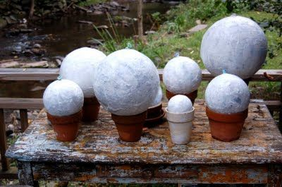

Once dry, paint each planet with a coat of white primer before applying the colour then let them dry again. Resting the planets on flowerpots helps keep them stable.
Step 6: Start Painting!

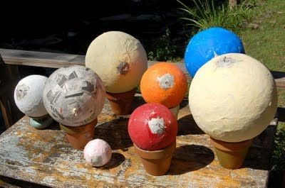

Acrylic paints are easier to mix and they clean up easily with water.
This image shows the first layer of colour. Let each dry before your second coat.

Step 7: Adding detail
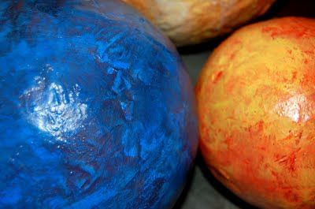
With two coats of base colour, sponge/paint on a second darker or lighter colour to bring out the texture. This works best when the planet is not fully dry. Have fun, you can't really make any mistakes here.
Spray a gloss coat on to give the planets some shine and protection.

Science/Maths

Use this interactive website and follow these instructions:

- Drop the ball from a set distance
- Repeat for each of the nine environments which have gravity
- Answer the questions below

https://www.schoolsobservatory.org/discover/sims-cals/gravsim

- Which celestial body, in this experiment, has the weakest gravitational force?

- Which has the strongest?

- Why do you think this is?

This is a graph of the acceleration of a ball in Earth’s gravitational field. Acceleration is the rate of change in velocity of an object, or just a fancy word for speeding up. It is part of a branch of science called physics.

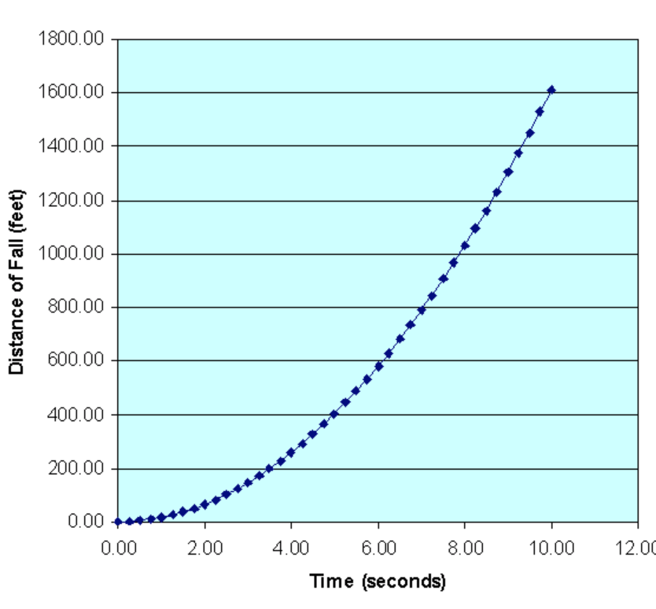
- Approximately how far does the ball fall after 6 seconds?

- How long does it take for the ball to fall 300 feet?

- The acceleration of the ball follows a pattern.

- Can you fill in the missing gaps?

0 | 1 | 4 | 9 |  | 25 | 36 | 49 |  | 81

How far can you continue with this pattern?

Nothing to do with gravity and accelerations, these ones, but can you figure out the missing numbers all the same?

1) 12 20 ______ 36 ______ ______

2) 1000 980 955 925 ______ ______

3) 6.4 6.9 ______ ______ 8.4 8.9

4) 10 40 _____ 100 ______ 160

5) 29 34 39 44 _____ _____

6) 15 19 ______ 27 31 ______

7) 99 87 ______ 63 51 ______

8) -9 -18 -27 ______ ______

Music

In Gustav Holst’s Planets, you hear a lot of string or bowed instruments.

Holst gave an instruction for the instrumentalists to strike the string with their bow, rather than draw it across the strings. This gave the string instruments a more percussive sound.

https://www.youtube.com/watch?v=5qzX2HZhXec

Tissue Box Banjo

Make your own stringed instrument:

Things You'll Need

- Empty tissue box (long)
- Empty paper towel roll
- Rubber bands
- Marker
- Scissors or knife
- Decorative items (e.g. paint, stickers, gift wrap paper, etc.)
Steps
Take an old empty tissue box. A long box rather than a square one is preferable

Cut off the cellophane or cardboard.

Put the paper towel roll on top, trace it with a marker, and cut along the lines.

Insert the paper towel roll in the hole. Make sure it's about 6 to 9 cm in. Tape may be used to hold the roll in place and make it sturdy.

Add the rubber band strings. Wrap a couple of rubber bands around on each side of the paper towel roll. Different types and sizes of rubber bands may be used to create different tones and sounds.

Decorate the box. Add stickers, paint some art designs, spray paint it, sprinkle glitter on it, and anything you would like. Now you're ready to roll!

You could get a thicker band for low sounds or a thin band for high sounds.

Zoology

Invertebrates
Butterflies

Butterflies are beautiful, flying insects with large scaly wings. Like all insects, they have six jointed legs, 3 body parts, a pair of antennae, compound eyes, and an exoskeleton. The three body parts are the head, thorax (the chest), and abdomen (the tail end).
The butterfly's body is covered by tiny sensory hairs. The four wings and the six legs of the butterfly are attached to the thorax. The thorax contains the muscles that make the legs and wings move.

When you go out for your daily exercise see if you can spot any of these:

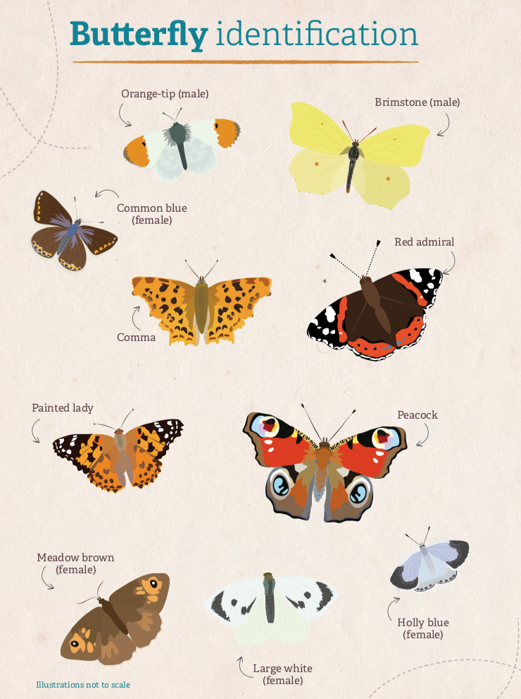

If you have a printer you could use this website to colour in and label any of the butterflies that you saw. If you don’t have a printer you could draw your own.

https://www.firstpalette.com/printable/butterflies.html

