Blue Group

I hope you all have had an amazing week off. What about the weather, hey! Hottest May on record. I’ve learnt how to paddle board. What have you been up to? If you find yourself not writing much of late – write in your journals all the amazing things you’ve been up to!

Geometry

Perimeter

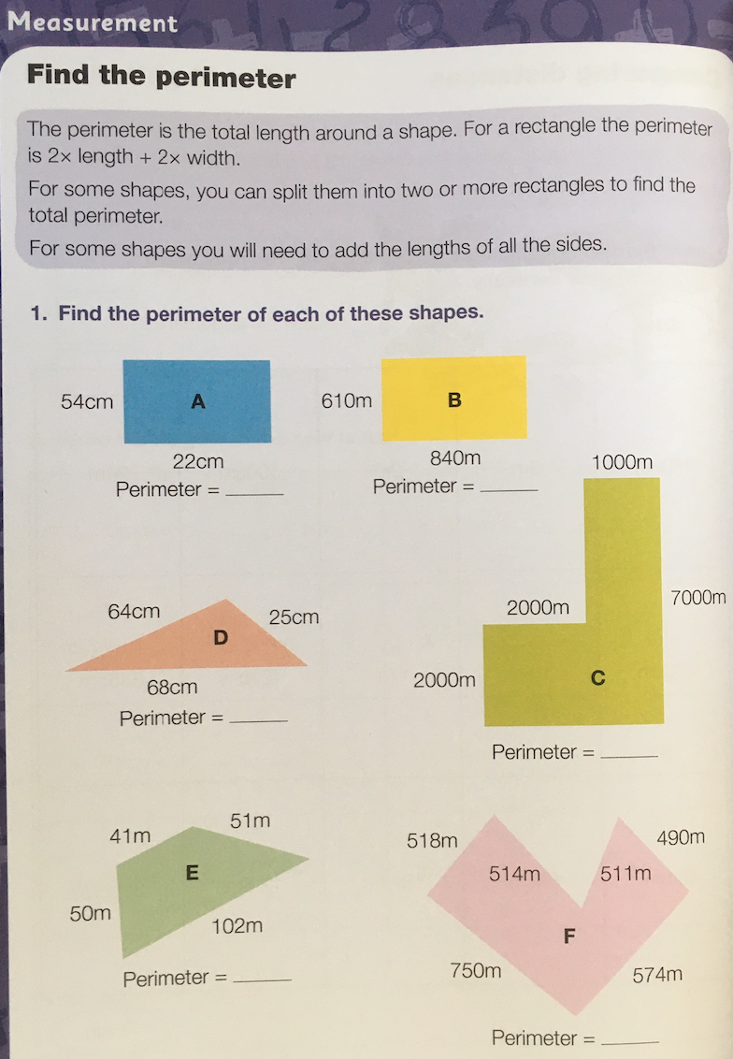

Biology/Reading

Plant biomes

Please, try and match the plants with the biomes. Read about the biomes first to inform your decisions.

https://earthobservatory.nasa.gov/experiments/biome/plant_it.php

Geometry

Angles

This’ll help spring your minds into gear:

https://www.bbc.co.uk/bitesize/guides/zrck7ty/test

Language

Literature

What a magnificent website this is! You’ll need to join but its quick and simple.
Poor Michael Rosen from ‘Going on a Bear Hunt’ fame, is thankfully on the mend from contracting corona. Hear his advice and try his ‘creative writing challenge. Or, pick any of the authors that you are fond of, watch their videos and try their challenges!

https://authorfy.com/

Biology

Human Beings

Healthy diets

Please find these and place them on a table:

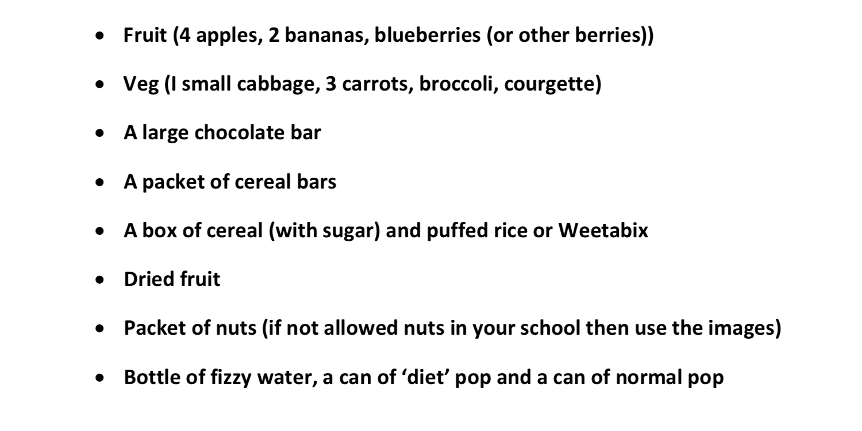

Alternatively, if you don’t have these items then print them out from the following page:

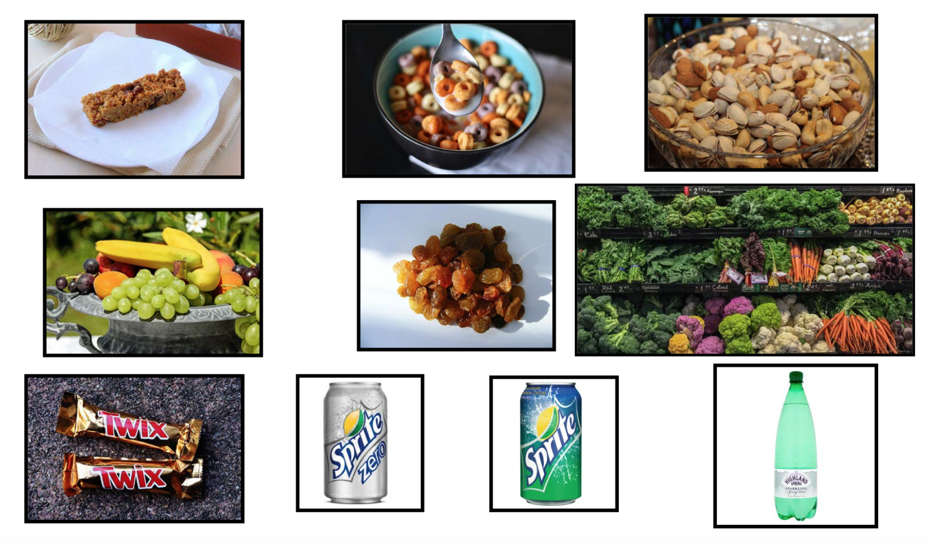
Test yourself in knowing which of the items on the table are high or low in sugars, fats and micronutrients.

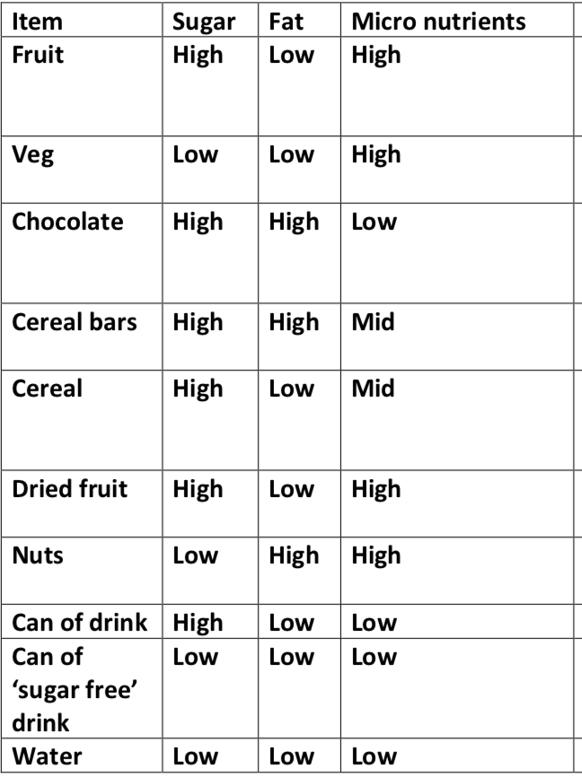

Fill in the sheet below. Stating ‘how’ you can achieve the ‘Aspects’ in the first column. For instance:

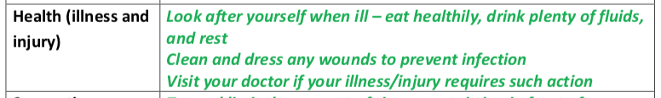

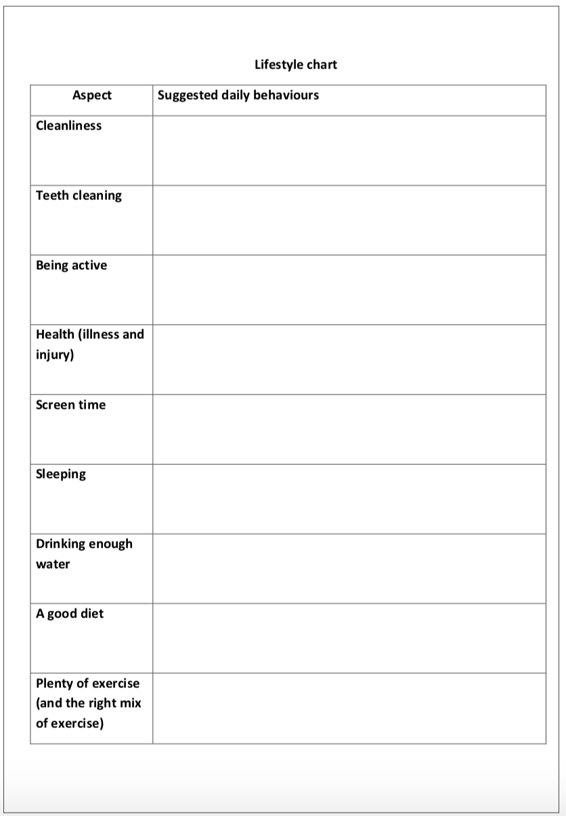

Reliable websites for information/research on diet
What should I be eating/drinking? Trust me I’m a Doctor, BBC
http://www.bbc.co.uk/programmes/articles/1yV5MBkc2Y6pQSWyMgR21y2/what- should-i-be-eating-drinking
Food and diet, NHS
http://www.nhs.uk/livewell/goodfood/Pages/Goodfoodhome.aspx
Heathy Eating, The British Heart Foundation
https://www.bhf.org.uk/heart-health/preventing-heart-disease/healthy-eating

Language

Writing instructions

Ahhhhhhhhhhhhhh! Mi hearties!

What a wonderful selection of islands you’ve been making. Very imaginative!

Task 3
Design a shelter for your first night on your island.
Write instructions that could help someone in a similar situation to you - just as Emil and Friedrich did for their scrummy recipes – use the treasure map paper to write on below.
Explain what materials would best protect you from weather and animals.
Make sure your instructions are easy to understand. Include diagrams.
KEY FEATURES OF INSTRUCTIONS:
- A title
- A list of things that you will need.
- Numbered steps (Each step set out on a new line)
- A sequence of steps set out in the right order – use language to help you (First; After that; Next; Last of all)

- Verbs which begin each instruction (put, get, spread, cut etc.)
- A top tip or handy hint such as: Try not to leave gaps in your shelter as it may leak if it rains.

*Feel free to look at Emil and Friedrich’s recipes for inspiration or use this website
https://www.bbc.co.uk/bitesize/topics/zkgcwmn/articles/zfrcmfr

Good luck baking me old seadogs!

