Red Group 08/06/20

As part of the Montessori Curriculum it is important for you to learn the skills involved in organising a trip for your peers. This is called ‘Going out’.

Take your time over this, we might not be able to go on each of your suggestions, but it’ll be great practice anyway and we’ll do our best to go on one or two before we break up for the summer.

You might want to take the rest of the Red Group on a walk, for instance; to see wildlife, plants, historical locations, geological features, like the highest hill, to name but a few.

There are number of things you need to plan before going. We use a ‘Going Out Form’ to help plan for these trips.

This form helps you to plan:

- Why you want your fellow pupils to visit a particular location.

- Where this location is.

- When this trip is going to occur.

- How you will get there.

- Who will go on the trip – children and adults

- What to bring/wear

- Schedule (needed but separate from Going Out form’)

GOING OUT FORM
Your name: Group name:
For correct attendance records, Health and Safety, in the event of a fire, in the event that parents or others need to know where child or staff member is.

This must be completed and emailed to info@brighton-montessori.org.uk FAO: Daisy for permission, BEFORE the next step.

When? | Time going Time back
Who? Highlight who has First Aid  Staff in attendance: | Names of Children:
Where?

Why? Ofsted will want to know
Relevance to Montessori / National Curriculum

How?
Transport to be used & Costs

Risk Assessment checked and attached by which member of staff?

Parents to be informed by date and by which member of staff?

Member of staff making request to Go Out?

Authorised by headteacher
WHY?

The trickiest part of this is perhaps choosing ‘why’ it is a good idea to go on a trip as far as the National Curriculum is concerned, so I’ve made a table (below) stating some of the reasons you might want to give. Try and only pick one or two reasons, we can always return another time to focus on different attributes, but one clear reason at a time, is enough:

ANIMALS
identify and name a variety of common animals including fish, amphibians, reptiles, birds and mammals
identify and name a variety of common animals that are carnivores, herbivores and omnivores
identify that most living things live in habitats to which they are suited and describe how different habitats provide for the basic needs of different kinds of animals and plants, and how they depend on each other
describe how animals obtain their food from plants and other animals, using the idea of a simple food chain, and identify and name different sources of food.
notice that animals, including humans, have offspring which grow into adults
explore and use classification keys to help group, identify and name a variety of living things in their local and wider environment
construct and interpret a variety of food chains, identifying producers, predators and prey.
describe the differences in the life cycles of a mammal, an amphibian, an insect and a bird
describe the life process of reproduction in some plants and animals.
PLANTS
observe and describe how seeds and bulbs grow into mature plants
find out and describe how plants need water, light and a suitable temperature to grow and stay healthy.
identify and describe the functions of different parts of flowering plants: roots, stem/trunk, leaves and flowers
investigate the way in which water is transported within plants
WEATHER AND SEASONS
observe changes across the four seasons
observe and describe weather associated with the seasons and how day length varies.

MAP AND COMPASS READING
use simple compass directions (North, South, East and West) and locational and directional language [for example, near and far; left and right], to describe the location of features and routes on a map
use the eight points of a compass, four and six-figure grid references, symbols and key (including the use of Ordnance Survey maps) to build their knowledge of the United Kingdom and the wider world
MECHANICS
recognise that some mechanisms, including levers, pulleys and gears, allow a smaller force to have a greater effect.
FOSSILS, ROCKS AND MINERALS
recognise that living things have changed over time and that fossils provide information about living things that inhabited the Earth millions of years ago.
recognise that environments can change and that this can sometimes pose dangers to living things.
recognise that soils are made from rocks and organic matter.
GEOLOGICAL FEATURES
use basic geographical vocabulary to refer to key physical features, including beach, cliff, coast, forest, hill, mountain, sea, ocean, river, soil, valley, vegetation, season and weather
use simple fieldwork and observational skills to study the geography of their school and its grounds and the key human and physical features of its surrounding environment.
name and locate counties and cities of the United Kingdom, geographical regions and their identifying human and physical characteristics, key topographical features (including hills, mountains, coasts and rivers), and land-use patterns; and understand how some of these aspects have changed over time
describe and understand key aspects of physical geography, including climate zones, biomes and vegetation belts, rivers, mountains, volcanoes, earthquakes, and the water cycle
HISTORY
human geography, including: types of settlement and land use, economic activity including trade links, and the distribution of natural resources including energy, food, minerals and water
changes in Britain from the Stone Age to the Iron Age

Learn about late Neolithic hunter-gatherers and early farmers, for example, Skara Brae Bronze Age religion, technology and travel, for example, Stonehenge, Iron Age hill forts: tribal kingdoms, farming, art and culture
the Roman Empire and its impact on Britain
a study of an aspect of history or a site dating from a period beyond 1066 that is significant in the locality.
the achievements of the earliest civilizations – an overview of where and when the first civilizations appeared and a depth study of one of the following: Ancient Sumer; The Indus Valley; Ancient Egypt; The Shang Dynasty of Ancient China

WHERE?

You need to state the exact location where you would like us to meet. We would have to go and return in separate cars. You could find the location on google maps and include a picture of the meeting point and, if it is a walk we are going on, the trail we might take. We do want to keep this local - unfortunately no trips to London, for the time being. We can’t expect parents to drive too far either - 15miles – max.

WHEN?

Is it open and if so – do they accept groups of around 8?
Here you will need to practice your phone skills to ask questions.
After finding out, jot down ‘drop off time and pick up time’ and the date this will occur.

HOW?

This would normally entail how to get there – train, bus, underground etc, but we will need to be able to go to the location either on foot from the school or in individual cars – for social distancing reasons.

WHO?

Which children? – Red Group and Maddy.

Which adults? – There needs to be me (Ben) as I have first aid and another adult. You don’t necessarily have to invite your parent, you could always enquire whether another parent from the group is available…

WHAT?

What the group will need to bring? Nets? Hats? Change of clothing? Appropriate footwear? Sun cream? Money? Lunch? Snack? Maps? Scavenger hunt resources? Journals? Sketch books? Mobile phone? Anything else you might think we need.

SCHEDULE

This means the timetable of the day.
If it’s a walk, how long is the walk? What time would you want to stop for snack/lunch/game/activity/talk/presentation/heading back.
We would expect you to be knowledgeable about the place you take us so swat up beforehand.

All subject areas
As discussed in the Zoom group, I would like you to undertake a project with a fellow pupil about a subject of your interest. For the moment we’re going to keep it real, therefore no modern fictional interests, please. i.e. Pokémon, Harry Potter et al (Greek Mythology, I’ll accept, at a push).
I will attach the project prompts for you, which you’re familiar with from the classroom. You could enlarge the ones you are interested in doing – this will save on paper.
If you have other interests, for instance, space; you can ask me for some question prompts, should you need them.
Don’t forget your interests could also be maths or language. You and a friend could work out all the prime numbers between 100-500 or finding all the names of animals with compound words.
Think about how you are going to display your research. In a book, timeline, poster, video presentation, PowerPoint?
Make sure you are clear with each other, which method of display you choose to do and which questions each of you are going to undertake - there’s little point both answering the same questions.
Best of luck!

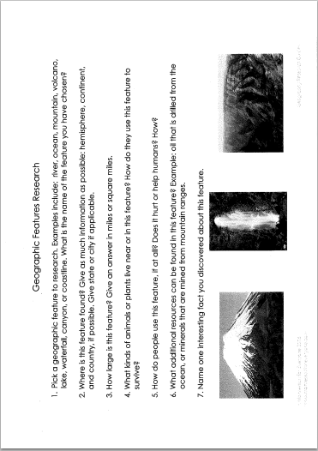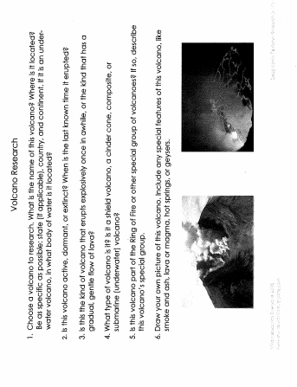
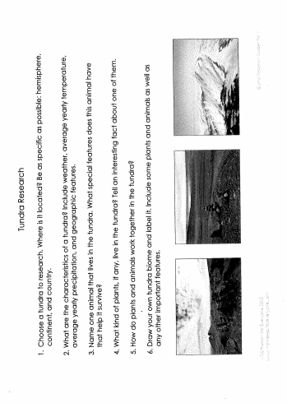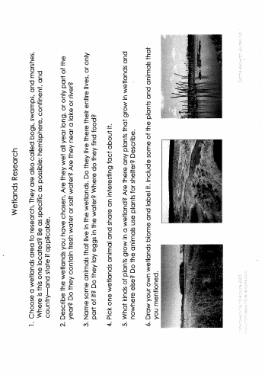
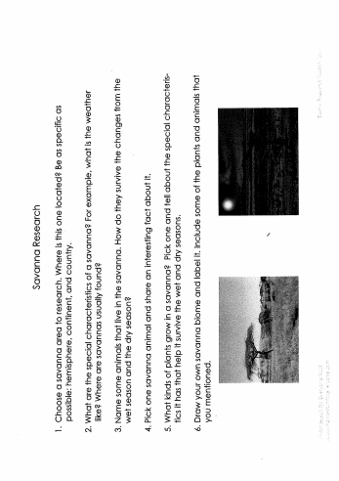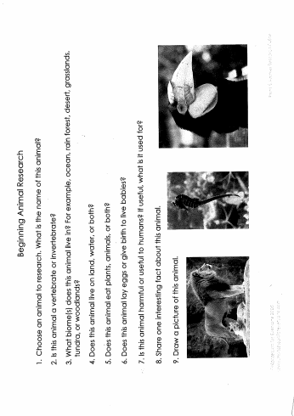

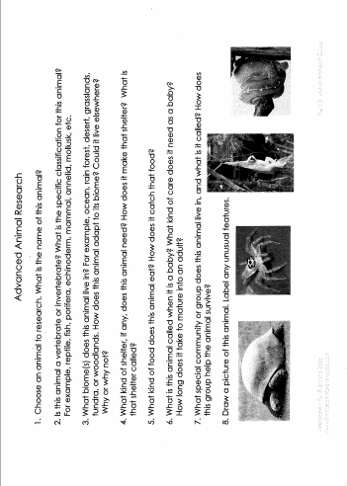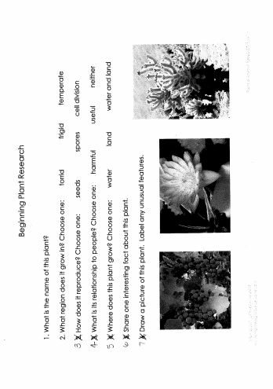

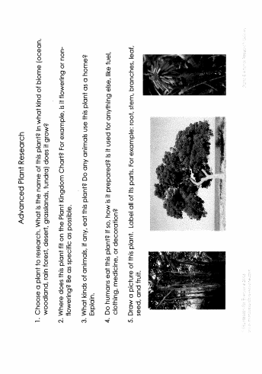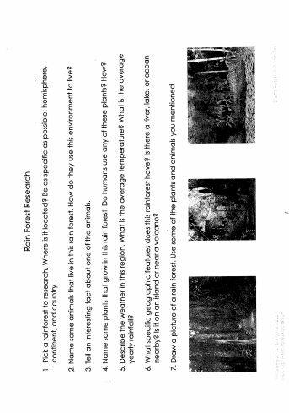

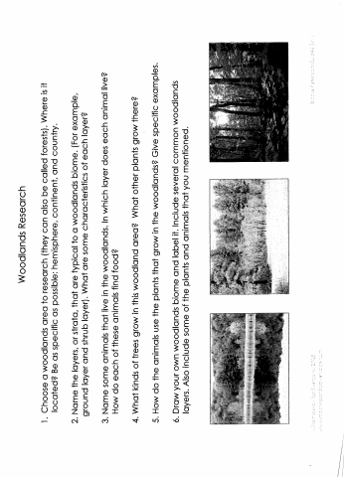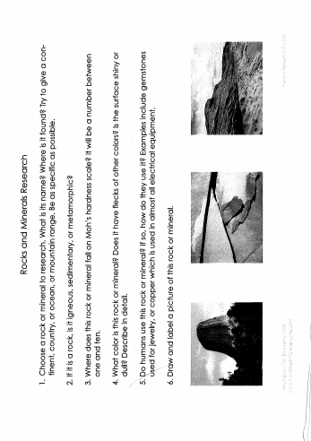

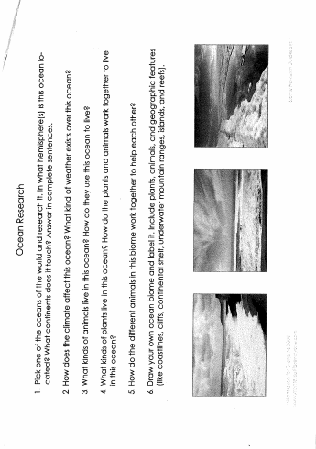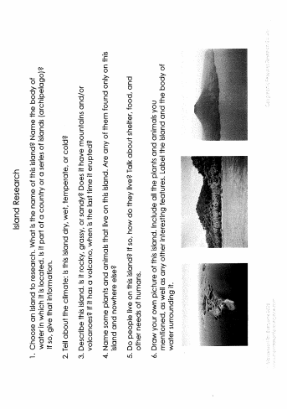
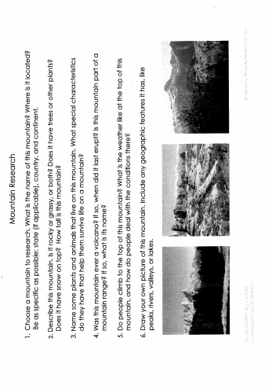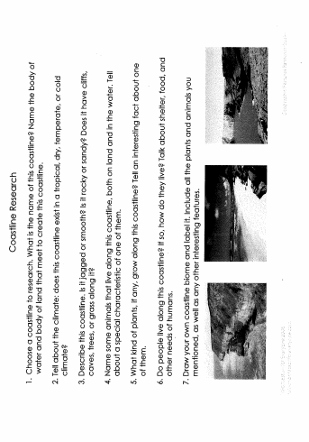

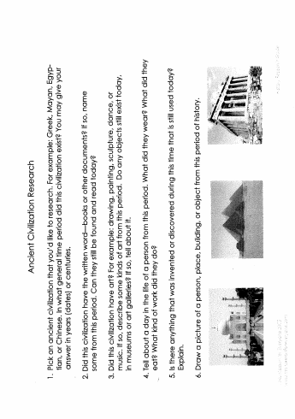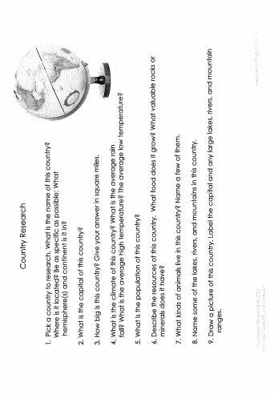

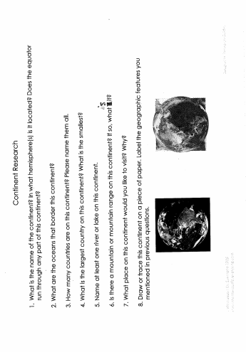

Language
Listening/Making/Writing/Drawing

Miniature books by your favourite authors
Why not listen to these ‘small’ stories

https://www.bl.uk/childrens-books/activities/miniature-books-by-your-favourite-authors

Try and make one of your own!

https://www.bl.uk/childrens-books/activities/make-a-miniature-book

Geography
Earth formed according to weight
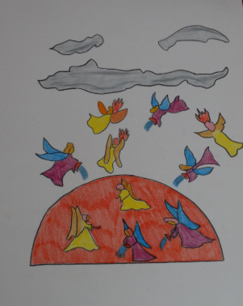
Lava lamp in a wine glass
Can you remember the ‘dance of the elements’ chart, above?
Can you remember the story I told about how the earth came to be? And the experiment with the honey, water and oil?
Here’s an extract from the1st Great Story:
‘The heavier particles went nearer to the heart of the earth and the lighter ones floated above them like oil floating on water.
Can you remember the names of the layers?
Why not re-enact the experiment and add some more fizz!

https://www.bing.com/videos/search?q=lava+lamp+in+a+wine+glass&&view=detail&mid=6F0DD88D35D1A0E176516F0DD88D35D1A0E17651&&FORM=VRDGAR&ru=%2Fvideos%2Fsearch%3Fq%3Dlava%2Blamp%2Bin%2Ba%2Bwine%2Bglass%26%26FORM%3DVDVVXX

Maths

Please visit here and try out the work for your age group. Too easy? Go for the class above. Too hard? Go to the class below. Find your level and work happily from there.

https://www.hamilton-trust.org.uk/blog/learning-home-packs/

Physical Exercise

I strongly recommend Joe Wicks. He’s been keeping my family sane for the last 10 weeks!

https://www.youtube.com/watch?v=1MBFhUtyyQM

