Blue Group

Geography

Land and water forms:

**A Bay**

[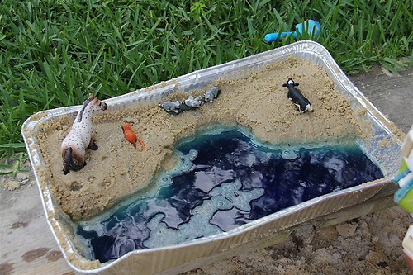](http://www.flickr.com/photos/47745580@N08/6044693749/)

If you have the chance to visit the beach, this is a fun Montessori geography activity that requires very little preparation or expense. And if you can’t go to the beach, a sandbox will work well also.

If you add blue food colouring (and maybe miniature boats) to the water along with miniature plastic animals to the sand, you can have even more fun.

Choose one and send in your picture:

Zoology

Make a loo roll bird feeder

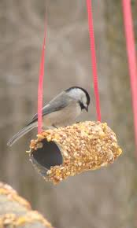

This is messy fun you can enjoy getting stuck into. And it will help you learn about the birds in your neighbourhood.

You can make this simple feeder with items you probably already have at home:

1. Smother a cardboard tube in peanut butter/lard (no added salt and sugar versions are suitable for birds).
2. Roll it in bird seed and thread some string through the hole.
3. Tie it up in your garden where birds will feel safe eating.

If you are very quiet, you might hopefully spot a number of birds.

Use the bird identification sheet in your pack to see how many visit your street/garden.

Woodland (log book)

Take your woodland log book with you the next time you go off the beaten track, make it as colourful as you can. Can’t wait to see the results!

Nature Walk

See what you can spot outside

Whilst you’re there make natural art:

To mix things up, put the pencils and crayons to one side and look for natural art materials instead. Collect fallen leaves, petals and sticks and use them to make a picture or sculpture.

You could even use the objects as 'stampers' or paintbrushes - dipping them in paint and rolling, brushing or stamping them on paper to create interesting patterns and effects.

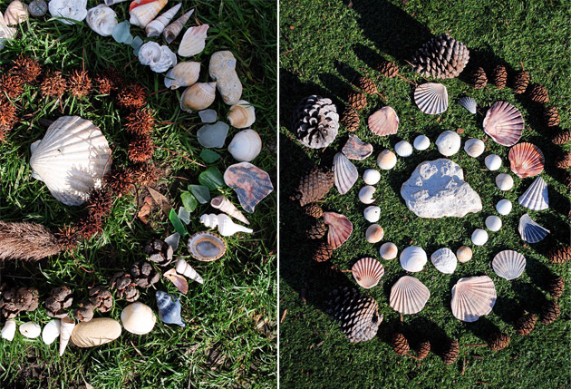

Botany

Plant a seed

1. Moisten the surface of the compost
2. Sprinkle the seeds evenly over the compost
3. Cover the seed pot (this will help germination)
4. Place the seed pot in a warm place
5. Uncover the seedlings once they germinate
6. It's very important to uncover the seedlings and expose them to light once they germinate,.
7. Place the seed tray on a windowsill where it should get enough light.
8. Turn the tray each day so seedlings are evenly illuminated.
9. Keep the compost moist with a spray mister.
10. During severe frosts, seed trays should be brought indoors or covered with insulation to guard against frost.
11. Take photos of their development.

Maths

C:\Users\user\AppData\Local\Microsoft\Windows\Temporary Internet Files\Content.IE5\2USVQG2K\MC900197778[1].wmf**Name_________________**

**Alien’s Movie**

Plan a movie for Mr Alien. His bank on his planet will only give him a budget of £800. Can you get him everything he needs and not spend more than his budget?

Remember, he wants the movie to be fun, exciting and have lots of props. Good luck!

**In your groups use the following pages to plan what Mr Alien needs to make his film.**

**You must:**

* **Choose 1 set from the list**
* **Choose at least 2 actors from the list**
* **Choose at least 1 advertising pack from the list**
* **Choose as many items from the props list**

**MOST IMPORTANTLY – WORK AS A TEAM!**

**YOU HAVE A BUDGET OF £800**

**Don’t exceed (go over) your budget!**

**You may use a calculator if you wish. Please write down any working out on these sheets.**

**SETS**

You need to choose **at least one** set from this list.

The film will take **2 full weeks** to make

|  |  |  |  |
| --- | --- | --- | --- |
| **Name** | **Details** | **Price** | **Notes** |
| A close up of a building  Description automatically generated  Cartoon City | * **25% off** total cost per day if hired for more than 7 days * To store your props **add** **£5** per day | £10 per day |  |
| A black and white photo of a house  Description automatically generated  Wild West | * **50% off** total cost per day if hired for more than 10 days * To store your props **minus** **£3** per day | **Price** |  |
| £26 per day |
| A picture containing water, standing, wet, group  Description automatically generated  Sci-Fi Central | * **10% off** total cost per day if hired for more than 7 days * To store your props **minus** **£2** per day | **Price** |  |
| £20 per day |
| A tree in a forest  Description automatically generated  Forest Films | * **20% off** total cost per day if hired for more than 7 days * To store your props **add** **£4** per day | **Price** |  |
| £17 per day |
| **Notes** | | | |

**Actors & Actresses**

You need to choose **at least two** people from this list

|  |  |
| --- | --- |
| **Adam Sandler**  £10 per day  Add 50p per day for lunch money | **Jack Black**  £11.50 per day  Lunch is £3 per day |
| **Amy Adams**  £11 per day  Add £1 per day for lunch money | **Johnny Depp**  £15 per day  Lunch is £1.50 per day |
| **Angelina Jolie**  £14 per day  Add £2.50 per day for lunch money  50% off total salary if she works with Brad | **Jonah Hill**  £10 per day  Lunch is £2 per day |
| **Brad Pitt**  £14 per day  Add £3 per day for lunch money  Works for just lunch money if A person looking at the camera  Description automatically generatedworking with Mr Bean | **Mr Bean**  £10 per day  Will work for 50% less per day if Brad Pitt is NOT in the film   |
| **Naomi Watts**  £8 per day  Add £1 per day for lunch money  A person smiling for the camera  Description automatically generatedTake away £4 per day from total cost if she works with a male actor | **Natalie Portman**  £9 per day  Minus £1 per day if works with Mr Bean  She brings her own lunch |
| **Notes** | |

**ADVERTISING PACKS**

Choose at least one advertising pack

|  |  |  |
| --- | --- | --- |
| **Advertising Pack** | **Details** | **Price** |
| A picture containing text, food  Description automatically generated  Pack A | Includes:  Movie trailer  Movie posters  Movie Website  Movie Facebook Page | £55 |
| A picture containing newspaper, food, device  Description automatically generated  Pack B | Includes:  Interviews with actors on the news  Interviews with actors on the TV  Movie posters | £25 |
| A close up of a fruit  Description automatically generated  Pack C | Includes:  Movie trailer  Movie posters  Movie Website  Movie Facebook Page  Large advertising billboards/posters by roads | £75 |

**PROPS**

You can choose as much as you want from this list. You just pay once for these, not per day.

Remember to keep within your budget!

|  |  |  |  |
| --- | --- | --- | --- |
| **Item** | **Details** | **Price** | **Tick** |
| Wave machine | Uses cams to move waves | £10.00 |  |
| Spaceship | Has levers, cams and pulleys for movable parts | £75.00 |  |
| Alien costumes | Full set for all actors | £25.00 |  |
| Cowboy costumes | Full set for all actors | £25.00 |  |
| Custom costumes | Full set for all actors – DESIGN YOUR OWN | £28.00 |  |
| Wizard costumes | Full set for all actors | £20.00 |  |
| Large robotic spider | Has movable legs and fangs | £14.00 |  |
| Large robotic horse | Can also be pushed along on wheels | £17.00 |  |
| Green screen | For filming against amazing scenery | £80.00 |  |
| Forrest scenery | Trees come with free oversized woodland animals | £15.00 |  |
| Woodland animals | Real life animals but they may make a mess | £14.00 |  |
| Princess castle | Add a bit of sparkle | £50.00 |  |
| Car | Price is per one car | £30.00 |  |
| Motorbike | Price is per one motorbike | £25.00 |  |
| Caravan | Price is per one caravan | £2.50 |  |
| Horse and Cart | Real life horse and one wooden cart | £15.00 |  |
| Lighting | Set the scene to night or day | £35.00 |  |
| Sound effects | Add drama and tension to your film | £72.00 |  |
| Army Tank | Price is per tank | £28.00 |  |
| Fireworks | Start your film off with a bang | £35.00 |  |
| Design a weapon | Design weapons of your choice for your actors | £30.00 |  |
| Tiny buildings | Make your actors look like giants | £68.00 |  |
| Animation Studio | Add animated effects to your movie | £100.00 |  |

**BUDGET PLANNER**

|  |  |  |
| --- | --- | --- |
|  | **Cost** | **Total Cost** |
| **Sets** |  |  |
| **Actors** |  |  |
| **Advertising** |  |  |
| **Props** |  |  |

**Final Cost of Film ___________**

**Amount over or under budget_______________**

**Fractions**

**Multiplication by a Fraction**

**Material: Cut out the fraction sheets provided (you might need to make your own copies, if you need more.**

**Multiplication of a Whole Number by a Fraction**

Take out 1 unit:

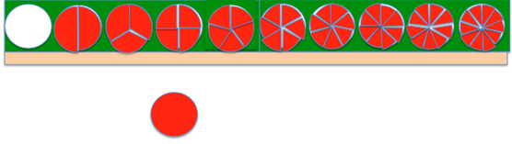

 I’d like to take this ,1 one half times (1 x ½). I need to exchange into 1/2s.

Change to 2 halves:

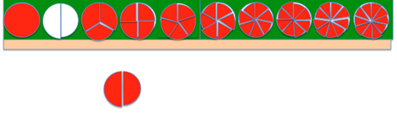

Now, I can take my one, 1 half time:

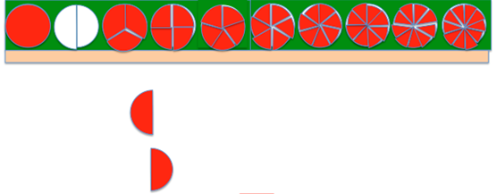

Show one half:

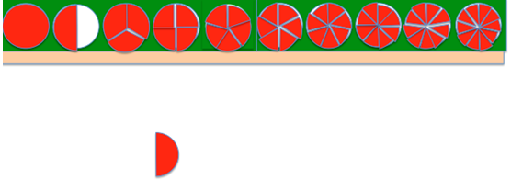

So 1 taken one half times = 1 half (1 x ½ =1/2)

Let’s do another one.

Write down on paper

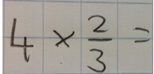

First get out 4.

Lay them out:

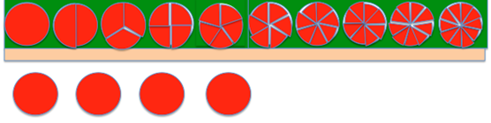

Here the multiplier tells to take 2/3 from each whole:

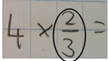

If I look at the denominator it tells me we need to break each whole into 3 pieces:

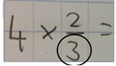

I need to exchange my units into thirds.

Place the 3 thirds below each whole

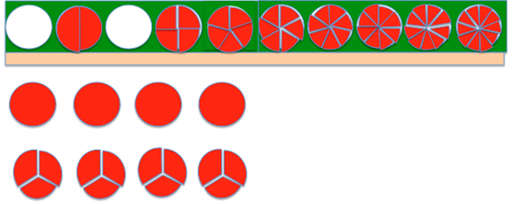

Then put back the wholes:

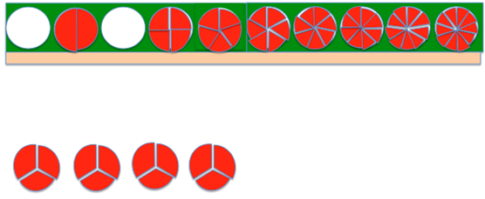

The numerator tells us to take 2 of each of these:

**C:\Users\Ben\AppData\Local\Microsoft\Windows\INetCache\Content.MSO\407867EE.tmp**

Bring them down (leaving the 1 (left) above it:

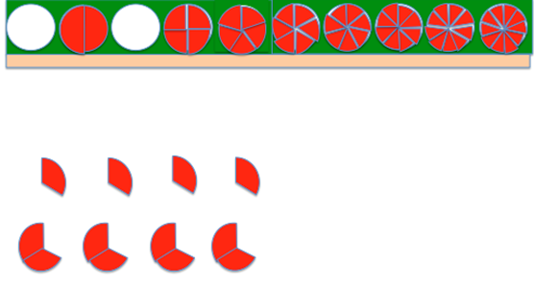 Put the ones away:

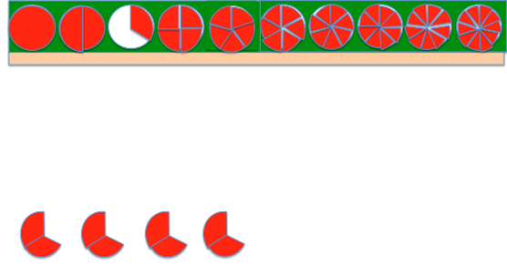

So lets see how many thirds we have:

Count the thirds (not putting them together)

8 thirds.

Write it down:

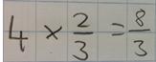

Can we express in fewer number of pieces? Put together and exchange:

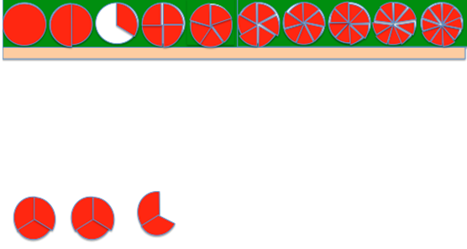

**C:\Users\Ben\AppData\Local\Microsoft\Windows\INetCache\Content.MSO\24F17904.tmp**

Another:

Read and write:

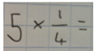

Take out 5:

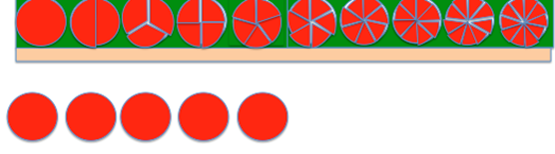

Multiplier tells us that we have to take one fourth from each whole:

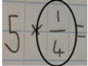

The denominator tells us we have to break each whole into 4 pieces:

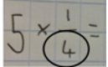

Exchange:

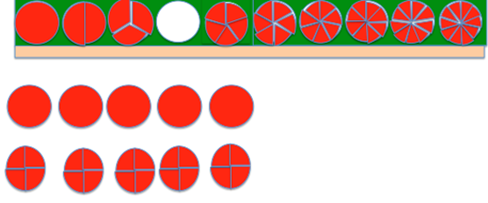

Put the wholes back:

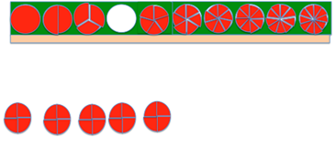

The numerator tells us we have to take 1 from each of those wholes:

**C:\Users\Ben\AppData\Local\Microsoft\Windows\INetCache\Content.MSO\221A6636.tmp**

Slip ¼ down from each 4/4 and put away the ¾ left:

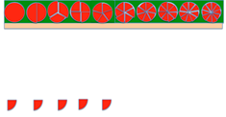

 Count the ¼s

5/4

Write it down:

**C:\Users\Ben\AppData\Local\Microsoft\Windows\INetCache\Content.MSO\1F4F6BE2.tmp**

Reduce it (add them together) 1 ¼:

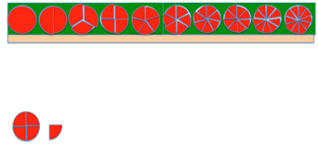

Write it down:

**C:\Users\Ben\AppData\Local\Microsoft\Windows\INetCache\Content.MSO\1CC1D64E.tmp**

**Multiplications**

Customise your times table test on Purple mash.

1. Pick a times table you’d like to master
2. Take 10 minutes trying to memorize them
3. Set the parameters on Purple Mash/multiplication/custom

Geometry

Decorate the net (flat 3D shape) before cutting it out and sticking it together. Cut around the flaps, as these will help you to stick it together.

Language

**Logical Analysis**

Cut out the Logical Analysis arrows and circles.

Write one of the suggested sentences on a slip of paper.

1. **Henry folded the mat.**
2. **John carried the ball.**
3. **The kitten chased the mouse.**

Put the red circle (predicate/verb) in the middle and ask yourself:

‘What word tells me what to do?’

Cut them out and place them on the circle.

Then use the arrows to ask:

‘Who is it that (did the predicate? - **the subject.**

**‘**Whom? What? **– direct object**

Now, write your own sentences with a subject, predicate and direct object.

Do the same again, finding the subject and the predicate. With the bits that you have left, try and work out (by reading the orange arrows) ‘What question they are the answer to’.

1. **Alice went timidly up to the door**
2. **The White Rabbit was by the fence**
3. **Little Emily gazed longingly.**
4. **The man drank from the basin.**
5. **Alan retreated fearfully.**
6. **Winnie the Pooh woke up suddenly in the middle of the night.**

Now, can you write your own?

**Mnemonic Elephants**

It can be quite difficult to learn spellings. Sometimes people use tricks to help them remember how to spell certain words.

One trick is to make up a little rhyme using the letters of the word that you are trying to learn.

For example: BECAUSE  
Big Elephants Can Always Understand Small Elephants.

If you can remember the rhyme, then you’ll always know how to spell because!

Think of some words that you find hard to spell. Try and see if you can make up a rhyme to help you remember the spelling.

It doesn’t matter how silly your rhyme is, as long as you remember it!

Write your rhyme down and send a picture in for others to use.

**Recipe**

Write down, in your best handwriting, a recipe that you enjoy making and would like to share with your friends.

Art

Equipment

* 4x sugar paper
* Pencil
* Paints

1st page: Using the paints mix the primary colours (Red, Blue and Yellow) together to see what happens. Think about combinations that you already know, and experiment with ones that you don’t.

2nd page: Look at the environment around you, take the colours from around you and try to replicate them. Think about the colour mixing that you have just done and how it will help you to create the colours in your environment.

3rd and 4th pages: Try to use the colours that you have made to paint the world that you see around you, you may wish to sketch out the shapes of the objects first.

Work Journals

Just think about how important it would be if a child found your journal in one hundred years’ time!

Continue to write, all the wonderful things you do, in it. Tells us about your emotions too, what/who you miss.

Maybe, do a good deed for the day and write about what you did.

Use your journal to then fill in the graph:

Then use it to input your data into Purple mash (2Graph)

<https://www.purplemash.com/#app/tools/2graph>