Red Group 15/06/20
Geography
Space
International Space Station
Please read the information below and then answer the questions.

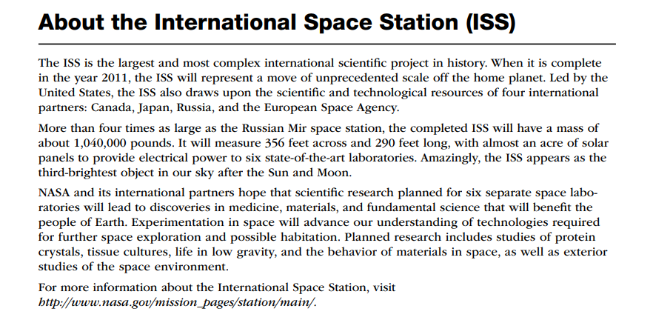

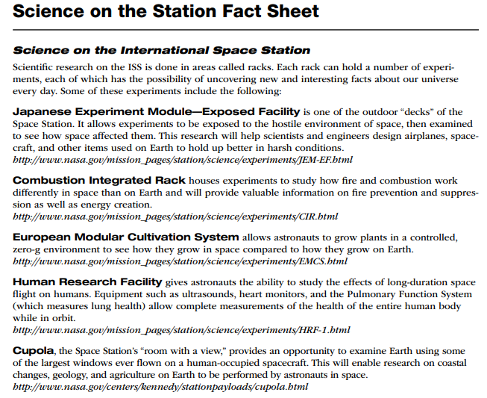
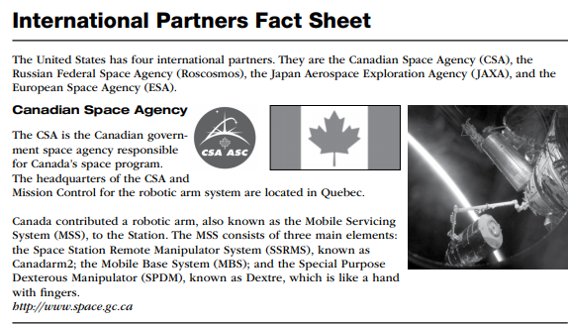
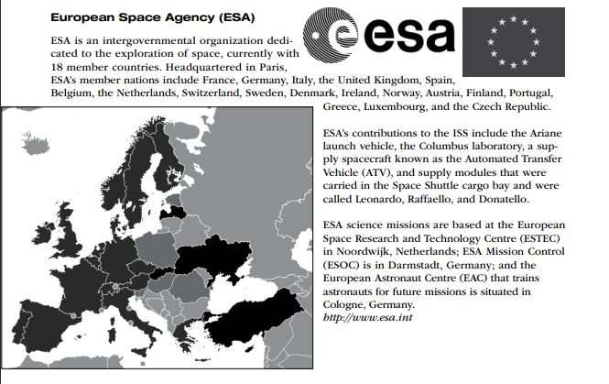
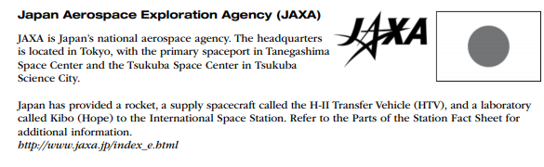

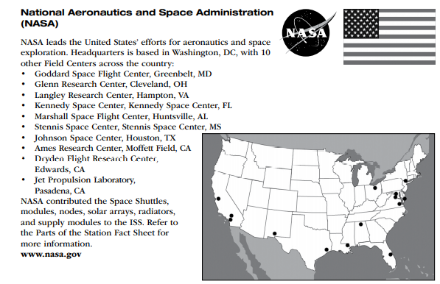

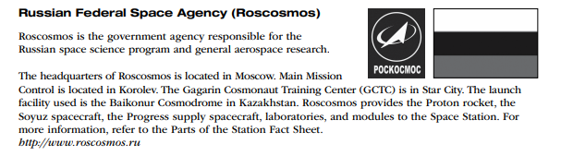
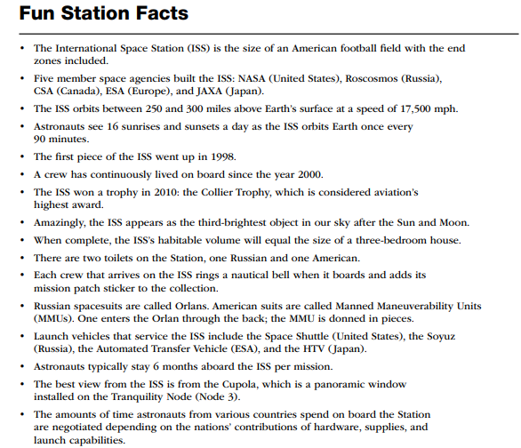
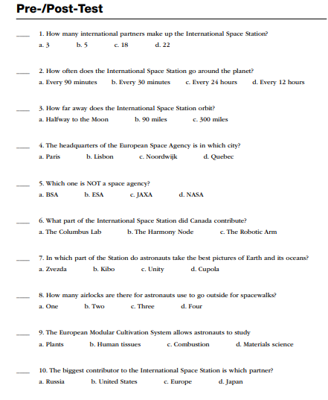

Can you describe, in writing, 3 ways you would improve the ISS.

Although the ISS is not visible, currently, in our skyline, it might be soon, so check when you might be able to see it from East Sussex.

https://spotthestation.nasa.gov/sightings/
Maths
Conversion
Pounds to Kilograms.
If you’re just trying to convert to kilograms for cooking or to know your weight theirs a handy rule of thumb you can use, which becomes inaccurate when measuring the weight of large objects so don’t use this when you work for ESA/NASA!
To get kilograms, divide by 2 then take of 1/10th of your answer
For example:
100 pounds
Divide by two = 50kg.
Take of 1/10th of 50 = 5
50 -5 = 45kg
What is the following in Kg (please show your working out)?

- 60 pounds

- 120 pounds:

- 280 pounds:

- 3400 pounds

- 5000 pounds

- Can you work out the weight of the ISS in Kilogrammes, using this method*

*When measuring really heavy things this system becomes inaccurate.
Botany/Art
Potatoes
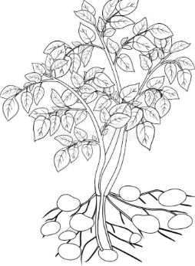
This is one of the menus from the ISS. The potato has come a very long way!
MEAL 3
Sauerkraut Soup (R) - Shepherd
Meat w/ Barley Kasha (T) - Shepherd
Pureed Vegetable Soup (R) - Krikalev & Gidzenko
Chicken in White Sauce (T) - Krikalev
Bream in Tomato Sauce (T) - Gidzenko
Mashed Potatoes (R) - Gidzenko
Moscow Rye Bread (IM)
Apricot Juice w/ Pulp (R)

Do you remember back on the 3rd of June we planted the potatoes with Debbie? Half were regional and half were Rocket? Well, it’s nearly time for us to harvest them (16th of March), weigh them and send in our results to GYOP (Grow Your Own Potatoes).

What is a potato? Anyone remember? Yes, of course it’s a tuber!
A tuber is a short, thick, round stem or root that grows underground, usually as an offshoot from the main stem of the plant. Tubers contain all the necessary parts to produce a new plant. If you leave a potato in the kitchen drawer for too long, for example, it will sprout.
Please, watch the below link showing how our potatoes grow:
Time lapse of a potato
In October 1995, the potato became the first vegetable to be grown in space. NASA and the University of Wisconsin, Madison, created the technology with the goal of feeding astronauts on long space voyages, and eventually, feeding future space colonies.
Botany
Swollen Roots

Can you match the pictures with the definitions?

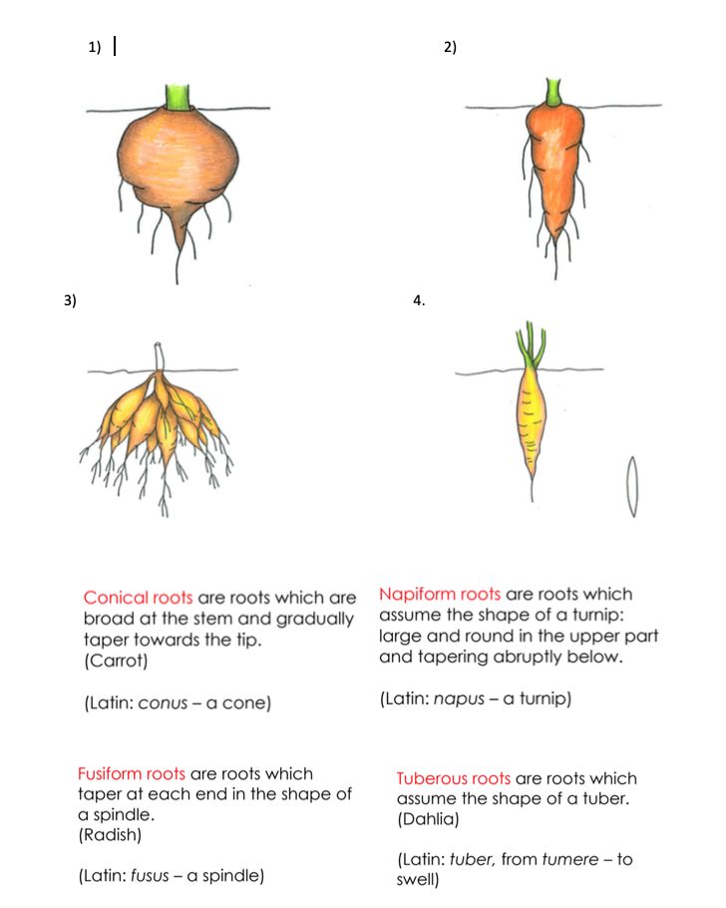

Draw your own detailed pictures and make your own definitions to make into a book.

Maths
Conversion from kilograms to grams

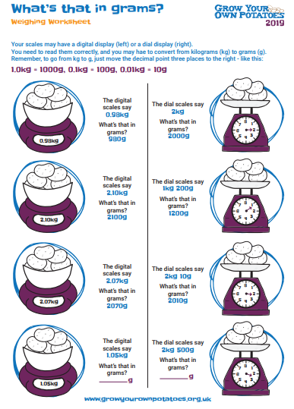

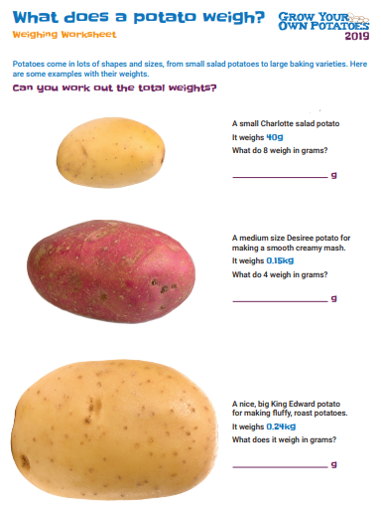

Read the ‘Potato Timeline’ below then answer the questions.

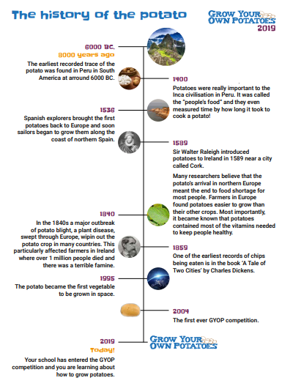

- Which country was the first ever recorded trace of the potato? Colour it in on this map:

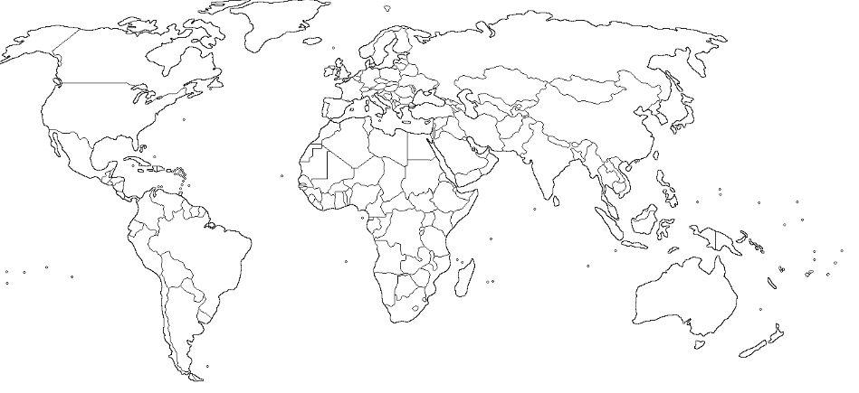

- Apart from eating them, what else did the Incas use potatoes for?

- Which country first brought back the potato to Europe. Colour it on the map!

- Give two reasons why farmers preferred to grow potatoes rather than their other crops.

- How many people, in Ireland, died due to the ‘potato blight’ in 1840?

- One of the first ever recordings of potatoes being made into chips was in Charles Dickens’ ‘Tale of Two Cities’; can you research what else he recorded that hadn’t been mentioned before – this could also refer to words, too.

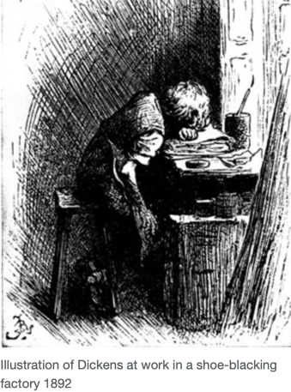
Language

Introducing Mr Dickens

Find out as much as you can about Charles Dickens.

His life

  - When and where was Charles Dickens born?
  - What were the names of Charles Dickens parents?
  - How old was Charles Dickens when he went to school?
  - What happened to his father that meant Charles Dickens left school?
  - Where did Charles Dickens go and work when the rest of his family moved to Marshalsea?
  - What were the conditions like where Charles Dickens worked as a child?
  - How long did Charles Dickens work for before going back to school?
  - In what year and to whom did Charles Dickens marry?
  - How many children did Charles Dickens have?
  - How did Charles Dickens die and in what year?

His works

- Which of his two famous novels were inspired by his experience working as a child?
- How did Charles Dickens begin his career?
- Which book shot Charles Dickens to fame in 1836?
- Which Queen did Charles Dickens perform before in 1851?
- What did Charles Dickens lecture against in the United States of America?

His times

What was ‘life’ like when Dickens was alive? Try and find out about new industry, life for the poor, schooling, Christmas.

Science
Science experiments
Click this link below:
Science experiments
*Please, always have an adult present when doing these experiments.
Choose two experiments and research the science behind them.

