Blue Group
Language
Writing
Task 2:
How did you get to your island?
Write about your arrival, explaining how you got there. Are you alone or with someone? Try and think of an interesting and unusual way to arrive. If you are writing it as a diary then give it a date. Were you alone when you travelled and what about now?
Remember to write in paragraphs and think carefully about punctuation and presentation. Use the best descriptive language you can, for example.
The stark contrast between the bright sun-drenched white sand and the dark Write a rhetorical question to finish the paragraph, for example:
- There's no hope, is there?
- How much longer will this injustice continue?

Science
Evaporation
Imagine you have yet to find a fresh water source on your island. You would need to make this in the meantime:
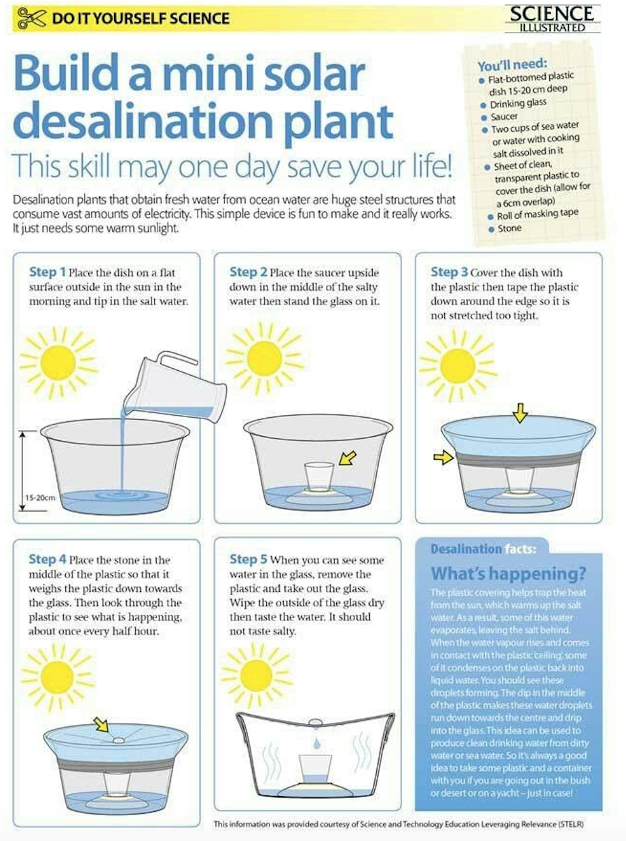
Zoology
Vertebrates
Use the suggestions below the table to help fill in the missing words.
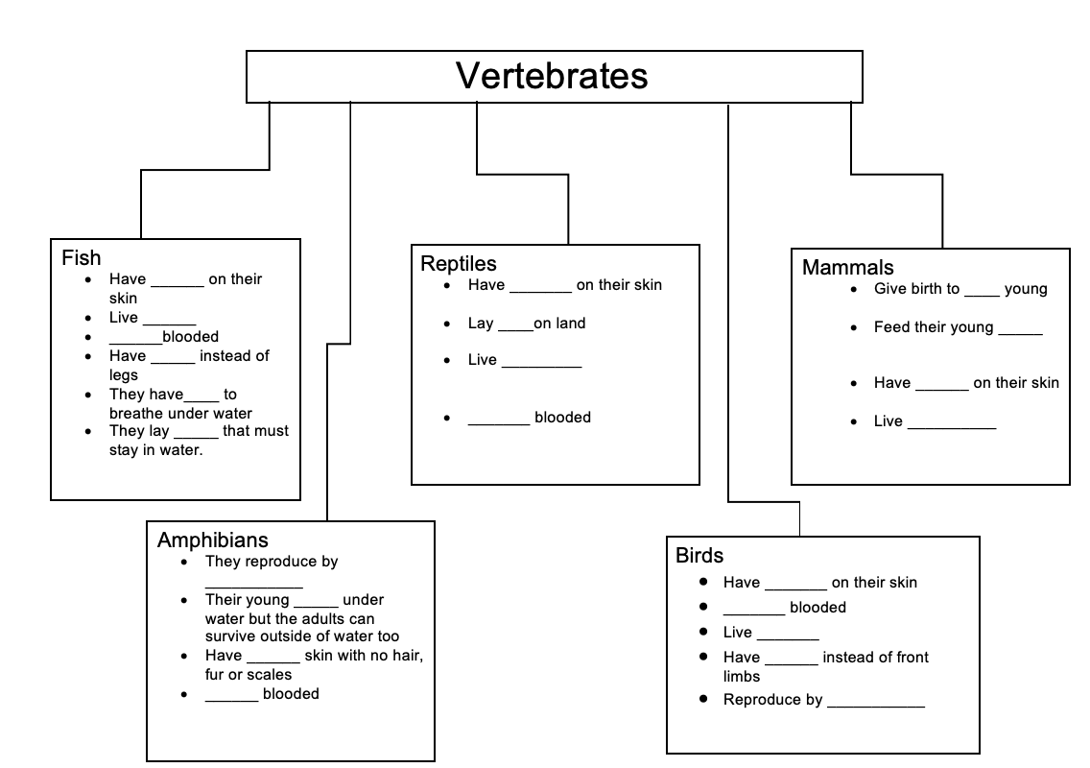
- Live in the sea
- Give birth to live young
- Feed their young on milk
- Live in water or on land
- Have feathers
- Live outside of water
- Have fins
- They have gills to breathe under water
- Have wings
- Lay eggs not in water
- They lay eggs that must stay in water
- They lay eggs in water
- Have moist skin with no hair, fur or scales
- Cold blooded
- Have scales
- Their young breathe underwater, but the adults can survive outside of water too
- Have hair/fur
- Cold blooded
- Warm blooded
- Have scales
- Lay eggs on land
- Live in water or on land
- Cold blooded
- Live in water

History
Tudors
Galleons

Why not listen to some Tudor music to inspire you whilst you work.

https://www.bbc.co.uk/teach/school-radio/history-tudors-music/zm4gvk7

Please, read the section below on Galleons then answer the questions.
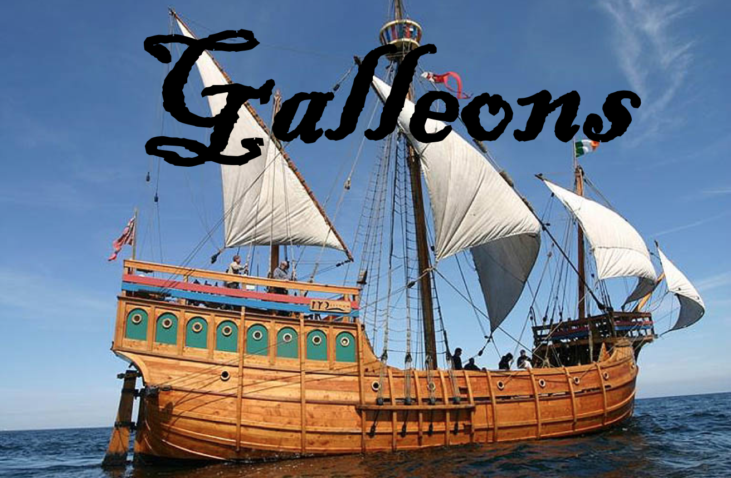
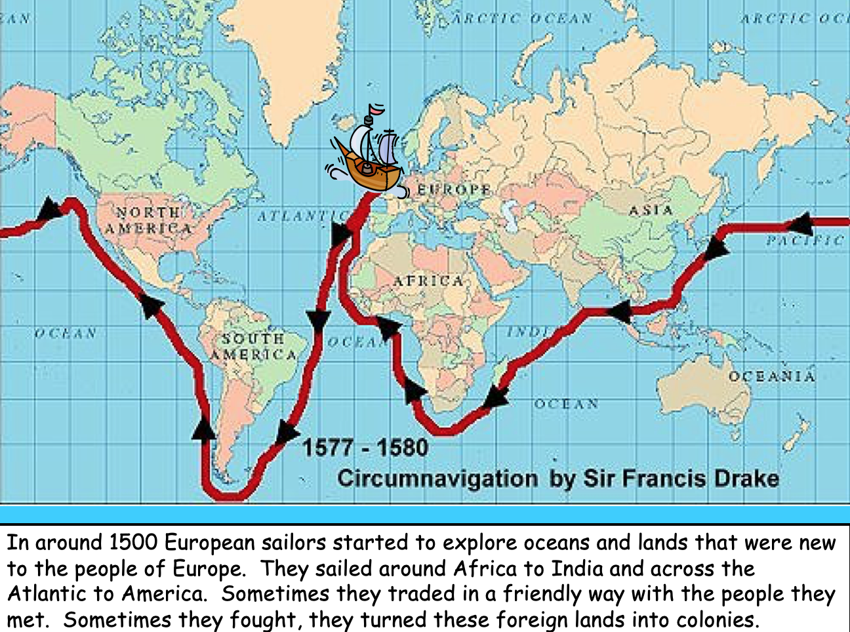
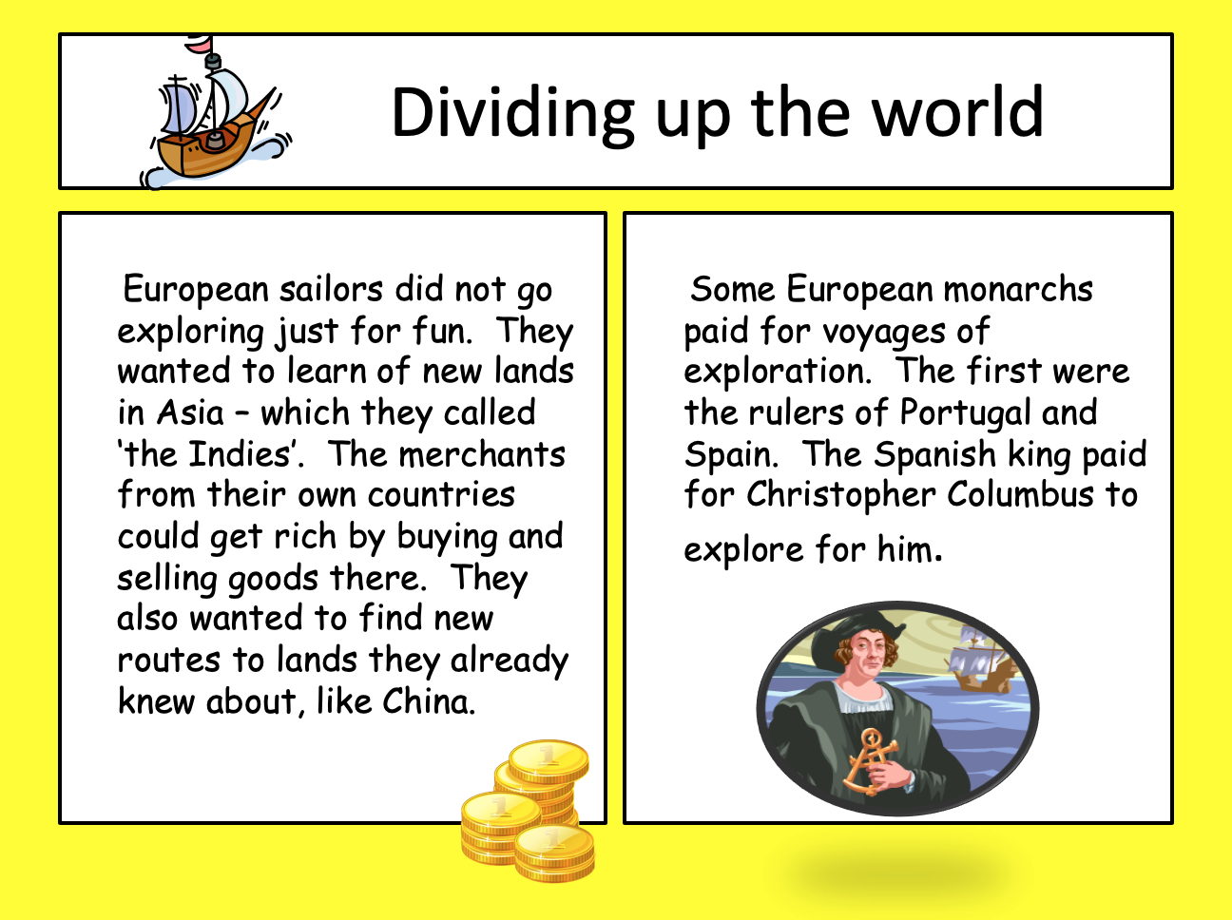
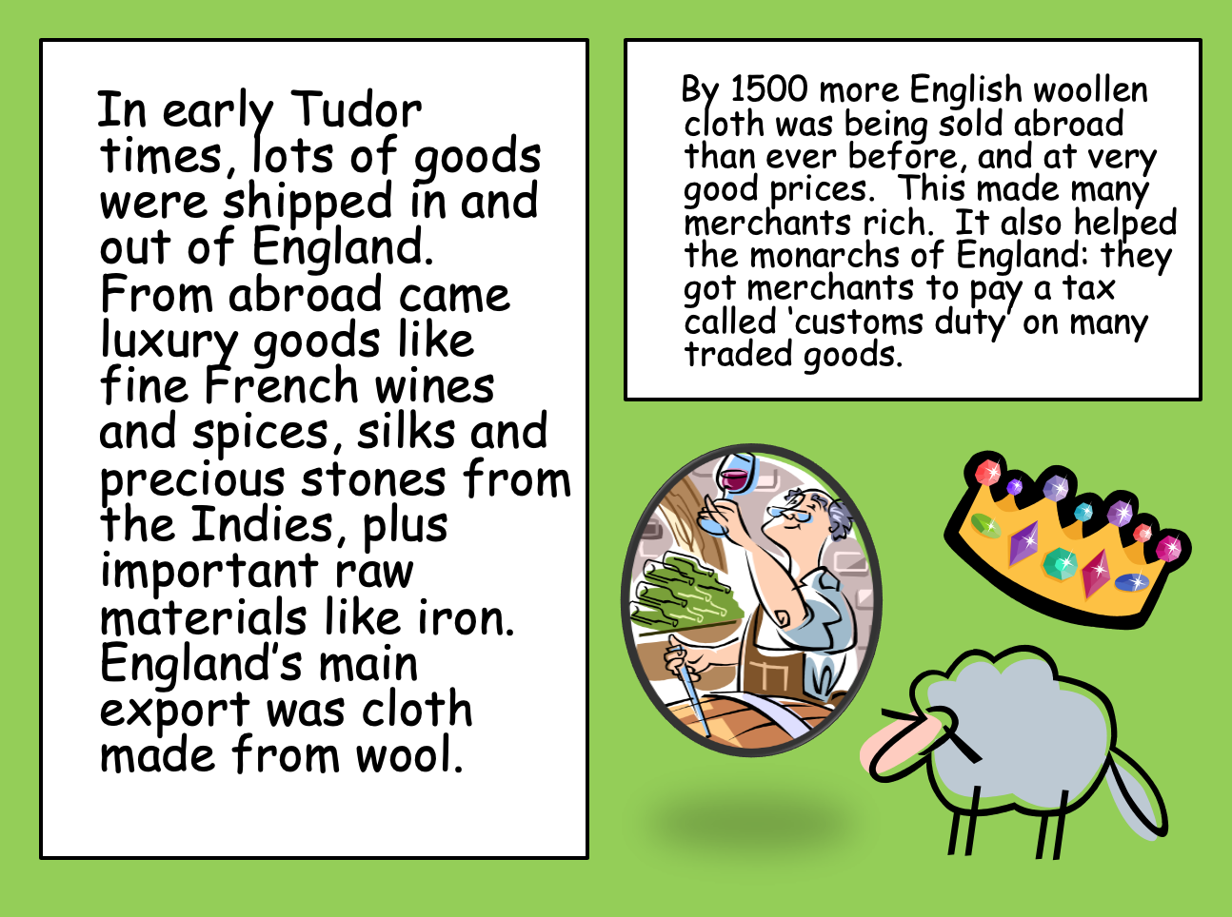
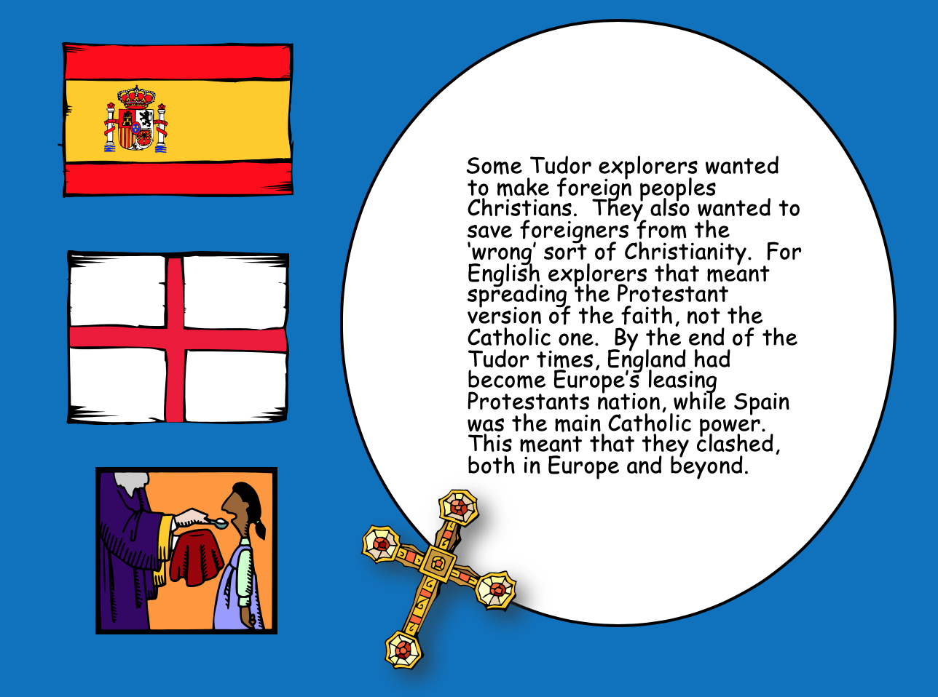
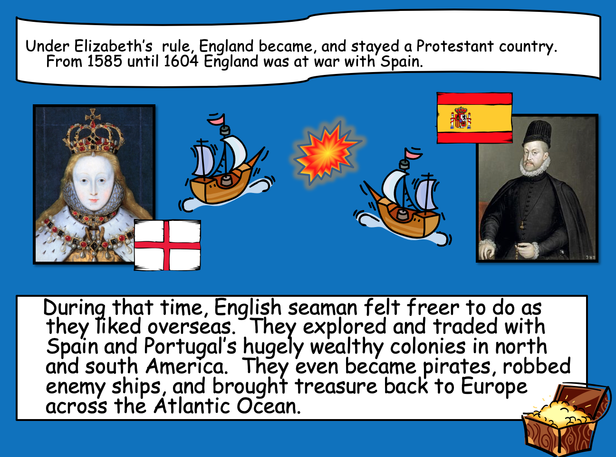
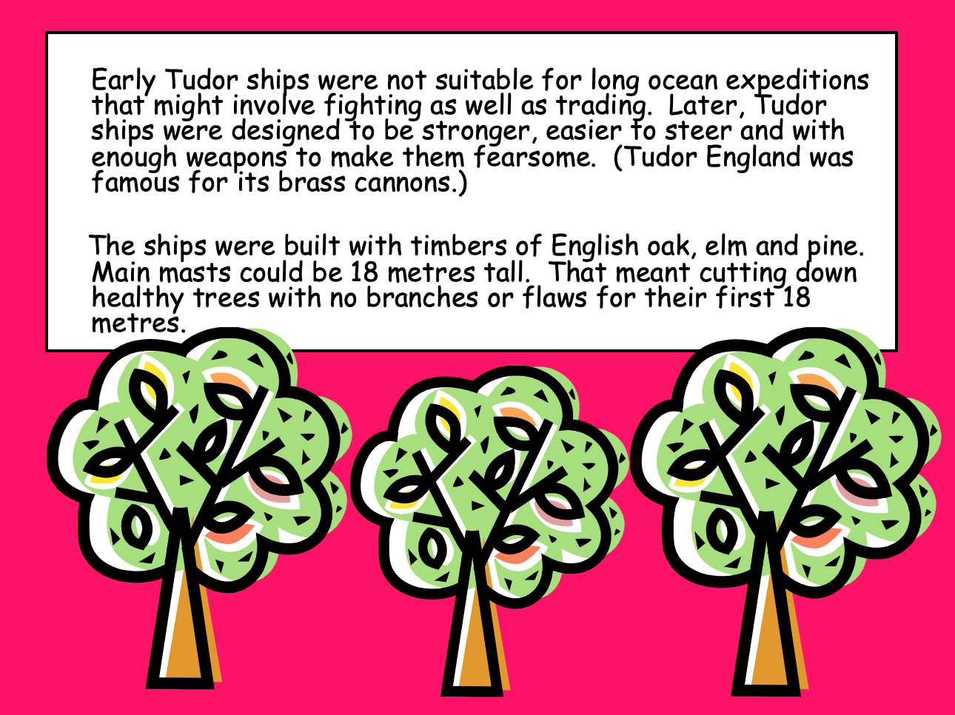
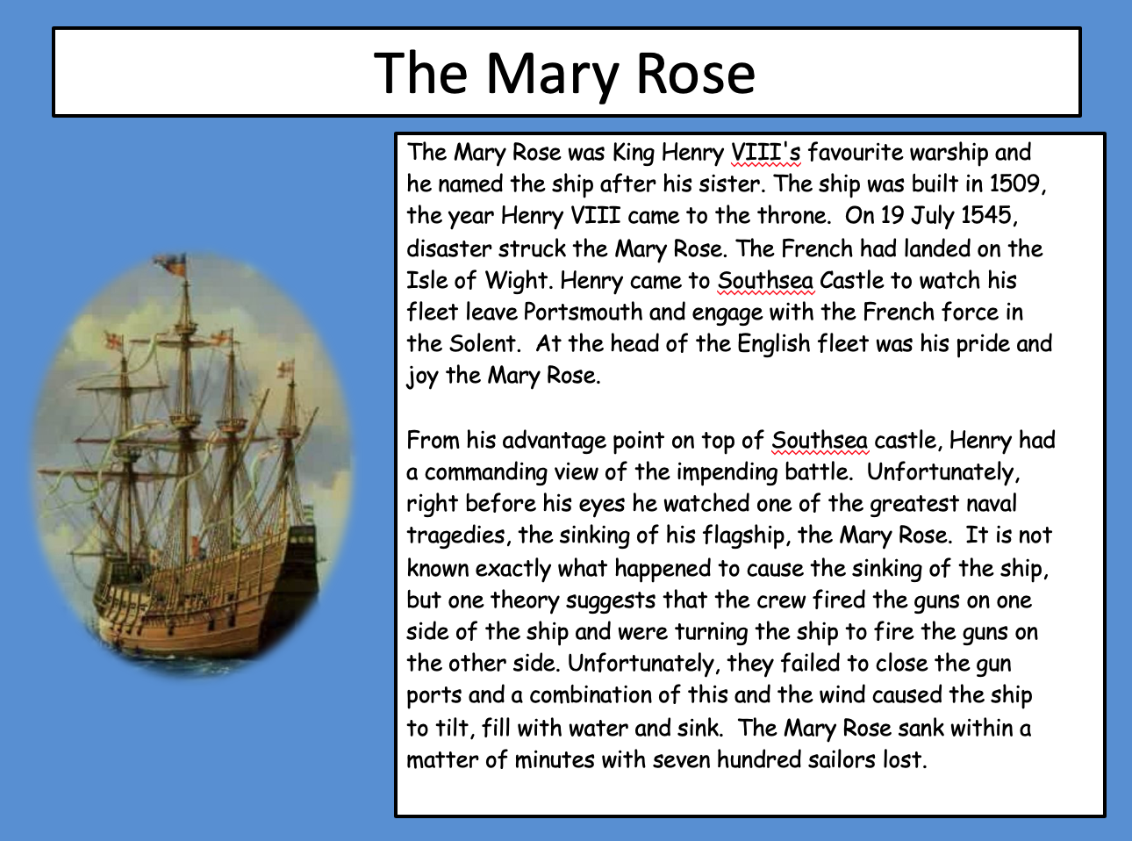
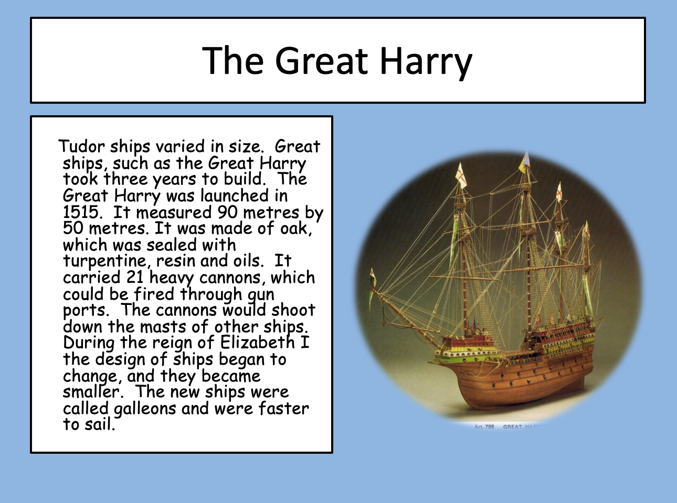
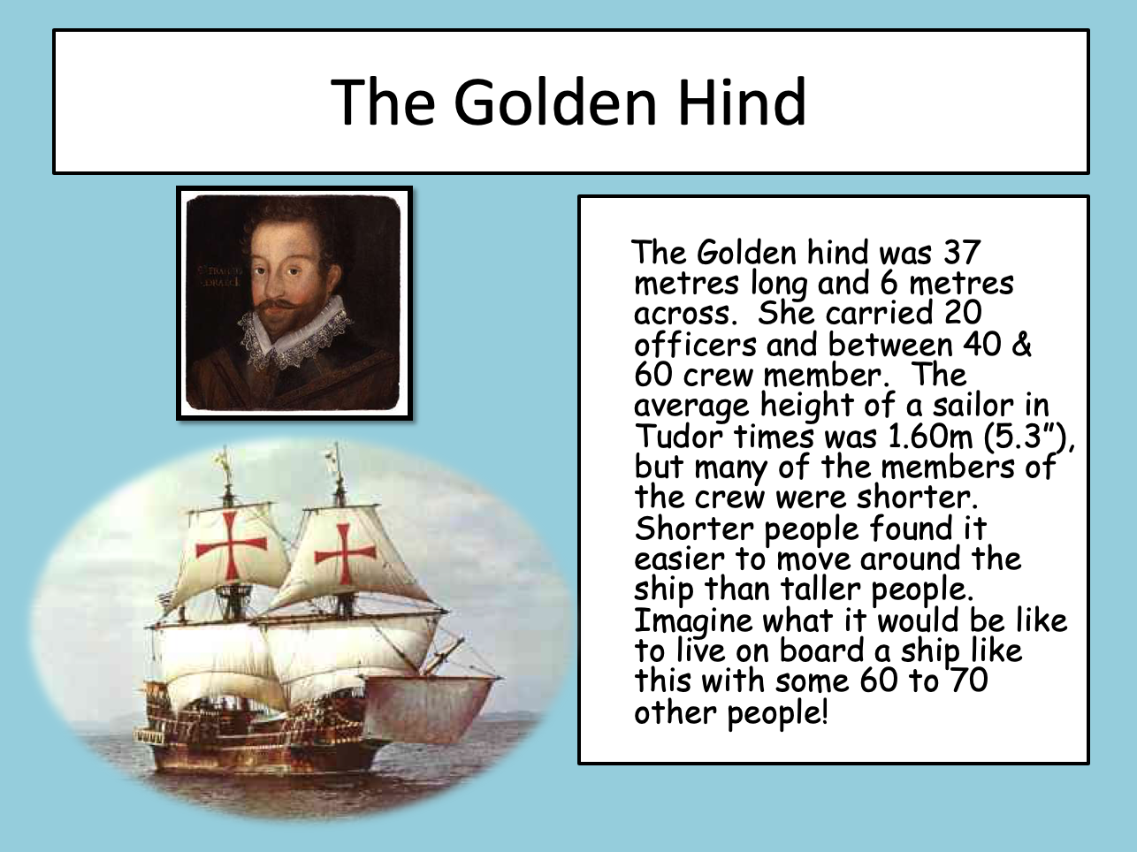
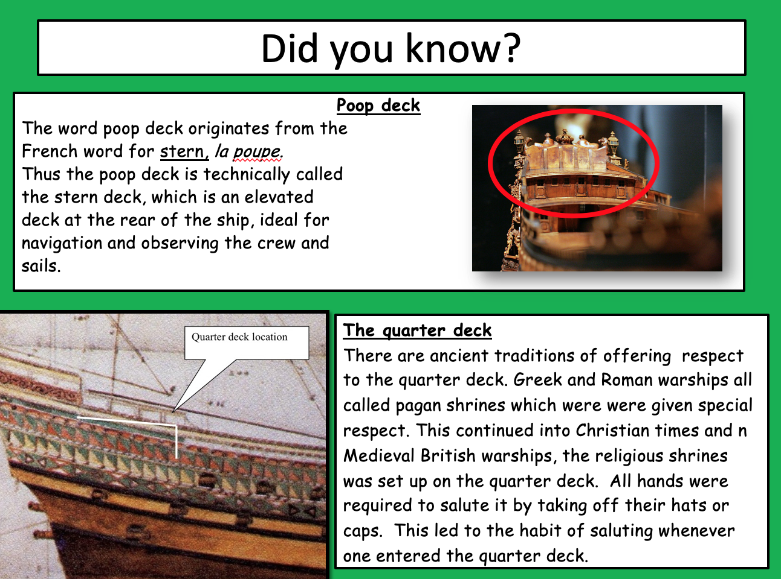

What does circumnavigation mean?

- Robin Crusoe wanted to be a sailor because of the adventure but what other reasons did sailors set sail?

- Who funded the first voyages?

- We imported many wonderful things but what did we export (trade out of England)?

- What according to the English was the wrong kind of ‘Christianity’?

- Between which dates were England and Spain at war?

- What kind of wood were the ships made from?

- Who was the Mary Rose named after?

- Where did it sink?

- What were the dimensions of ‘The Great Harry’?

- Why did they start building ships that were smaller?

- The average height of a sailor in Tudor times was 5.3” (five foot three inches), nowadays the average height for an Englishman is 5.9”, why do you think we’ve got taller?

- Research from a book or the internet, the average life expectancy of woman or men from Tudor times. What is the difference in years between now and then?

- Why is it called the poop deck?

Art

Galleon

https://www.youtube.com/watch?v=vmK826mU6Yc

Music by Wolfgang Amadeus Mozart (27 January 1756 – 5 December 1791), baptised as Johannes Chrysostomus Wolfgangus Theophilus Mozart, was a prolific and influential composer of the Classical period.

Maths

Perimeter

Robinson’s Farm Project
Robinson has a problem. He needs to work out how much fencing he needs to make for his fields, so his goats don’t escape. Can you help him?
25 m
10 m
2.
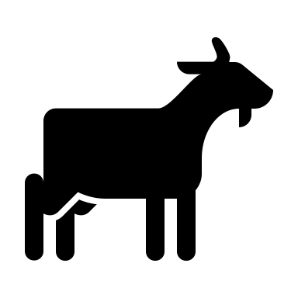
1.
5 m
10 m
11 m
3 4.
20 m
12 m
15 m
18 m

50 m
5. 6.
9 m
23 m

7. Trickier? Why not work out the area (length x width).

8. If the average height of the trees on the island were 4 metres high, and each post that he makes is 1metre tall, how many trees would he need to cut down to make the largest enclosure, above?

Science/Maths

Baking

Poor old Robinson longed for bread. Without many of the ingredients – yeast and butter to add flavour – he had to make flatbreads, with simply, flour and water. Imagine the delight if he was able to make these!
Why not have a go.

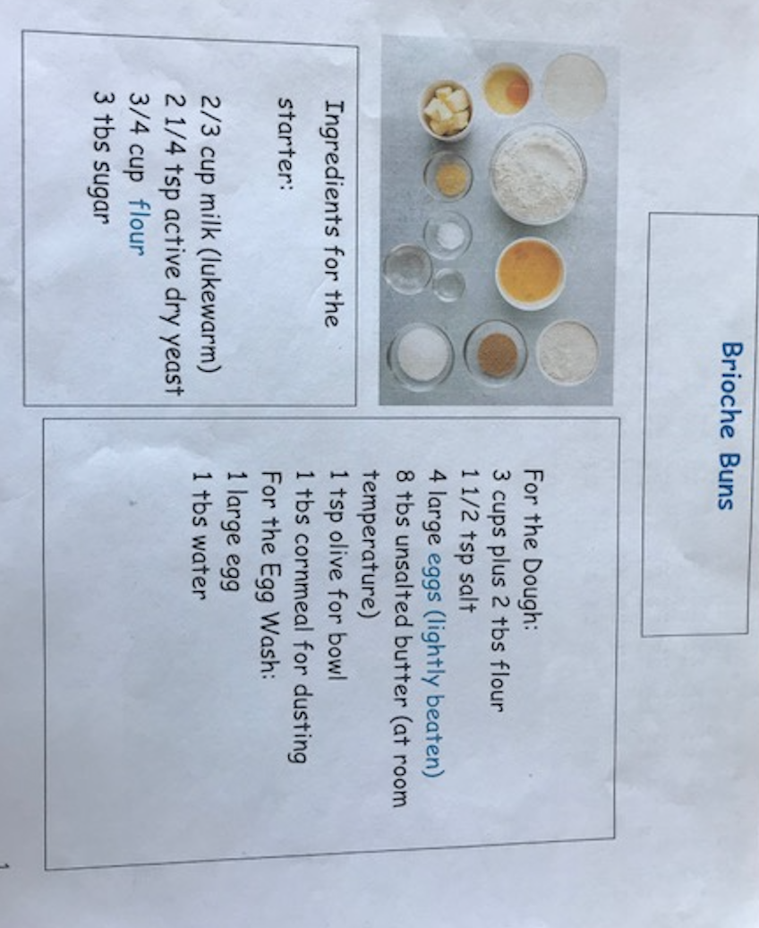

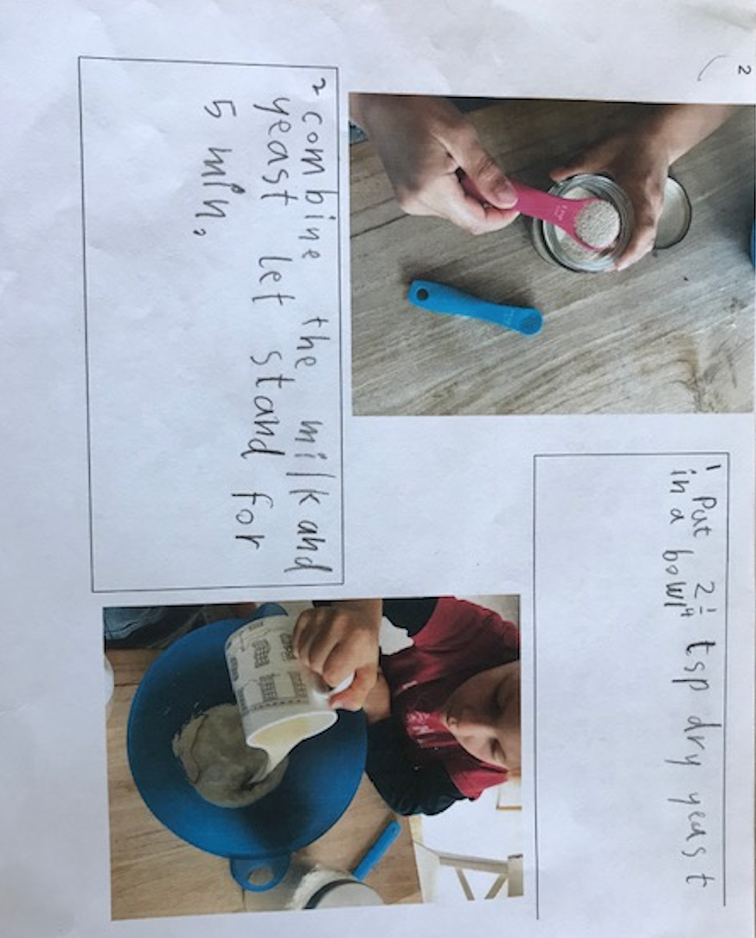

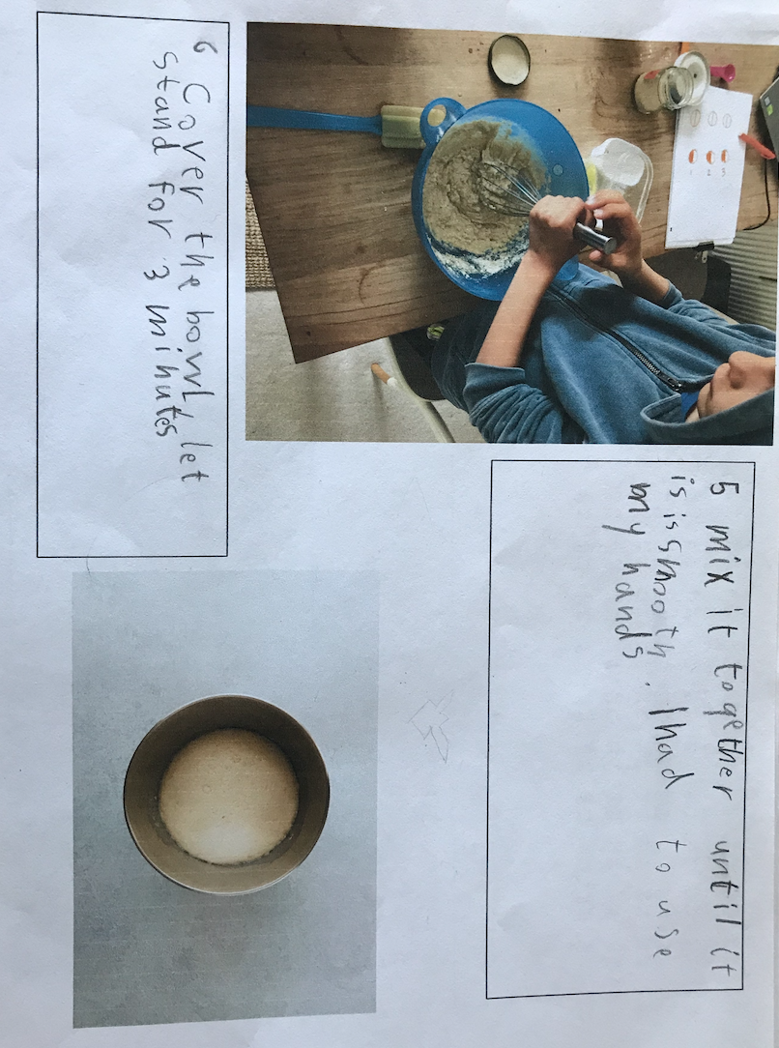
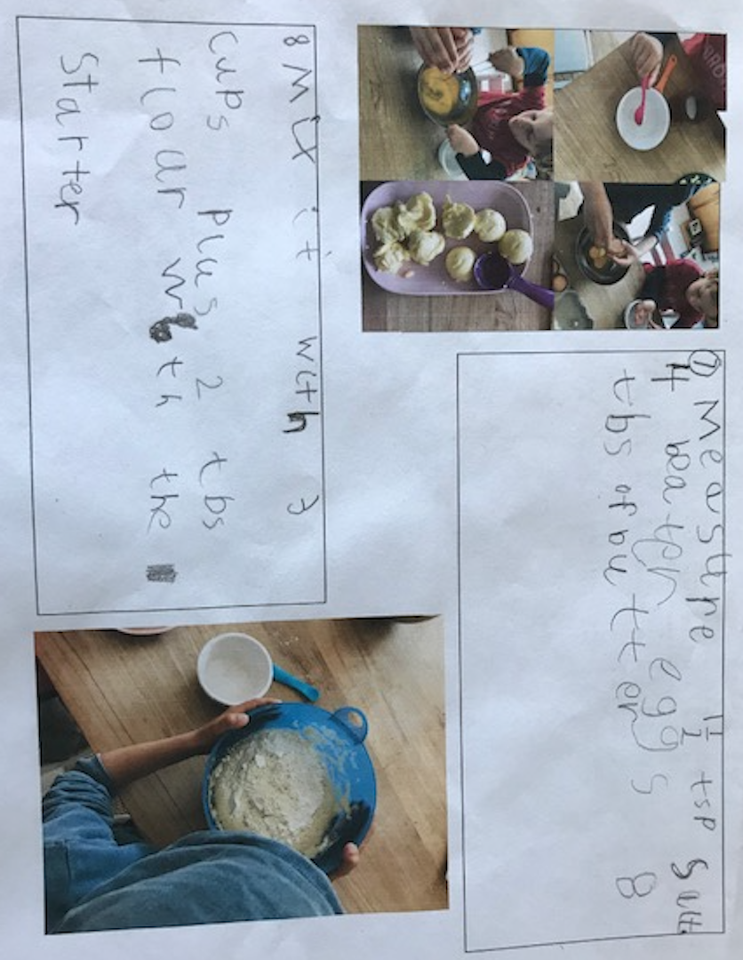

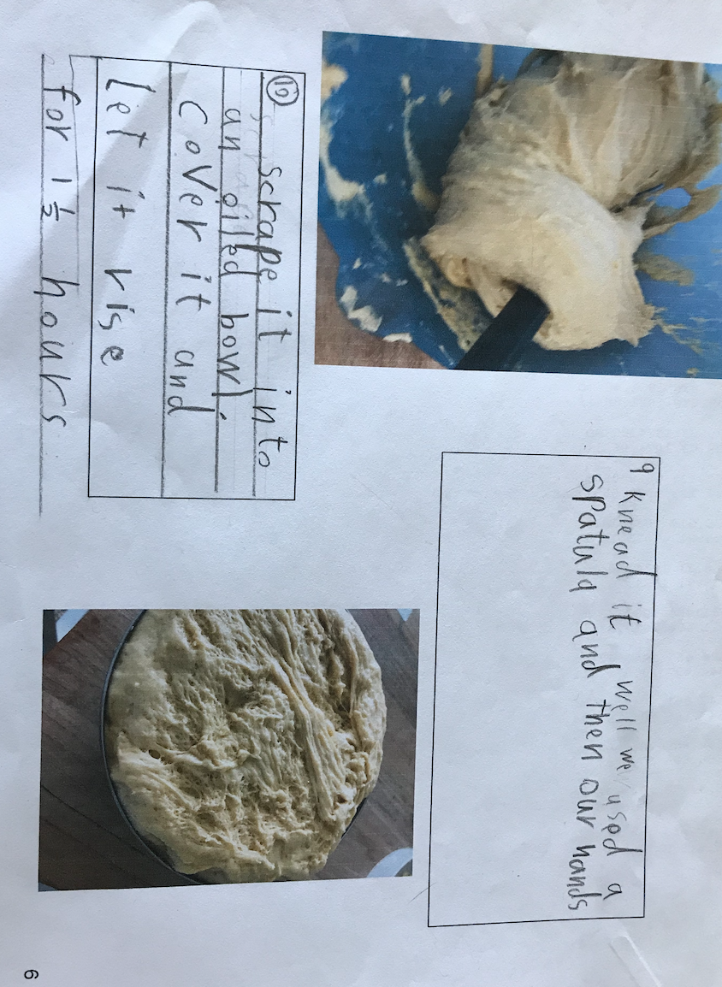

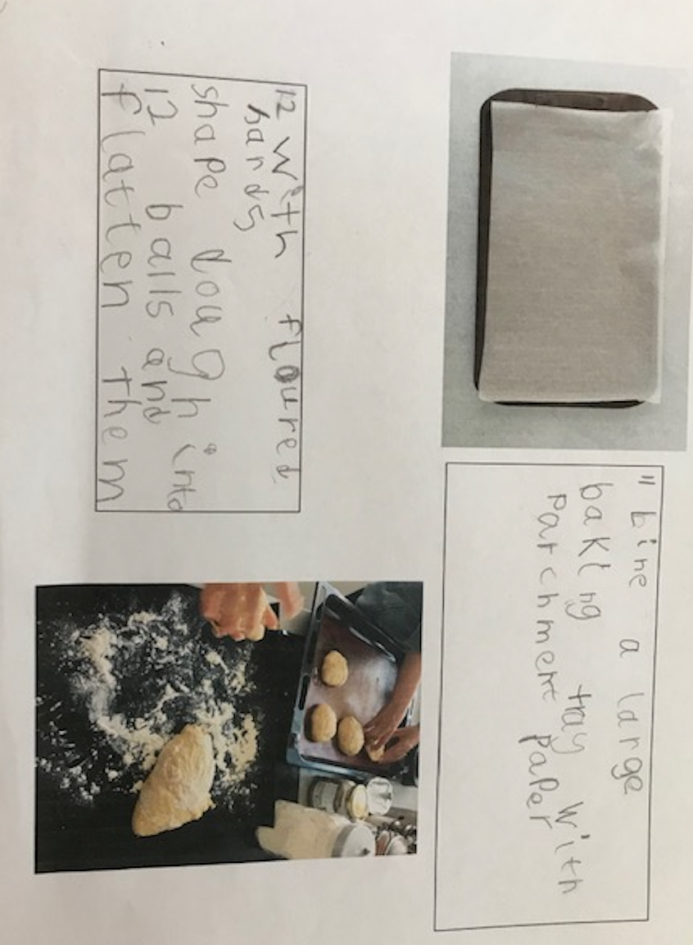

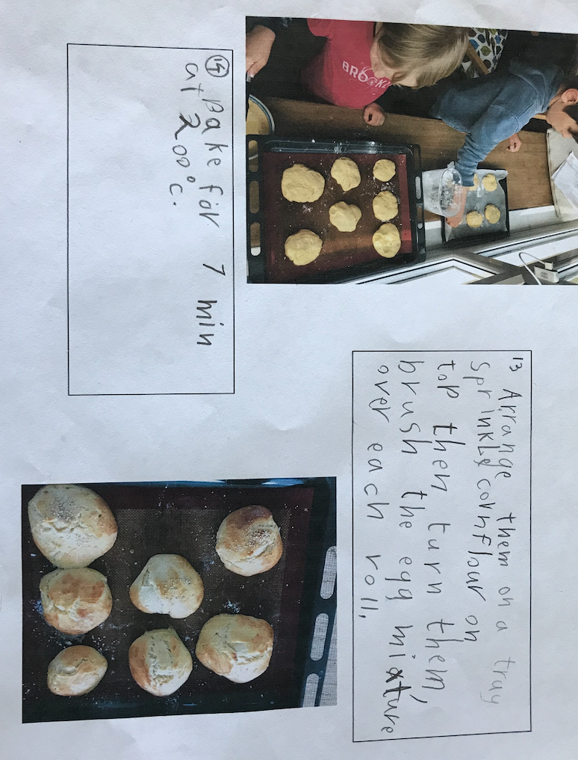

Thanks once again Emil and Friedrich for this wonderful tutorial on how to make ‘Brioche Buns’.
I will be asking you, next week, to build a shelter, on your island and write the instruction just as Emil and Friedrich have here. As you can see, most of the first words in the sentence are verbs – scrape, knead, mix…

Good luck baking me old seadogs!

